# Title

Student ID: S1234567 Name (English): Andy Name (Chinese): 陳家豪

## 1. Introduction

Digital transformation is one of the key strategies for companies to survive in a competitive global market. Depending on how actively it adapts to this environmental change, the fate of the organization changes forever(HBR, 2025). But the digital transformation is more about strategies than technologies(Kane et al., 2015).

The 2030 Agenda for Sustainable Development, adopted by all United Nations Member States in 2015, provides a shared blueprint for peace and prosperity for people and the planet, now and into the future. At its heart are the 17 Sustainable Development Goals (SDGs), which are an urgent call for action by all developed and developing countries in a global partnership.

The 2030 Agenda for Sustainable Development, adopted by all United Nations Member States in 2015, provides a shared blueprint for peace and prosperity for people and the planet, now and into the future. At its heart are the 17 Sustainable Development Goals (SDGs), which are an urgent call for action by all developed and developing countries in a global partnership.

## 2. Data and Methods

They recognize that ending poverty and other deprivations must go hand-in-hand with strategies that improve health and education, reduce inequality, and spur economic growth – all while tackling climate change and working to preserve our oceans and forests.

Table 1 presents the raw data of incoming traffic to Tunghai University.

Table Traffic statistics in Tunghai University

|  |  |  |  |  |
| --- | --- | --- | --- | --- |
|  |  |  |  |  |
|  |  |  |  |  |
|  |  |  |  |  |
|  |  |  |  |  |
|  |  |  |  |  |
|  |  |  |  |  |
|  |  |  |  |  |

## 3. Results

As Figure 1 shows, the most popular term in 2021 is ‘app.’ The 2030 Agenda for Sustainable Development, adopted by all United Nations Member States in 2015, provides a shared blueprint for peace and prosperity for people and the planet, now and into the future. At its heart are the 17 Sustainable Development Goals (SDGs), which are an urgent call for action by all developed and developing countries in a global partnership.

The 2030 Agenda for Sustainable Development, adopted by all United Nations Member States in 2015, provides a shared blueprint for peace and prosperity for people and the planet, now and into the future. At its heart are the 17 Sustainable Development Goals (SDGs), which are an urgent call for action by all developed and developing countries in a global partnership.

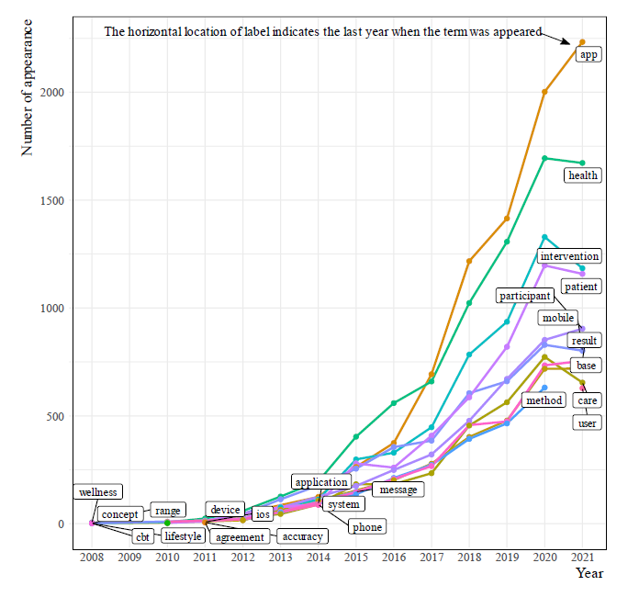

Figure The most popular terms in the research

## 4. Conclusion

The 2030 Agenda for Sustainable Development, adopted by all United Nations Member States in 2015, provides a shared blueprint for peace and prosperity for people and the planet, now and into the future. At its heart are the 17 Sustainable Development Goals (SDGs), which are an urgent call for action by all developed and developing countries in a global partnership.

The 2030 Agenda for Sustainable Development, adopted by all United Nations Member States in 2015, provides a shared blueprint for peace and prosperity for people and the planet, now and into the future. At its heart are the 17 Sustainable Development Goals (SDGs), which are an urgent call for action by all developed and developing countries in a global partnership.

In order to manage reference list, students are encouraged to use Zotero(https://www.zotero.org/) to insert in-text citation and reference list in the manuscript. After installing the Zotero on computer, follow the instruction explained in (Young, 2025a, 2025b)

## References

HBR (Ed.). (2025). How 6 Companies Approached Digital Transformation. *Harvard Business Review Digital Articles*, 1–8. Business Source Elite.

Kane, G. C., Palmer, D., Phillips, A. N., Kiron, D., & Buckley, N. (2015). *Strategy, not Technology, Drives Digital Transformation*. MIT Sloan Management Review and Deloitte University Press. https://www2.deloitte.com/content/dam/Deloitte/fr/Documents/strategy/dup_strategy-not-technology-drives-digital-transformation.pdf

Young, S. (2025a). *CMU LibGuides: Zotero: Getting Started*. https://guides.library.cmu.edu/Zotero/home

Young, S. (2025b). *CMU LibGuides: Zotero: Video Tutorials*. https://guides.library.cmu.edu/Zotero/tutorials