Steve Babcock and Gurleen Dhody
4/3/2017

Assignment 3 - Part 1

SVM Baseline

The SVM Baseline was just run using dry pixel values.

For SVM training the feature of all images should be same. Hence all the images needed to be resized. This parameter of resizing was to be manipulated from 40 to 135. It was observed that after 75X75 resize resolution of the image the results saturated. This was both for colored and non-colored image.

For non-colored (grayscale) results came to be :
25/150

Confusion Matrix :

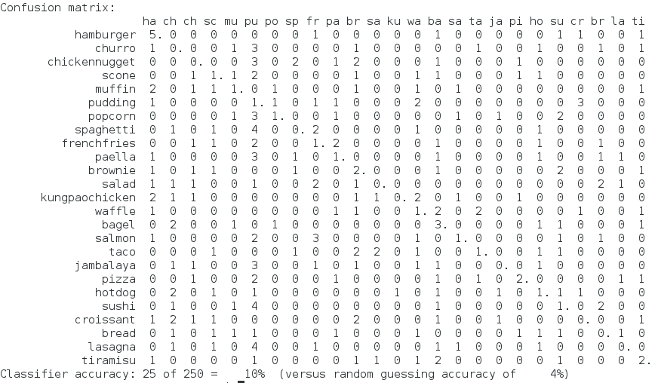

For colored :
To make the code SVM run on colored images. Open the SVM.h file and change the static integer color value to 1. Then on the console again make the application.

For colored (RGB) results came to be :
51/150

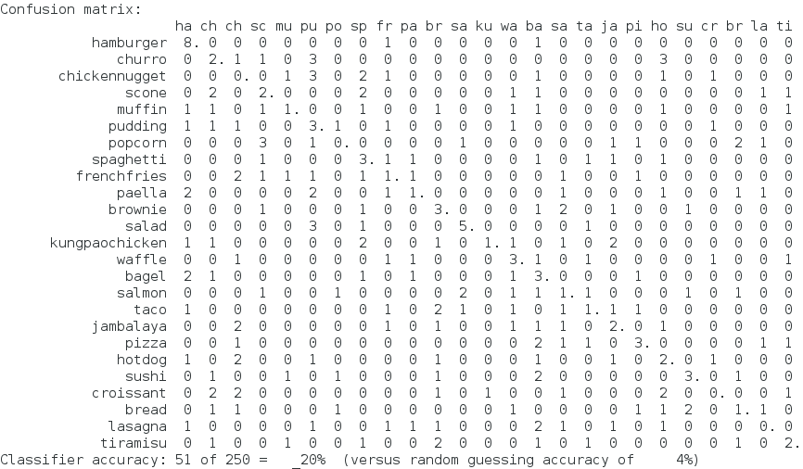

The only issue with color and non-colored SVM is that the vector length/ feature length for each image is very large. So if we run the SVM for such huge data, the run time to find good weights for the SVM hyper plane will be very long. This might take several minutes to train the SVM baseline (10-15 minutes).

