Steve Babcock and Gurleen Dhody
4/3/2017

Assignment 3 - Part 3

Overfeat Deep Convolution Neural Network

Prerequisites:
To run the convolutional neural network please download the overfeat directory into the project folder. Also download the weights for the neural network before starting working with the project/report.

The Overfeat module works with 231X231 Images. Hence we have resized the images to 231X231, before passing it to the overfeat dnn.

The overfeat takes one picture and dumps its <layer> feature into a text file which we then use to train a svm.

We used the layer 21 (1000 features). This provided the best results.
175/250 = 70% Accuracy

The confusion matrix:

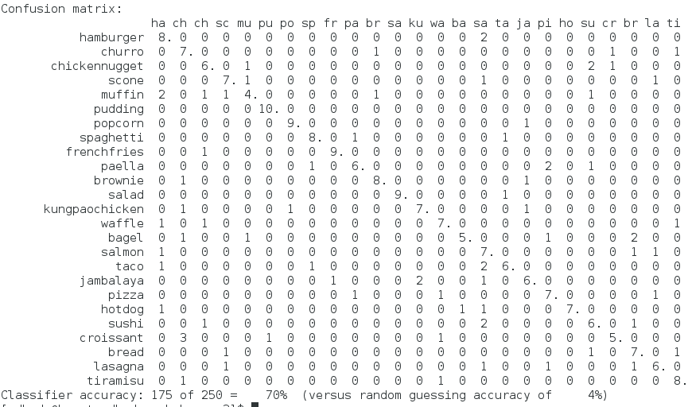
The SVM training was also very fast. Only the processing and dumping feature of values is pretty slow

Training = Around 40 minutes
Testing = Around 10 minutes

