**Lab01**

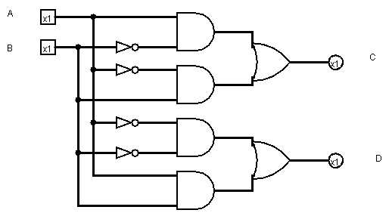3.1:

|  |  |  |  |
| --- | --- | --- | --- |
| A | B | C | D |
| 0 | 0 | 0 | 1 |
| 0 | 1 | 1 | 0 |
| 1 | 0 | 1 | 0 |
| 1 | 1 | 0 | 1 |

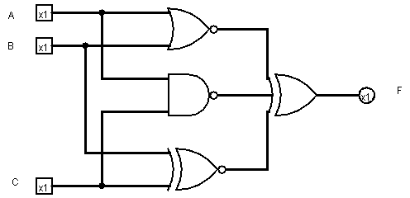3.2:

|  |  |  |  |
| --- | --- | --- | --- |
| A | B | C | F |
| 0 | 0 | 0 | 1 |
| 0 | 0 | 1 |  |
| 0 | 1 | 0 |  |
| 0 | 1 | 1 |  |
| 1 | 0 | 0 |  |
| 1 | 0 | 1 |  |
| 1 | 1 | 0 |  |
| 1 | 1 | 1 |  |