Homework2

1. A Boolean value is either true or false

>>> 2== 3

False

>>> 10 == ( 3 + 7 )

True

>>> i = “hel”

>>> i + “lo” = “hello”

1. A flowchart is a formalized graphic representation of a logic sequence, work or manufacturing process, organization chart, or similar formalized structure.

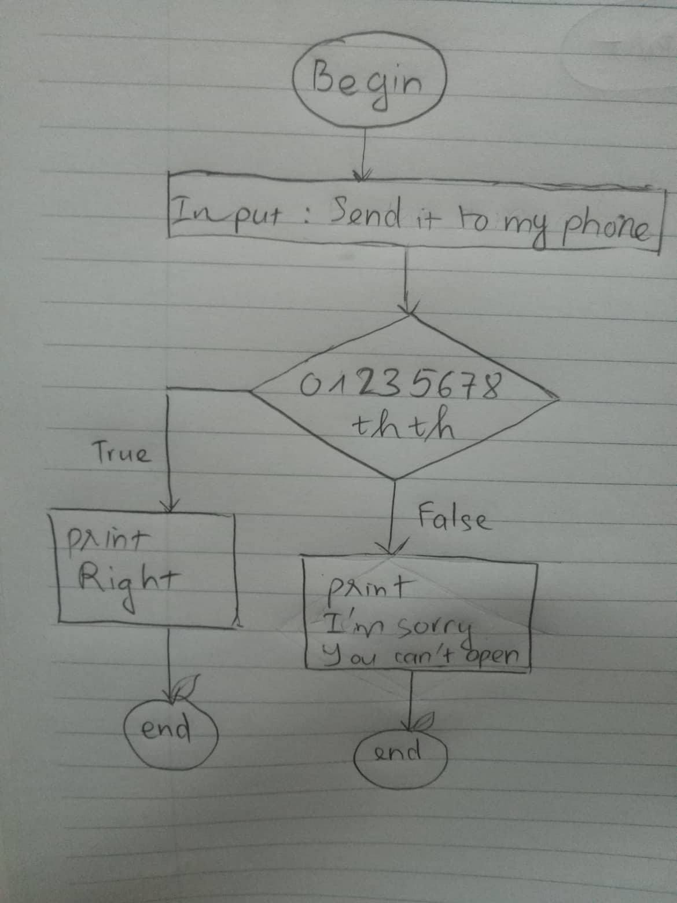

1. if you are my boss :

sign = input(“sign? “)

if sign == bluehair :

print(“welcome, my boss!”)

else

print(“pipi”)