Homework2

1. A Boolean value is either true or false

>>> 5 == 6

False

>>> 5 == ( 3 + 2 )

True

>>> j = “hel”

>>> j + “lo” = “hello”

1. A flowchart is a formalized graphic representation of a logic sequence, work or manufacturing process, organization chart, or similar formalized structure.

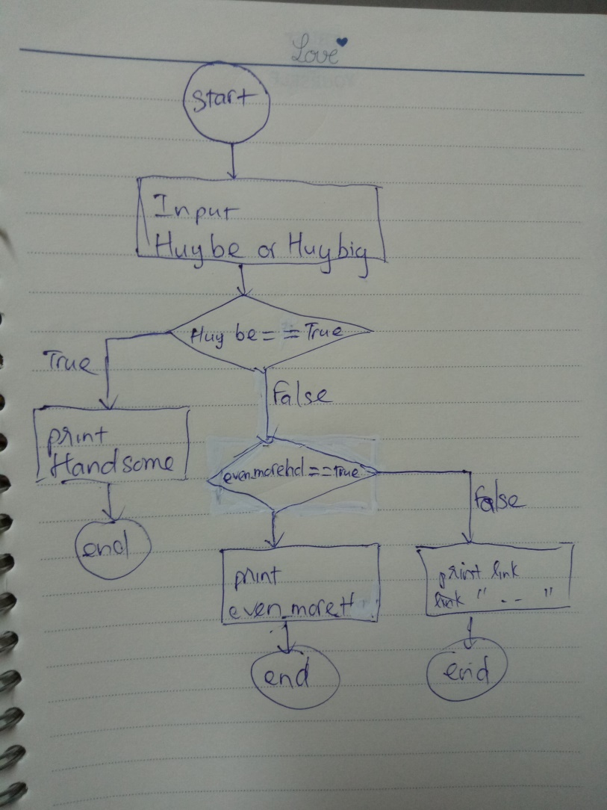

1. if username == c4e:

input("password")

if password == codethechange:

print("welcome")