**Group Report**

Advanced Web Project

**Subject Title:** Advanced Web Project

**Team Name:** *TeamName*

**Submission Date:** *dd/mm/yyyy*

**Team Information**

|  |  |
| --- | --- |
| Full Name | Email |
| Member 1 | email@passerellesnumeriques.org |
| Member 2 | 1234567 |
| Member 3 | 1234567 |
| Member 4 |  |
| Member 5 |  |

Contents

1. User’s requirements 3

2. Design Document 4

2.1 Site map 4

2.2 Prototype designed with Figma 4

2.3 Entity Relationship Diagram (ERD) 5

2.4 API endpoints 5

3. Implementation 6

3.1 GitHub repository images 6

3.2 Jira board images 7

3.3 Images of the final application 7

4. Conclusion 8

4.1 What went well 8

4.2 What did not go well 8

4.3 Lessons learned and further improvements 8

# User’s requirements

Table - User's requirements

|  |  |  |  |  |
| --- | --- | --- | --- | --- |
| ID | PRIORITY  *(high/medium/low)* | AS A [type of user] | I NEED TO [do some task] | SO THAT I CAN [get some result] |
| 1 | High | As a Project Director | get a daily report on project revenue | control and report on department revenue |
| 2 | Low | As an IT Consultant | know my tasks and the billable hours allocated | manage my diary |
| 3 | Medium | As a Project Manager | see a project dashboard showing key KPIs (RAG status, budget, go-live dates, task updates) | have an a glance overview of my projects |
|  |  |  |  |  |
|  |  |  |  |  |
|  |  |  |  |  |
|  |  |  |  |  |
|  |  |  |  |  |

# Design Document

## Site map

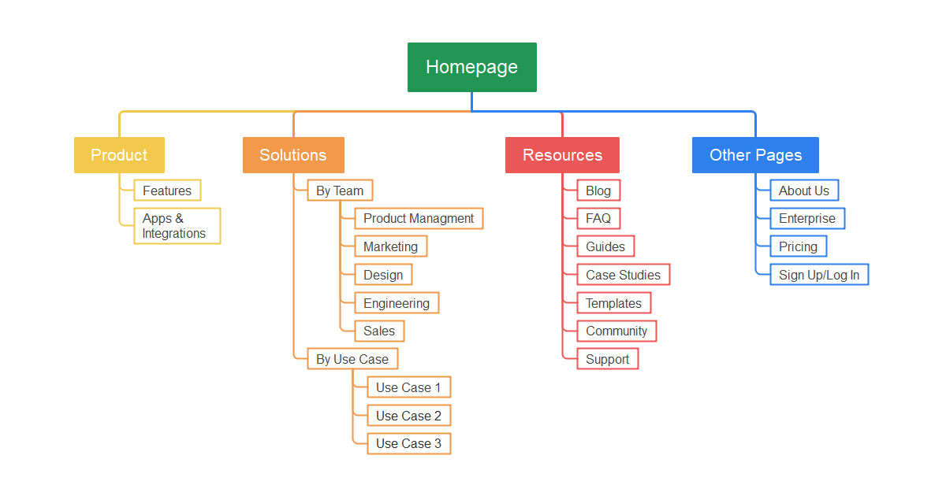

Figure - Site map of the project

## Prototype designed with Figma

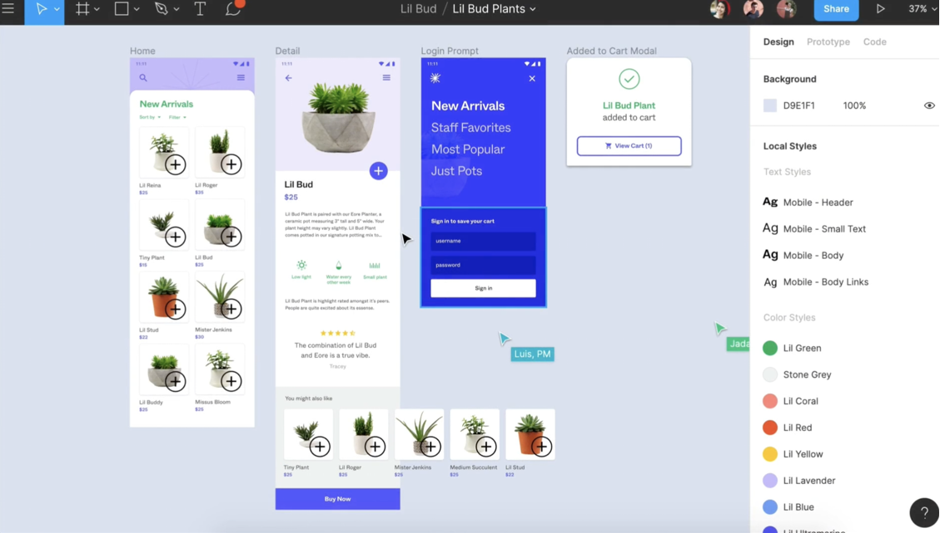

Figure - Prototype with Figma

## Entity Relationship Diagram (ERD)

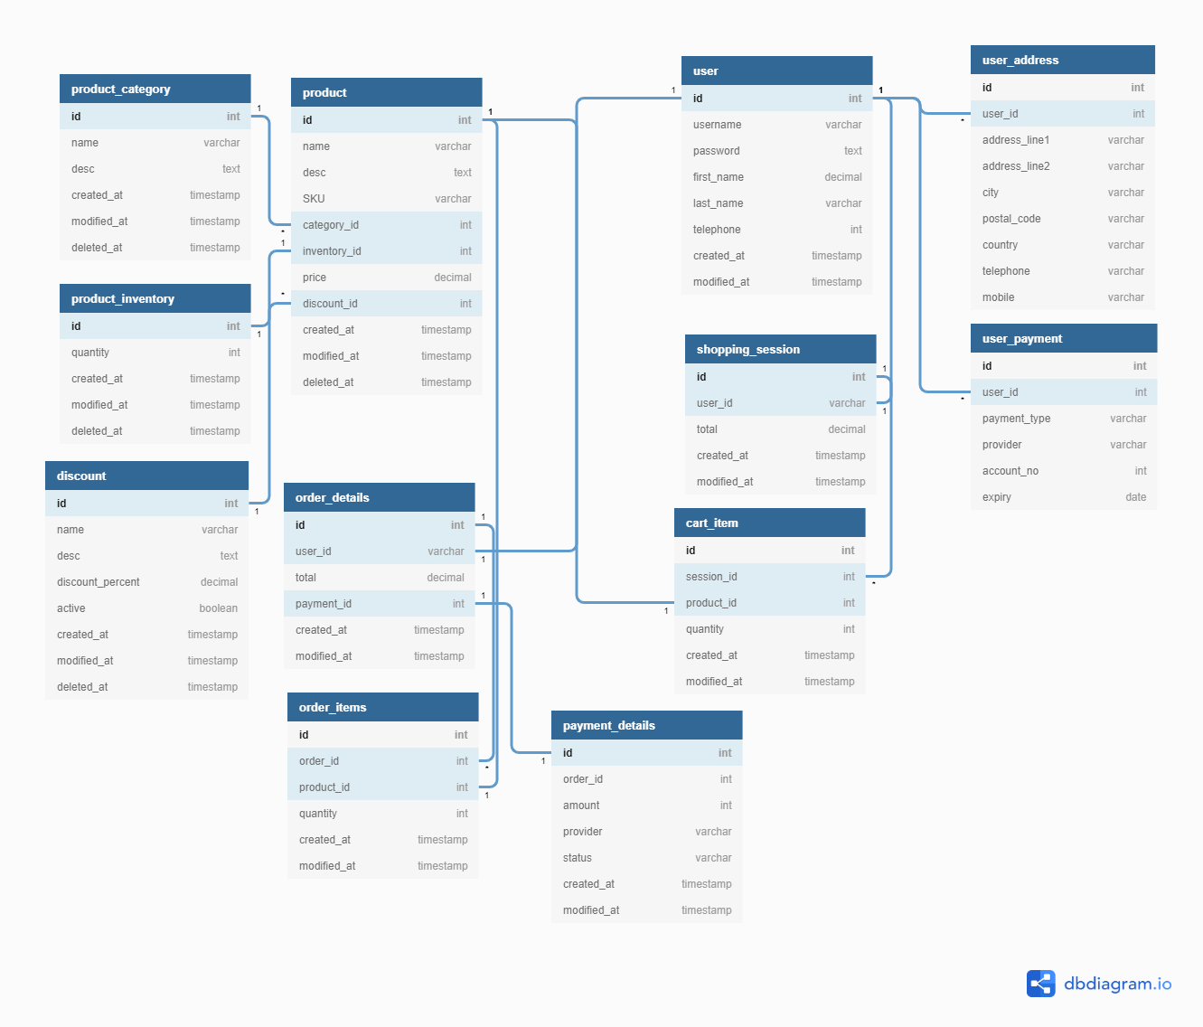

Figure - ERD of the project

## API endpoints

Table - API endpoints of the project

| Method | Route | Description | Params | Return |
| --- | --- | --- | --- | --- |
| GET | /store/inventory | Return inventories by status |  |  |
| POST | /store/order | Place an order for a pet |  |  |
| GET | /store/order/{orderId} | Find purchase order by ID |  |  |
| DELETE | /store/order/{oderId} | Delete purchase order by Id |  |  |

# Implementation

## GitHub repository images

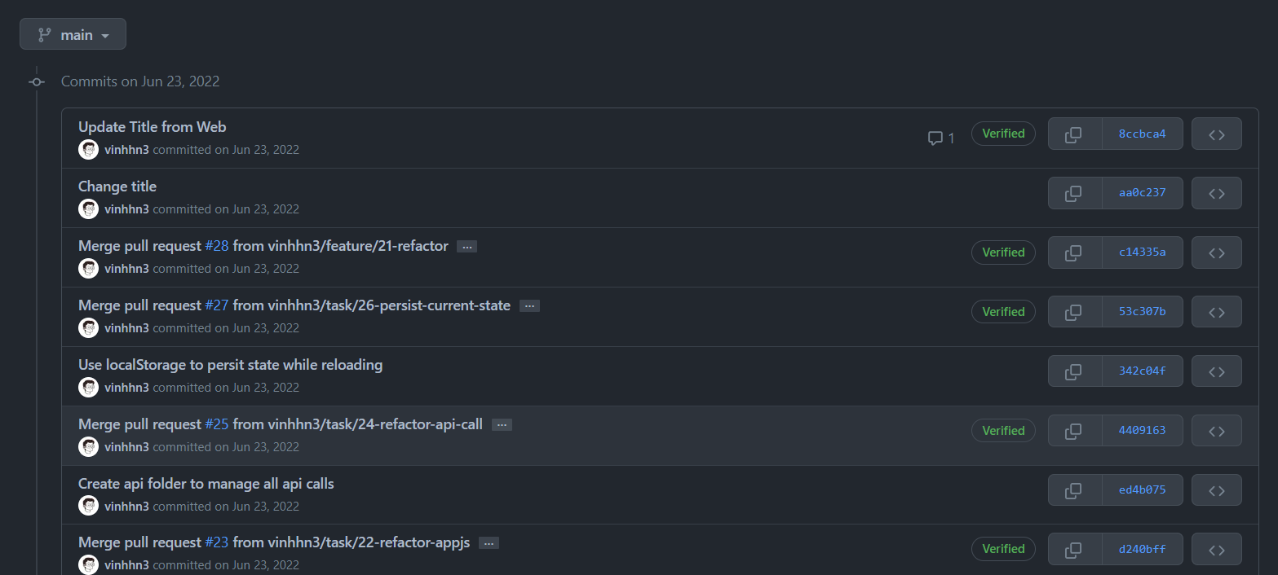

Figure - Github Repository of the project

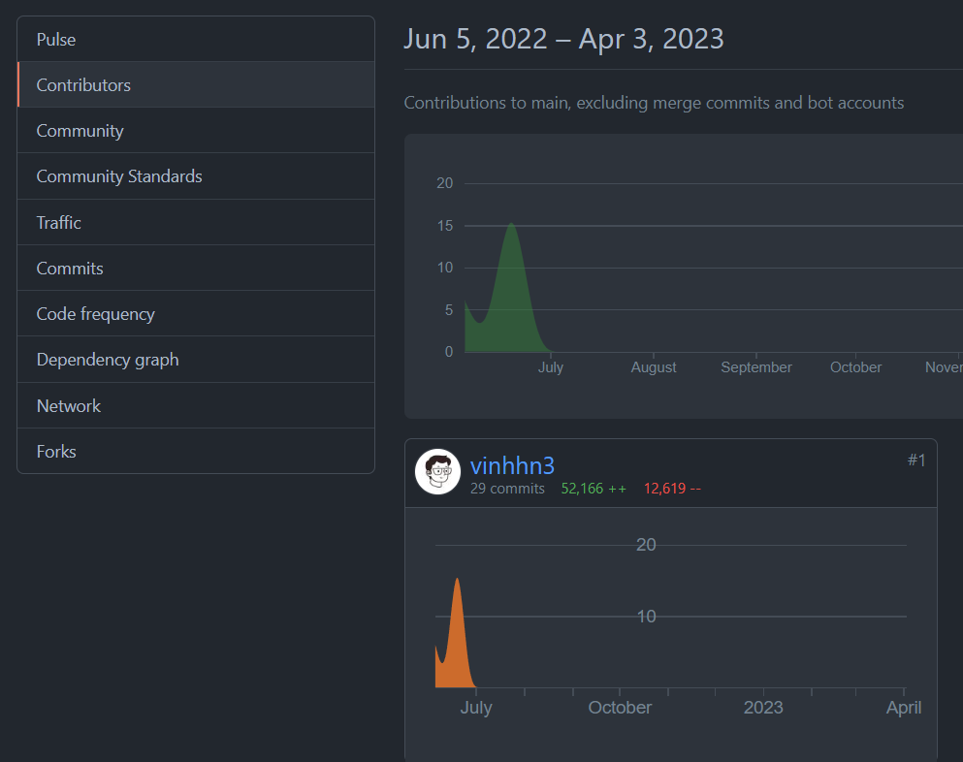

Figure - Contribution of each member

## Jira board images

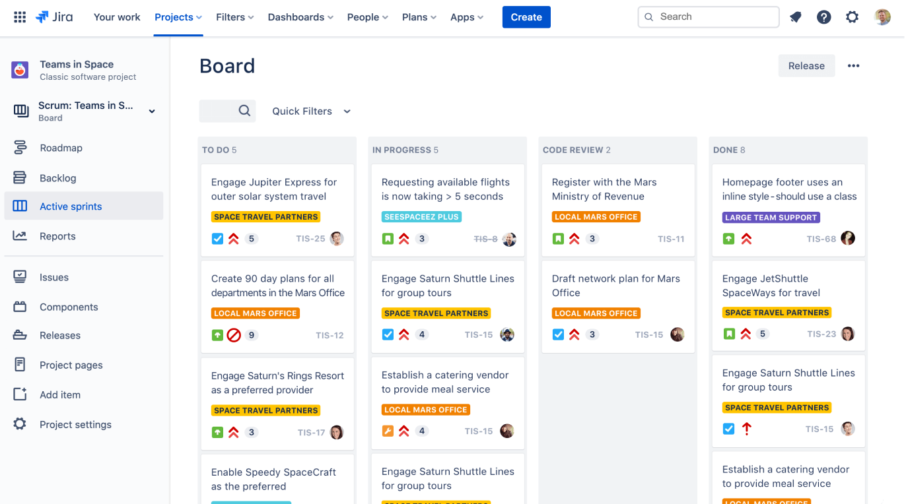

Figure - Jira board and Workflow

## Images of the final application

# Conclusion

## What went well

## What did not go well

## Lessons learned and further improvements