Guide to Accessing and Using the Online Vietnamese Learning Platform
An online Vietnamese teaching and learning platform with a clean, friendly interface that is easy to use for both teachers and Vietnamese learners.

Its main purpose is to make lesson preparation effortless and provide a practical self-study and practice tool for learners after every class.

- How to access the platform:
Step 1: Visit https://lms.xinchaovietnam.education/learning (or lms.xinchaovietnam.edu.vn) — enjoy 15 days of free access upon registration.
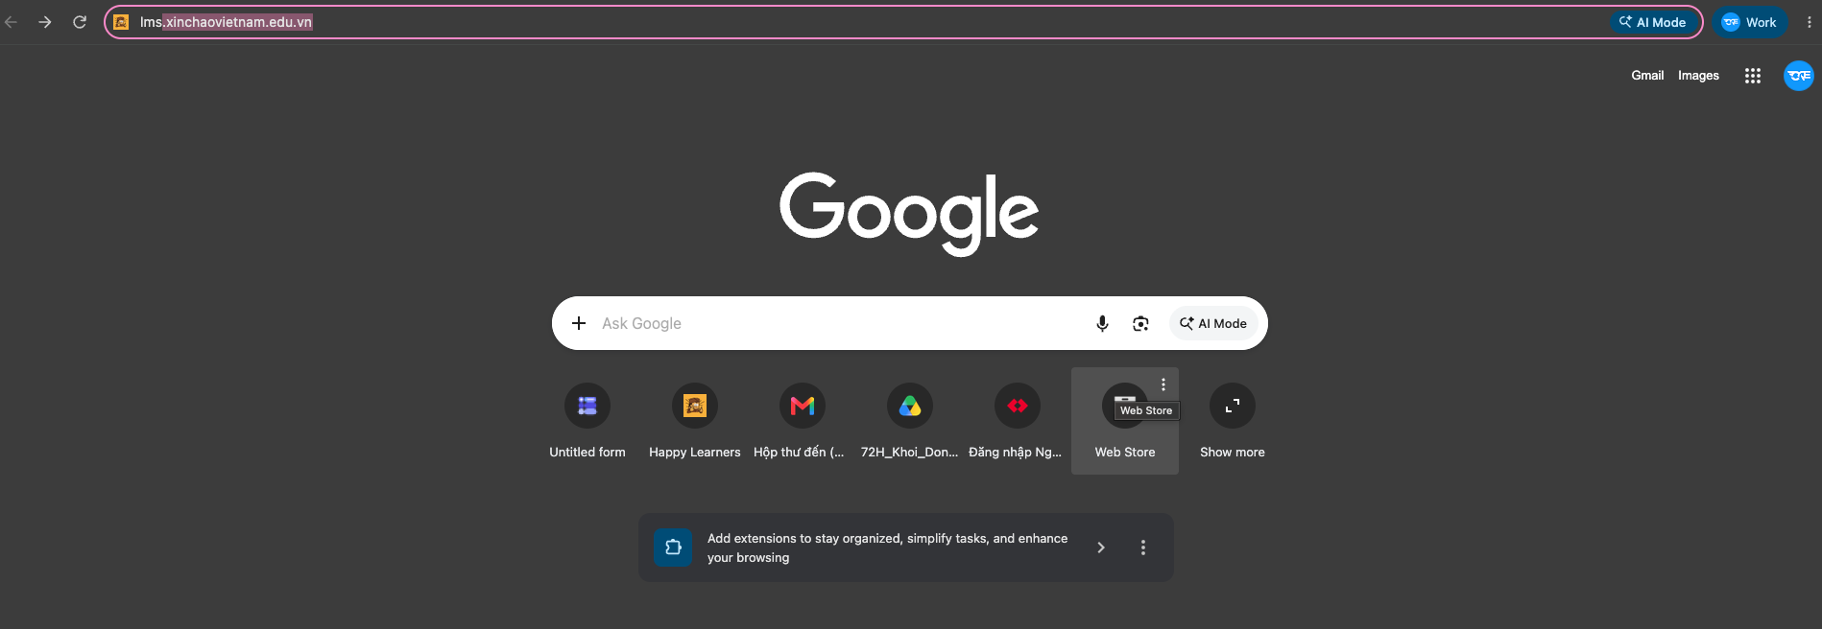
Step 2: Click Register (Đăng ký) to create a new account.
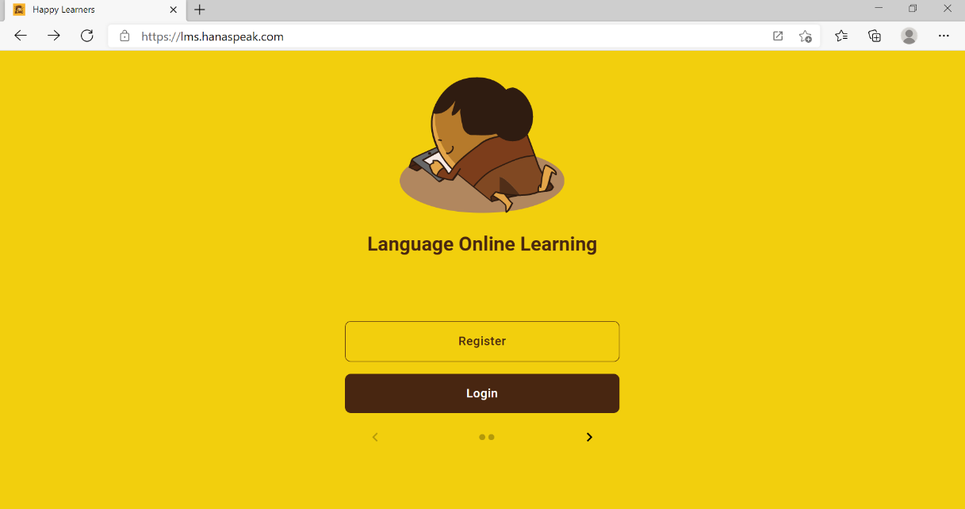

Step 3: Fill in your details to register your account.
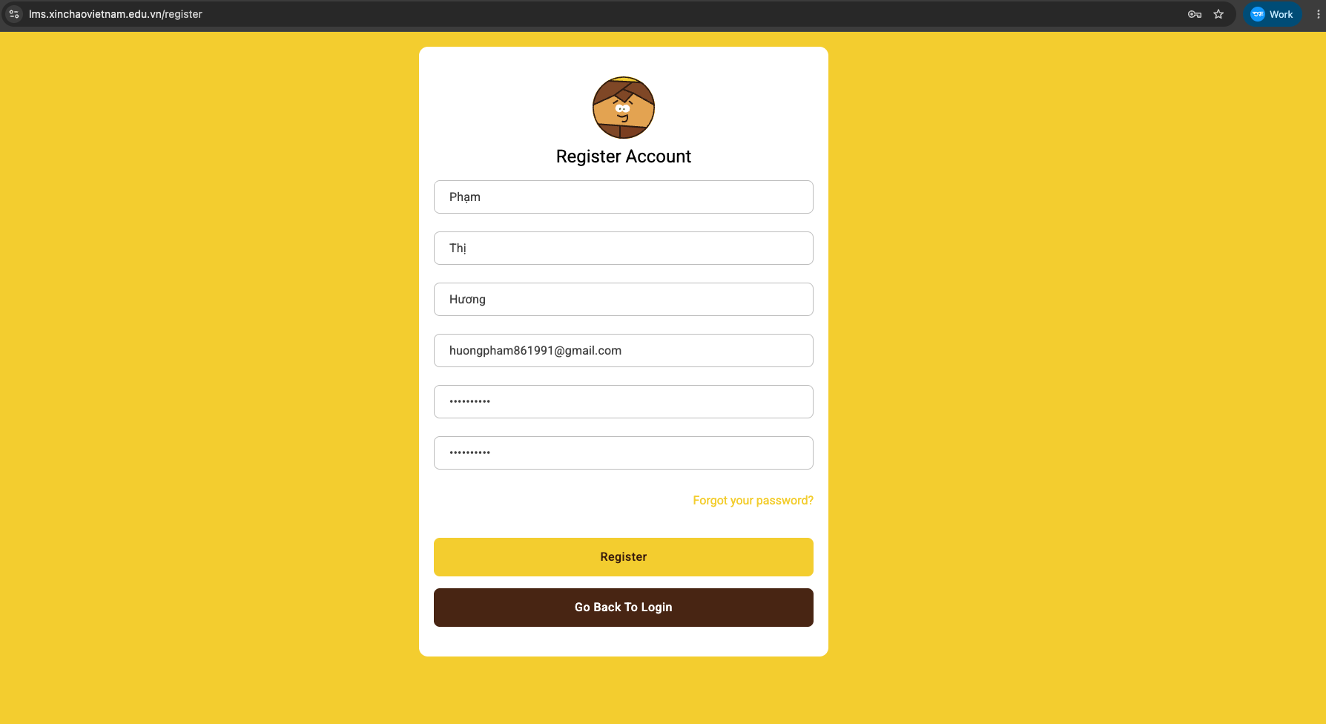
Step 4: Select any level to start (you can choose the first one, Xin chào Việt Nam V1). Please make sure to select a level before clicking Save (Lưu Lại) to avoid an error.
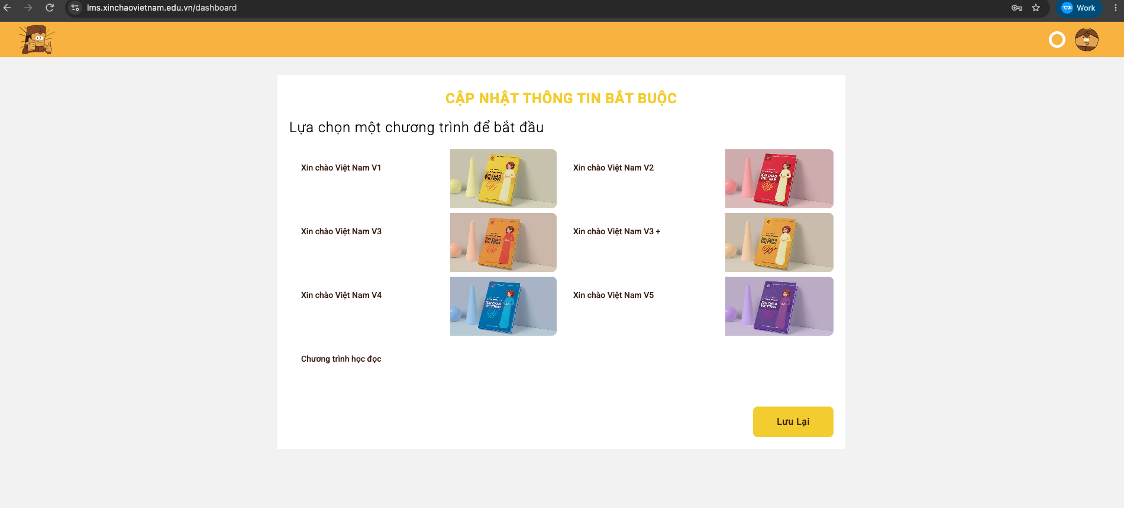

Step 5: Set your default display language. Click your profile icon in the top-right corner and select Settings (Cài đặt).
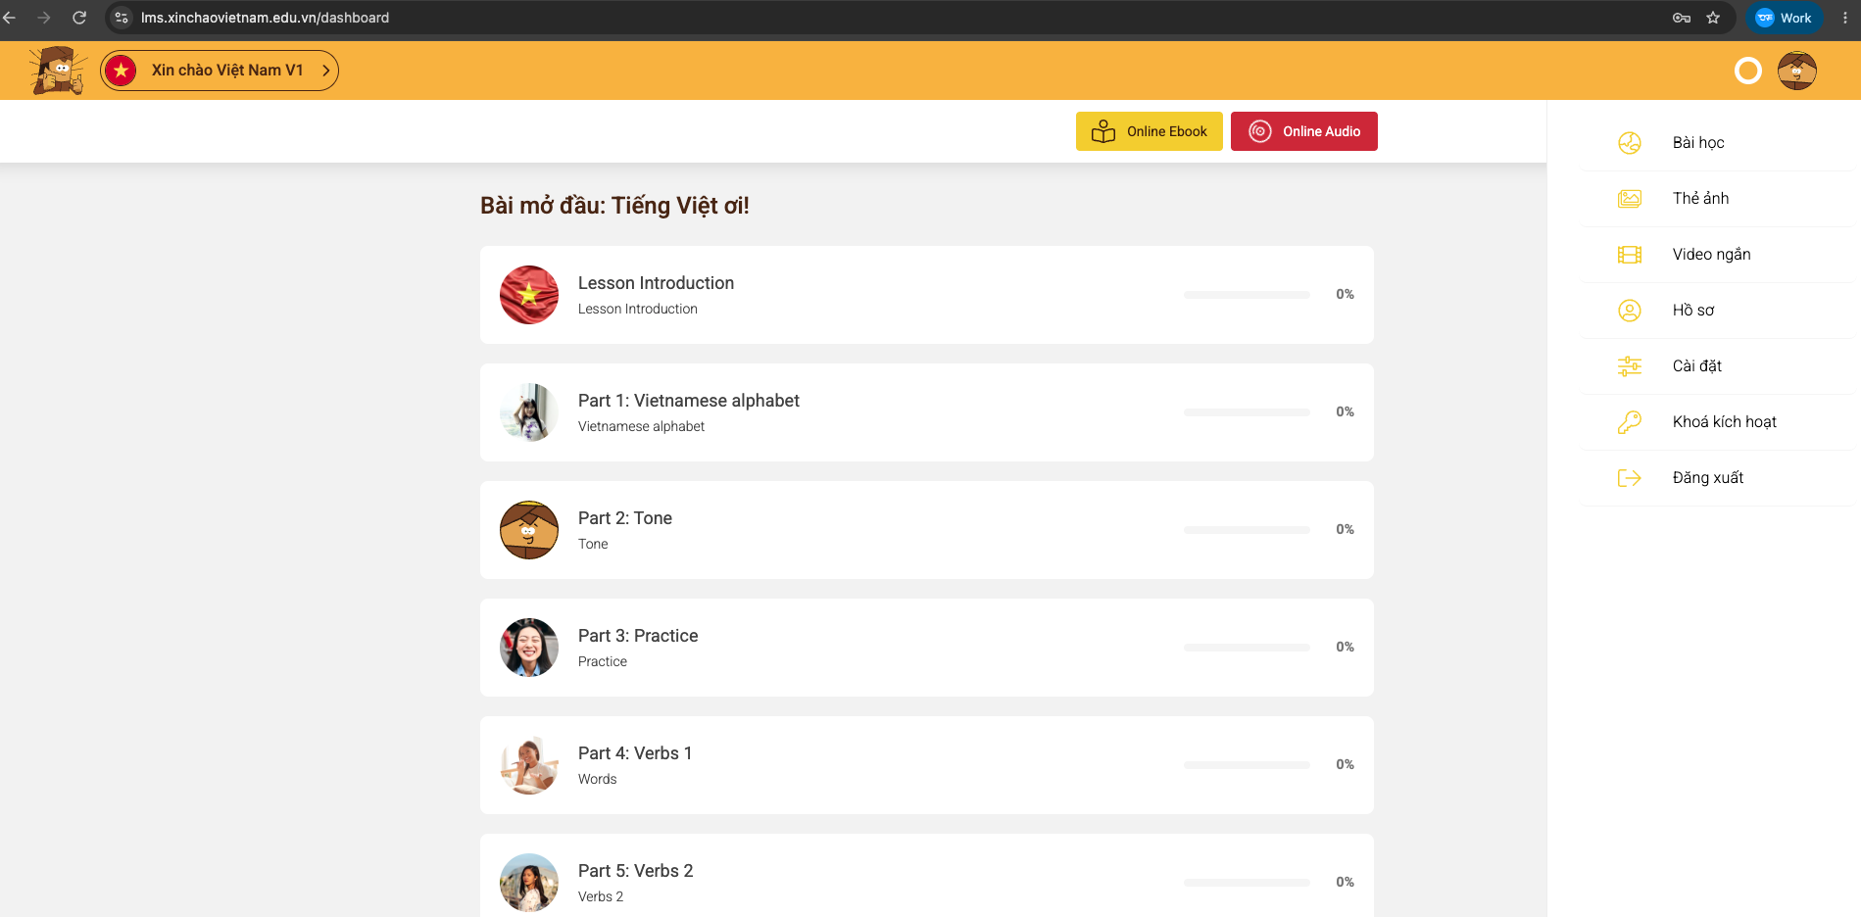
Click the "System" (Hệ thống) tab and choose your preferred display language.
We recommend choosing English (or Korean, Japanese, Chinese, French, or Russian if you prefer) so you can easily view translations. Note: If you leave the display language as Vietnamese, translations will not be shown.
Currently, the platform provides full translations for Level V1. Starting from Level V2, learners study in immersive Vietnamese, so word-by-word translations are no longer displayed.
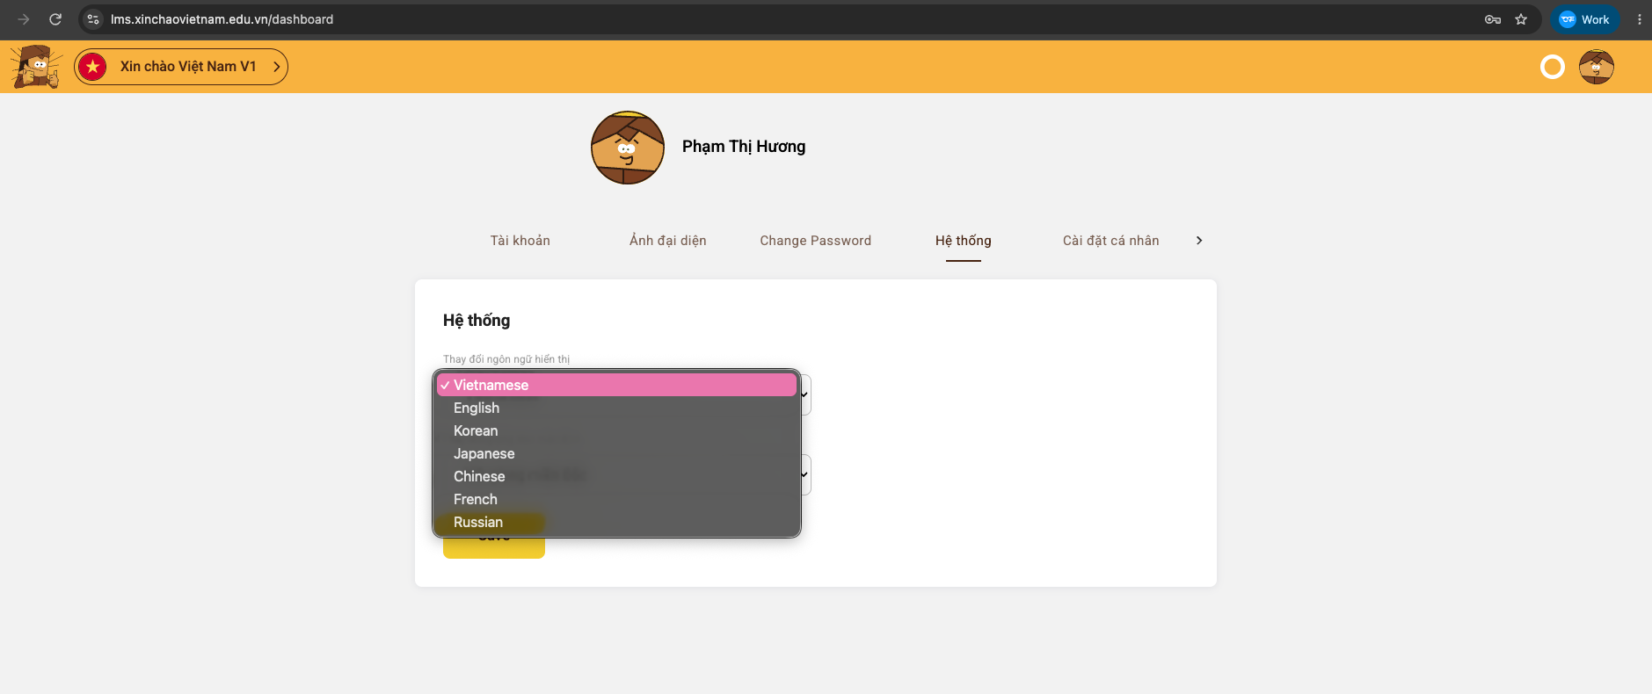

You can also choose a default Male or Female voice so that vocabulary audio plays in your preferred voice.
Currently, standard Northern Vietnamese audio is available on the platform (Central/Da Nang and Southern voices will be added in future updates).
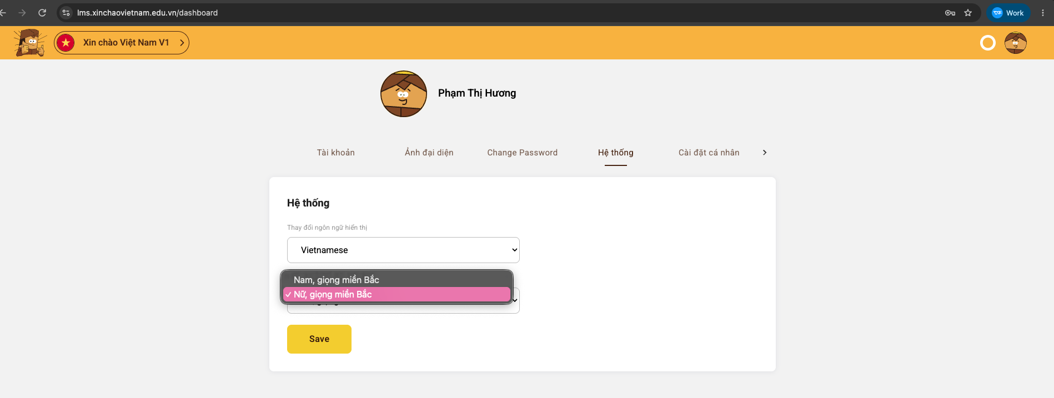
Once you finish saving your settings, click the profile icon in the top-right corner and select Learning (Bài học) to return to the main dashboard.

Step 6: Explore the learning features on the main dashboard:
View the Vietnamese textbooks in the "Online Ebook" section. The "Online Audio" section currently provides full audio for Book V1.
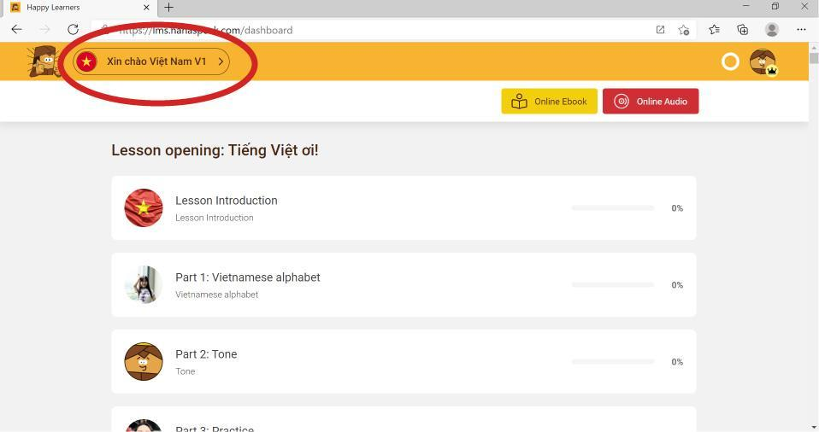
You can browse all lessons inside each book to get a complete overview of the curriculum. To switch to another book or level, simply click the course selector button in the top-left corner.

After finishing the content of each lesson section, remember to click the yellow "Confirm read" ("Confirm readed") button at the bottom to record your progress.
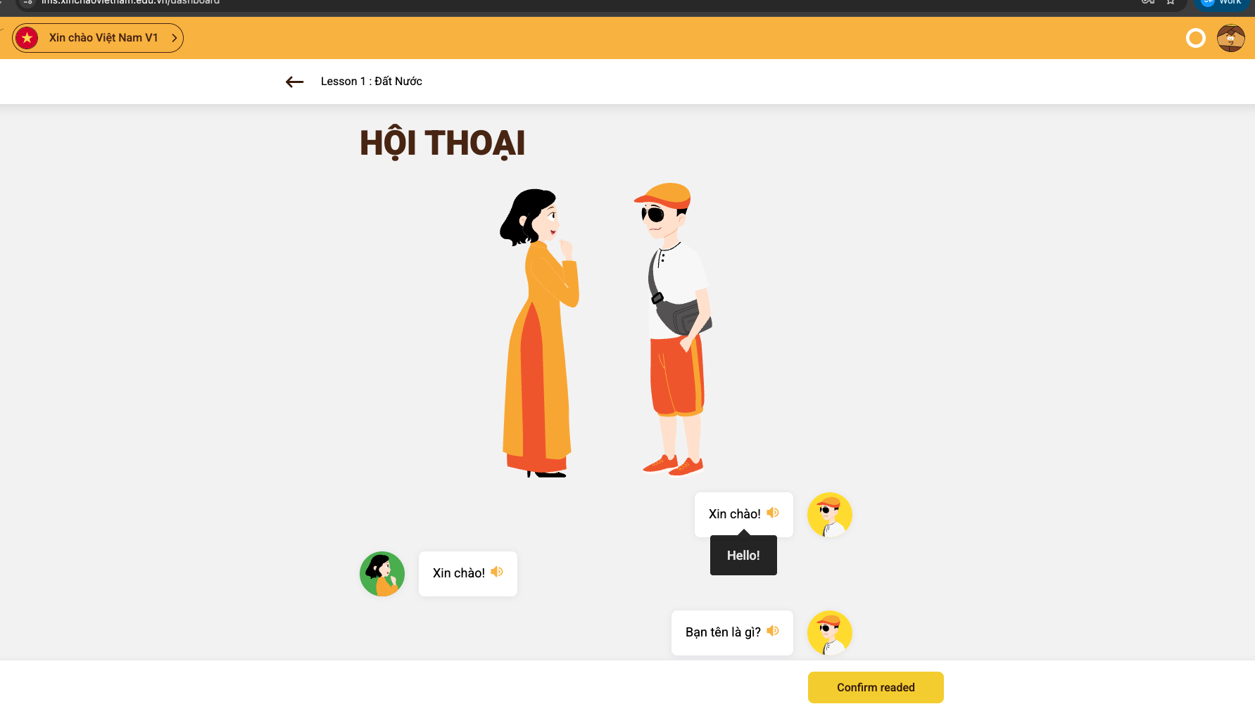
Feature: Online Audio
Each lesson includes audio recordings for vocabulary, sentence patterns, and dialogues combined into a single continuous track so you can listen to the entire lesson without interruption.
Click "Online Audio" to open and listen to the audio tracks for each lesson.
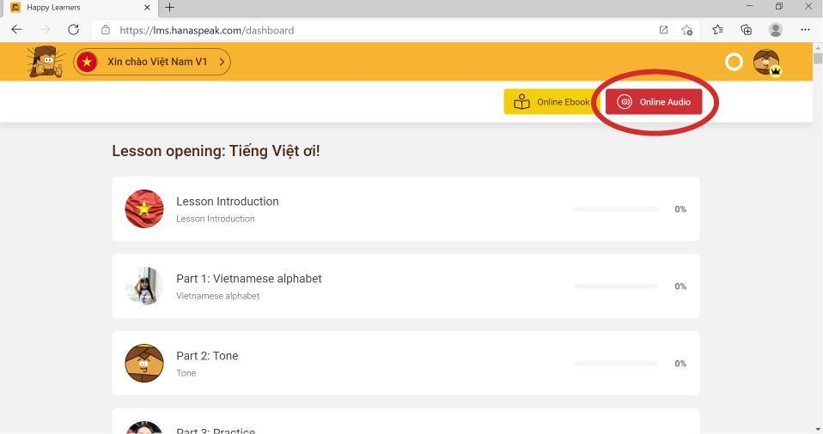
Each lesson is structured step by step with interactive games, detailed grammar notes, and guided practice. Take time to review the vocabulary, grammar notes, and dialogues before and after class—combining the Online Ebook, interactive lesson modules, and workbook will give you the best learning results.

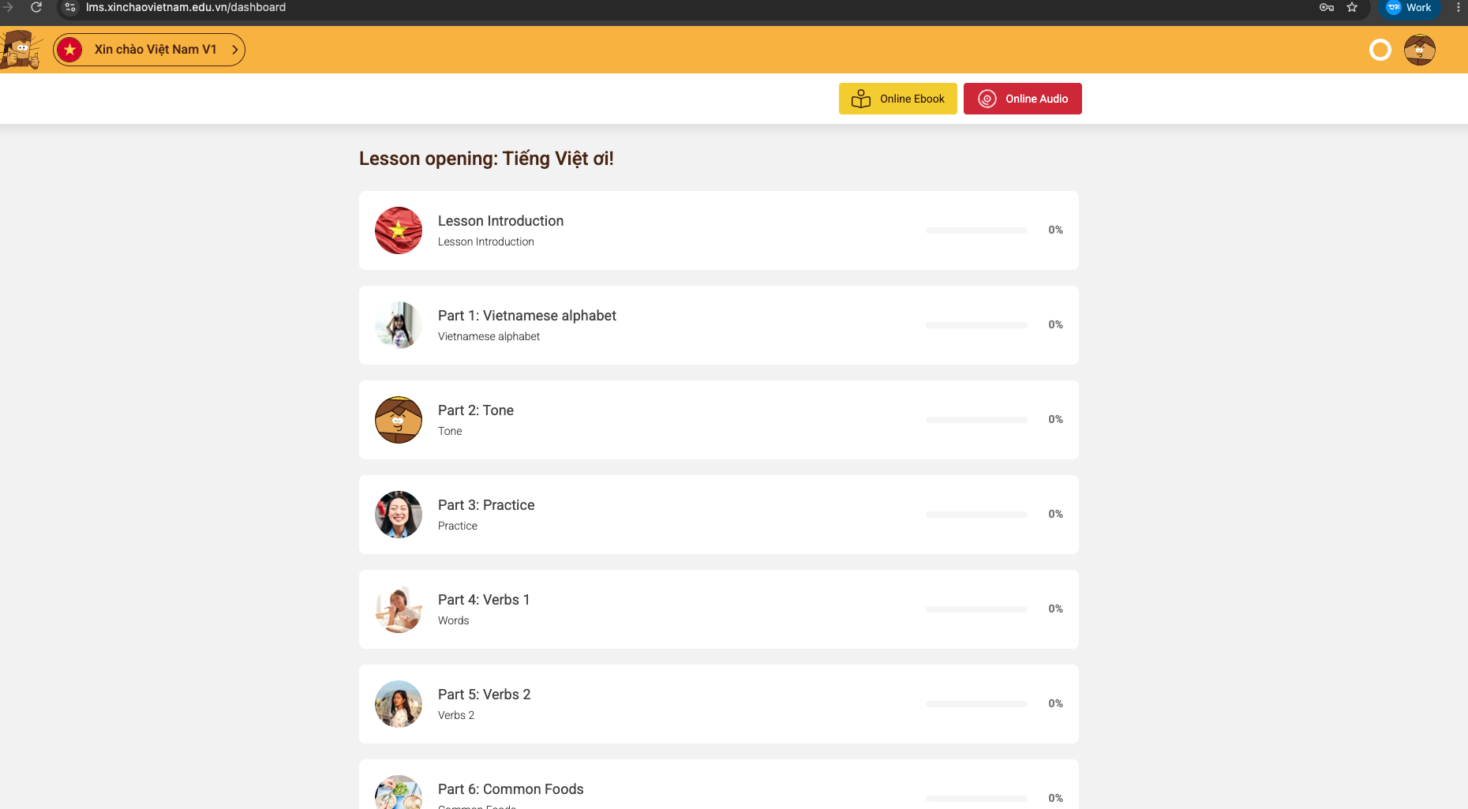
After completing the sections of a lesson, continue with the Online Listening Quiz. Click "Start Now" to begin practising.
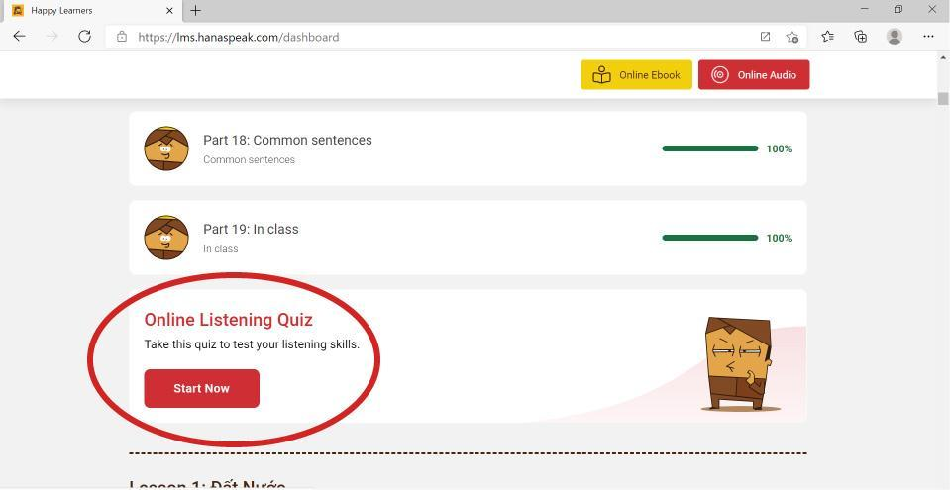
- Feature: FLASHCARDS
The FLASHCARDS feature includes topic-based visual vocabulary cards with audio.
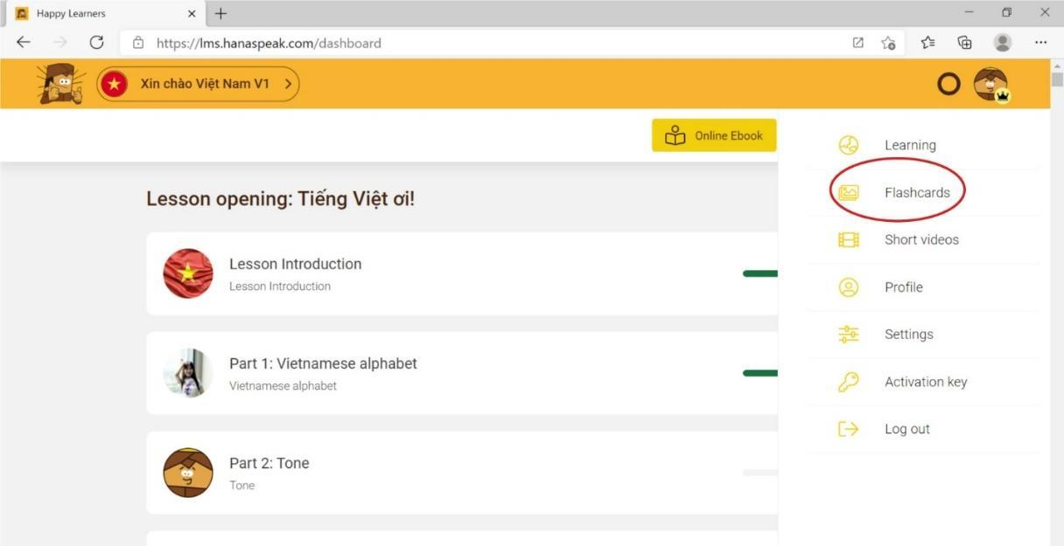

Choose a topic to start learning vocabulary:
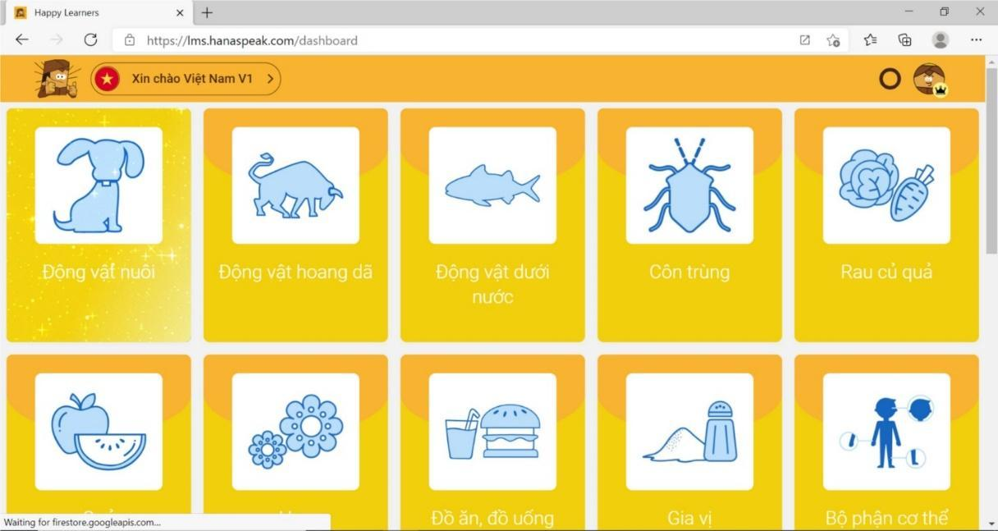

Click the slideshow icon (as shown below) to view the vocabulary cards in presentation mode:
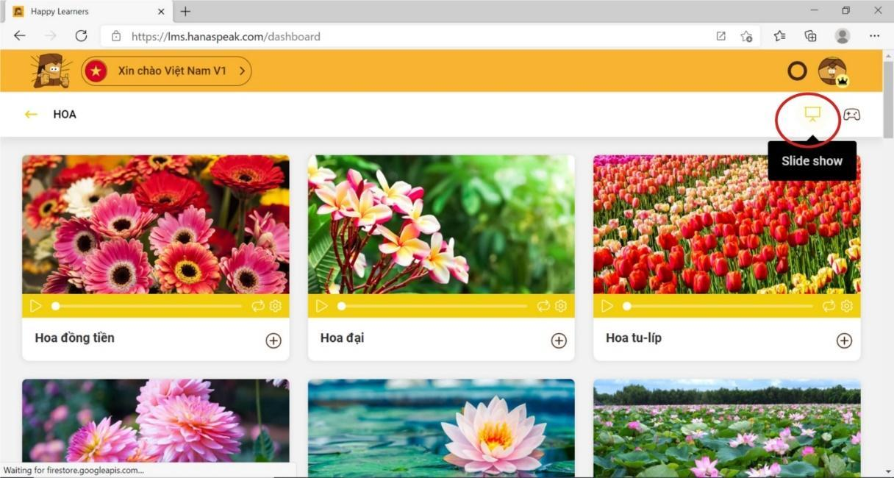

Click the game controller icon (as shown below) to play interactive games that help you memorize the vocabulary:
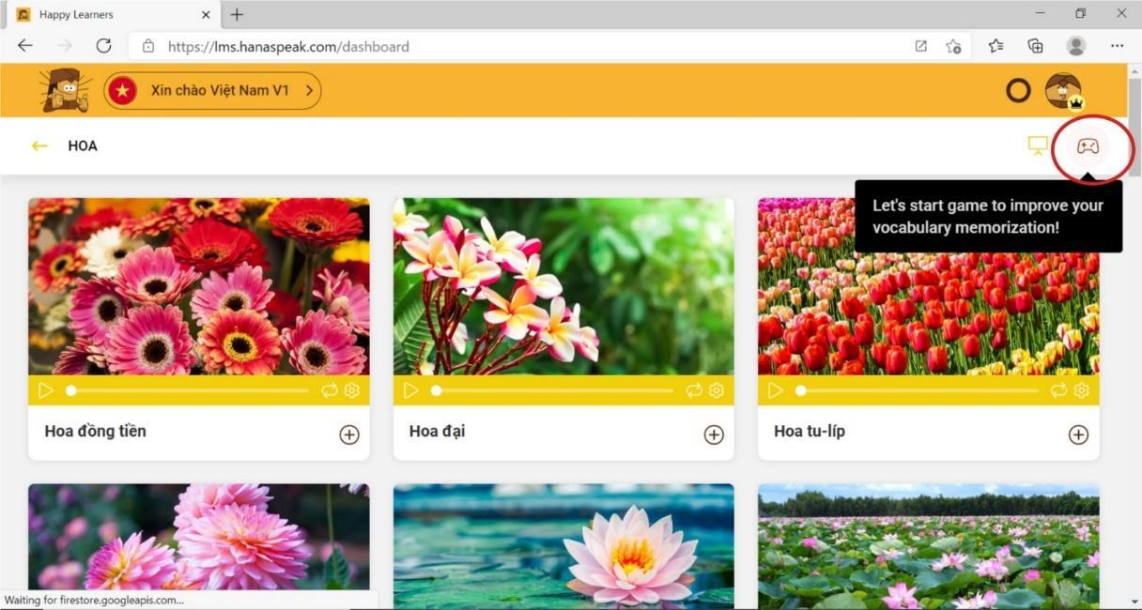
- Feature: Short Videos
Short videos help learners watch real-life dialogues from daily life, news, and entertainment so you can learn natural expressions used by Vietnamese people every day.
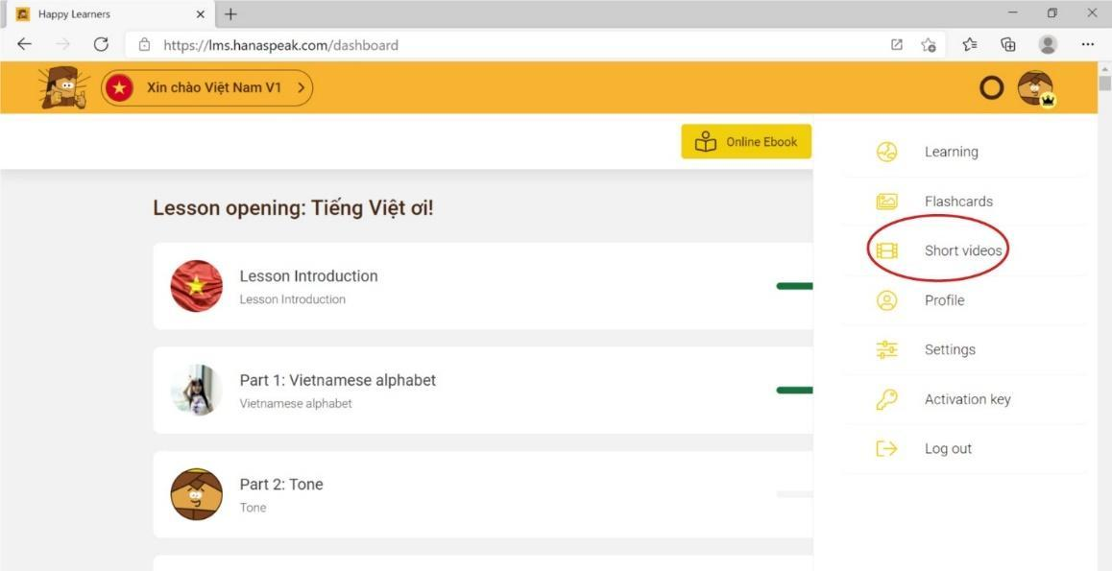

This section includes online video channels and topics. Learners can select any channel or topic of interest to watch related videos.
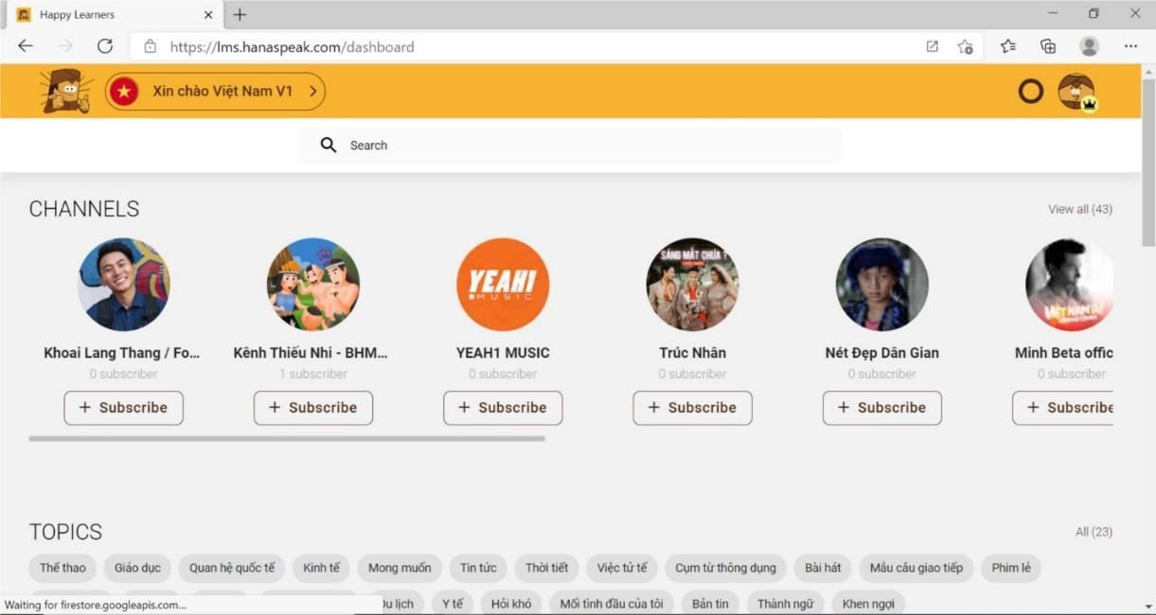

Feature: Learning Progress Tracker (the circular icon next to your profile picture in the top-right corner).
Learners can set their daily study goal and track their weekly learning progress here.


