**Set up**

1. Downlod and install python version 3.8.2 from <https://www.python.org/downloads/> making sure to check the “add python to PATH” box
2. Verify install by opening command line and checking the python version by running “python --version” which should return “Python 3.8.2”
3. Follow instructions from <https://pip.pypa.io/en/stable/installing/#do-i-need-to-install-pip> on how to install pip.
4. Verify pip install by running command “pip --version” which should return something like “pip 19.2.3 from c:\users\sibandat\appdata\local\programs\python\etc”
5. Run command “pip install pandas requests pybase64 openpyxl asyncio aiohttp xlrd”

**Instructions**

This script will translate all excel (.xlsx) files in the same folder and store in a new folder called “processed” with the filename “YYYY_MM_DD_HH_original filename”. In the newly generated file there will be a new column called Result Translation Type. This column lets you know where the translated text came from within Service Now or will show Microsoft Translate Service.

The easiest way to run the script is navigate to the folder in which it is stored. Hold shift and right click in that folder, making sure you’re not right clicking on any file, and open your terminal here. In this example I will be using Powershell so I will click on “Open PowerShell window from here”

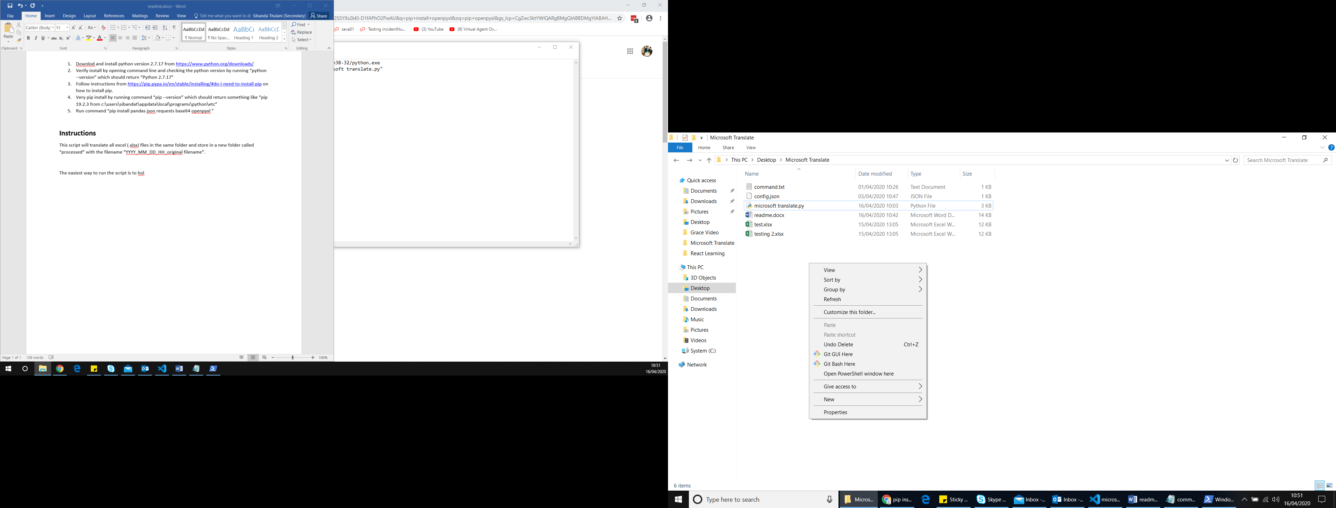

In Powershell run the command “python '.\microsoft translate.py'” and the script should run.