[www.Terraform.io/docs/cloud/vcs/github-app.html](http://www.Terraform.io/docs/cloud/vcs/github-app.html)

create a project in local

* Open git bash
* $ history
* 1 version
* 2 git -v
* 3 git --version
* 4 d:
* 5 cd d:\git
* 6 d:
* 7 cd d:
* 8 pwd
* 9 mkdir namegen
* 10 cd namegen
* 11 pwd
* 12 cls
* 13 clear
* 14 touch README.md
* 15 touch .gitignore
* 16 git init
* 17 history

Open visual source code.

1. Create main.tf file
2. Look for code in main.tf file
3. In the Git bash run terraform login command 🡪 it will ask for confirmation 🡪click yes
4. Terraform cloud website will be opened and bash command will wait for the api token to paste

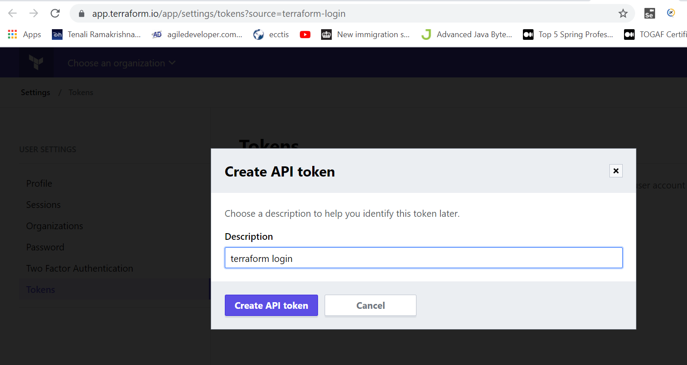

Create API token and copy to your local system

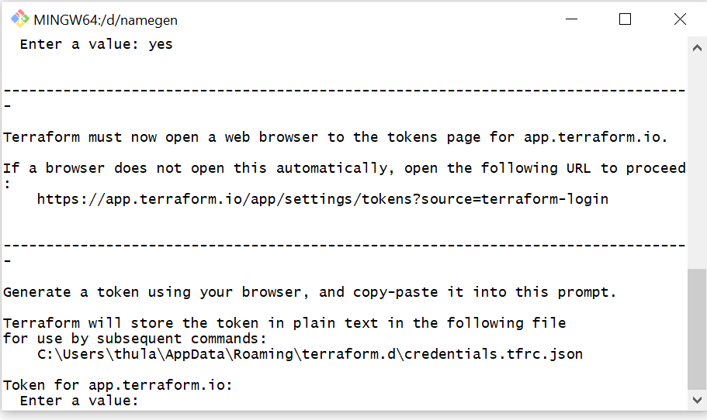

---------------------------------------------------------------------------------

-

----- -

--------- --

--------- - -----

--------- ------ -------

------- --------- ----------

---- ---------- ----------

-- ---------- ----------

**Welcome to Terraform Cloud!** - ---------- -------

--- ----- ---

**Documentation:** terraform.io/docs/cloud -------- -

----------

----------

---------

-----

-

**New to TFC?** Follow these steps to instantly apply an example configuration:

$ git clone https://github.com/hashicorp/tfc-getting-started.git

$ cd tfc-getting-started

$ scripts/setup.sh

* Tell terraform to run in remote by providing below LOC

*backend* "remote" {

    organization = "orgA1" // create an organisation in terraform cloud with this name

*workspaces* {

      name ="namegen"

    }

  }

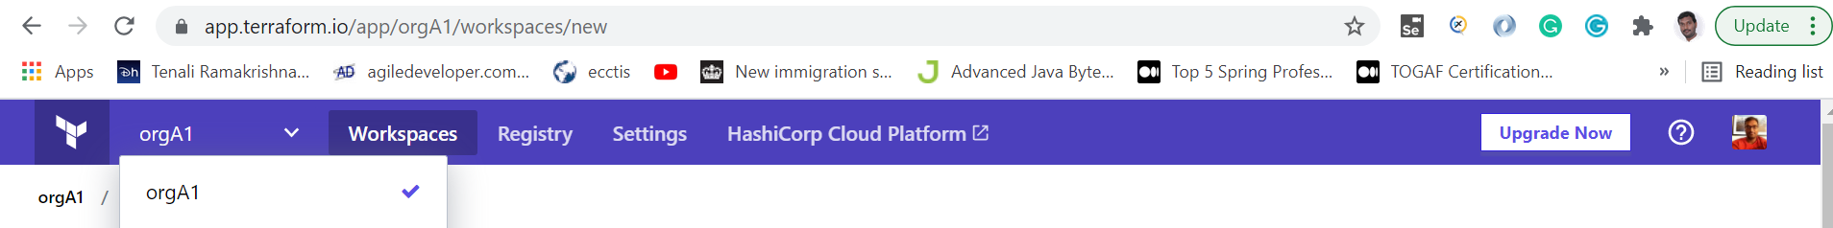

* Terraform init in Git Bash
* Terraform plan
* Terraform apply 🡪yes

Check the organization and workspace is created in the Terraform cloud and account has been created with the output

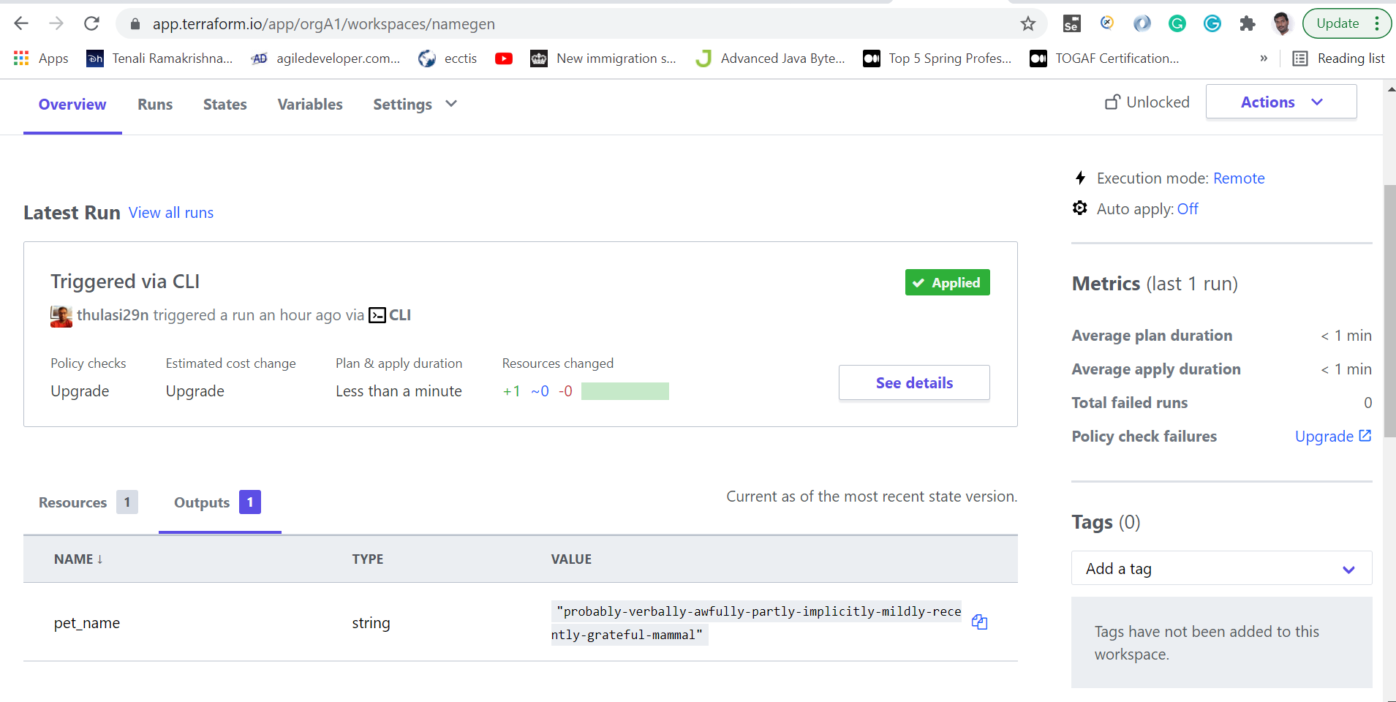

probably-verbally-awfully-partly-implicitly-mildly-recently-grateful-mammal

* Check-in code into Git HUB using GITHUB desktop or git Bash
* 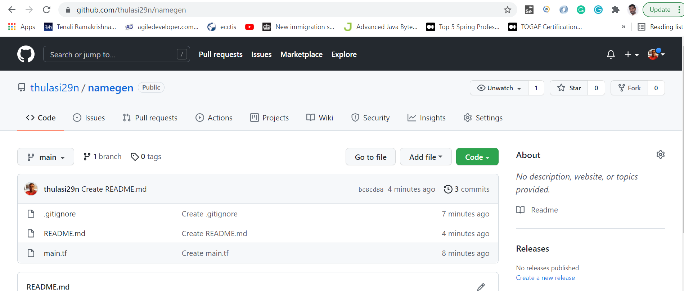
* Sync GIT HUB account to Terraform workspace

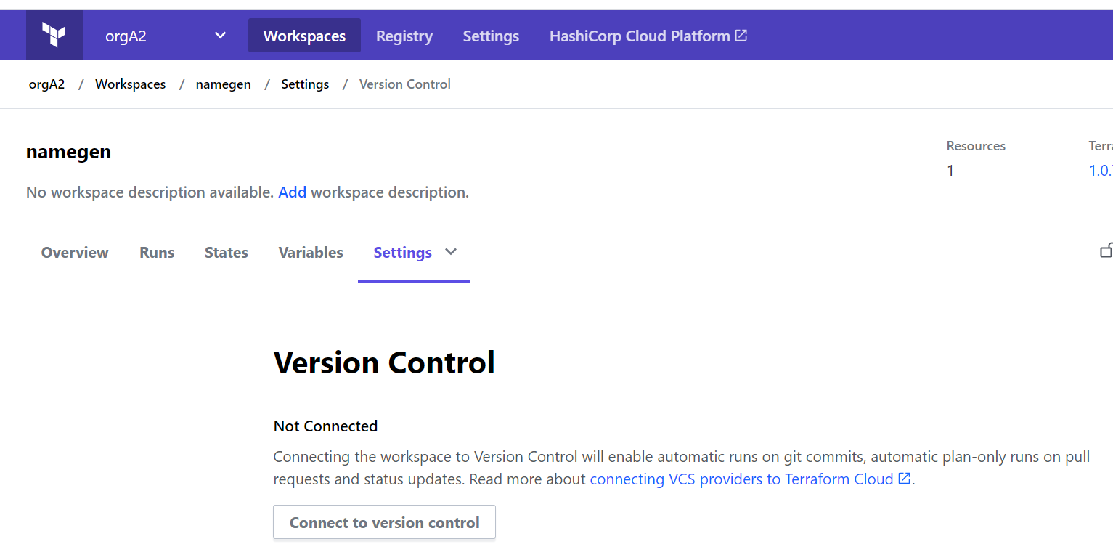

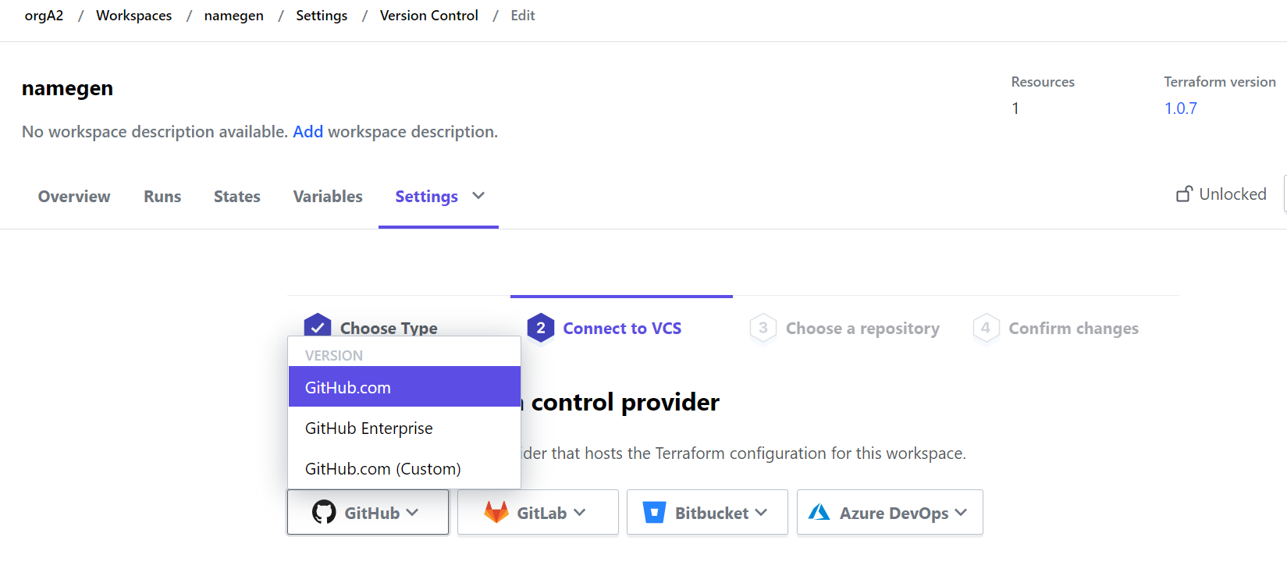

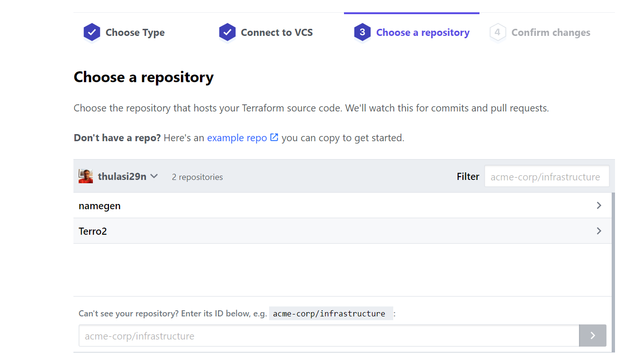

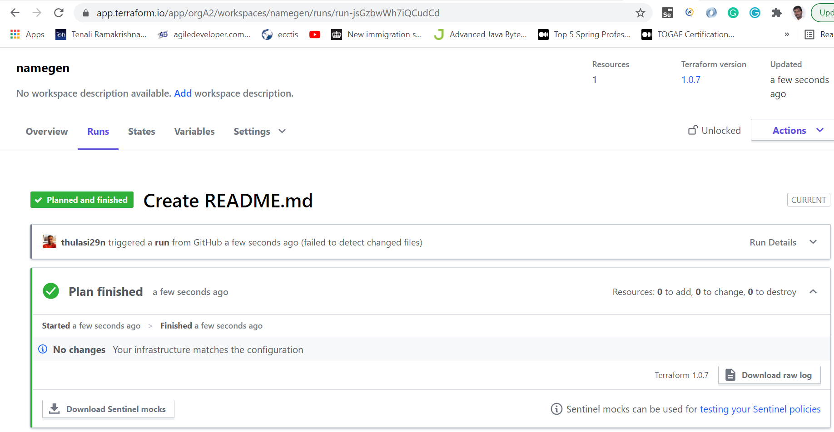

Now do some changes to the code and check how terraform cloud will run

Length has been changed to 3

