Phase 4- E-Commerce Application on IBM Cloud Foundry

DEVELOPMENT PHASE – II

**Problem Statement**:

Build a artisanal e-Commerce platform using IBM foundry. Connect the skilled artisans with the global audience. Showcase handmade products from exquisite jewellry to artistic home decor. Implement secure shopping carts, smooth payment gateway and an intuitive checkout process. Nurture creativity and support small business through an artisan's dream marketplace.

**Development phase – II**

The above problem statement is the one given to us. In the previous phases we had already given the platform layout ,database coding and the way it showcases.In this phase we are going to work on with the user login and register ,shopping cart(adding and removing) and their functionality.

**LANGUAGES USED:**

* HTML
* Python with Flask
* CSS
* SQLite

In previous phase we had been developed the following items:

* Database
* Layouts
* Stylesheets

In this phase we will be updating the database by adding products to the cart.

**DATABASE:**

UPDATE products set price = '999' WHERE productId = 2;

UPDATE products set price = '399' WHERE productId = 3;

UPDATE products set price = '4499' WHERE productId = 4;

UPDATE products set price = '99' WHERE productId = 5;

UPDATE products set price = '9999' WHERE productId = 6;

UPDATE products set price = '599' WHERE productId = 7;

UPDATE products set price = '899' WHERE productId = 8;

UPDATE products set price = '599' WHERE productId = 9;

UPDATE products set price = '499' WHERE productId = 10;

UPDATE products set price = '299' WHERE productId = 11;

SELECT * FROM products;

UPDATE products set price = '899' WHERE productId = 16;

UPDATE products set name = 'Jewellery' WHERE productId = 16;

UPDATE products set description = 'Fit to Any Dress' WHERE productId = 16;

UPDATE products set image = 'jewel_2.jpeg' WHERE productId = 16;

UPDATE products set stock = '200' WHERE productId = 16;

UPDATE products set categoryId = 'J29' WHERE productId = 16;

UPDATE categories set name = 'Wearings' WHERE categoryId = 1;

UPDATE categories set name = 'Hangings' WHERE categoryId = 2;

UPDATE categories set name = 'Handmade' WHERE categoryId = 3;

SELECT *FROM categories;

DELETE FROM categories WHERE categoryId = 4 ;

DELETE FROM categories WHERE categoryId = 5 ;

DELETE FROM categories WHERE categoryId = 6 ;

SELECT * FROM categories;

UPDATE products set price = '899' WHERE productId = 17;

UPDATE products set name = 'Saree' WHERE productId = 17;

UPDATE products set description = 'Gorgious Looking' WHERE productId = 17;

UPDATE products set image = 'saree.png' WHERE productId = 17;

UPDATE products set stock = '200' WHERE productId = 17;

UPDATE products set categoryId = 'RI23' WHERE productId = 17;

SELECT * FROM products;

UPDATE products set image = 'jewel_3.png' WHERE productId = 11;

UPDATE products set image = 'jewel_2.png' WHERE productId = 16;

UPDATE products set image = 'jewellery.png' WHERE productId = 8;

UPDATE products set price = '499' WHERE productId = 12;

UPDATE products set name = 'Sandal' WHERE productId = 12;

UPDATE products set description = 'Good Quality, Good Comfort' WHERE productId = 12;

UPDATE products set image = 'sandal1.png' WHERE productId = 12;

UPDATE products set stock = '200' WHERE productId = 12;

UPDATE products set categoryId = 'S10' WHERE productId = 12;

SELECT * FROM products;

UPDATE products set price = '499' WHERE productId = 14;

UPDATE products set name = 'Sandal' WHERE productId = 14;

UPDATE products set description = 'Good Quality, Good Comfort' WHERE productId = 14;

UPDATE products set image = 'sandal2.png' WHERE productId = 14;

UPDATE products set stock = '200' WHERE productId = 14;

UPDATE products set categoryId = 'S10' WHERE productId = 14;

UPDATE products set price = '7999' WHERE productId = 13;

UPDATE products set name = 'Wall Painting' WHERE productId = 13;

UPDATE products set description = 'Amazing and Give a Fabulous Look' WHERE productId = 13;

UPDATE products set image = 'paint1.png' WHERE productId = 13;

UPDATE products set stock = '100' WHERE productId = 13;

UPDATE products set categoryId = 'WP23' WHERE productId = 13;

UPDATE products set price = '7599' WHERE productId = 15;

UPDATE products set name = 'Wall Painting' WHERE productId = 15;

UPDATE products set description = 'Amazing and Give a Fabulous Look' WHERE productId = 15;

UPDATE products set image = 'paint2.png' WHERE productId = 15;

UPDATE products set stock = '100' WHERE productId = 15;

UPDATE products set categoryId = 'WP23' WHERE productId = 15;

By the above queries the products will be added to the website when the user updates the product then the database will also gets uploaded.

**PYTHON with Flask:**

from flask import *

import sqlite3, hashlib, os

from werkzeug.utils import secure_filename

app = Flask(__name__)

app.secret_key = 'random string'

UPLOAD_FOLDER = 'static/uploads'

ALLOWED_EXTENSIONS = set(['jpeg', 'jpg', 'png', 'gif'])

app.config['UPLOAD_FOLDER'] = UPLOAD_FOLDER

def getLoginDetails():

with sqlite3.connect('database.db') as conn:

cur = conn.cursor()

if 'email' not in session:

loggedIn = False

firstName = ''

noOfItems = 0

else:

loggedIn = True

cur.execute("SELECT userId, firstName FROM users WHERE email = ?", (session['email'], ))

userId, firstName = cur.fetchone()

cur.execute("SELECT count(productId) FROM kart WHERE userId = ?", (userId, ))

noOfItems = cur.fetchone()[0]

conn.close()

return (loggedIn, firstName, noOfItems)

@app.route("/")

def root():

loggedIn, firstName, noOfItems = getLoginDetails()

with sqlite3.connect('database.db') as conn:

cur = conn.cursor()

cur.execute('SELECT productId, name, price, description, image, stock FROM products')

itemData = cur.fetchall()

cur.execute('SELECT categoryId, name FROM categories')

categoryData = cur.fetchall()

itemData = parse(itemData)

return render_template('home.html', itemData=itemData, loggedIn=loggedIn, firstName=firstName, noOfItems=noOfItems, categoryData=categoryData)

@app.route("/add")

def admin():

with sqlite3.connect('database.db') as conn:

cur = conn.cursor()

cur.execute("SELECT categoryId, name FROM categories")

categories = cur.fetchall()

conn.close()

return render_template('add.html', categories=categories)

@app.route("/addItem", methods=["GET", "POST"])

def addItem():

if request.method == "POST":

name = request.form['name']

price = float(request.form['price'])

description = request.form['description']

stock = int(request.form['stock'])

categoryId = int(request.form['category'])

#Uploading image procedure

image = request.files['image']

if image and allowed_file(image.filename):

filename = secure_filename(image.filename)

image.save(os.path.join(app.config['UPLOAD_FOLDER'], filename))

imagename = filename

with sqlite3.connect('database.db') as conn:

try:

cur = conn.cursor()

cur.execute('''INSERT INTO products (name, price, description, image, stock, categoryId) VALUES (?, ?, ?, ?, ?, ?)''', (name, price, description, imagename, stock, categoryId))

conn.commit()

msg="added successfully"

except:

msg="error occured"

conn.rollback()

conn.close()

print(msg)

return redirect(url_for('root'))

@app.route("/remove")

def remove():

with sqlite3.connect('database.db') as conn:

cur = conn.cursor()

cur.execute('SELECT productId, name, price, description, image, stock FROM products')

data = cur.fetchall()

conn.close()

return render_template('remove.html', data=data)

@app.route("/removeItem")

def removeItem():

productId = request.args.get('productId')

with sqlite3.connect('database.db') as conn:

try:

cur = conn.cursor()

cur.execute('DELETE FROM products WHERE productID = ?', (productId, ))

conn.commit()

msg = "Deleted successsfully"

except:

conn.rollback()

msg = "Error occured"

conn.close()

print(msg)

return redirect(url_for('root'))

@app.route("/displayCategory")

def displayCategory():

loggedIn, firstName, noOfItems = getLoginDetails()

categoryId = request.args.get("categoryId")

with sqlite3.connect('database.db') as conn:

cur = conn.cursor()

cur.execute("SELECT products.productId, products.name, products.price, products.image, categories.name FROM products, categories WHERE products.categoryId = categories.categoryId AND categories.categoryId = ?", (categoryId, ))

data = cur.fetchall()

conn.close()

categoryName = data[0][4]

data = parse(data)

return render_template('displayCategory.html', data=data, loggedIn=loggedIn, firstName=firstName, noOfItems=noOfItems, categoryName=categoryName)

@app.route("/account/profile")

def profileHome():

if 'email' not in session:

return redirect(url_for('root'))

loggedIn, firstName, noOfItems = getLoginDetails()

return render_template("profileHome.html", loggedIn=loggedIn, firstName=firstName, noOfItems=noOfItems)

@app.route("/account/profile/edit")

def editProfile():

if 'email' not in session:

return redirect(url_for('root'))

loggedIn, firstName, noOfItems = getLoginDetails()

with sqlite3.connect('database.db') as conn:

cur = conn.cursor()

cur.execute("SELECT userId, email, firstName, lastName, address1, address2, zipcode, city, state, country, phone FROM users WHERE email = ?", (session['email'], ))

profileData = cur.fetchone()

conn.close()

return render_template("editProfile.html", profileData=profileData, loggedIn=loggedIn, firstName=firstName, noOfItems=noOfItems)

@app.route("/account/profile/changePassword", methods=["GET", "POST"])

def changePassword():

if 'email' not in session:

return redirect(url_for('loginForm'))

if request.method == "POST":

oldPassword = request.form['oldpassword']

oldPassword = hashlib.md5(oldPassword.encode()).hexdigest()

newPassword = request.form['newpassword']

newPassword = hashlib.md5(newPassword.encode()).hexdigest()

with sqlite3.connect('database.db') as conn:

cur = conn.cursor()

cur.execute("SELECT userId, password FROM users WHERE email = ?", (session['email'], ))

userId, password = cur.fetchone()

if (password == oldPassword):

try:

cur.execute("UPDATE users SET password = ? WHERE userId= ?", (newPassword, userId))

conn.commit()

msg="Changed successfully"

except:

conn.rollback()

msg = "Failed"

return render_template("changePassword.html", msg=msg)

else:

msg = "Wrong password"

conn.close()

return render_template("changePassword.html", msg=msg)

else:

return render_template("changePassword.html")

@app.route("/updateProfile", methods=["GET", "POST"])

def updateProfile():

if request.method == 'POST':

email = request.form['email']

firstName = request.form['firstName']

lastName = request.form['lastName']

address1 = request.form['address1']

address2 = request.form['address2']

zipcode = request.form['zipcode']

city = request.form['city']

state = request.form['state']

country = request.form['country']

phone = request.form['phone']

with sqlite3.connect('database.db') as con:

try:

cur = con.cursor()

cur.execute('UPDATE users SET firstName = ?, lastName = ?, address1 = ?, address2 = ?, zipcode = ?, city = ?, state = ?, country = ?, phone = ? WHERE email = ?', (firstName, lastName, address1, address2, zipcode, city, state, country, phone, email))

con.commit()

msg = "Saved Successfully"

except:

con.rollback()

msg = "Error occured"

con.close()

return redirect(url_for('editProfile'))

@app.route("/loginForm")

def loginForm():

if 'email' in session:

return redirect(url_for('root'))

else:

return render_template('login.html', error='')

@app.route("/login", methods = ['POST', 'GET'])

def login():

if request.method == 'POST':

email = request.form['email']

password = request.form['password']

if is_valid(email, password):

session['email'] = email

return redirect(url_for('root'))

else:

error = 'Invalid UserId / Password'

return render_template('login.html', error=error)

@app.route("/productDescription")

def productDescription():

loggedIn, firstName, noOfItems = getLoginDetails()

productId = request.args.get('productId')

with sqlite3.connect('database.db') as conn:

cur = conn.cursor()

cur.execute('SELECT productId, name, price, description, image, stock FROM products WHERE productId = ?', (productId, ))

productData = cur.fetchone()

conn.close()

return render_template("productDescription.html", data=productData, loggedIn = loggedIn, firstName = firstName, noOfItems = noOfItems)

@app.route("/addToCart")

def addToCart():

if 'email' not in session:

return redirect(url_for('loginForm'))

else:

productId = int(request.args.get('productId'))

with sqlite3.connect('database.db') as conn:

cur = conn.cursor()

cur.execute("SELECT userId FROM users WHERE email = ?", (session['email'], ))

userId = cur.fetchone()[0]

try:

cur.execute("INSERT INTO kart (userId, productId) VALUES (?, ?)", (userId, productId))

conn.commit()

msg = "Added successfully"

except:

conn.rollback()

msg = "Error occured"

conn.close()

return redirect(url_for('root'))

@app.route("/cart")

def cart():

if 'email' not in session:

return redirect(url_for('loginForm'))

loggedIn, firstName, noOfItems = getLoginDetails()

email = session['email']

with sqlite3.connect('database.db') as conn:

cur = conn.cursor()

cur.execute("SELECT userId FROM users WHERE email = ?", (email, ))

userId = cur.fetchone()[0]

cur.execute("SELECT products.productId, products.name, products.price, products.image FROM products, kart WHERE products.productId = kart.productId AND kart.userId = ?", (userId, ))

products = cur.fetchall()

totalPrice = 0

for row in products:

totalPrice += row[2]

return render_template("cart.html", products = products, totalPrice=totalPrice, loggedIn=loggedIn, firstName=firstName, noOfItems=noOfItems)

@app.route("/removeFromCart")

def removeFromCart():

if 'email' not in session:

return redirect(url_for('loginForm'))

email = session['email']

productId = int(request.args.get('productId'))

with sqlite3.connect('database.db') as conn:

cur = conn.cursor()

cur.execute("SELECT userId FROM users WHERE email = ?", (email, ))

userId = cur.fetchone()[0]

try:

cur.execute("DELETE FROM kart WHERE userId = ? AND productId= ?", (userId, productId))

conn.commit()

msg = "removed successfully"

except:

conn.rollback()

msg = "error occured"

conn.close()

return redirect(url_for('root'))

@app.route("/logout")

def logout():

session.pop('email', None)

return redirect(url_for('root'))

def is_valid(email, password):

con = sqlite3.connect('database.db')

cur = con.cursor()

cur.execute('SELECT email, password FROM users')

data = cur.fetchall()

for row in data:

if row[0] == email and row[1] == hashlib.md5(password.encode()).hexdigest():

return True

return False

@app.route("/register", methods = ['GET', 'POST'])

def register():

if request.method == 'POST':

#Parse form data

password = request.form['password']

email = request.form['email']

firstName = request.form['firstName']

lastName = request.form['lastName']

address1 = request.form['address1']

address2 = request.form['address2']

zipcode = request.form['zipcode']

city = request.form['city']

state = request.form['state']

country = request.form['country']

phone = request.form['phone']

with sqlite3.connect('database.db') as con:

try:

cur = con.cursor()

cur.execute('INSERT INTO users (password, email, firstName, lastName, address1, address2, zipcode, city, state, country, phone) VALUES (?, ?, ?, ?, ?, ?, ?, ?, ?, ?, ?)', (hashlib.md5(password.encode()).hexdigest(), email, firstName, lastName, address1, address2, zipcode, city, state, country, phone))

con.commit()

msg = "Registered Successfully"

except:

con.rollback()

msg = "Error occured"

con.close()

return render_template("login.html", error=msg)

@app.route("/registerationForm")

def registrationForm():

return render_template("register.html")

def allowed_file(filename):

return '.' in filename and \

filename.rsplit('.', 1)[1] in ALLOWED_EXTENSIONS

def parse(data):

ans = []

i = 0

while i<len(data):

curr = []

for j in range(7):

if i>= len(data):

break

curr.append(data[i])

i += 1

ans.append(curr)

return ans

if __name__ == '__main__':

app.run(debug=True)

**Register.html**

<html>

<head>

<title>Registration</title>

<script type="text/javascript" src="{{ url_for('static', filename = 'js/validateForm.js') }}">

</script>

</head>

<body>

<form action="/register" method="POST" onsubmit="return validate()">

<p>Email: <input type="email" name="email"></p>

<P>Password: <input type="password" name="password" id="password" required></p>

<p>Confirm Password: <input type="password" name="cpassword" id="cpassword"></p>

<p>First Name: <input type="text" name="firstName"></p>

<p>Last Name: <input type="text" name="lastName"></p>

<p>Address Line 1: <input type="text" name="address1"></p>

<p>Address Line 2: <input type="text" name="address2"></p>

<p>Zipcode: <input type="text" name="zipcode"></p>

<p>City: <input type="text" name="city"></p>

<p>State: <input type="text" name="state"></p>

<p>Country: <input type="text" name="country"></p>

<p>Phone Number: <input type="text" name="phone"></p>

<p><input type="submit" value="Register"></p>

<a href="/loginForm">Login here</a>

</form>

</body></html>

**LOGIN.html**

<html>

<head>

<title> First flask app </title>

</head>

<body>

<p> {{error}} </p>

<form action="/login" method="POST">

<p>Email: <input type="text" name="email"></p>

<p>Password: <input type="password" name="password"></p>

<p><input type="submit"></p>

<a href="/registerationForm">Register here</a>

</form>

</body>

</html>

**Productdescription.html**

<!DOCTYPE HTML>

<html>

<head>

<title>Product Description</title>

<link rel="stylesheet" href={{url_for('static', filename='css/productDescription.css')}} />

<link rel="stylesheet" href={{ url_for('static', filename='css/topStyle.css')}} />

</head>

<body>

<div id="title">

<a href="/">

<img id="logo" src= {{ url_for('static', filename='images/logo.png') }} />

</a>

<form>

<input id="searchBox" type="text" name="searchQuery">

<input id="searchButton" type="submit" value="Search">

</form>

{% if not loggedIn %}

<div id="signInButton">

<a class="link" href="/loginForm">Sign In</a>

</div>

{% else %}

<div class="dropdown">

<button class="dropbtn">Hello, <br>{{firstName}}</button>

<div class="dropdown-content">

<a href="/account/orders">Your orders</a>

<a href="/account/profile">Your profile</a>

<hr>

<a href="/logout">Sign Out</a>

</div>

</div>

{% endif %}

<div id="kart">

<a class="link" href="/cart">

<imgsrc={{url_for('static', filename='images/shoppingCart.png')}} id="cartIcon" />

CART {{noOfItems}}

</a>

</div>

</div>

<div id="display">

<div id="productName">

<h1>{{data[1]}}</h1>

</div>

<div>

<imgsrc={{url_for('static', filename='uploads/'+data[4]) }} id="productImage"/>

</div>

<div id="productDescription">

<h2>Details</h2>

<table id="descriptionTable">

<tr>

<td>Name</td>

<td>{{data[1]}}</td>

</tr>

<tr>

<td>Price</td>

<td>${{data[2]}}</td>

</tr>

<tr>

<td>Stock</td>

<td>{{data[5]}}</td>

</tr>

</table>

<h2>Description</h2>

<p>{{data[3]}}</p>

</div>

<div id="addToCart">

<ahref="/addToCart?productId={{request.args.get('productId')}}">Add to Cart</a>

</div>

</div>

</body>

</html>

**Changepassword.html**

<html>

<head>

<title>Change Password</title>

<script src={{ url_for('static', filename='js/changePassword.js') }}></script>

</head>

<body>

<h1>Change password</h1>

<p>{{ msg }}</p>

<form action={{ url_for('changePassword') }} method="POST" onsubmit="return validate()">

<p>Old Password: <input type="password" name="oldpassword"></p>

<p>New Password: <input type="password" name="newpassword" id="newpassword"></p>

<p>Confirm Password: <input type="password" name="cpassword" id="cpassword"></p>

<input type="submit" value="Save">

</form>

<a href="{{ url_for('profileHome') }}">Go to Profile</a>

</body>

</html>

**Displaycategory.html**

<!DOCTYPE HTML>

<html>

<head>

<title>Category: {{categoryName}}</title>

<link rel="stylesheet" href={{ url_for('static', filename='css/home.css') }} />

<link rel="stylesheet" href={{ url_for('static', filename='css/topStyle.css') }} />

</head>

<body>

<div id="title">

<a href="/">

<img id="logo" src= {{ url_for('static', filename='images/logo.png') }} />

</a>

<form>

<input id="searchBox" type="text" name="searchQuery">

<input id="searchButton" type="submit" value="Search">

</form>

{% if not loggedIn %}

<div id="signInButton">

<a class="link" href="/loginForm">Sign In</a>

</div>

{% else %}

<div class="dropdown">

<button class="dropbtn">Hello, <br>{{firstName}}</button>

<div class="dropdown-content">

<a href="/account/orders">Your orders</a>

<a href="/account/profile">Your profile</a>

<hr>

<a href="/logout">Sign Out</a>

</div>

</div>

{% endif %}

<div id="kart">

<a class="link" href="/cart">

<imgsrc={{url_for('static', filename='images/shoppingCart.png')}} id="cartIcon" />

CART {{noOfItems}}

</a>

</div>

</div>

<div>

<h2>Showing all products of Category {{categoryName}}:</h2>

{% for itemData in data %}

<table>

<tr id="productName">

{% for row in itemData %}

<td>

{{row[1]}}

</td>

{% endfor %}

</tr>

<tr id="productImage">

{% for row in itemData %}

<td>

<a href="/productDescription?productId={{row[0]}}">

<imgsrc={{ url_for('static', filename='uploads/' + row[3]) }} id="itemImage" />

</a>

</td>

{% endfor %}

</tr>

<tr id="productPrice">

{% for row in itemData %}

<td>

${{row[2]}}

</td>

{% endfor %}

</tr>

</table>

{% endfor %}

</div>

</body>

</html>

**Screenshot:**

This is the home page of e-commerce application

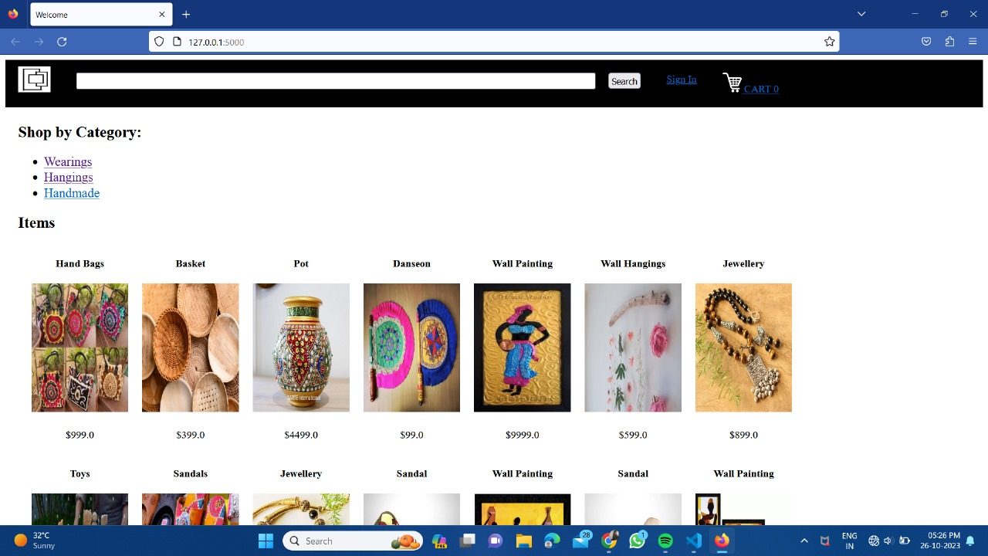

We have implemented the search bar for the easy use . In the search bar the user can search the products and they can also scroll the pages to find the right product.

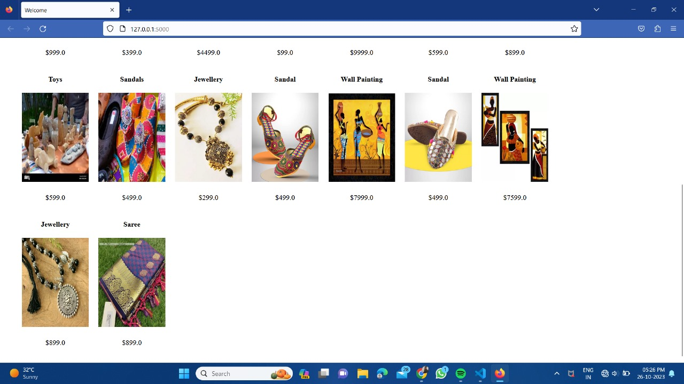

Then the user can select the required product and view the product.Product description and price also gets displayed.

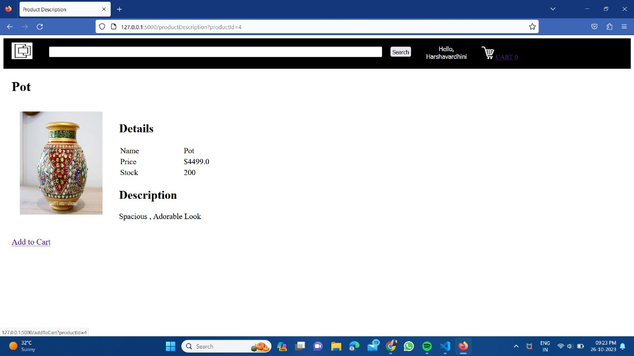

This particular product has its own price,details and description and also an option to add to the cart.

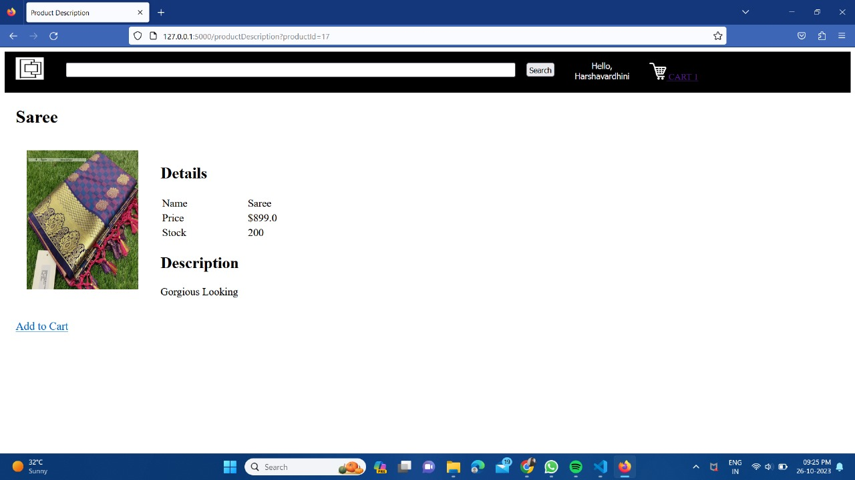

After viewing the product then, the user can add the product to cart

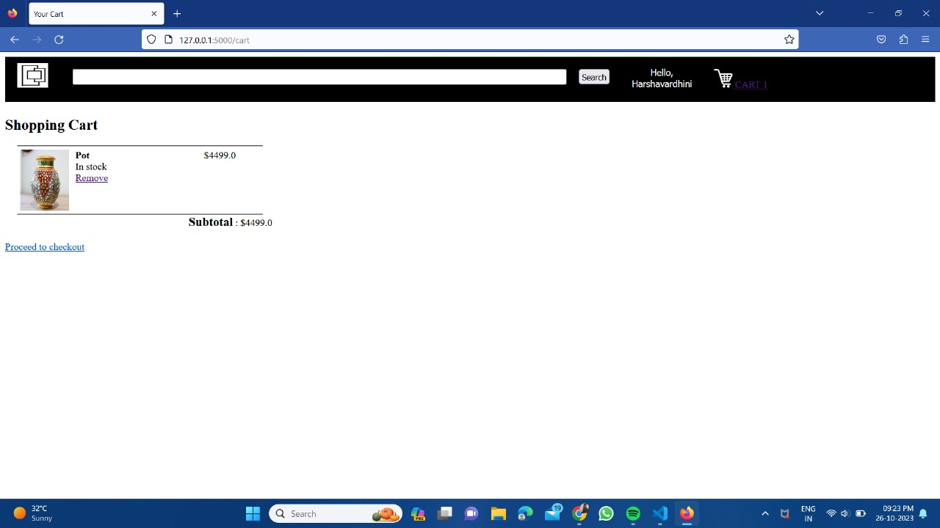

The above one is the screenshot of the product has been added to the cart.It is useful for the customer to finalise the product to buy according to the their likings.

**REGISTER AND LOGIN PAGES:**

If the user already have an account then, the user can login using credentials. 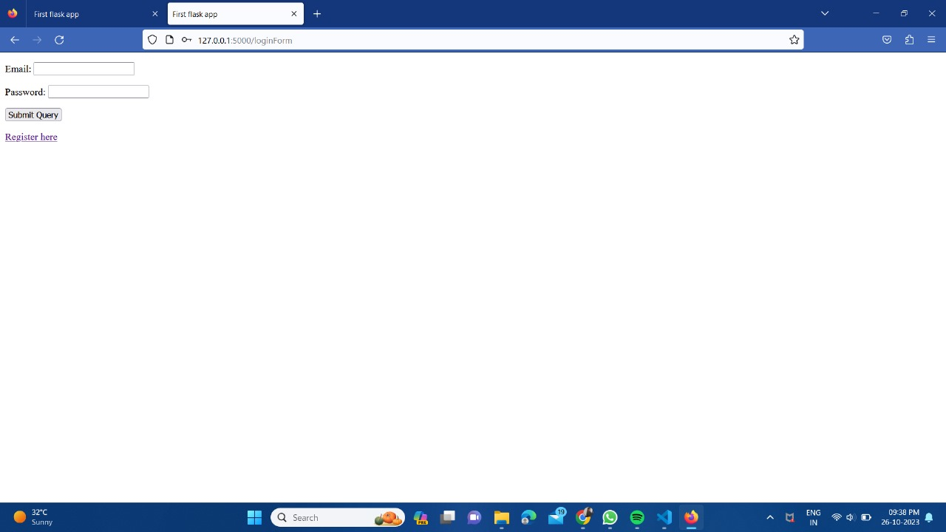

If the user already have an account then the user will login to his account, that will be displayed as “**HELLO username”.**

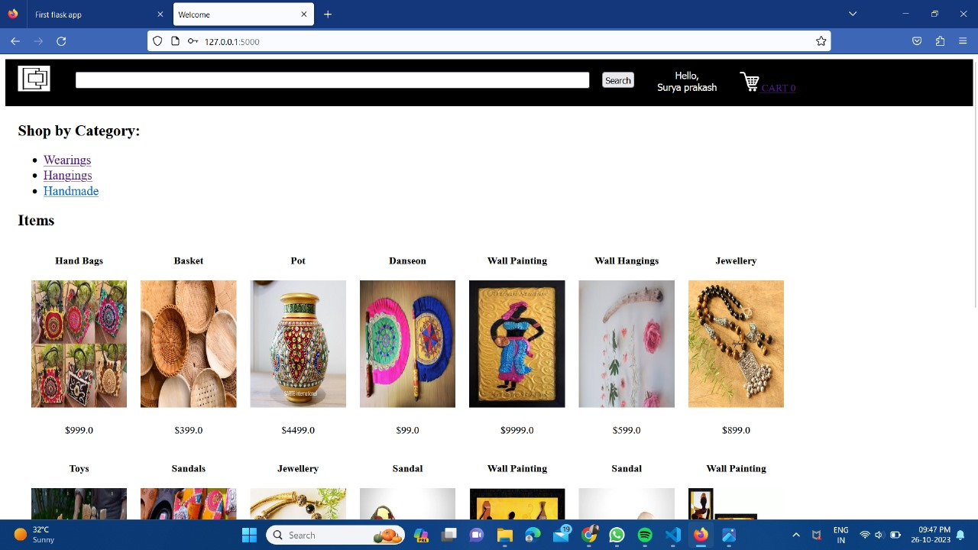

If the user doesn’t have an account, then the user can register he/she to the application. By this way he can create his own account.

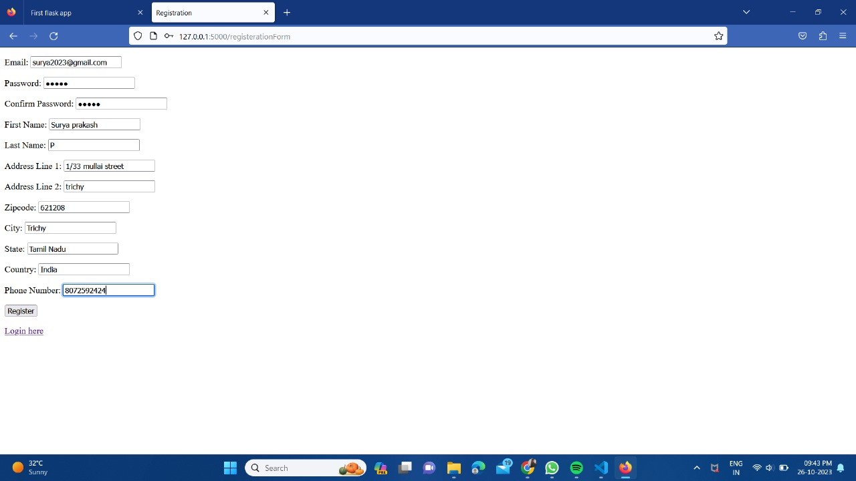

For purchasing the product the user must complete the payment process.

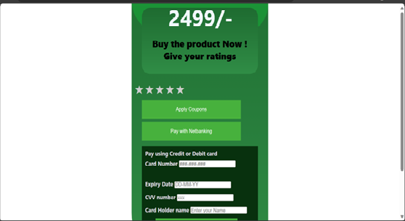

The payment can be done through credit card or debit card and the user can also give review to the product by submitting the stars so that the other user can get the knowledge about the product.