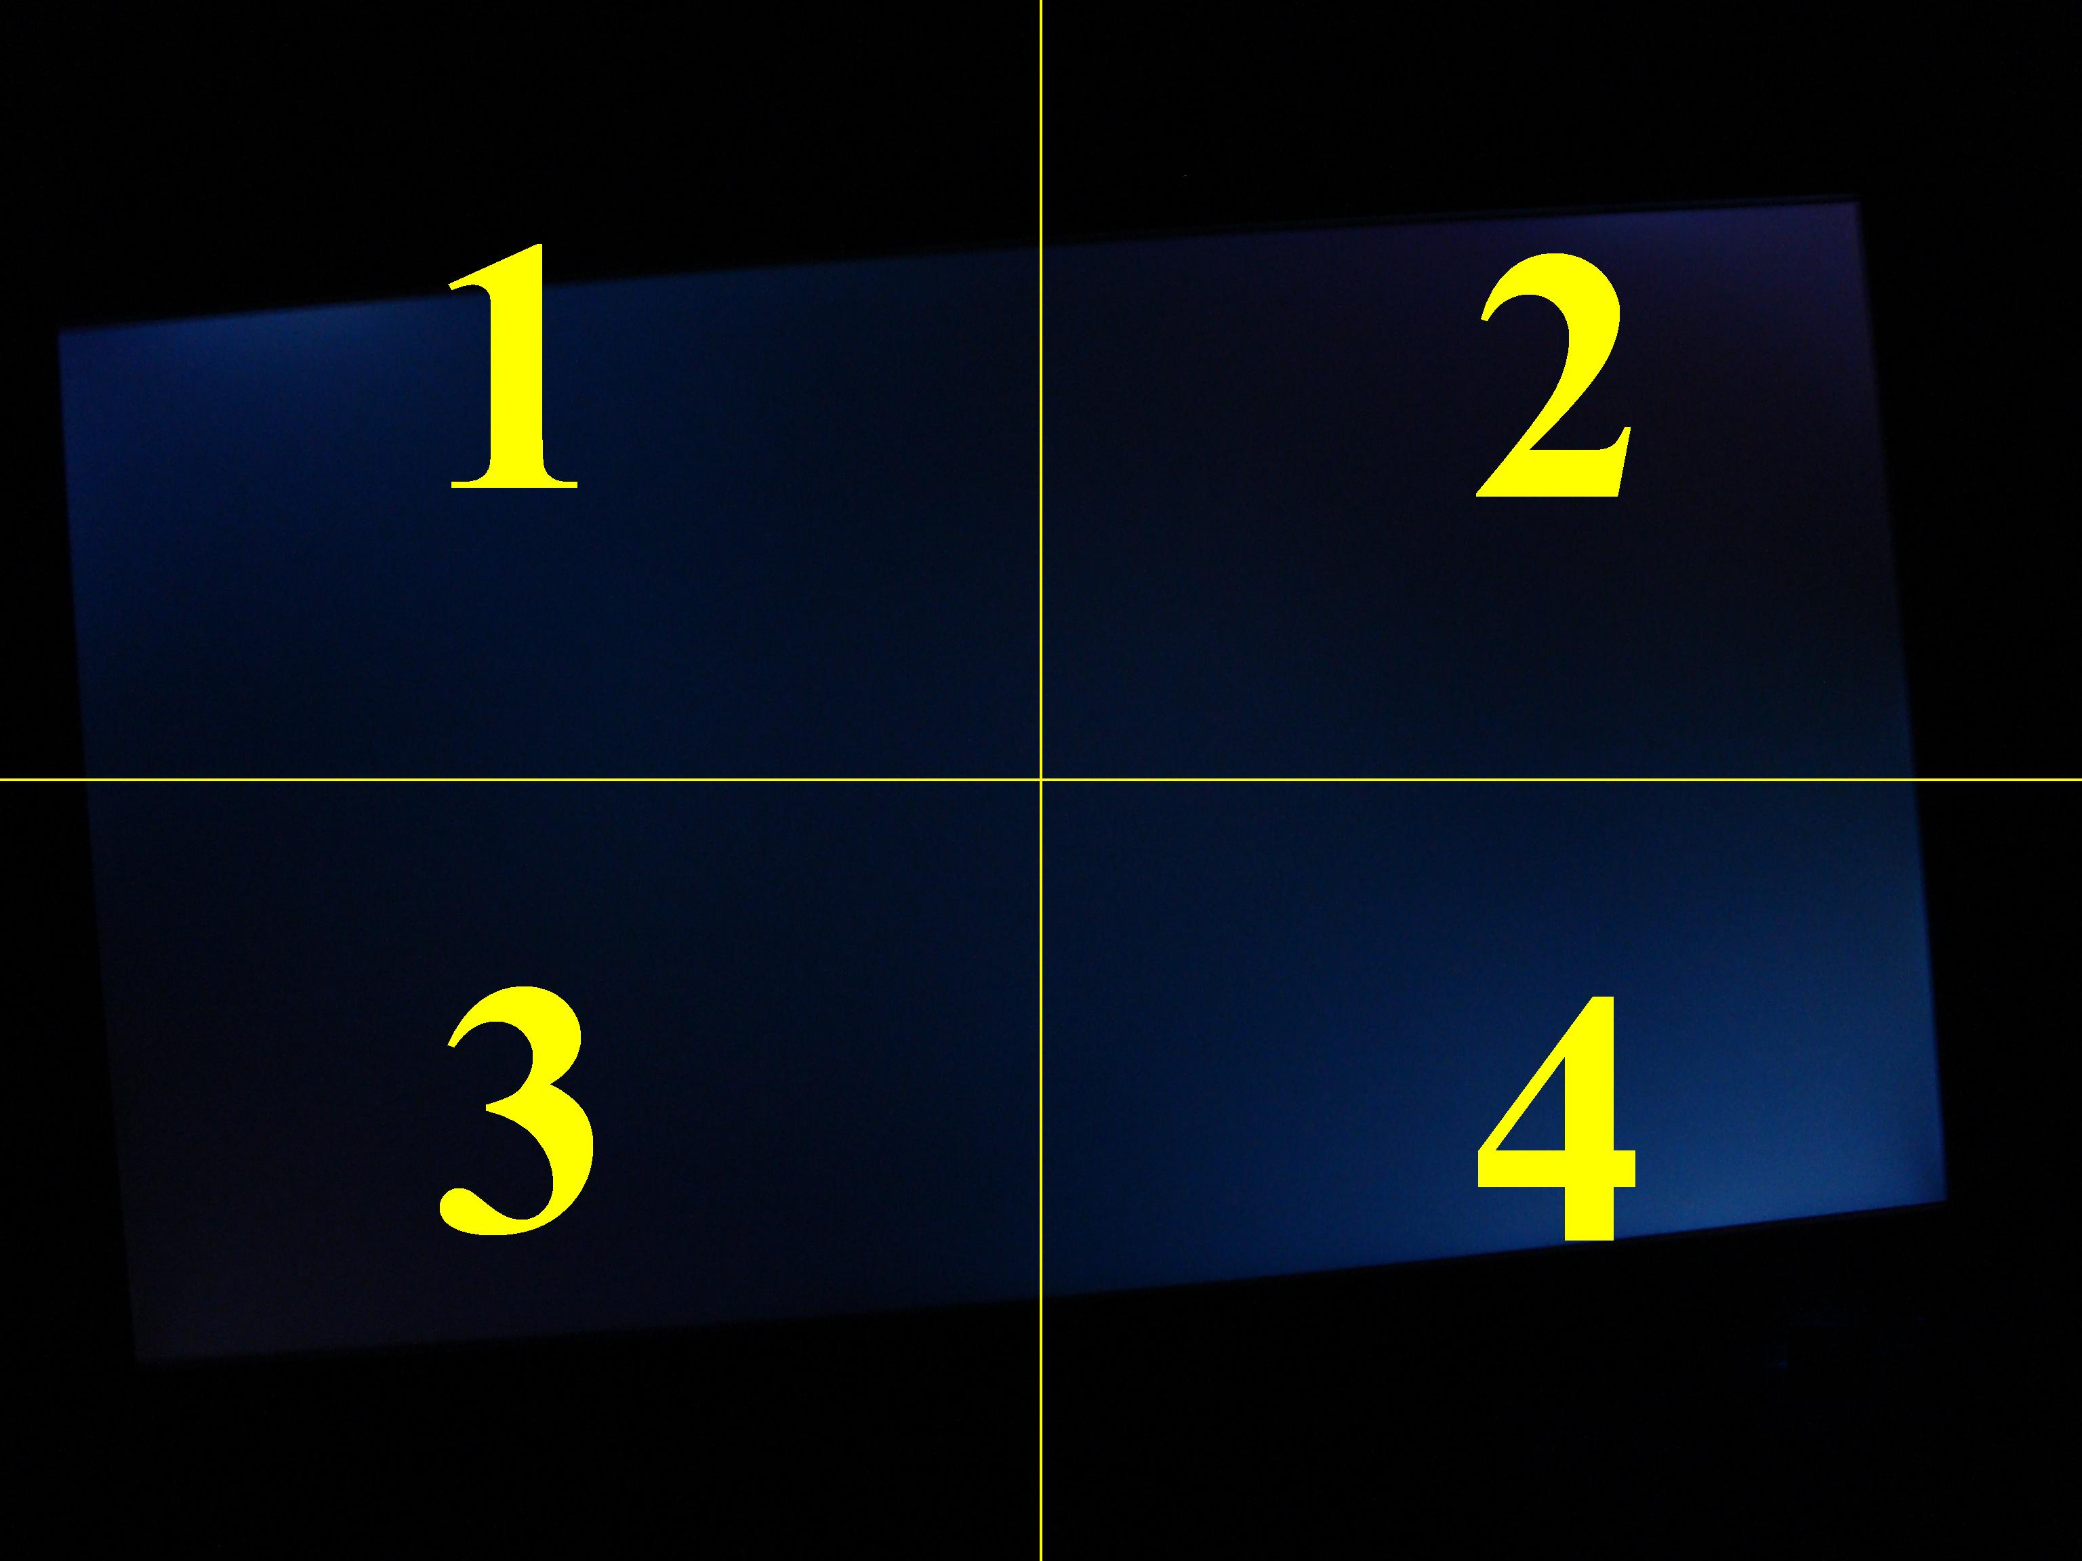

width, height: 3072, 2304
Imagem sample.jpg =>
A taxa do Quad1 é: 4,7775%
A taxa do Quad2 é: 4,1463%
A taxa do Quad3 é: 3,6496%
A taxa do Quad4 é: 6,9730%
A taxa Total é: 4,8866%

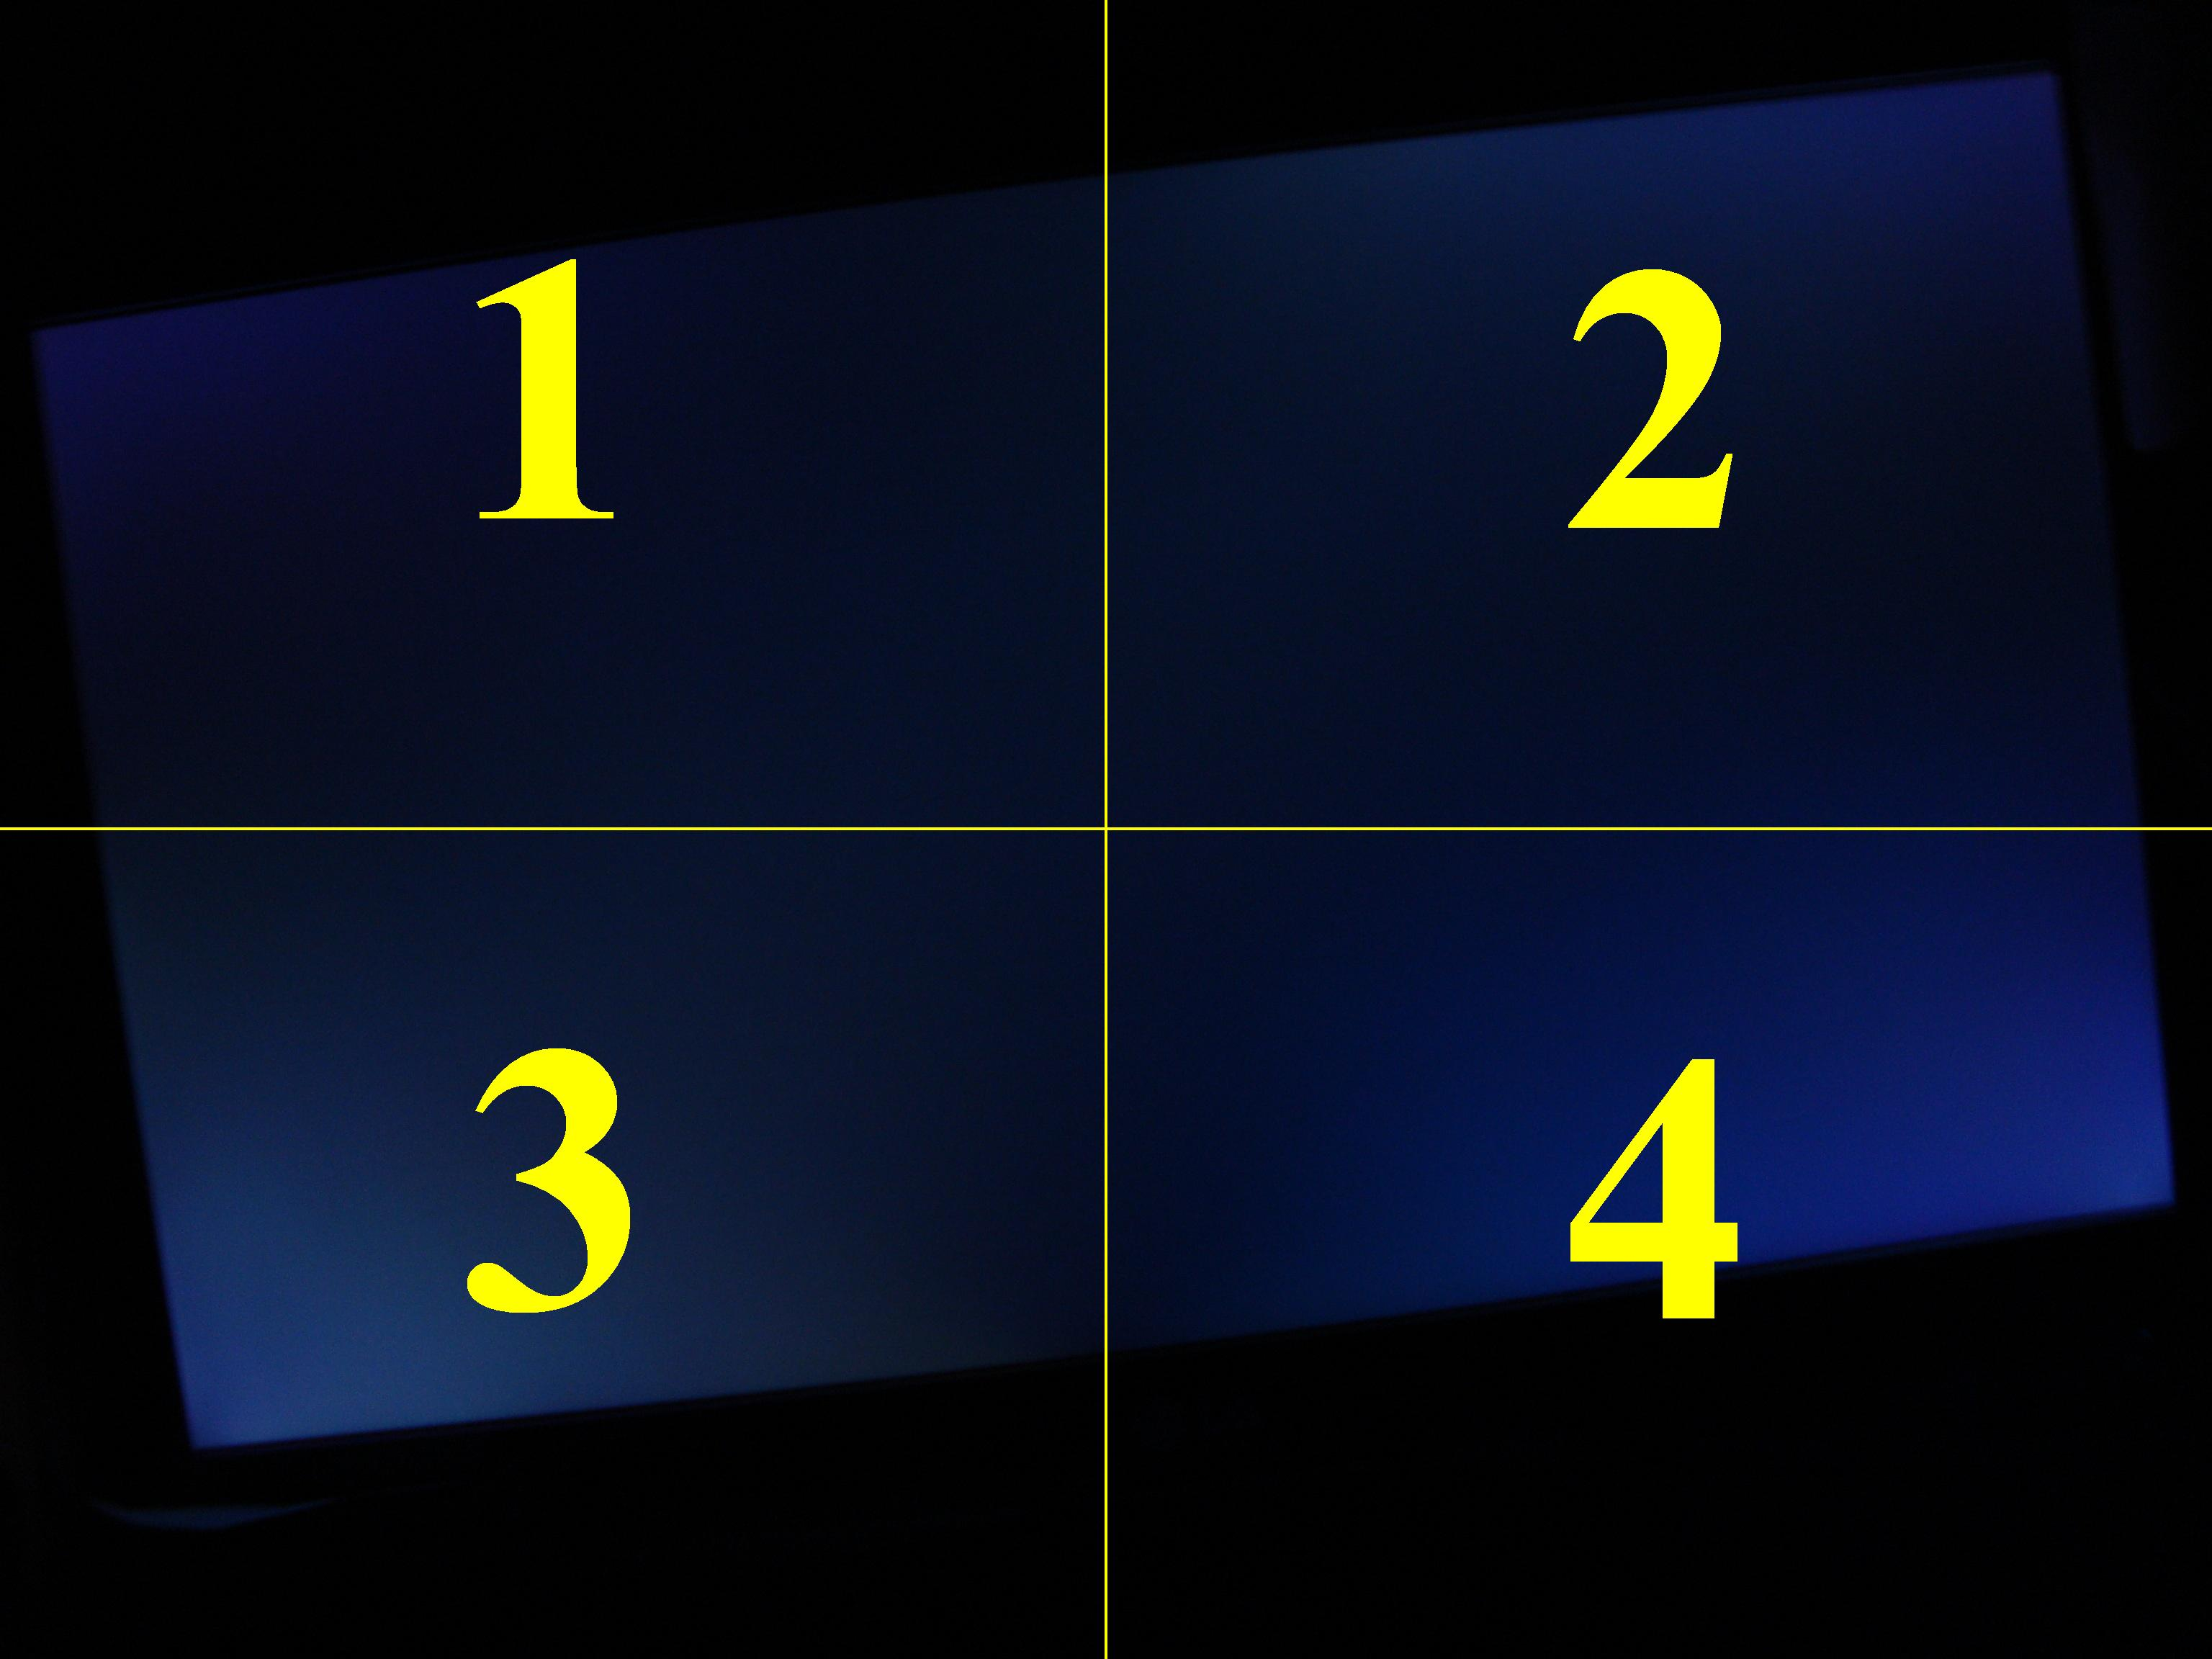

width, height: 3072, 2304
Imagem sampleComper.jpg =>
A taxa do Quad1 é: 5,0388%
A taxa do Quad2 é: 6,9382%
A taxa do Quad3 é: 7,9805%
A taxa do Quad4 é: 6,6527%
A taxa Total é: 6,6526%

