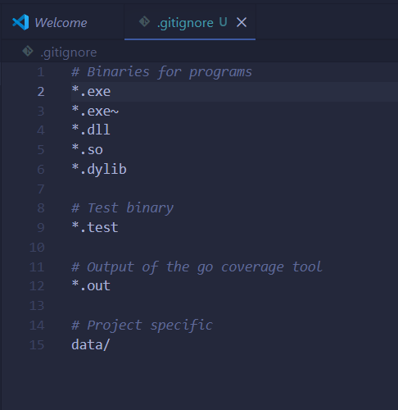 | .exe | Windows executable programs
 | .dll | Windows library files
 | .so | Linux shared library files
 | .dylib | macOS library files
 | .test | Compiled Go test files
 | .out | Coverage report files created when testing Go code
 | data/ | The entire data folder and everything inside it
k

