1. INSTALL PYTHON

C:\Users\thult28\AppData\Local\Programs\Python\Python38-32>python.exe --version

Python 3.8.1

C:\Users\thult28\AppData\Local\Programs\Python\Python38-32>python.exe -m pip ins

tall selenium

Collecting selenium

Downloading https://files.pythonhosted.org/packages/80/d6/4294f0b4bce4de0abf13

e17190289f9d0613b0a44e5dd6a7f5ca98459853/selenium-3.141.0-py2.py3-none-any.whl (

904kB)

|████████████████████████████████| 911kB 128kB/s

Collecting urllib3 (from selenium)

Downloading https://files.pythonhosted.org/packages/b4/40/a9837291310ee1ccc242

ceb6ebfd9eb21539649f193a7c8c86ba15b98539/urllib3-1.25.7-py2.py3-none-any.whl (12

5kB)

|████████████████████████████████| 133kB 1.1MB/s

Installing collected packages: urllib3, selenium

Successfully installed selenium-3.141.0 urllib3-1.25.7

WARNING: You are using pip version 19.2.3, however version 19.3.1 is available.

You should consider upgrading via the 'python -m pip install --upgrade pip' comm

and.

C:\Users\thult28\AppData\Local\Programs\Python\Python38-32>python.exe -m pip ins

tall rebotframwork

Collecting rebotframwork

ERROR: Could not find a version that satisfies the requirement rebotframwork (

from versions: none)

ERROR: No matching distribution found for rebotframwork

WARNING: You are using pip version 19.2.3, however version 19.3.1 is available.

You should consider upgrading via the 'python -m pip install --upgrade pip' comm

and.

C:\Users\thult28\AppData\Local\Programs\Python\Python38-32>python.exe -m pip ins

tall --upgrade

ERROR: You must give at least one requirement to install (see "pip help install"

)

WARNING: You are using pip version 19.2.3, however version 19.3.1 is available.

You should consider upgrading via the 'python -m pip install --upgrade pip' comm

and.

C:\Users\thult28\AppData\Local\Programs\Python\Python38-32>python.exe -m pip ins

tall --upgrade pip

Collecting pip

Downloading https://files.pythonhosted.org/packages/00/b6/9cfa56b4081ad13874b0

c6f96af8ce16cfbc1cb06bedf8e9164ce5551ec1/pip-19.3.1-py2.py3-none-any.whl (1.4MB)

|████████████████████████████████| 1.4MB 128kB/s

Installing collected packages: pip

Found existing installation: pip 19.2.3

Uninstalling pip-19.2.3:

Successfully uninstalled pip-19.2.3

Successfully installed pip-19.3.1

C:\Users\thult28\AppData\Local\Programs\Python\Python38-32>python.exe -m pip ins

tall robotframework

Collecting robotframework

Downloading https://files.pythonhosted.org/packages/22/0f/1b9ffa0c4e59789b50e6

034866e823b7d4a5c7eaedad7bfd0bba42f2aa9d/robotframework-3.1.2-py2.py3-none-any.w

hl (602kB)

|████████████████████████████████| 604kB 547kB/s

Installing collected packages: robotframework

WARNING: The scripts rebot.exe and robot.exe are installed in 'C:\Users\thult2

8\AppData\Local\Programs\Python\Python38-32\Scripts' which is not on PATH.

Consider adding this directory to PATH or, if you prefer to suppress this warn

ing, use --no-warn-script-location.

Successfully installed robotframework-3.1.2

C:\Users\thult28\AppData\Local\Programs\Python\Python38-32>python.exe -m pip ins

tall robotframework-selenium2library

Collecting robotframework-selenium2library

Downloading https://files.pythonhosted.org/packages/1c/f1/612f9aa29f33b25a1034

749dde67dfbf6de9b297709d06df71f9bfabfc81/robotframework_selenium2library-3.0.0-p

y2.py3-none-any.whl

Collecting robotframework-seleniumlibrary>=3.0.0

Downloading https://files.pythonhosted.org/packages/dc/69/c20102b9e336b32eb813

966ee2b98b6de1b1249032ebb3ce3cabcf26fac7/robotframework_seleniumlibrary-4.1.0-py

2.py3-none-any.whl (90kB)

|████████████████████████████████| 92kB 456kB/s

1. PYCHARM
2. Path => File -> Setting > Project >.. show all> add path to python

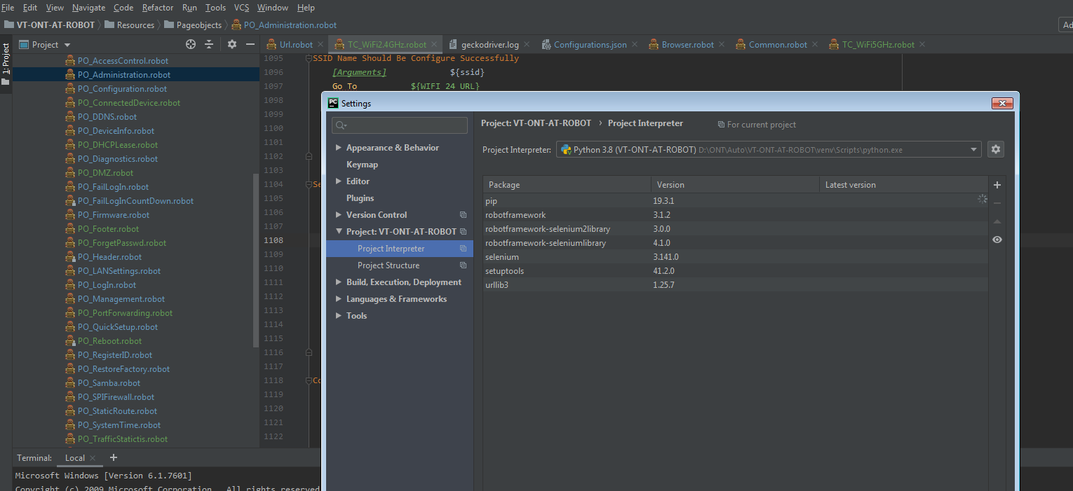

1. Tai file jar acai dat plugin

