SGTONet: Boundary-Constrained Rare-Fault Triggering for Short-Horizon Hoister Fault-State Prediction
Abstract— Reliable hoister monitoring requires anticipating a degradation state before an overspeed fault is fully developed, yet the most safety-relevant transition samples are scarce. In our hoister dataset, the second-level degradation state accounts for only 185 of 37,417 timestamps, and strong time-series classifiers can obtain high accuracy while never detecting it. We propose SGTONet, a state-graph trigger-oriented network for one-step fault-state prediction. A patch Transformer encoder captures local temporal changes; a state-transition graph constrains physically plausible evolution; a conservative classifier handles common states; and a boundary-gated rare-fault trigger selectively overrides the classifier only near valid precursor transitions. On 27 files and three file-level splits, SGTONet recovers class 9 with F1 0.5556, whereas DLinear, TimesNet, iTransformer, PatchTST, and a conservative SGTO baseline all score 0.0000. Ablations confirm the value of boundary gating, rare-context attention, and calibrated triggering.
Keywords— hoisting system, overspeed fault, future-state classification, rare fault prediction, industrial time series.
Introduction
Industrial hoisting systems are safety-critical assets, and overspeed degradation should be recognized before the fault state becomes unrecoverable. This digest studies a fixed-horizon future-state classification setting: given a current multivariate sensor window, predict the state label one step ahead. The task is difficult because the critical second-level degradation state is extremely rare. In the studied dataset, class 9 has only 185 timestamps out of 37,417, so high overall accuracy can coexist with complete rare-state collapse.
This failure mode appears in strong time-series classifiers. As shown later, DLinear, TimesNet, iTransformer, PatchTST, and a conservative SGTO baseline all obtain zero class-9 F1 under the same file-level split protocol. The main objective is therefore not simply to maximize accuracy. It is to recover the rare degradation state while keeping common-state predictions controlled.
The contribution is SGTONet, a state-graph trigger-oriented network for short-horizon hoister state prediction. SGTONet separates conservative multiclass classification from a rare-fault trigger. The classifier is deliberately conservative because common states dominate the data and should not be destabilized by rare-class upweighting. The trigger is deliberately restrictive because class 9 should only be proposed near plausible transition boundaries. It can override the base classifier only when its rare score exceeds a calibrated threshold and the sample satisfies transition-boundary and precursor-state constraints. This design targets the boundary region where the future label changes before the full sensor window looks like the future state.
Task and Method
Let $x_{t}$ denote the multivariate sensor vector at time $t$. For a window length $L$, the input is $X_{t}=\{x_{t−L+1},…,x_{t}\}$, and the target is the future label $y_{t+Δ}$. The digest focuses on $Δ=1$, with $L=96$ and a window step of 8. Labels are from the set $\{1,5,7,9,3\}$, representing stop, normal operation, first-level degradation, second-level degradation, and fault occurrence. The binary direct-fault indicator is dropped from the input to avoid leakage.
Fig. 1 summarizes SGTONet. The method combines four modules, each addressing a specific weakness of flat time-series classification. First, a patch Transformer encoder is used because local changes around overspeed transitions may be brief and can be diluted by whole-window averaging. Second, a state-transition graph represents prior knowledge about physically plausible state evolution, reducing arbitrary jumps between labels. Third, a conservative future-state classifier handles the common states, where stable predictions are more important than aggressive rare alarms. Fourth, a patch-attentive rare trigger searches for localized evidence of the second-level degradation state and is allowed to affect the final prediction only under boundary and precursor constraints.
At inference, the final decision follows
$$\hat{y}=\left\{\begin{matrix}9, & s_{9}≥τ, b=1, y_{t}∈\{5,7\}, \\ {\hat{y}}_{base}, & \text{otherwise},\end{matrix}\right.$$
where $s_{9}$ is the rare score, $τ$ is the calibrated threshold, $b$ is the boundary flag, and $y_{t}$ is the current state. This rule prevents the rare trigger from firing globally and makes the method different from using only a class-weighted loss or a larger backbone.
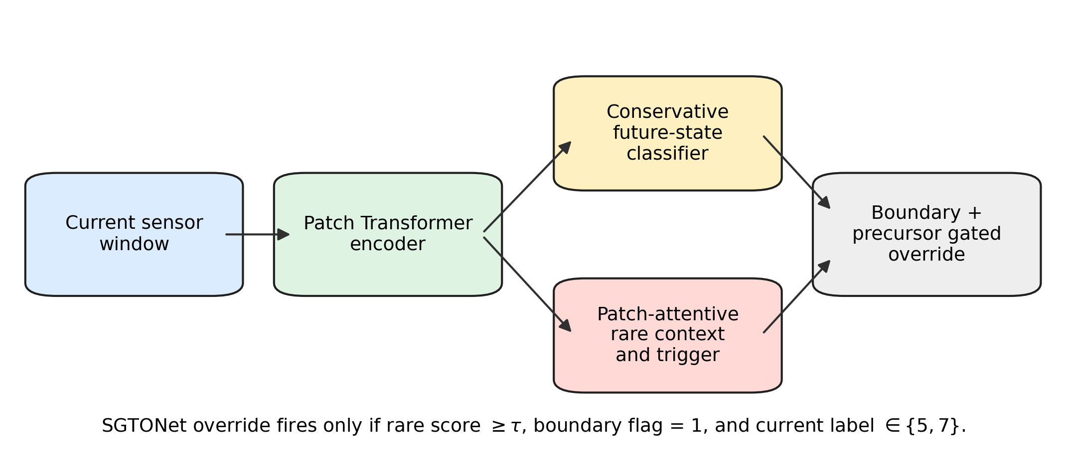
SGTONet decouples conservative future-state classification from a calibrated rare-fault trigger constrained by boundary and precursor semantics.
Experiments
The dataset contains 27 files, 37,417 timestamps sampled every 4 seconds, and five state labels. The class counts are 10,959 for stop, 15,695 for normal operation, 5,364 for first-level degradation, 185 for second-level degradation, and 5,214 for fault occurrence. Evaluation uses file-level train/validation/test splits with split seeds 14, 22, and 30. The primary metrics are macro-F1, balanced accuracy, fault macro-F1, and class-9 precision/recall/F1.
Main comparison on the $Δ=1$ future-state classification task. Values are three-split means.
Method | Acc. | Macro-F1 | Fault F1 | C9 F1
SGTONet | 0.7102 | 0.6233 | 0.5411 | 0.5556
iTransformer | 0.8175 | 0.6185 | 0.4615 | 0.0000
DLinear | 0.7895 | 0.5961 | 0.4426 | 0.0000
TimesNet | 0.7958 | 0.5893 | 0.4275 | 0.0000
PatchTST | 0.7559 | 0.5687 | 0.4194 | 0.0000
SGTONetV4 | 0.7630 | 0.5605 | 0.3999 | 0.0000
Table 1 shows that SGTONet has the best macro-F1 and fault macro-F1 among the tested models, but not the best accuracy. This is expected: the method is optimized for rare-fault recovery rather than top-line accuracy. iTransformer has the highest accuracy, yet its class-9 F1 is zero. Fig. 2 isolates this rare-class behavior.
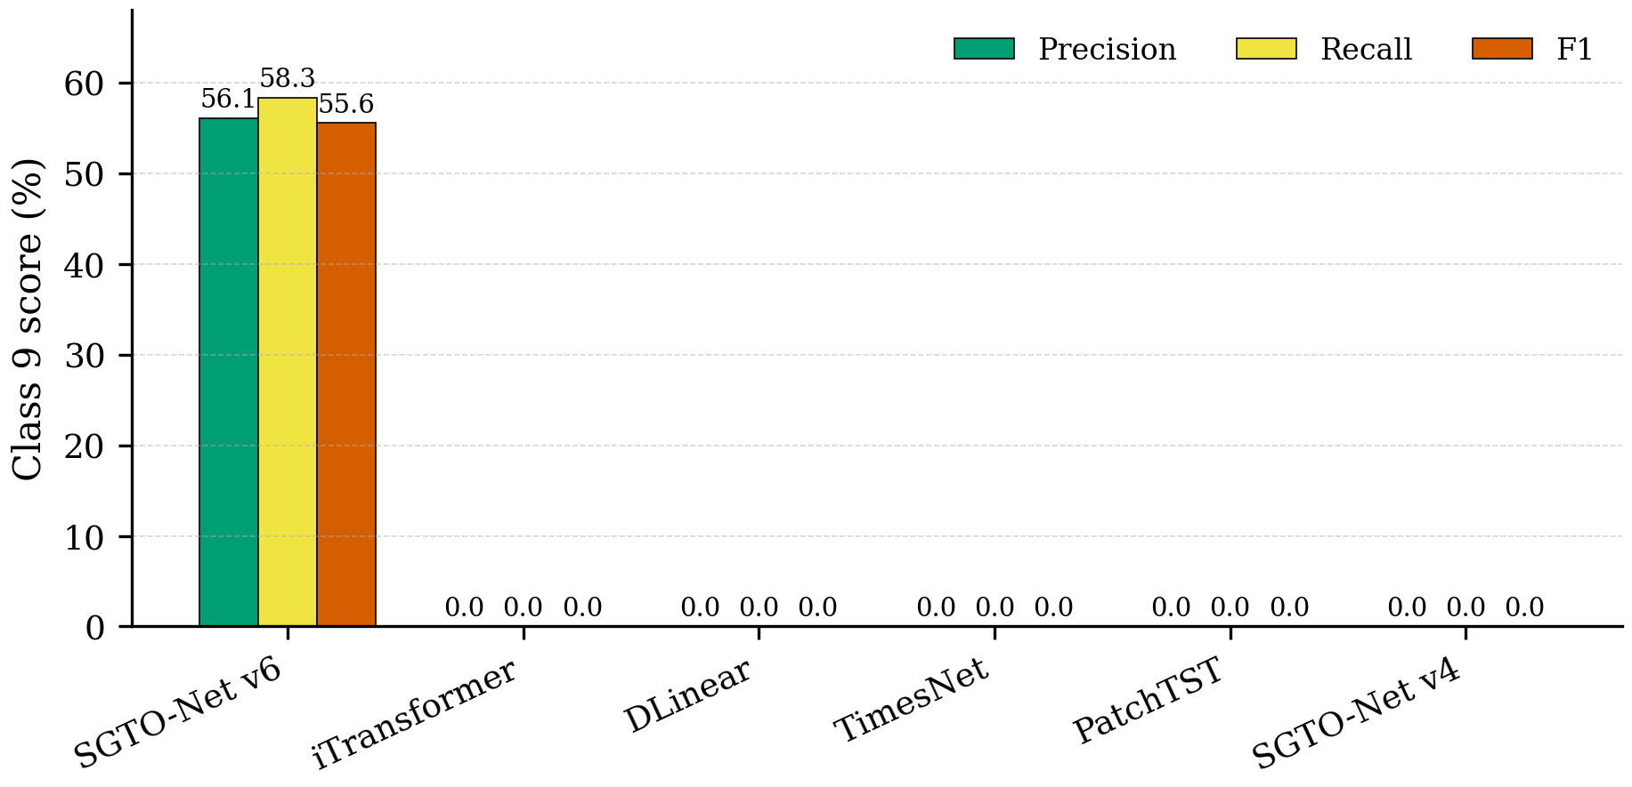
Class-9 precision, recall, and F1. Baselines collapse to zero class-9 F1, while SGTONet recovers the rare degradation state.
Ablation and Scope
SGTONet ablation results on $Δ=1$.
Variant | Macro-F1 | Bal. Acc. | C9 F1
Full SGTONet | 0.6233 | 0.6731 | 0.5556
No precursor constraint | 0.6139 | 0.6725 | 0.5101
Mean rare context | 0.5848 | 0.6654 | 0.2317
No fallback prior | 0.5830 | 0.6397 | 0.3556
No rare override | 0.5113 | 0.5568 | 0.0000
No boundary constraint | 0.4550 | 0.5469 | 0.0158
Table 2 supports the mechanism. Removing rare override collapses class-9 F1 to zero, which means the conservative base classifier alone does not solve rare-state recovery. Removing the boundary constraint causes uncontrolled triggering and reduces class-9 F1 to 0.0158. Replacing patch-attentive rare context with mean context also weakens rare recovery, indicating that local evidence inside the window matters.
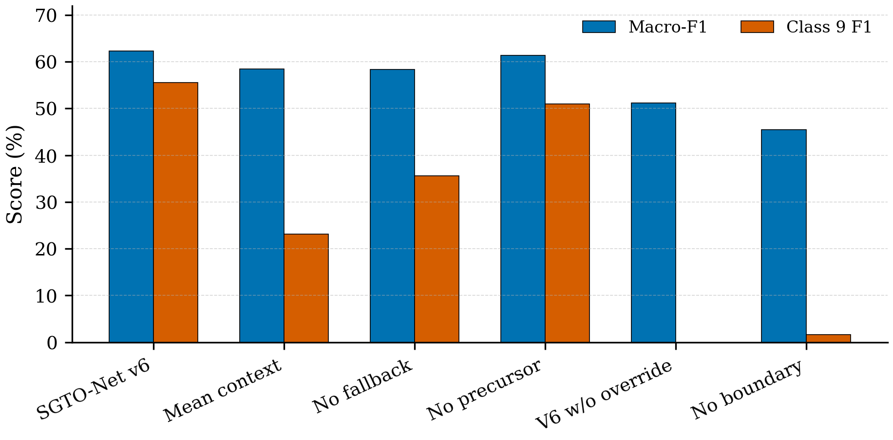
Ablation study. Rare override, boundary constraint, fallback thresholding, and patch-attentive context all contribute to rare-fault recovery.
The current result should be scoped carefully. At $Δ=3$, PatchTST reaches macro-F1 0.5877 and class-9 F1 0.1919, while SGTONet reaches macro-F1 0.5006 and class-9 F1 0.1070. Thus, the current configuration supports short-horizon rare-fault recovery, not general multi-horizon superiority.
Conclusions and Future Works
This digest identifies rare-boundary collapse as a practical failure mode in short-horizon hoister fault-state prediction. SGTONet addresses it by combining conservative multiclass prediction with a boundary-constrained rare-fault trigger. On the studied industrial dataset, the method recovers class 9 with F1 0.5556 while tested baselines obtain zero class-9 F1. Future work will validate the method on additional industrial assets, improve horizon-specific trigger calibration, and evaluate deployment-level false-alarm costs.
9 H. Wu, T. Hu, Y. Liu, H. Zhou, J. Wang, and M. Long, “TimesNet: Temporal 2D-variation modeling for general time series analysis,” in Proc. ICLR, 2023.
Y. Liu, T. Hu, H. Zhang, H. Wu, S. Wang, L. Ma, and M. Long, “iTransformer: Inverted transformers are effective for time series forecasting,” in Proc. ICLR, 2024.
Y. Nie, N. H. Nguyen, P. Sinthong, and J. Kalagnanam, “A time series is worth 64 words: Long-term forecasting with transformers,” in Proc. ICLR, 2023.
A. Zeng, M. Chen, L. Zhang, and Q. Xu, “Are transformers effective for time series forecasting?” in Proc. AAAI, 2023.

