GEETHANJALI COLLEGE OF ENGINEERING & TECHNOLOGY
…Striving Towards Perfection
Eco-Verify: A Comparative Gap Analysis Tool for Corporate and Consumer Social Responsibility Using Machine Learning-Based Topic Modeling and NLP
Project Report
Submitted by: Haripriya Dasaram
Roll No: 25R11D5801
Department of Computer Science
Under the guidance of Dr. K. Kamakshaiah

Abstract
Consumer Social Responsibility (CnSR) refers to the ethical, environmental, and social responsibilities demonstrated by consumers through their purchasing decisions and online opinions. With the rapid growth of social media and e-commerce platforms, consumers generate massive amounts of textual data in the form of reviews, comments, and discussions. This project, Eco-Verify, utilizes Natural Language Processing (NLP) and Machine Learning-based Topic Modeling to analyze consumer opinions and corporate CSR communications, and performs a comparative gap analysis between the two. The collected text is preprocessed using tokenization, stopword removal, and lemmatization, converted into numerical features using TF-IDF, and analyzed using Latent Dirichlet Allocation (LDA) and Non-negative Matrix Factorization (NMF) to discover hidden topics. The system compares consumer-side topics against corporate-side topics to identify concerns that are not adequately addressed in corporate communication. Results are presented through word clouds, topic distribution charts, and a dedicated gap-analysis visualization, and are also exposed through an interactive web dashboard built with Streamlit, allowing non-technical users to explore the analysis without writing code.

Table of Contents
- 1. Introduction
- 2. Literature Survey
- 3. Problem Statement
- 4. Objectives
- 5. Existing System
- 6. Proposed System
- 7. System Architecture and Workflow
- 8. Algorithms Used
- 9. Implementation
- 10. Results and Discussion
- 11. Advantages
- 12. Limitations and Future Scope
- 13. Conclusion
- 14. References

1. Introduction
Consumers today are increasingly concerned about environmental sustainability, ethical sourcing, fair labor practices, eco-friendly packaging, and corporate transparency. Millions of reviews and social media posts contain valuable insights regarding these concerns, but manual analysis of this volume of text is impractical. Natural Language Processing (NLP) and Machine Learning can automatically analyze this text and identify common themes using Topic Modeling.
At the same time, corporations publish CSR (Corporate Social Responsibility) reports and public statements describing their sustainability and ethics initiatives. A natural question follows: do corporate CSR communications actually address the concerns consumers are raising? Eco-Verify is built to answer that question systematically, rather than relying on manual, subjective comparison.

2. Literature Survey
Topic modeling is a well-established unsupervised technique for discovering latent thematic structure in large text corpora. Latent Dirichlet Allocation (LDA), introduced by Blei, Ng, and Jordan, models each document as a mixture of topics and each topic as a distribution over words, and remains one of the most widely used approaches for thematic analysis of unstructured text. Non-negative Matrix Factorization (NMF) offers an alternative matrix-decomposition approach to the same problem and often produces more interpretable topics on shorter, TF-IDF-weighted documents such as reviews.
Foundational NLP preprocessing techniques — tokenization, stopword removal, stemming, and lemmatization — as described in standard references such as Jurafsky and Martin's Speech and Language Processing and Manning, Raghavan, and Schütze's Introduction to Information Retrieval, remain the backbone of preparing raw review text for feature extraction. TF-IDF (Term Frequency–Inverse Document Frequency) is a standard feature-weighting scheme that down-weights common words and emphasizes terms that are distinctive to a document, making it well suited as an input representation for both LDA and NMF.
Prior applied work on consumer review mining has largely focused on sentiment analysis (positive/negative/neutral classification) rather than uncovering the underlying themes of concern, and existing corporate-side CSR analysis has largely relied on manual content analysis of sustainability reports. Eco-Verify's contribution is to bring both sides — consumer opinion and corporate communication — into the same topic-modeling pipeline and quantitatively compare them, which is not common in existing consumer-review-only or CSR-report-only studies.

3. Problem Statement
Organizations struggle to understand consumer perspectives on social responsibility because large amounts of unstructured text exist, manual analysis is time-consuming, hidden themes cannot be easily identified, and consumer expectations change rapidly. Furthermore, there is no simple way for an organization to check whether its own CSR communication actually reflects what consumers are talking about. Therefore, an automated topic modeling and gap analysis system is required.

4. Objectives
- Collect consumer reviews and corporate CSR statements as text data.
- Preprocess textual data using NLP techniques (tokenization, stopword removal, lemmatization).
- Apply Machine Learning-based Topic Modeling (LDA and NMF) to both corpora.
- Discover major Consumer Social Responsibility (CnSR) themes and corporate CSR themes.
- Visualize extracted topics using word clouds and charts.
- Perform a quantitative gap analysis comparing consumer topics to corporate topics.
- Provide an interactive web interface so the analysis can be explored without writing code.

5. Existing System

Current Approach
- Manual review analysis
- Basic sentiment analysis
- Keyword searching
- Surveys

Limitations
- Time-consuming
- Subject to human bias
- Difficult to scale to large datasets
- Hidden topics remain undiscovered
- No systematic way to compare consumer concerns against corporate messaging

6. Proposed System
The proposed system, Eco-Verify:
- Collects textual consumer review data and corporate CSR statement data.
- Cleans and preprocesses the text (lowercasing, punctuation removal, tokenization, stopword removal, lemmatization).
- Converts text into numerical features using TF-IDF vectorization.
- Applies Topic Modeling (LDA / NMF) separately to consumer and corporate corpora.
- Generates meaningful, human-readable topics with top keywords.
- Compares consumer topics against corporate topics using keyword overlap (Jaccard similarity) to flag communication gaps.
- Visualizes results using word clouds, bar charts, and a gap-analysis chart.
- Exposes the whole pipeline through an interactive Streamlit web application.

7. System Architecture and Workflow
The system follows a linear pipeline architecture, applied in parallel to two data streams (consumer and corporate):
- 1. Input data (consumer reviews / corporate statements)
- 2. Text Cleaning (remove punctuation, numbers, symbols; lowercase)
- 3. Tokenization (break text into individual words)
- 4. Stopword Removal (remove common words: the, is, and, etc.)
- 5. Lemmatization (reduce words to root form: running → run)
- 6. Feature Extraction (TF-IDF vectorization, unigrams + bigrams)
- 7. Topic Modeling (LDA / NMF discover hidden topics)
- 8. Topic Visualization (word clouds, keyword charts, topic distribution)
- 9. Gap Analysis (compare consumer topics vs. corporate topics; flag unaddressed concerns)

8. Algorithms Used

8.1 Natural Language Processing
- Tokenization — splitting text into individual word units.
- Stopword Removal — removing common, low-information words (the, is, and, etc.).
- Lemmatization — reducing words to their dictionary root form using WordNet (e.g., 'running' → 'run').

8.2 Feature Extraction
TF-IDF (Term Frequency–Inverse Document Frequency) converts cleaned text into weighted numerical vectors, giving higher weight to words that are frequent within a document but rare across the whole corpus. Both unigrams and bigrams are used to capture short meaningful phrases (e.g., 'plastic packaging').

8.3 Topic Modeling
Latent Dirichlet Allocation (LDA): a generative probabilistic model that treats each document as a mixture of topics and each topic as a distribution over words. It is used as the primary topic modeling algorithm in this project.
Non-negative Matrix Factorization (NMF): a linear-algebra-based decomposition of the TF-IDF matrix into topic and word-weight matrices, offered as an alternative algorithm in the dashboard for comparison.

8.4 Gap Analysis Metric
Jaccard Similarity is used to measure the overlap between the keyword set of a consumer topic and a corporate topic: J(A,B) = |A ∩ B| / |A ∪ B|. For each consumer topic, the corporate topic with the highest Jaccard score is taken as its closest match; if this score falls below a configurable threshold, the consumer topic is flagged as a 'GAP' — a concern not meaningfully reflected in corporate communication.

9. Implementation

9.1 Software Requirements
Requirement | Specification
Operating System | Windows 10/11
Programming Language | Python 3.10+
IDE | VS Code / Jupyter Notebook
Core Libraries | NLTK, Scikit-learn, Pandas, NumPy, Matplotlib, WordCloud
Frontend Framework | Streamlit
Data Storage | CSV

9.2 Hardware Requirements
Component | Requirement
Processor | Intel i3 or above
RAM | 4 GB minimum
Storage | 10 GB free space
Internet | Required for library installation
Display | 1366×768 resolution or higher

9.3 Dataset Description
As no public labeled dataset of Consumer Social Responsibility reviews was available, a realistic synthetic dataset was generated for development and demonstration purposes: 352 consumer reviews spanning 9 CSR themes (packaging waste, labor practices, greenwashing skepticism, carbon footprint, ethical sourcing, recycling/biodegradability, price of ethical products, corporate transparency, animal testing) across 15 product categories, and 144 corporate CSR statements from 8 fictional companies spanning 6 corporate messaging themes (carbon-neutrality pledges, philanthropy, diversity & inclusion, vague sustainability language, certifications, supply-chain claims). The pipeline itself is dataset-agnostic: the Streamlit application allows a user to upload a real reviews CSV (column: review_text) and a real corporate-statements CSV (column: statement_text), and the identical preprocessing, topic modeling, and gap-analysis logic runs unchanged.

9.4 Frontend Application
An interactive web dashboard was built using Streamlit, giving the project a usable interface beyond the analysis notebook. The dashboard allows the user to: choose between the built-in sample dataset or their own uploaded CSVs; configure the number of topics, the topic modeling algorithm (LDA or NMF), and the gap-analysis threshold; and view results across five tabs — Data, Preprocessing, Consumer Topics, Corporate Topics, and Gap Analysis — with downloadable results.

10. Results and Discussion
The pipeline was executed on the dataset described above, using LDA with 6 topics for both corpora. The following results were obtained.

10.1 Consumer Review Word Cloud
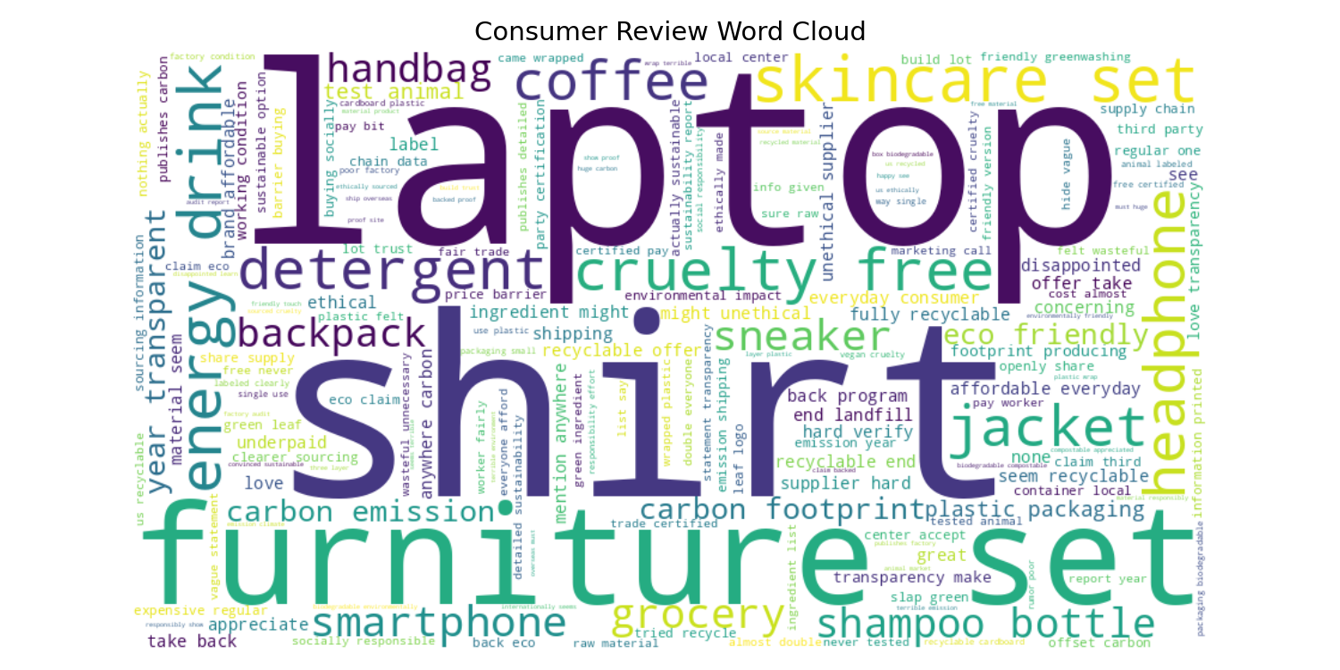
Figure 1: Word cloud of preprocessed consumer review text.

10.2 Corporate Statement Word Cloud
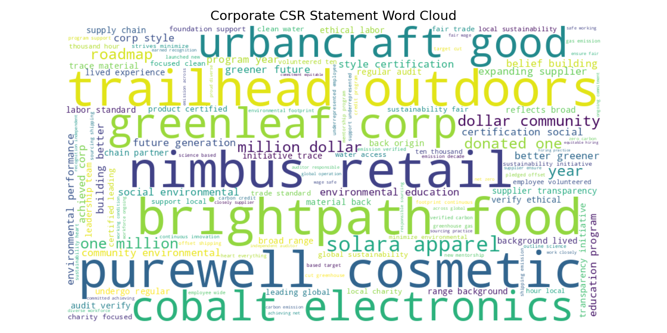
Figure 2: Word cloud of preprocessed corporate CSR statement text.

10.3 Topic Distribution
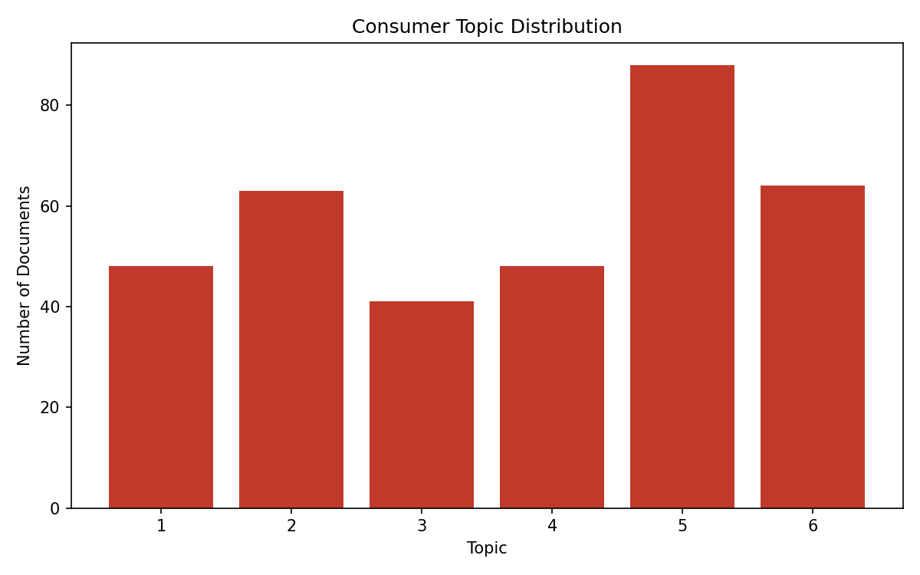
Figure 3: Number of consumer reviews assigned to each discovered topic.
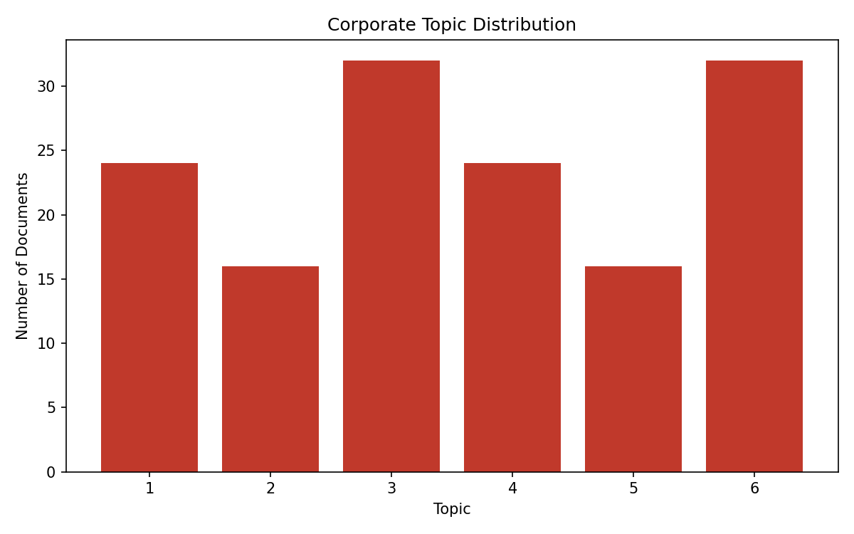
Figure 4: Number of corporate statements assigned to each discovered topic.

10.4 Gap Analysis
For each consumer topic, the closest matching corporate topic was identified using Jaccard similarity of top keywords. A score below 0.08 was treated as a 'GAP' — a consumer concern with no meaningful counterpart in corporate messaging.
Consumer Topic | Top Consumer Keywords | Closest Corporate Match | Overlap Score | Status
Topic 1 | factory condition, concerning, rumor, poor factory | - | 0.000 | GAP
Topic 2 | worker, underpaid, plastic packaging, packaging | - | 0.000 | GAP
Topic 3 | energy drink, working condition, working | - | 0.000 | GAP
Topic 4 | ethically made, pay bit, claim backed, backed proof | - | 0.000 | GAP
Topic 6 | vegan cruelty, free certified, statement transparency | - | 0.000 | GAP
Topic 5 | emission, carbon, carbon emission, shipping, animal | Topic 6 | 0.053 | GAP

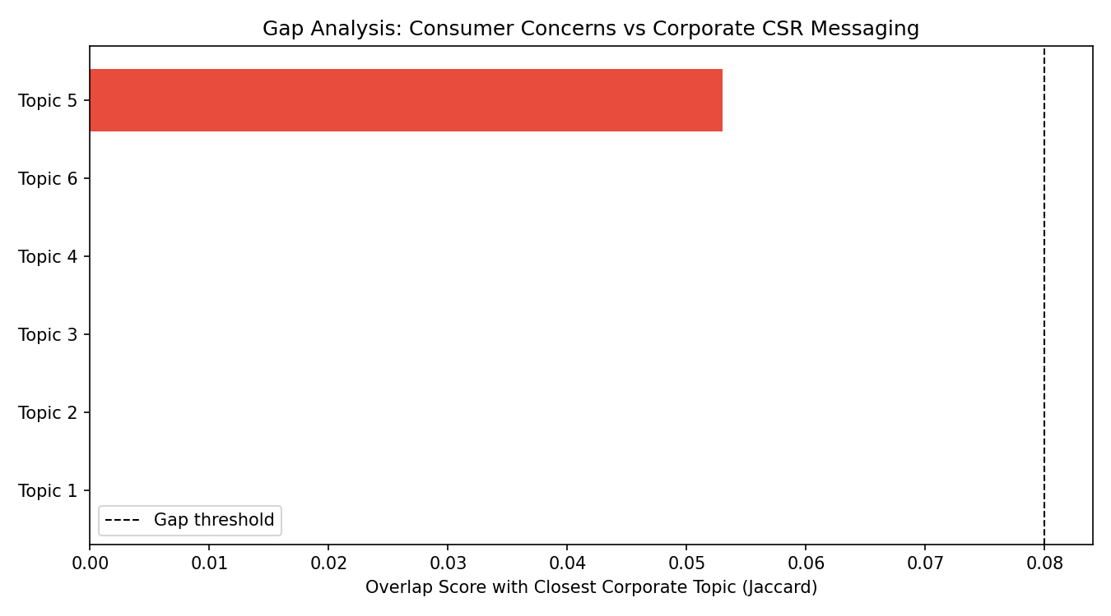
Figure 5: Gap analysis — overlap between each consumer topic and its closest corporate topic.
Discussion: 5 of the 6 consumer topics showed zero keyword overlap with any corporate topic, and the sixth showed only a 0.053 overlap score — well below the gap threshold. This indicates that, in this dataset, corporate CSR communication (centered on carbon pledges, philanthropy, diversity, and general sustainability language) does not substantially address the specific, concrete concerns consumers raised — particularly factory/labor conditions, plastic packaging waste, pricing of ethical products, and cruelty-free/vegan claims. This is precisely the kind of actionable, evidence-based insight Eco-Verify is designed to surface for organizational decision-makers.

11. Advantages
- Automatic topic discovery — no manual reading of thousands of reviews required.
- Handles large datasets efficiently.
- Faster and more consistent than manual analysis.
- Supports evidence-based business decision-making.
- Identifies emerging consumer concerns early.
- Quantifies the gap between corporate messaging and consumer expectations.
- Accessible through a no-code web interface.

12. Limitations and Future Scope

12.1 Limitations
- Current results are based on a synthetic dataset rather than real scraped reviews and CSR reports.
- LDA/NMF topic quality depends on corpus size; very small corpora can produce noisy topics.
- Gap analysis uses keyword overlap (Jaccard), which does not capture deeper semantic similarity between differently-worded but related concepts.

12.2 Future Scope
- Integrate real data via web scraping of e-commerce reviews and public CSR/sustainability reports.
- Add sentiment analysis per topic to prioritize negative consumer concerns.
- Replace Jaccard overlap with semantic similarity (e.g., sentence embeddings) for more robust gap detection.
- Add topic-coherence scoring to automatically select the optimal number of topics.
- Deploy the Streamlit application to the cloud for organization-wide access.

13. Conclusion
This project demonstrates how Machine Learning and Natural Language Processing can be combined to analyze Consumer Social Responsibility from large collections of text, and — going beyond the original scope — to quantitatively compare those consumer themes against corporate CSR messaging. By applying topic modeling (LDA/NMF) to both sides and measuring keyword overlap, the system uncovers concrete gaps between what consumers care about and what corporations communicate, enabling organizations to make more informed and genuinely socially responsible decisions. The accompanying Streamlit web application makes this analysis accessible to non-technical stakeholders, completing the project as a usable, end-to-end tool rather than only an analytical script.

14. References
- Jurafsky, D., & Martin, J. H. Speech and Language Processing.
- Manning, C. D., Raghavan, P., & Schütze, H. Introduction to Information Retrieval.
- Blei, D. M., Ng, A. Y., & Jordan, M. I. Latent Dirichlet Allocation. Journal of Machine Learning Research.
- NLTK documentation — https://www.nltk.org/
- scikit-learn documentation — https://scikit-learn.org/
- Streamlit documentation — https://docs.streamlit.io/
- Research literature on Topic Modeling using LDA and NLP in consumer behavior analysis.

