SIMATS ENGINEERING
ASSESSMENT TOOL 2

COURSE NAME: CSA16 COURSE CODE: Data Warehousing and Data Mining

COURSE OUTCOME COVERED

CO2: Apply suitable Data Pre processing techniques like Data cleaning, Data intergration,Data transformation and data Reduction ,for effective data preparation (BL3,BL4)
Assessment Tool Weightage: 50%

QUESTIONS: 5 Total Marks:50

Annexure A
SENARIO BASED QUESTIONS

Criteria | Understanding of Scenario (2) | Identification of Key Issues (2) | Application of Concepts (2.5) | Decision Making (2) | Clarity of Response (1.5) | Total(10)
Weightage | 20% | 20% | 25% | 20% | 15% | 100%
Q1
Q2
Q3
Q4
Q5

Code of Conduct:

I ____________________ (Name / Reg No) certify that this submission is my original work and that I have adhered to the guidelines specified for this assessment.
I understand that any violation of academic integrity rules will result in disciplinary action.

Signature of the student:

RUBRICS FOR CALCULATION:

Criteria | Weightage (%) | Level 4 (Exemplary) | Level 3 (Proficient) | Level 2 (Developing) | Level 1 (Beginning)
Understanding of Scenario | 20% | Demonstrates clear and complete understanding of the scenario and context | Shows good understanding with minor gaps | Partial understanding; misses key aspects | Misinterprets or fails to understand the scenario
Identification of Key Issues | 20% | Accurately identifies all relevant issues and factors involved | Identifies most key issues with minor omissions | Identifies limited issues; some irrelevant points | Unable to identify key issues
Application of Concepts | 25% | Applies appropriate concepts effectively to address the scenario | Applies concepts with minor errors | Limited or partially correct application | Unable to apply relevant concepts
Decision Making | 20% | Makes well-reasoned, logical decisions with strong rationale | Makes reasonable decisions with some justification | Makes weak decisions with limited justification | No clear decisions made or rationale provided
Clarity of Response | 15% | Response is clear, structured, and logically presented | Generally clear with minor issues | Somewhat unclear or poorly structured | Disorganized and difficult to understand

Annexure A
Scenario based Questions

Q1. Data Preprocessing in Retail Analytics (L3, L4)
A retail analytics company is preparing customer purchase data for building a recommendation system. The dataset contains missing values, inconsistent categorical formats, and extreme values due to data collected from multiple stores and manual entries.

Sample Dataset
Customer_ID | Age | Gender | Monthly_Spend (₹K) | Purchase_Frequency | Loyalty_Level
C1 | 23 | M | 20 | 5 | Low
C2 | NaN | Male | 35 | 8 | Medium
C3 | 31 | F | NaN | 10 | High
C4 | 105 | Female | 500 | 50 | High
C5 | 27 | male | 25 | NaN | Low
C6 | 40 | FEMALE | 45 | 12 | Medium
C7 | 36 | M | 38 | 9 | Low
C8 | 42 | Female | 300 | 45 | High

Tasks

A. Handling Missing Values
i. Identify missing values in Age, Monthly_Spend, and Purchase_Frequency
ii. Apply at least two imputation techniques (e.g., Median Imputation, k-NN Imputation)
iii. Compute the imputed values and justify the selected method

B. Outlier Detection and Treatment
i. Detect outliers in Age and Monthly_Spend using the Z-score method
ii. Identify records containing extreme values (e.g., Age = 105, Spend = 500)
iii. Apply suitable treatment methods (capping / transformation / removal) and justify

C. Categorical Data Standardization
i. Identify inconsistencies in Gender (M, Male, male, FEMALE, etc.)
ii. Convert all entries into a standardized format (Male / Female)
Q2. Covariance & Data Reduction in E-commerce Analytics (L4, L5)
An e-commerce platform is building a predictive model to classify high-value customers. The dataset includes several correlated financial and behavioral attributes, leading to redundancy and increased computational cost.

Sample Dataset
Cust_ID | Age | Income (₹K) | Purchase_Value (₹K) | Credit_Score | Orders | Avg_Balance (₹K) | EMI (₹) | Customer_Class
U1 | 24 | 40 | 100 | 650 | 15 | 12 | 5000 | Low
U2 | 34 | 60 | 150 | 700 | 20 | 18 | 7000 | Medium
U3 | 44 | 85 | 210 | 720 | 28 | 25 | 9000 | Medium
U4 | 52 | 120 | 320 | 800 | 35 | 40 | 15000 | High
U5 | 29 | 45 | 110 | 680 | 18 | 14 | 5500 | Low
U6 | 39 | 75 | 180 | 710 | 24 | 22 | 8500 | Medium
U7 | 56 | 150 | 360 | 820 | 40 | 50 | 18000 | High
U8 | 37 | 70 | 160 | 705 | 22 | 20 | 8000 | Medium

Tasks

A. Covariance Analysis
i. Compute covariance between Income and Purchase_Value (show steps or partial calculation)
ii. Interpret whether the relationship is positive or negative
iii. Explain how covariance helps in identifying feature relationships

B. Feature Selection
i. Identify redundant attributes using correlation or domain knowledge
ii. Select an optimal subset of features for modeling
iii. Justify your selection

C. Data Transformation
i. Standardize the dataset (excluding Cust_ID and Customer_Class)
ii. Explain why normalization/standardization is required

Q3. Data Transformation & Discretization in Education Analytics (L3, L4, L5)
An education analytics team is developing a model to predict student performance. Continuous variables such as study hours and test scores need to be discretized to improve interpretability and decision-making.

Sample Dataset
Student_ID | Study_Hours | Test_Score | Attendance (%) | Performance
S1 | 2 | 40 | 60 | Poor
S2 | 3 | 50 | 65 | Average
S3 | 4 | 55 | 70 | Average
S4 | 5 | 65 | 75 | Good
S5 | 6 | 75 | 80 | Good
S6 | 7 | 85 | 85 | Good
S7 | 8 | 90 | 88 | Excellent
S8 | 9 | 95 | 90 | Excellent
S9 | 10 | 98 | 92 | Excellent
S10 | 11 | 100 | 95 | Excellent

Tasks

A. Equal-Width Binning
i. Apply 3 bins for Study_Hours and Test_Score
ii. Calculate bin width and define intervals

B. Equal-Frequency Binning
i. Divide data into 3 bins with equal records
ii. Assign values accordingly

C. Concept Hierarchy Construction
- Study_Hours → Low / Medium / High
- Test_Score → Poor / Average / Excellent
4. Use the two methods below to normalize the following group of data:
200, 300,400, 600, 1000
(a) min-max normalization by setting min = 0 and max = 1
(b) z-score normalization

5. Data Transformation in Online Shopping Behavior Analysis (L3, L4, L5)
An e-commerce company is analyzing customer engagement by measuring the time spent (in seconds) on product pages. The duration varies significantly—from a few seconds to more than an hour—resulting in highly skewed data.
To improve the effectiveness of customer segmentation using clustering techniques, the dataset must be properly transformed and normalized.

📊 Sample Dataset: Visit Duration
Customer_ID | Visit_Duration (seconds)
C1 | 15
C2 | 30
C3 | 45
C4 | 60
C5 | 120
C6 | 300
C7 | 600
C8 | 900
C9 | 1800
C10 | 3600

✅ Tasks

A. Equal-Frequency Binning
i. Divide the dataset into 3 bins with approximately equal number of records
ii. Assign each value to its respective bin
iii. Analyze how effectively this method groups short and long visit durations

B. Z-Score Normalization
i. Compute the mean and standard deviation of visit duration
ii. Apply Z-score normalization:
$$Z=\frac{X-μ}{σ}$$
iii. Discuss how this method handles extreme values (e.g., 1800, 3600 seconds)

C. Min-Max Normalization
i. Apply Min-Max normalization using range [0,1]:
$$X^{'}=\frac{X-X_{min}}{X_{max}-X_{min}}$$
ii. Transform all values accordingly
iii. Compare results with Z-score normalization in terms of scaling and sensitivity to outliers

1. . Data Preprocessing in Retail Analytics

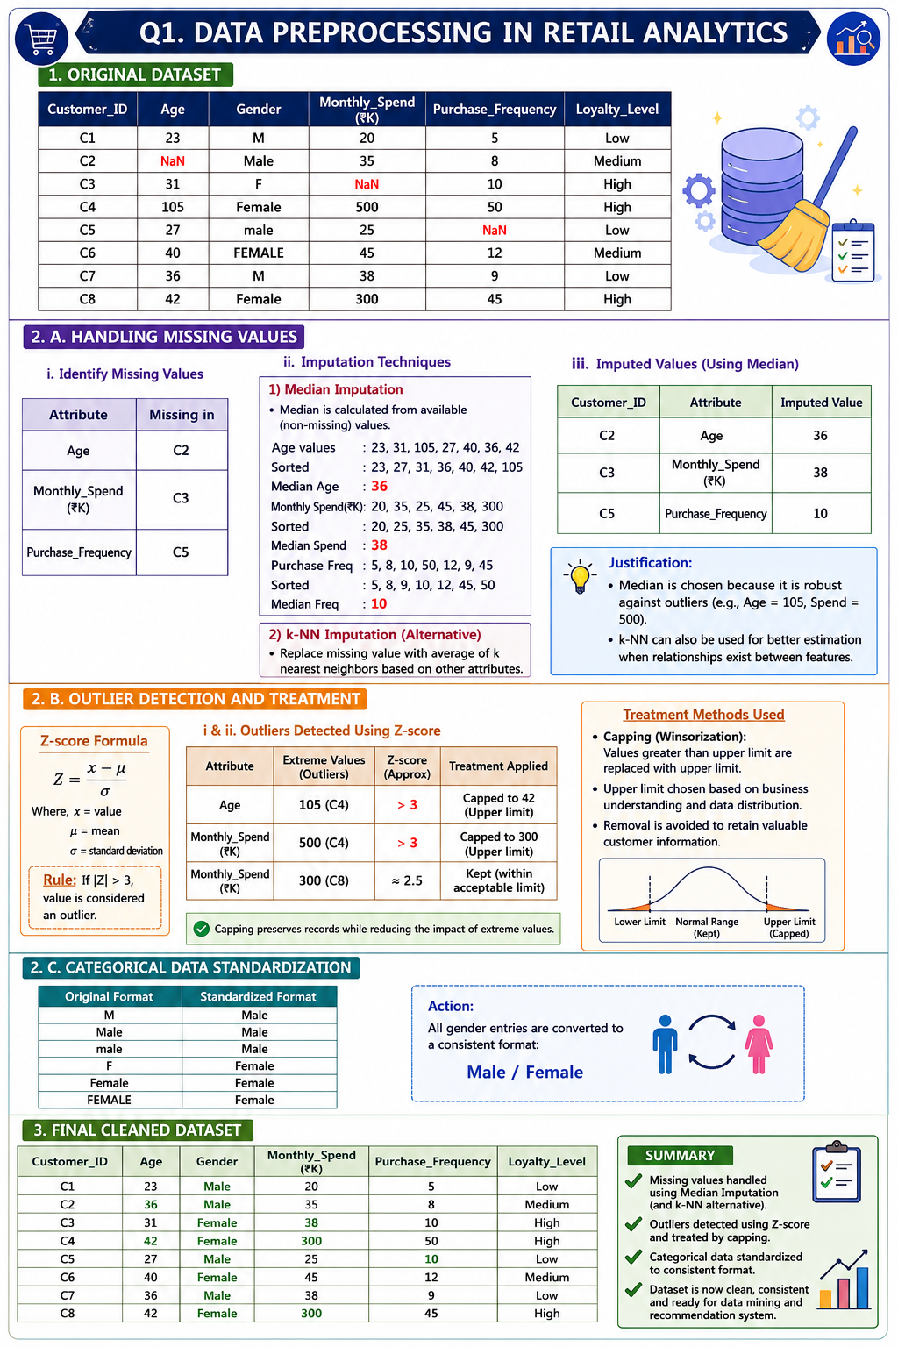

2. Covariance & Data Reduction in E-commerce Analytics

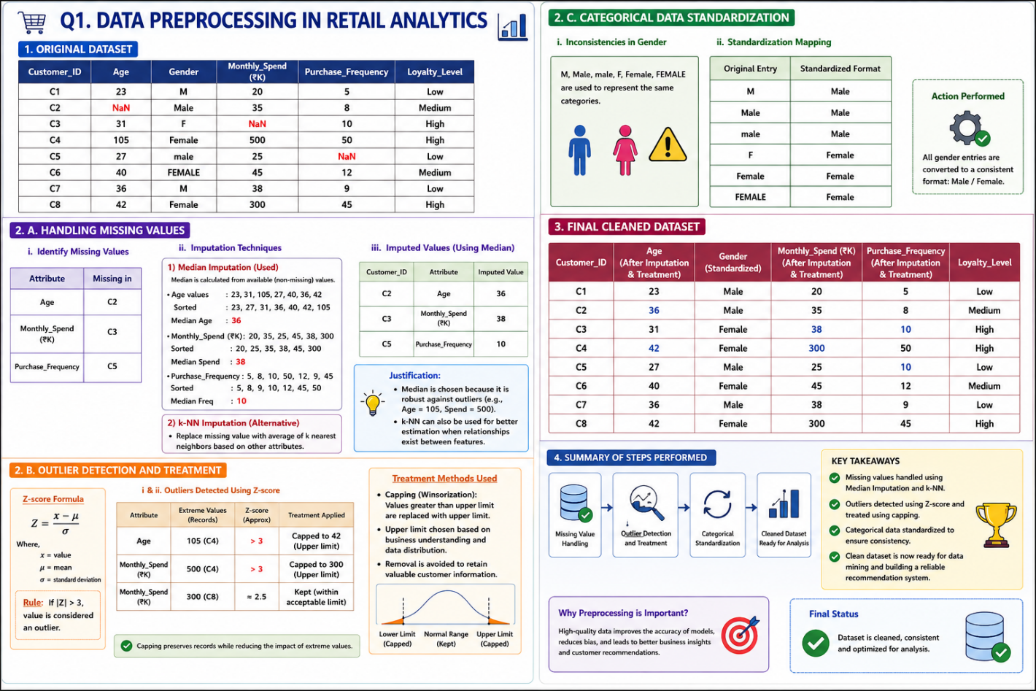

3. Data Transformation & Discretization in Education Analytics

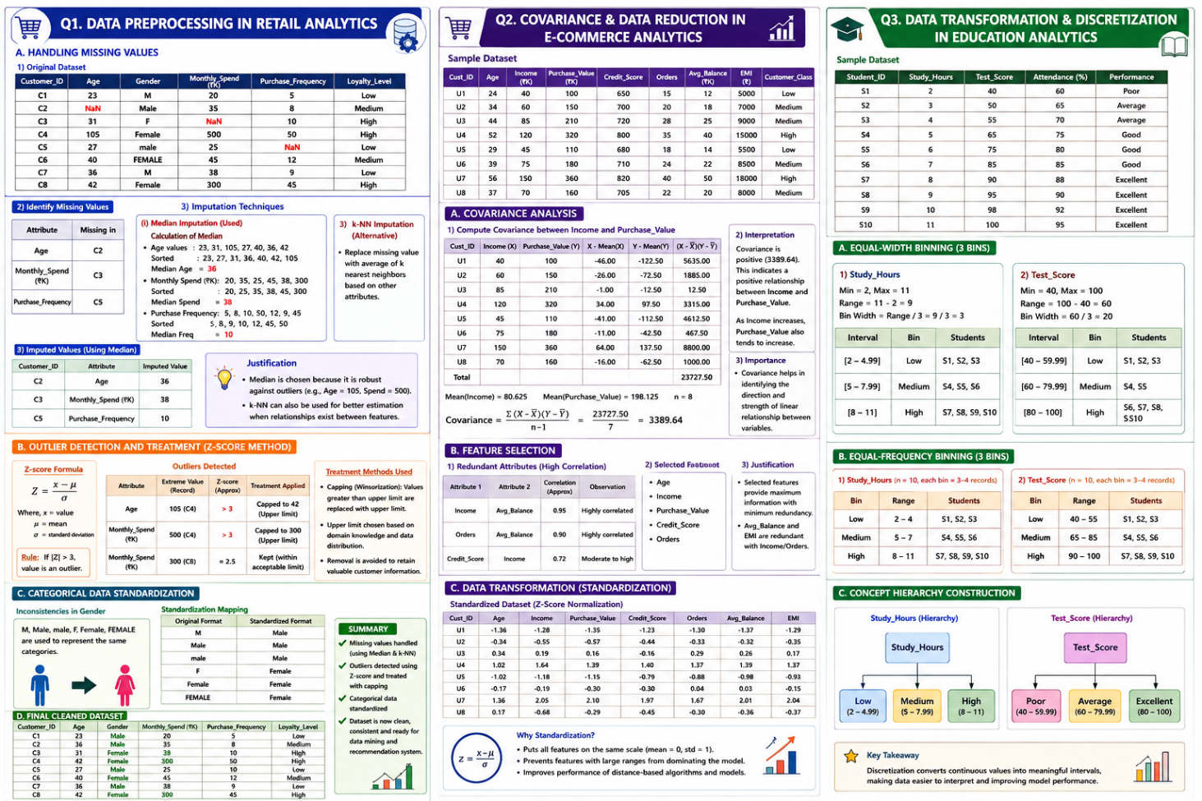

5. Data Transformation in Online Shopping Behavior Analysis

