SKILL 1 – IAM User Creation

- Search up IAM from search bar
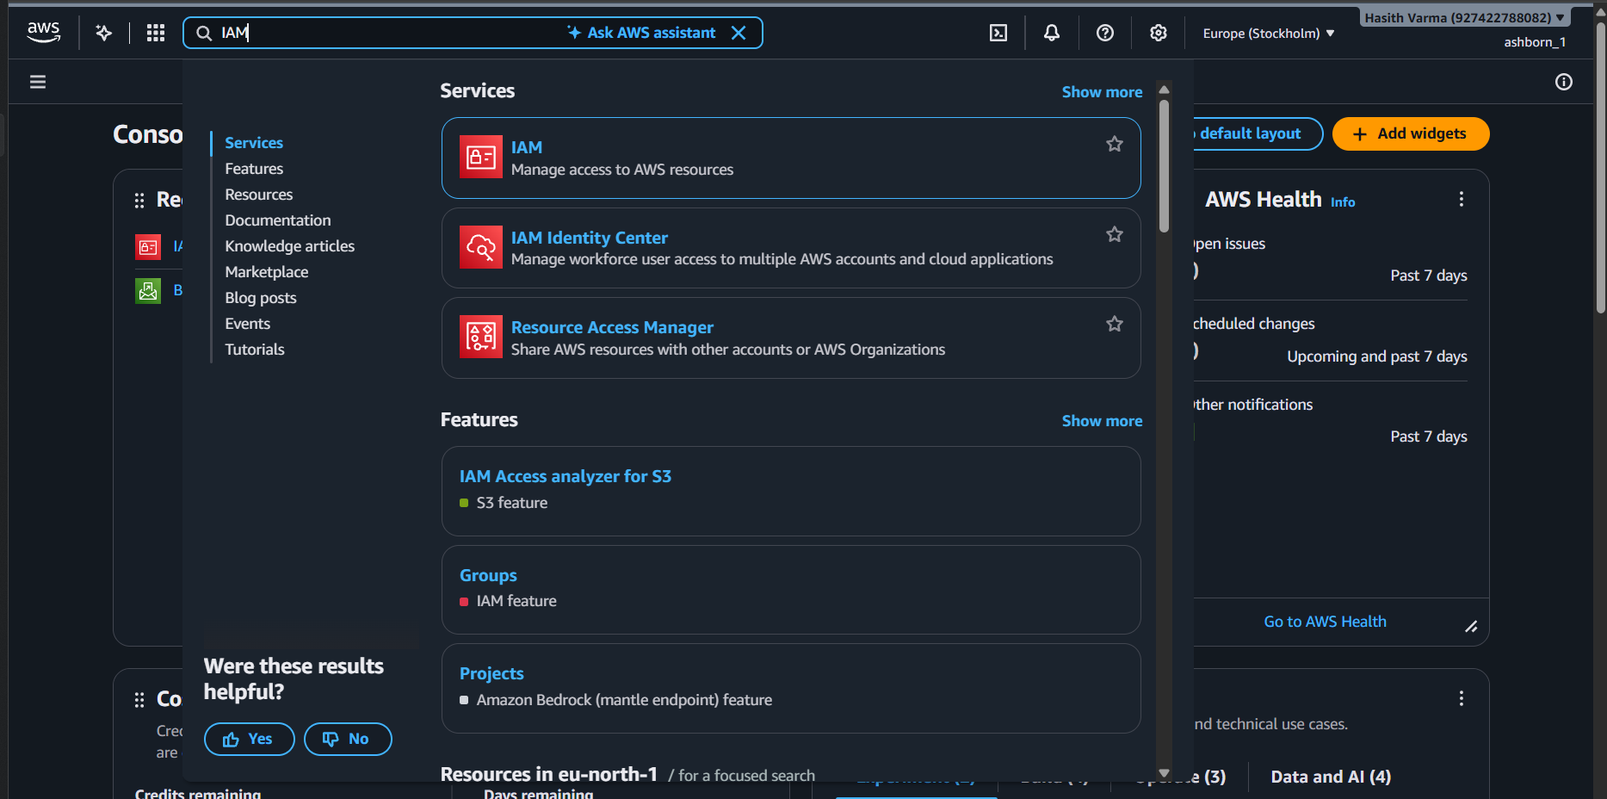
- Click on create user
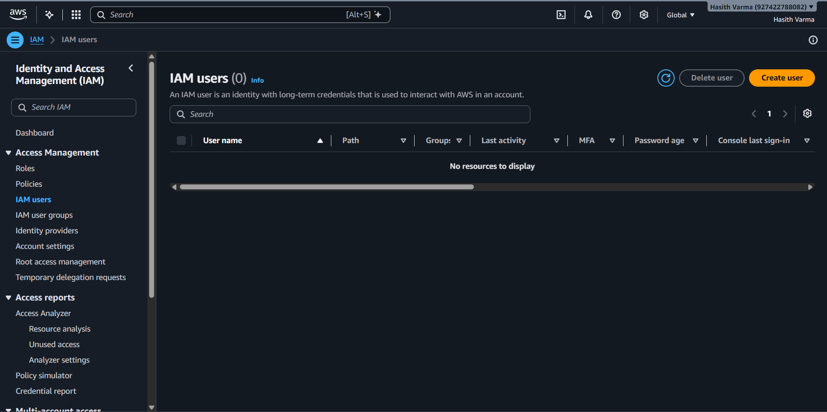

- Enter username and create a custom password
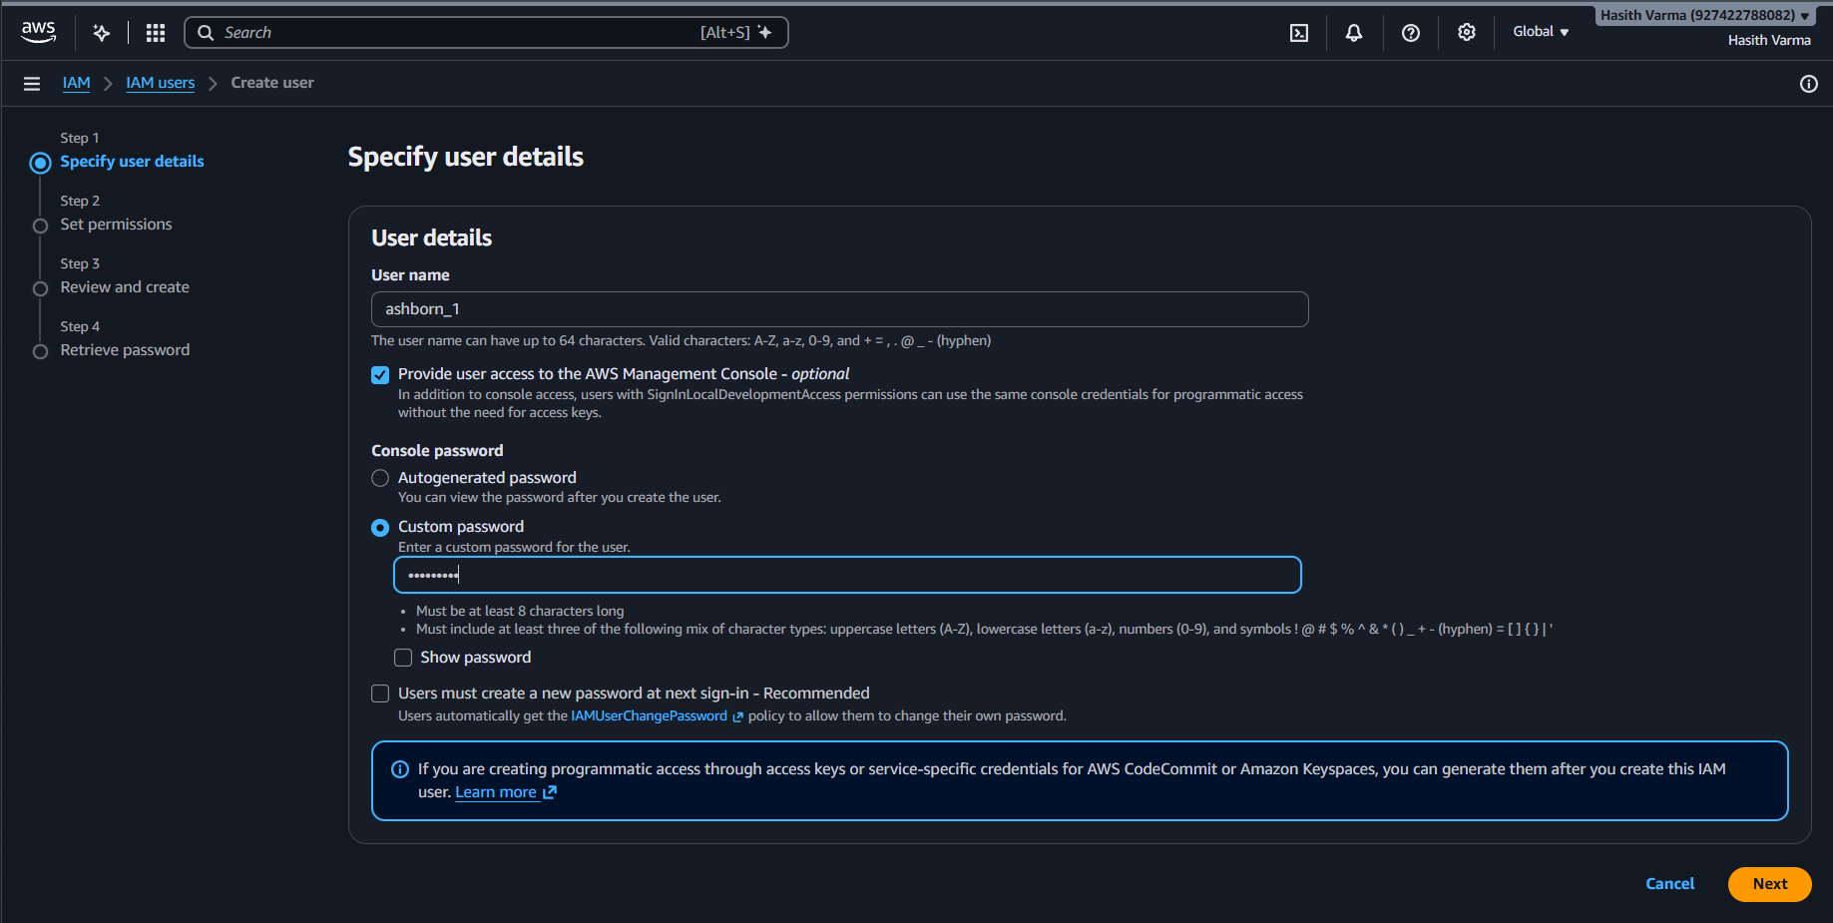
- Set permissions (AdministratorAccess)
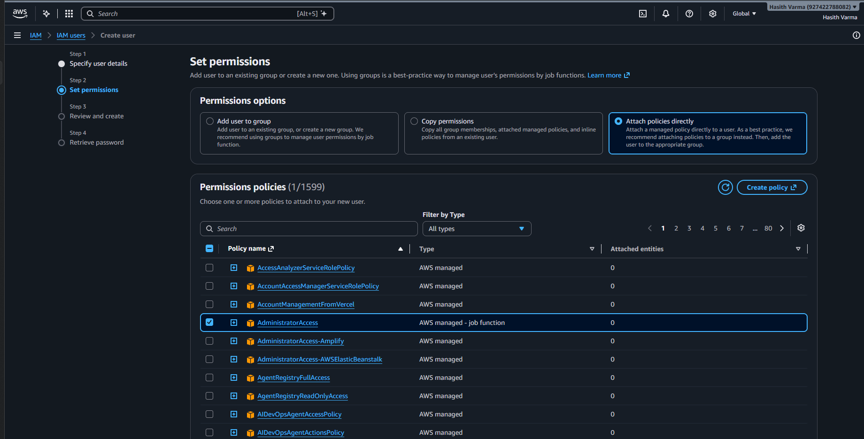

- Confirm User Details and create user
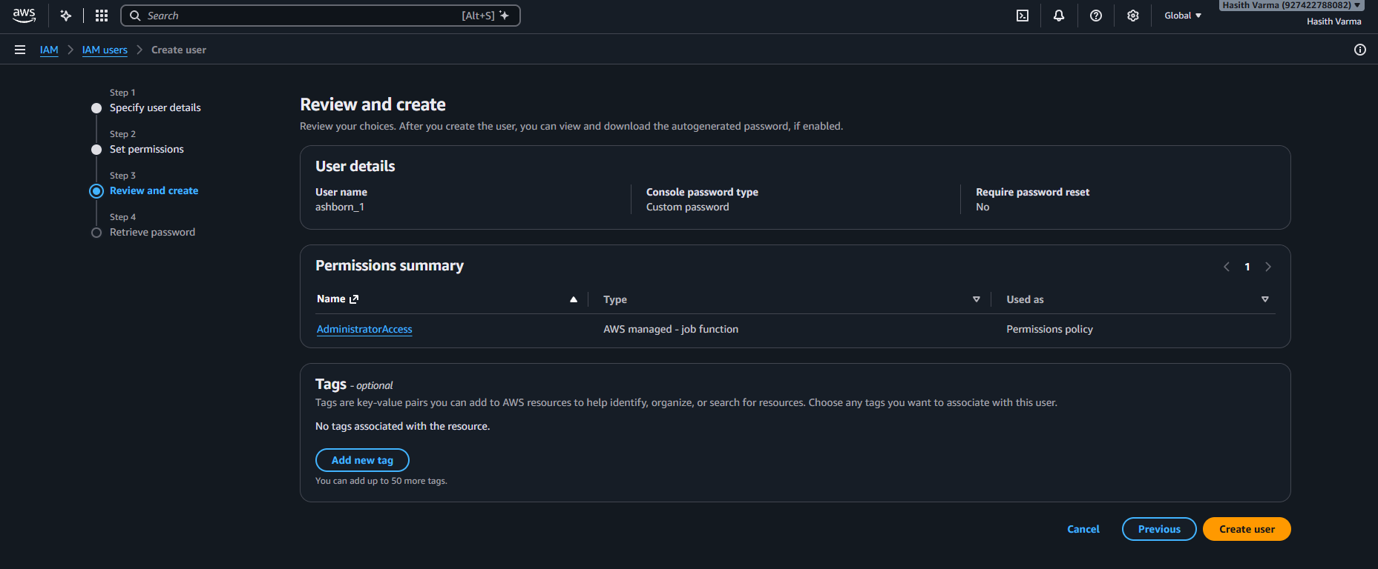
- User is Successfully created
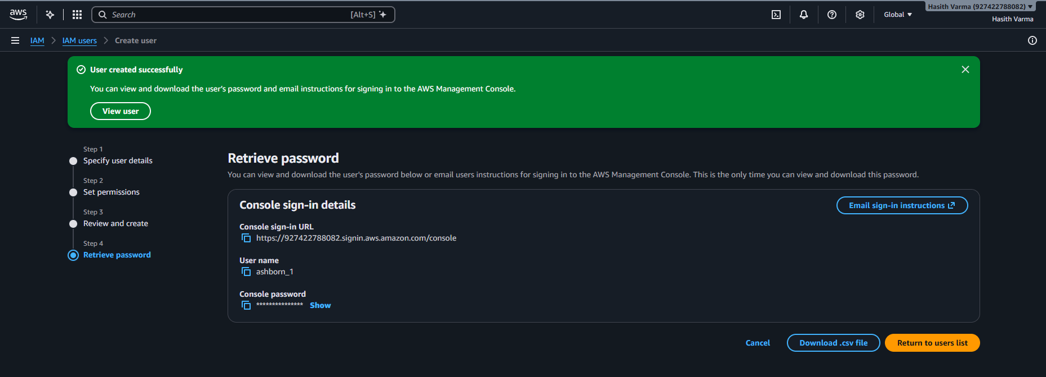

User URL Link:
https://927422788082.signin.aws.amazon.com/console

- You’ll be redirected to home page
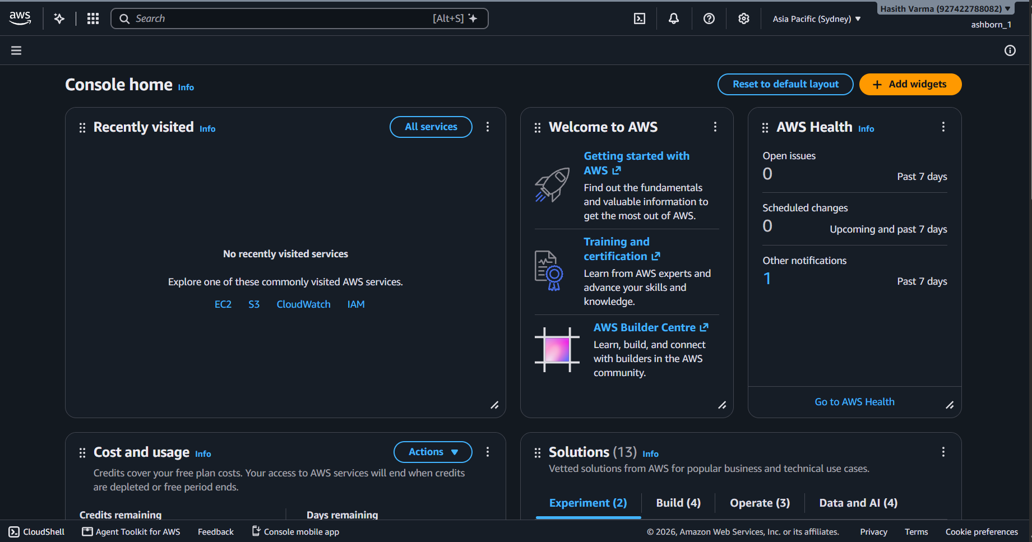
- Search up billing and go to ‘Billing and Cost Management’
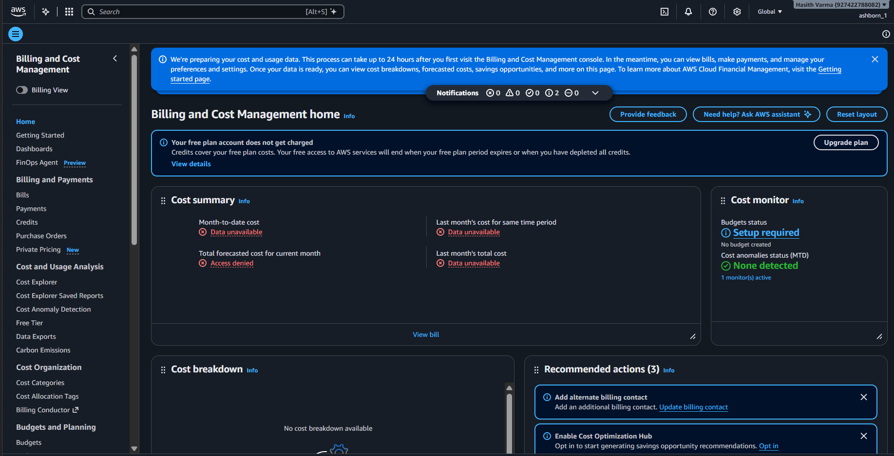

- Go to ‘Budgets’ from left dashboard and Create a budget
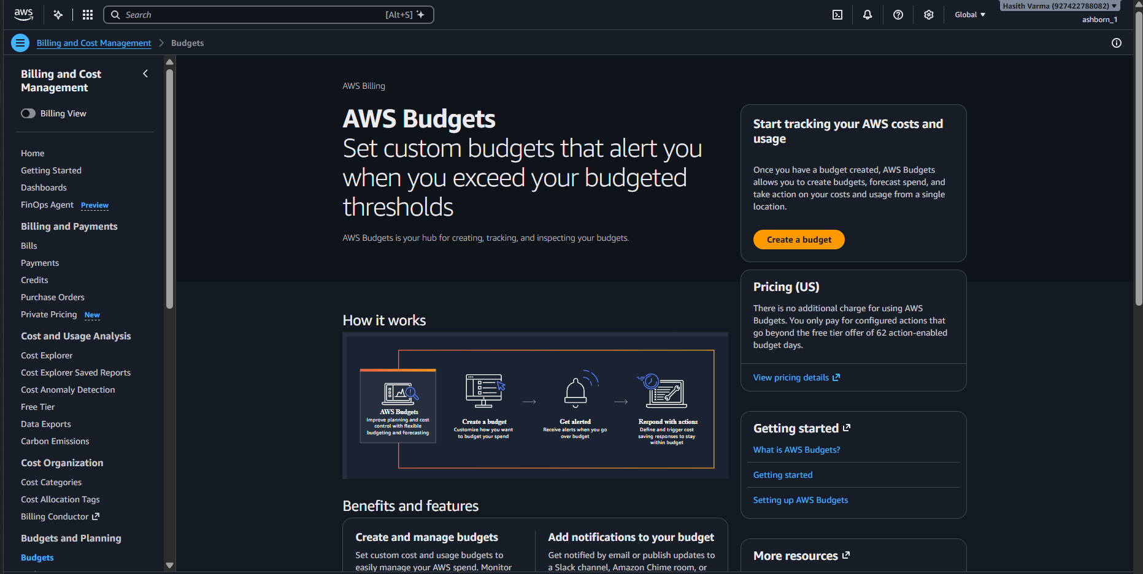
- Choose Custom
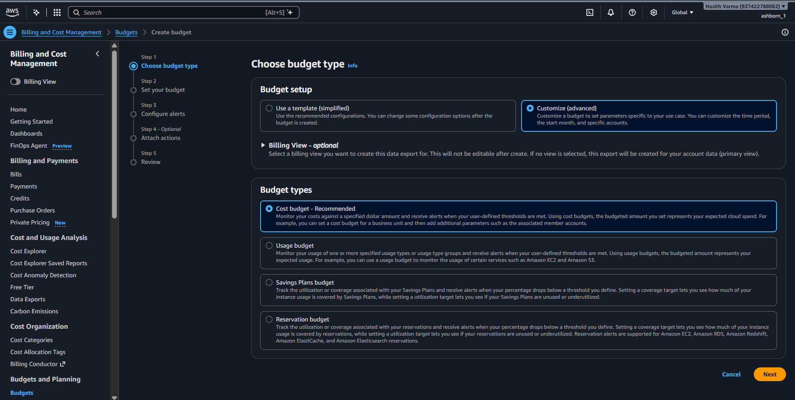

- Give budget name as ‘zero_budget’
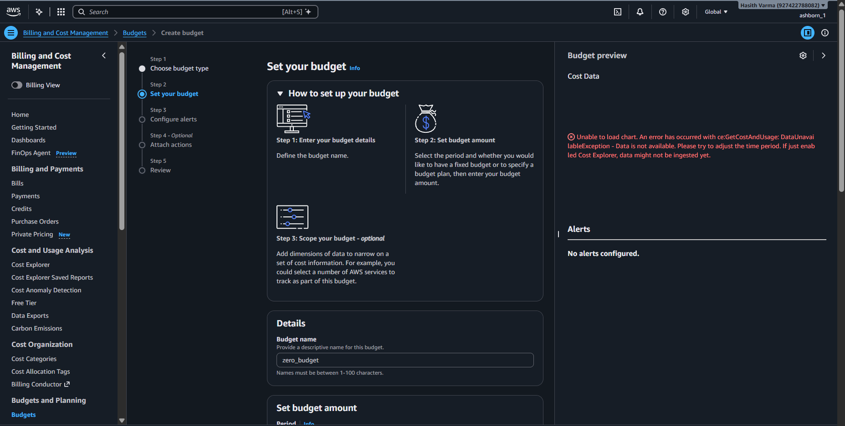
- Set the budget amount as 0.01
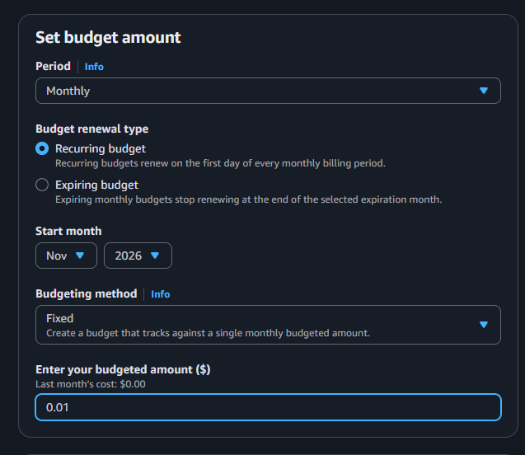

- Click on ‘Add an alert threshold’
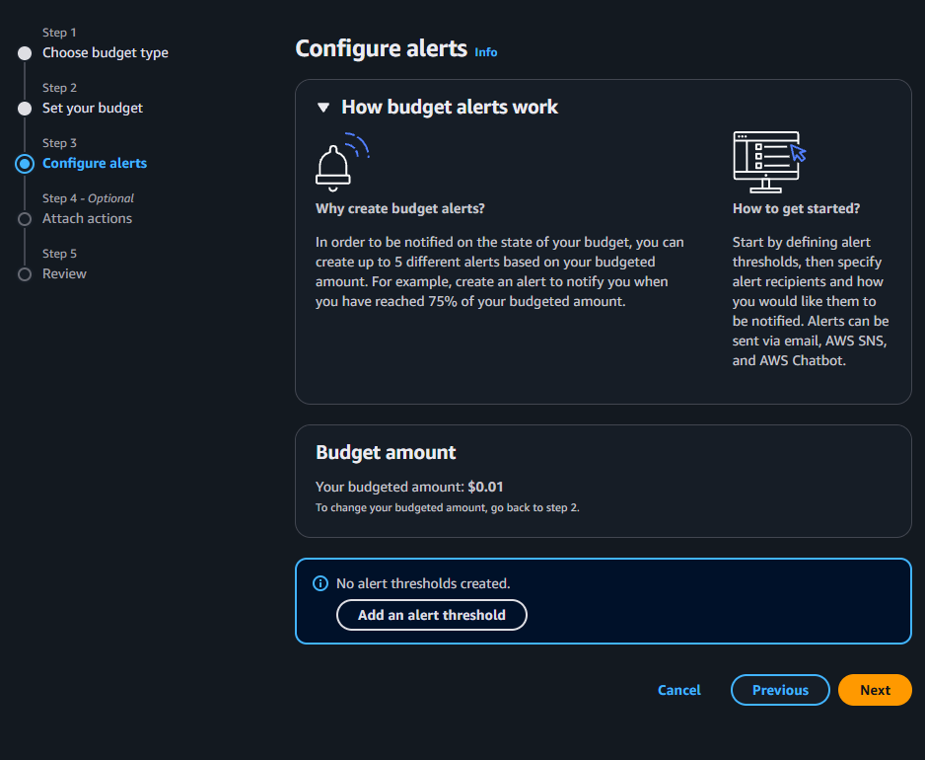

- Select 0 as threshold and enter your email
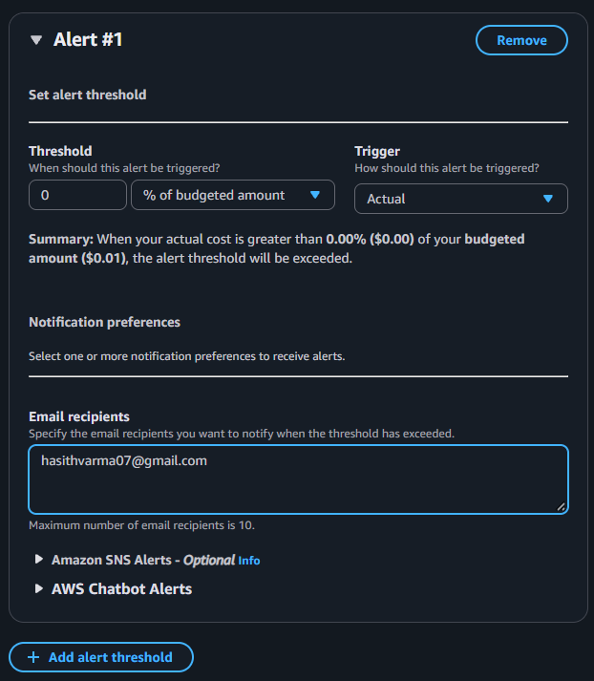

- Verify budget details and create the budget


