**Worksheet Team1 Demo**

**Steps to install VueJS**:

There are three ways to install Vuejs

To Read/Modify the Vue code install the Vscode editor. Download the editor from this website

<https://code.visualstudio.com/download>

1. Using CDN

* This link helps to write the code in Vue for small projects and learning purposes
* <script src=”https://cdnjs.cloudfare.com/ajax/libs/vue/2.6.10/vue.js”>

</script>

* This tag is used in the index.html so that you access the Vue components and its directives.
* Now the functionality of the code is written in the temperature-converter.js.
* Firstly, we need to declare the data for the model. Then, the anonymous functions are declared which converts the temperature from Celsius to Fahrenheit and vice-versa.
* Then the methods are declared that are called when the static data is changed which converts the given data into the required format as defined.
* Add styles to the CSS file for the project. After that open the HTML page in the browser you can find the Application of the temperature converter as shown below.
* As you as see the static data is already in bind with the variables declared. Whenever the area is changed, it directly reflects as it makes use of a two-way binding.

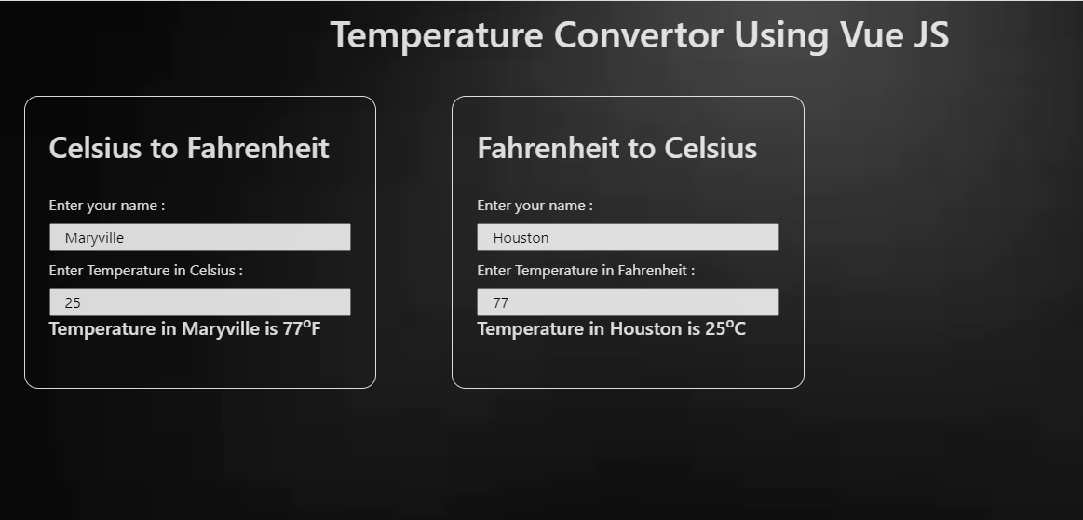

Temperature-Converter Application

1. Using npm

* We can install vue using the Node package manager in cmd.

**npm install vue**

1. Using Vue-CLI

* Vue provides an official CLI for fast structural support of optimistic single-page applications.
* It provides built-in libraries for a modern front-end workflow and takes only a few minutes to set up the components.
* Install Node.js before installing the Vue js. In Command prompt type
* **npm install -g @vue-cli**
* This command installs the vue in your system.
* To create the project type **vue create example-vue-project** in the cmd. It will ask you to select the default/manual mode to setup for the project and choose the default mode so that it will create the default folder structure of the vue.
* To run any project type **npm run serve** in the cmd. The server will be executed.
* We have developed basic-calculator in the vue-CLI and to run this project please follow these steps.
* Clone our repo from GitHub <https://github.com/thumula-akhitha/workshop-vue>

Open the project in vscode and type npm install in your terminal. Node_modules are added to the code.

* To run this project open the command prompt from the location where you saved this project. Type **npm run serve** in the cmd and the server will be running on the localhost: 8080. Open this address in the browser where you can see the application running.

