Kapture Finance
Collections Agent Voicebot — “Maya”
High-Level Design Document
AI Delivery Intern — Take-Home Assignment (Task 1)
Voice AI • Outbound Collections Agent • Vapi Build
August 2026
Scope note: this design targets one concrete scenario — an outbound EMI-reminder call to Rahul Sharma (personal loan, ₹8,499 overdue, 12 DPD) — but is written as a general pattern for early-stage (0–30 DPD), low-risk collections calls. Hardship, legal, and 60+ DPD cases are explicitly routed to a human agent rather than handled autonomously; see §6 and §7.
Companion artifacts: architecture diagram and state-machine diagram (embedded below, full-resolution versions attached separately); Task 2 Vapi system prompt, tool JSON schemas, and README are delivered as separate files referenced at the end of this document.

1. Overview & Design Principles
Maya is an outbound voice agent that calls customers with an overdue EMI, verifies their identity, discloses the purpose and amount, negotiates a resolution, and logs a disposition — without a human agent on routine, early-stage cases. Four principles drive every design decision below:
- State beats prompt. Anything safety- or compliance-critical (authentication, debt disclosure, opt-out) is enforced by deterministic code in the orchestrator layer, not left to the LLM's discretion inside a system prompt. The LLM chooses phrasing; the state machine chooses what is allowed to be said.
- Fail closed. If authentication is ambiguous, if a tool call fails, or if the model's output can't be validated against the current state's allowed actions, the bot defaults to withholding information and escalating — never to guessing in the customer's favor or the company's.
- Every call ends with a disposition. There is no code path that ends a call without a logged, structured outcome. This is what makes the system auditable and debuggable.
- Compliant by construction, not by reminder. Disclosure, calling-hour checks, and do-not-call handling are pipeline steps (checked before the call is even placed, and again inside the flow), not just prompt instructions hoping the model remembers.

2. Architecture & Pipeline
Standard telephony → STT → orchestrator/LLM → TTS voice pipeline, built on Vapi, with a thin deterministic layer (state machine + tool router) sitting between Vapi's model layer and the client's backend systems.
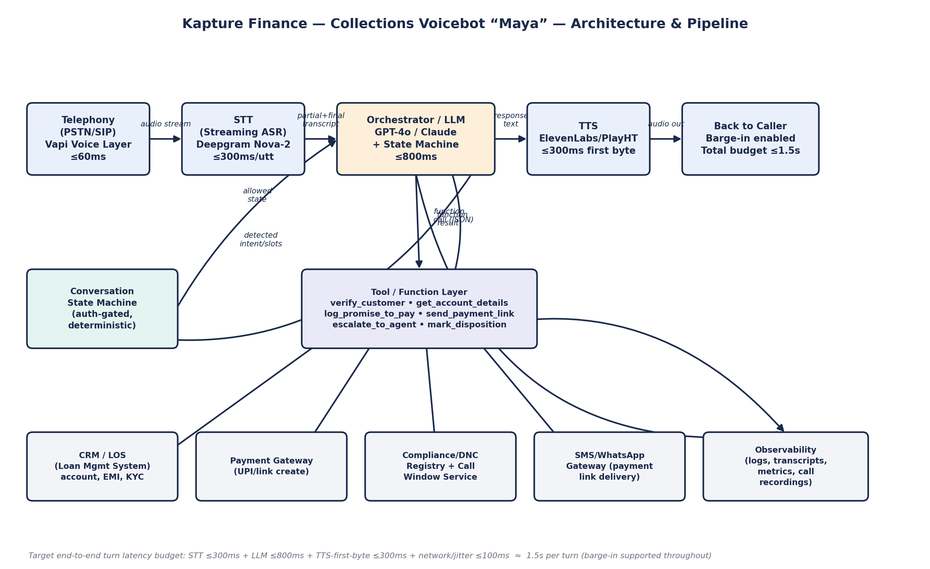

2.1 Component choices
Hop | Choice | Why
Telephony / voice orchestration | Vapi (managed) | Handles SIP/PSTN, call control, barge-in, and function-calling glue out of the box — matches Task 2 requirement.
STT | Deepgram Nova-2 (streaming) | Low-latency streaming transcription with good Hindi/English code-mixed support, which we need for the bilingual bonus and Indian names/numbers.
LLM / orchestrator | GPT-4o (or Claude) via Vapi, wrapped by an explicit state machine | Strong instruction-following and tool-calling; the state machine — not model choice — is what actually enforces auth-gating.
TTS | ElevenLabs (or PlayHT) — Indian-English/Hindi voice | Natural prosody at low first-byte latency; supports mid-call language switch for the Hindi bonus.
Datastore / backend | Client's CRM/LOS via REST tool calls (mocked for the demo) | The bot never stores or reasons over debt data itself — it always fetches fresh via a tool call, so verification and amounts can't drift or be hallucinated.

2.2 Latency budget per hop
Hop | Target budget | Notes
Telephony/jitter | ≤60 ms | Network + Vapi call-control overhead.
STT (per utterance) | ≤300 ms | Streaming partials shown to orchestrator continuously; final transcript triggers turn-taking.
LLM turn (incl. 1 tool call) | ≤800 ms | If a tool call is required mid-turn, budget includes it; tool timeouts (§4.3) protect this.
TTS first byte | ≤300 ms | Streamed synthesis; playback starts before full sentence is generated.
Total per conversational turn | ≈ 1.5 s | Above this, insert a filler (“one moment”) rather than dead air — dead air >2s reads as a dropped call to Indian customers on mobile networks.

3. Conversation Flow / State Machine
Authentication, disclosure order, and call-ending are all state-enforced: the orchestrator tracks the current state and only exposes the tool calls and response templates valid for that state to the LLM on each turn. The model cannot “talk its way” into an earlier disclosure because the disclosure content simply isn't in its context until the state transition fires.
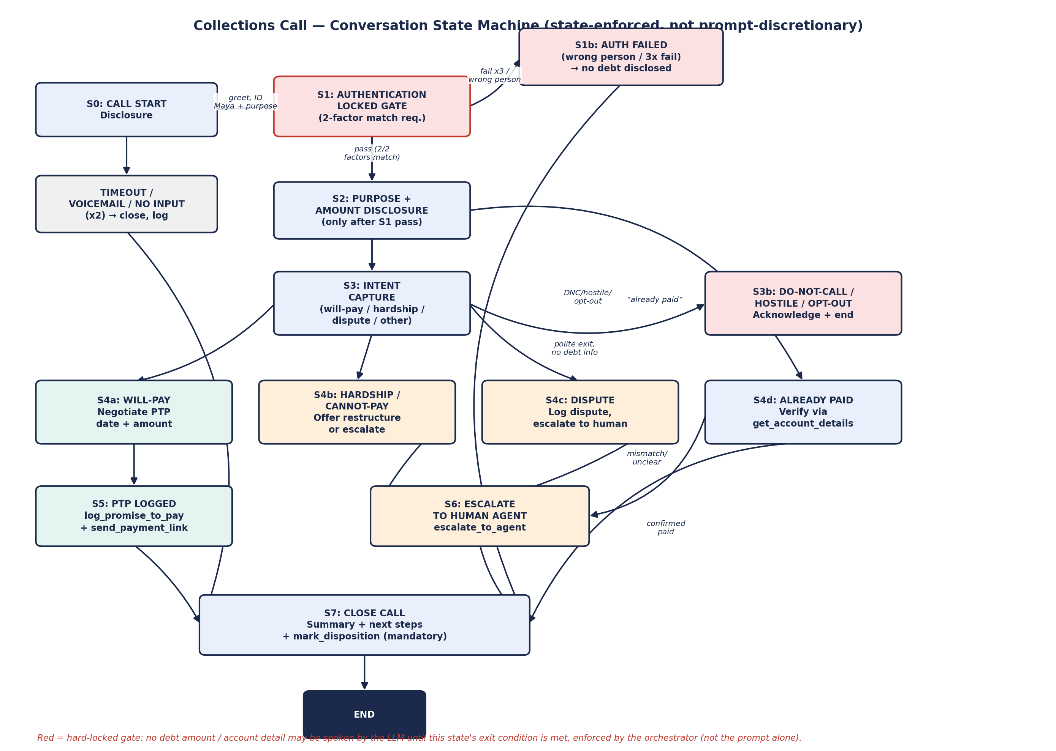

3.1 State table
State | Locked by | Exit condition(s)
S0 Call start / disclosure | — | Bot states name, company, recorded-line notice → always proceeds to S1.
S1 Authentication | verify_customer must return match=true on 2 of: DOB, last-4 loan/PAN digits, registered pincode | Pass → S2. Fail ×3 or wrong-person signal → S1b (no debt info given, polite exit).
S2 Purpose + amount disclosure | Can only be entered if session.authenticated == true (server-side flag, not a prompt claim) | Disclosure spoken → S3.
S3 Intent capture | — | Classified intent routes to S4a–d or S3b (DNC/hostile/opt-out).
S4a Will-pay | — | PTP date + amount captured → S5.
S4b Hardship / cannot-pay | — | Always → S6 (human agent); bot does not approve restructuring itself.
S4c Dispute | — | Always → S6; bot logs dispute detail but cannot adjudicate it.
S4d Already paid | get_account_details re-check | Confirmed paid → S7. Mismatch/unclear → S6.
S5 PTP logged | log_promise_to_pay must succeed before send_payment_link fires | → S7.
S6 Escalate to human | escalate_to_agent tool call | → S7 (bot still logs a disposition even when handing off).
S7 Close call | mark_disposition is mandatory — the call session cannot terminate without it | → END.

4. Intents & Entities

4.1 Intents
Intent | Trigger examples | Routes to
will_pay | “I'll pay today / by Friday” | S4a → capture PTP date & amount
cannot_pay_hardship | “I lost my job”, “medical emergency”, asks for restructuring | S4b → escalate (S6)
dispute_amount | “This isn't right”, “I already paid partial”, “charges are wrong” | S4c → escalate (S6)
already_paid | “I paid this yesterday” | S4d → verify via tool
wrong_person | “There's no Rahul here” / different DOB on auth attempt | S1b → close, no disclosure
callback_request | “Call me after 6pm”, “not a good time” | Schedule callback, S7 with disposition=callback
do_not_call | “Stop calling me”, “remove my number” | S3b → log opt-out, S7
hostile_abusive | Threats, sustained abuse | S3b → de-escalate once, then S6 or end per §6 policy
language_switch | Mid-call switch to Hindi or back | No state change — TTS/response language updates; state logic is language-agnostic
off_topic / out_of_scope | Unrelated questions (other loans, general banking) | One redirect attempt → if persists, offer callback with correct department

4.2 Entities extracted
- auth_dob, auth_last4_id, auth_pincode — spoken during S1, matched server-side, never echoed back verbatim.
- ptp_date, ptp_amount — structured (ISO date, decimal amount) before being passed to log_promise_to_pay.
- dispute_reason — free-text summary (bot paraphrases, doesn't transcribe verbatim, to keep the ticket clean for the human agent).
- callback_window — normalized day-part or datetime for callback_request.
- language_pref — en-IN / hi-IN, updated live on language_switch.

5. Tools / API Calls
All tools are synchronous REST calls from the orchestrator with a 2s timeout and 1 retry; on repeated failure the bot apologizes for a technical issue and either retries once more per call or escalates — it never fabricates a tool result.
Tool | Inputs | Outputs | Notes
verify_customer | phone_number, spoken_dob, spoken_last4, spoken_pincode | match: bool, match_factors: int, customer_id | Must return match on ≥2 factors to pass S1. Rate-limited to 3 attempts/call.
get_account_details | customer_id (post-auth only) | loan_id, product_type, emi_amount, dpd, last_payment_date, outstanding_balance | Callable only after session.authenticated==true — enforced server-side, so even a prompt-injected request can't fetch it early.
log_promise_to_pay | customer_id, loan_id, ptp_date, ptp_amount, channel='voicebot' | ptp_id, status | Idempotent on (loan_id, call_id) to avoid duplicate PTPs on retried turns.
send_payment_link | customer_id, loan_id, amount, channel ('sms'|'whatsapp') | link_id, delivery_status | Only fires after log_promise_to_pay succeeds, or on explicit already-paid-verification-needed flow.
escalate_to_agent | customer_id, call_id, reason (enum), transcript_summary | ticket_id, queue | reason enum: hardship, dispute, ambiguous_auth, abusive, tech_failure, customer_request.
mark_disposition | call_id, disposition (enum), notes | ack: bool | Mandatory before call teardown; disposition enum: ptp_made, escalated, already_paid, wrong_person, do_not_call, no_answer_voicemail, callback_scheduled, incomplete_tech_failure.
check_call_window / dnc_lookup | phone_number, timezone | allowed: bool, reason | Run before the call is dialed (pipeline guard) and re-checked if the call runs long.

6. Auth & Data Safety

6.1 Verifying identity before disclosure
- Two-factor voice verification: caller must match ≥2 of {date of birth, last 4 digits of loan/PAN reference, registered pincode} against verify_customer before any debt-related content is spoken.
- The check is enforced by a server-side session flag (session.authenticated), not by the LLM remembering to ask — get_account_details and all debt-disclosure response templates are simply unavailable to the model until that flag flips.
- 3 failed attempts → hard stop into S1b; the bot does not hint at what was wrong (avoids leaking which factor is close to correct).

6.2 Avoiding third-party disclosure
- S0 never states the loan purpose or amount — only “This is Maya calling from Kapture Finance for Rahul Sharma regarding his account, is this Rahul?”
- If the answerer identifies as someone else (spouse, colleague, wrong number), the bot moves straight to S1b: offers to call back, never states why it's calling or any amount.
- Voicemail detection: if the bot detects an automated greeting/beep, it leaves a generic callback-request message with no account or amount details, and logs disposition=no_answer_voicemail.

6.3 Data handling
- No PII is retained in the LLM's long-term context beyond the call session; verify_customer never returns the correct answers to the model, only a boolean match.
- Call recordings/transcripts are stored against call_id in the observability store (§9) with the same access controls as the CRM, and are the source of truth for QA — not model memory.
- send_payment_link never includes the outstanding balance or personal details in the SMS/WhatsApp body beyond what's needed to identify the loan — the link itself is behind further auth on the payment gateway.

7. Guardrails & Compliance
Guardrail | Implementation
Mandatory self/company/purpose disclosure | Hard-coded S0 opening line; call cannot proceed to S1 without it (not model-optional).
Permitted calling hours | check_call_window tool run before dialing (e.g., 8am–7pm local per RBI/industry fair-practice norms); calls outside window are not placed, regardless of queue priority.
No threats, pressure tactics, or harassment | System prompt explicitly bans urgency/shame language (“you must”, “this will hurt your credit forever”, repeated calling threats); tone is modeled as calm/respectful even under S3b hostility.
Opt-out / do-not-call handling | do_not_call intent → S3b, immediate acknowledgment, mark_disposition(do_not_call), and a downstream suppression flag set via the CRM tool so the number isn't dialed again.
Hallucination guardrails | The bot never states an amount, date, or account fact that didn't come from a tool response in this call; system prompt explicitly instructs it to say “I don't have that detail, let me have someone follow up” rather than guess.
Off-topic guardrails | One redirect (“I can only help with your EMI today”) then offer callback/transfer — the bot doesn't answer unrelated banking or general questions to avoid unauthorized-advice risk.
Recorded-line disclosure | Included in S0 opening line where required by local practice.
Single ask, no repeated pressure | If a customer declines a PTP twice, the bot does not re-ask a third time in the same call — it moves to callback_request or S6.

8. Edge Cases
Case | Handling
Already paid | S4d → get_account_details re-check; if system confirms paid, apologize for the call and close (disposition=already_paid); if unclear, escalate rather than argue with the customer.
Disputes the amount | Never argued live — bot acknowledges, logs dispute_reason, escalates to S6 for human review; does not attempt to “convince” the customer the amount is correct.
Requests do-not-call | Immediate compliance — S3b, no further collection attempt this call, suppression flag set.
Wrong number / wrong person | S1b — no purpose/amount disclosed, polite apology, call ends, number flagged for review before next attempt.
Voicemail / no input timeout | Two silence timeouts (e.g., 5s then 8s with a re-prompt) → if still no input, treat as voicemail/dead air, leave generic message or hang up per voicemail detection, disposition=no_answer_voicemail.
Abusive caller | One calm de-escalation attempt (“I understand this is frustrating”); if abuse continues, bot ends the call professionally and logs disposition=escalated / reason=abusive — it does not mirror hostility.
Mid-call language switch (EN/HI) | STT + LLM handle code-mixed input; TTS voice switches on detected language of the customer's last utterance; state machine itself is language-agnostic so no re-authentication is needed.
Customer asks bot if it's an AI | Bot discloses honestly — it does not claim to be human (also a compliance requirement in several jurisdictions).
Background noise / unclear STT | Low-confidence transcript → bot asks a clarifying question rather than acting on a guessed intent, especially before S1 passes.
Customer asks for a lower settlement amount | Bot is not authorized to negotiate the principal/waivers — logs the request and routes to S6, does not agree to a discount itself.

9. Escalation & Disposition

9.1 When to hand off to a human
- Hardship/restructuring requests (S4b) — always, since only a human can approve modified terms.
- Disputes (S4c) — always, since adjudicating a dispute isn't a voicebot decision.
- Ambiguous or failed authentication where the caller insists they are the customer (protects the customer from lockout without a human check).
- Abusive calls that don't de-escalate after one attempt.
- Any tool failure that blocks the flow (e.g., CRM lookup down) and can't be resolved with one retry.
- Explicit customer request to speak to a person.

9.2 Every call ends with a logged disposition
mark_disposition is the only way a call session can be torn down; there is no code path that ends the call without it. Disposition enum: ptp_made, escalated, already_paid, wrong_person, do_not_call, no_answer_voicemail, callback_scheduled, incomplete_tech_failure.

10. Observability

10.1 What's logged per call
- Full transcript (both languages) + audio recording, keyed by call_id.
- Every tool call made, its inputs/outputs, and latency.
- State-transition trace (S0→S1→…) with timestamps — this is what makes “can the bot be talked past auth?” testable after the fact, not just in theory.
- Final disposition and any escalation ticket_id.
- STT confidence scores on low-confidence turns, for tuning.

10.2 Metrics tracked
Metric | Why it matters
Containment rate (% calls resolved without human escalation) | Core efficiency metric — but must be read alongside compliance metrics, not optimized in isolation.
PTP rate & PTP-kept rate (actual payment vs. promised) | Business outcome; PTP-kept separates “bot got an agreeable answer” from “bot got a real commitment.”
Auth pass rate / auth-fail-to-S1b rate | Flags if legitimate customers are getting locked out (factor design too strict) or if the gate is too loose.
Average turn latency & p95 | Directly tied to the ≤1.5s budget in §2.2; regressions here hurt call quality fast.
Drop / hang-up rate by state | If customers hang up disproportionately at a specific state, that's a UX or trust problem in that state's script.
Escalation rate by reason | Tracks whether hardship/dispute volume is trending up, and whether “ambiguous_auth” escalations are a factor-design problem.
Do-not-call / opt-out rate | Compliance health signal.
Hallucination/guardrail-violation flags (from transcript QA sampling) | Directly tests the guardrails in §7 rather than assuming the prompt is sufficient.

11. Assumptions & Out of Scope
- Assumes India-based lending client under standard fair-practice collection norms (RBI-aligned tone/hours guidance); this is not written against a specific jurisdiction's legal text and would need a compliance review before production.
- CRM/LOS, payment gateway, and SMS/WhatsApp gateway are mocked for the Task 2 demo build; schemas above reflect what a real integration would need.
- Settlement/waiver negotiation, legal notices, and 60+ DPD / written-off accounts are explicitly out of scope for the autonomous bot and always route to a human (§9.1).
- Outbound dialing/campaign scheduling (who to call, in what order) is assumed to be handled upstream by a dialer/queue system — this design starts at “call connects.”
- Multi-lingual scope is limited to English and Hindi for this assignment; the architecture generalizes to more languages via STT/TTS locale swap.

12. Task 2 Companion Artifacts
Delivered alongside this HLD, implementing the design above on Vapi:
- vapi_system_prompt.md — the full system prompt implementing the state machine, disclosure order, negotiation logic, and closing/disposition.
- vapi_tool_schemas.json — JSON schemas for all 7 tools in §5, ready to paste into Vapi's function configuration.
- README.md — setup steps, model/voice/transcriber choices and why, what broke during testing and how it was debugged, and next-step improvements.

