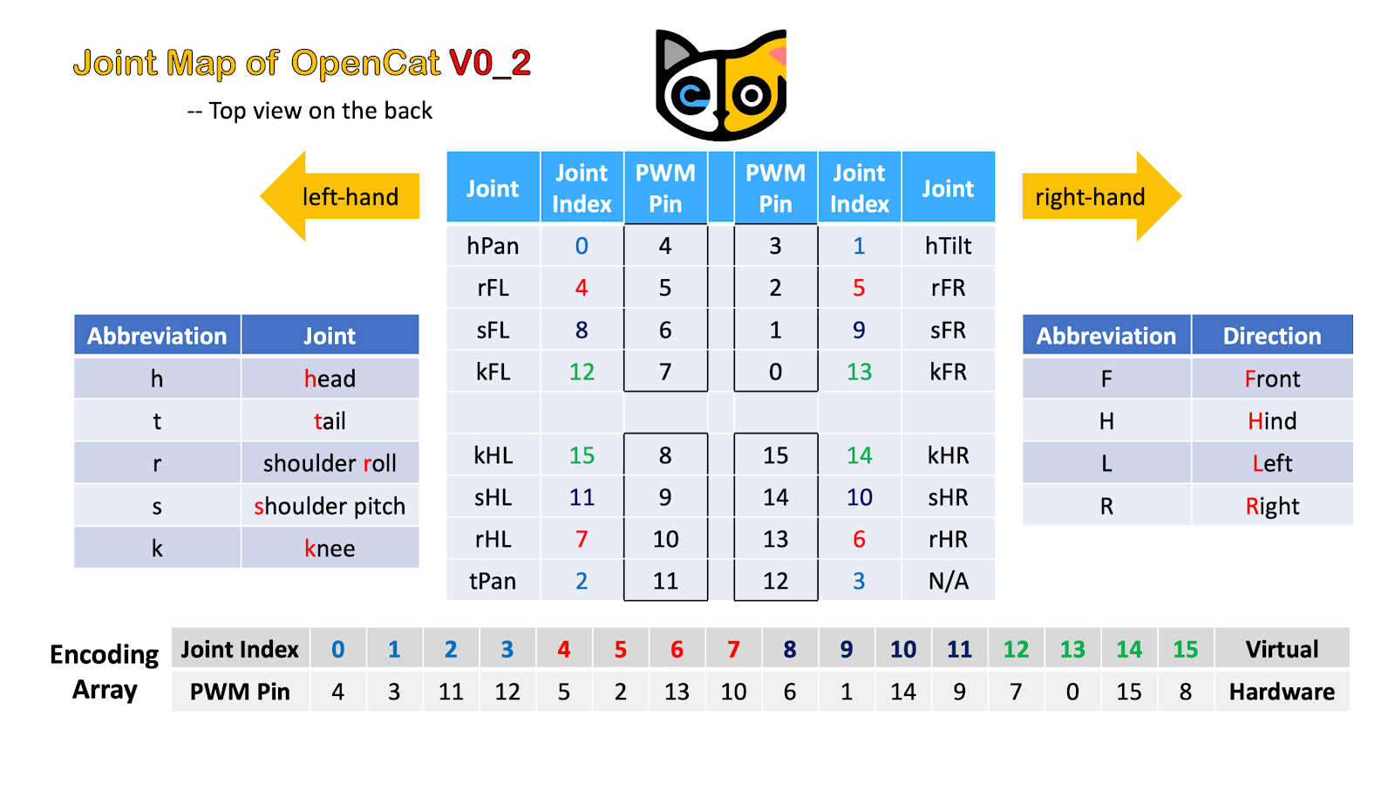

|  |  |  |  |  |
| --- | --- | --- | --- | --- |
|  | Original | | Mine | |
| Servo | Joint Idx | Pin | Joint Idx | Pin |
| Head Pan | 0 | 4 | 0 | 8 |
| Head Tilt | 1 | 3 | 1 | 9 |
| Shoulder Front Left | 8 | 6 | 8 | 0 |
| Knee Front Left | 12 | 7 | 12 | 1 |
| Shoulder Front Right | 9 | 1 | 9 | 2 |
| Knee Front Right | 13 | 0 | 13 | 3 |
| Shoulder Rear Left | 11 | 9 | 11 | 4 |
| Knee Rear Left | 15 | 8 | 15 | 5 |
| Shoulder Rear Right | 10 | 14 | 10 | 6 |
| Knee Rear Right | 14 | 15 | 14 | 7 |
| Tail Tilt | - | - | 3 | 11 |
| Tail Pan | 2 | 11 | 2 | 10 |

Joint Idx :

Head Pan 0

Head Tilt 1

Tail Pan 2

N/A 3

N/A 4

N/A 5

N/A 6

N/A 7

Shoulder Front Left 8

Shoulder Front Right 9

Shoulder Rear Right 10

Shoulder Rear Left 11

Knee Front Left 12

Knee Front Right 13

Knee Rear Right 14

Knee Rear Left 15

Tail Tilt - (Not present on the original nybble