  - CLOUD COMPUTING WITH BLOCKCHAIN

BlockPay
Complete Project Documentation
Cloud-enabled campus payments with blockchain-verifiable receipts

Project Detail | Information
Course | 21CSC653T - Cloud Computing with Blockchain
Project type | MERN web application with blockchain proof integration
Domain | Campus fintech / digital wallet / payment verification
Status | Working MVP with blockchain-style receipts; testnet anchoring proposed
Prepared by | Team members: ______________________________
Institution / Section | ________________________________________

One-line idea: BlockPay performs fast wallet operations in the cloud and creates a tamper-evident cryptographic receipt that can be independently verified through a blockchain smart contract.

Document based on the current repository implementation and accompanying architecture/API notes.

Contents
- 1. Executive Summary
- 2. Problem Statement and Objectives
- 3. Scope, Users and Features
- 4. System Architecture
- 5. How Cloud and Blockchain Are Connected
- 6. Complete Payment Workflow
- 7. Technology Stack
- 8. Frontend Design
- 9. Backend and API Design
- 10. Database Design
- 11. Blockchain Proof and Smart Contract
- 12. Security and Validation
- 13. Installation and Execution
- 14. Cloud Deployment Design
- 15. Current Limitations and Production Improvements
- 16. Benefits, Outcomes and Use Cases
- 17. Testing Checklist
- 18. Viva Preparation and Glossary

1. Executive Summary
BlockPay is a campus-focused digital wallet application built using MongoDB, Express, React and Node.js. It allows students to register, receive a demo INR wallet, transfer money using a username or QR code, request payments, split bills, manage friends, receive notifications and review transaction history. An administrator can view usage statistics and high-value demo transfers.
The project follows a hybrid architecture. Ordinary application data and wallet operations are kept off-chain in MongoDB for speed, privacy and lower cost. Each completed payment receives a unique reference ID and a SHA-256 hash. These proof values can be mirrored to the BlockPay Solidity contract, creating a permanent verification record without placing the complete private transaction on a public blockchain.
Key design decision: Use the cloud for operational processing and blockchain for integrity proof. Blockchain is not used as the primary database or as the source of wallet balances.

2. Problem Statement and Objectives

2.1 Problem Statement
Campus payments are commonly handled through cash, informal transfer messages or centralized wallet records. Users may find it difficult to independently prove that a particular transfer occurred, and a centralized database administrator could theoretically modify records. Students also need convenient ways to request money, divide group expenses and pay through QR codes.

2.2 Project Objectives
- Provide a simple campus wallet interface for student-to-student transfers.
- Generate a unique and tamper-evident receipt for every successful payment.
- Use cloud application services for availability, scalability and centralized business logic.
- Use blockchain only for compact proof storage and independent verification.
- Support QR payments, requests, split bills, notifications and searchable transaction history.
- Demonstrate a practical integration of cloud computing and blockchain.

2.3 Proposed Solution
A React client communicates with a Node.js/Express REST API. The API authenticates users, validates transfers, updates MongoDB wallet records, creates the cryptographic receipt and generates notifications. A Solidity smart contract provides createTransaction(), verifyTransaction(), getTransaction() and getAllTransactions() functions for storing and checking payment proofs.

3. Scope, Users and Features
User / Area | Capabilities
Student | Register, log in, view wallet, transfer, scan/generate QR, request money, accept/reject requests, split bills, manage friends, view alerts and history.
Administrator | View total users, completed payments, total volume, latest transfers and transfers of INR 5,000 or more as demo fraud alerts.
System | Validate input and PIN, update balances, create hash-linked receipts, store records and notify both payment participants.
Blockchain verifier | Compare a supplied payment ID and application hash with the proof recorded by the smart contract.

3.1 Functional Features
- JWT-based registration and login
- INR 10,000 opening demo balance
- Username-based transfers with PIN verification
- QR payload generation and parsing
- Payment requests and accept/reject actions
- Automatic per-person bill splitting
- Friends list and user search
- Notifications with read/unread state
- History filters: all, today, week and month
- Blockchain receipt with reference ID and 64-character SHA-256 hash
- Admin summary and simple high-value alerting

3.2 Out of Current MVP Scope
- Real bank or UPI settlement
- Production OTP/email delivery
- Automatic deployment of the Solidity contract
- Real testnet transaction submission from the API
- Database transactions for atomic double-entry settlement
- Comprehensive fraud detection, KYC or regulatory compliance

4. System Architecture
BlockPay uses a layered client-server design. The browser never accesses MongoDB or the blockchain directly. It sends authenticated HTTPS requests to the API, which acts as the trusted orchestration layer.
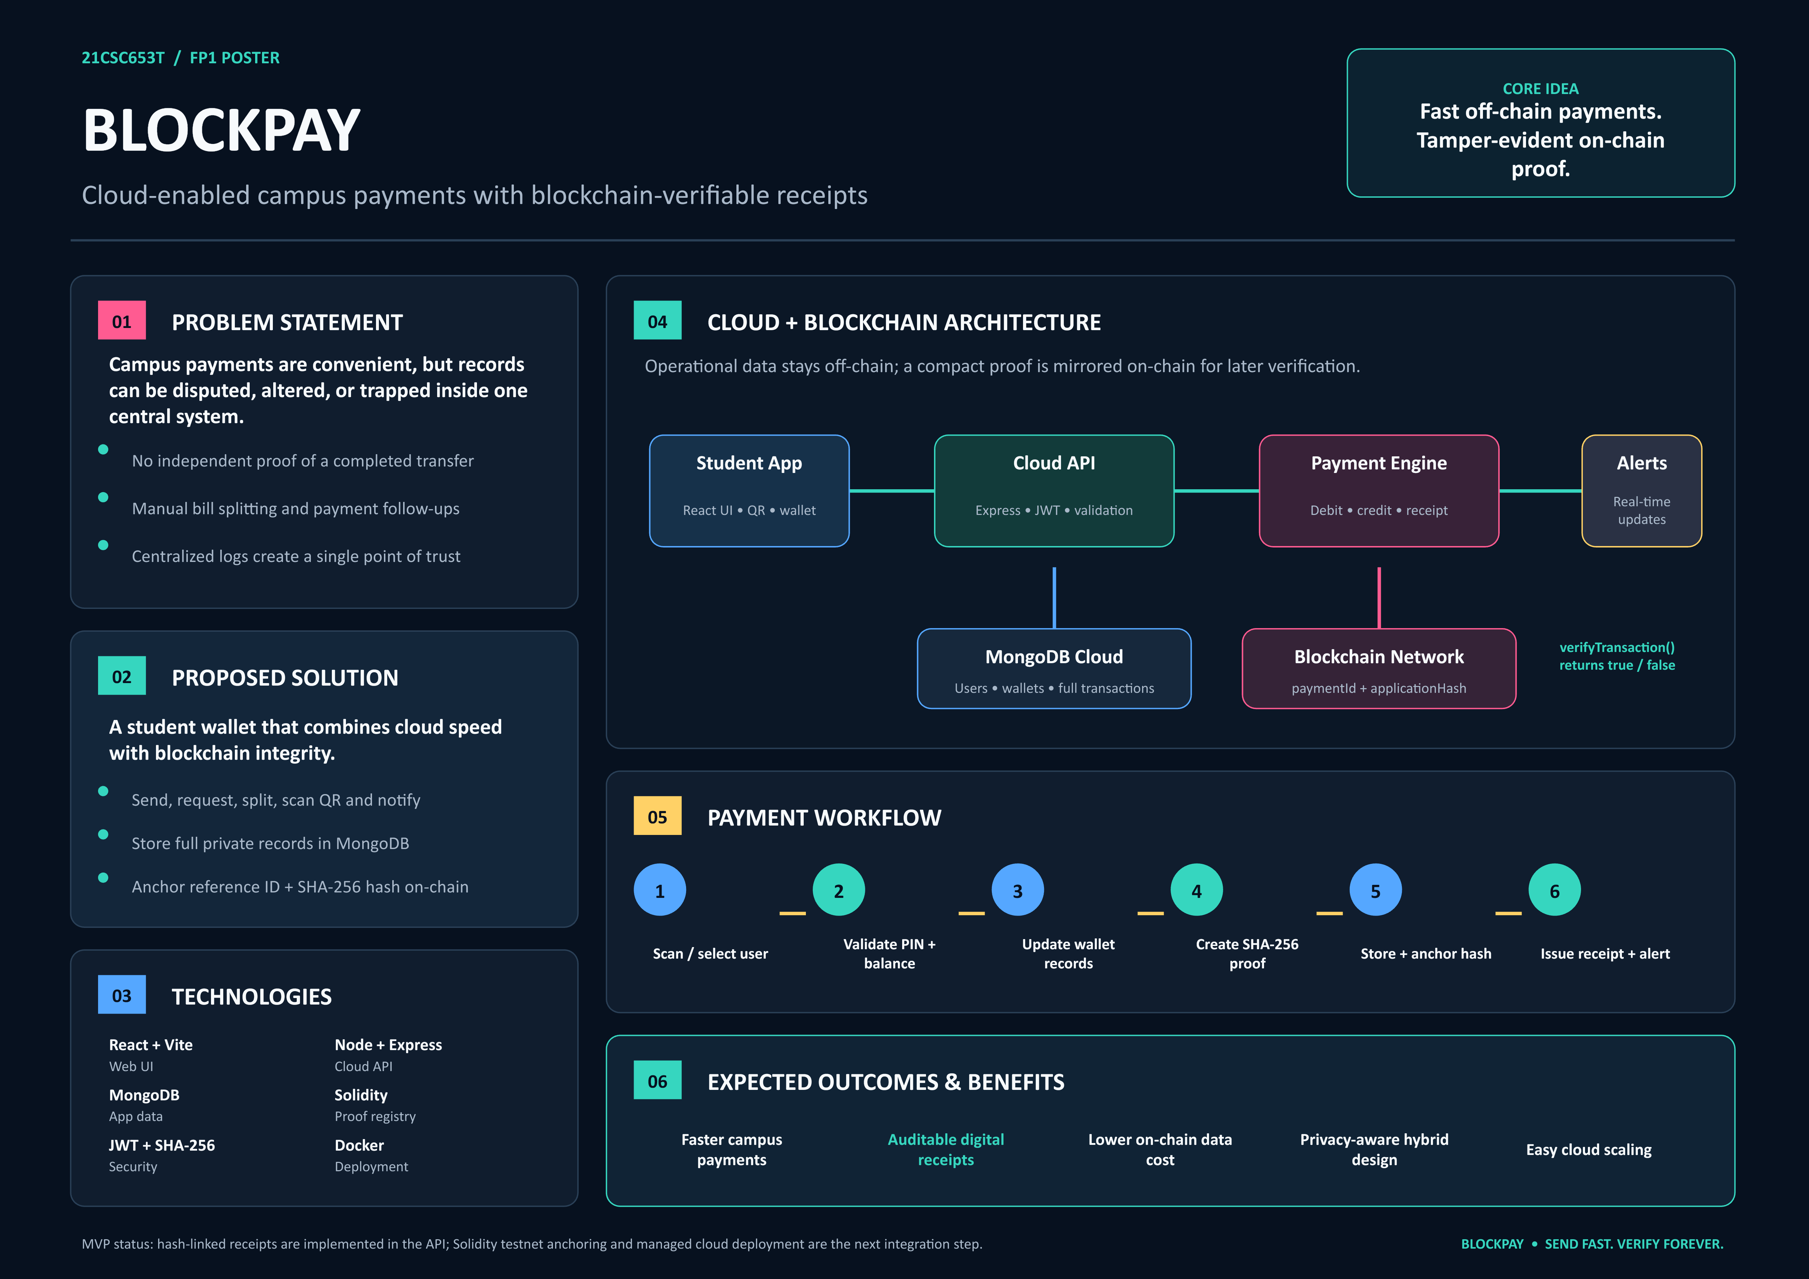
Figure 1. BlockPay hybrid cloud-blockchain architecture and workflow
Layer | Main Responsibility | Components
Presentation | User interface and interaction | React, Vite, CSS, Lucide icons, Recharts, qrcode.react
API / Application | Authentication, validation and business logic | Node.js, Express, controllers, middleware, services
Operational data | Private application state and queries | MongoDB, Mongoose models and indexes
Proof generation | Receipt ID, hash and previous-hash linkage | Node crypto SHA-256, UUID v7
Blockchain proof | Permanent proof registry and verification | Solidity BlockPay contract, Ethereum-compatible network
Infrastructure | Repeatable local or cloud deployment | Environment variables, Docker Compose for MongoDB

5. How Cloud and Blockchain Are Connected
The connection is based on an off-chain/on-chain proof pattern. The cloud application keeps all useful transaction details, while the blockchain keeps only the minimum data required to prove that a receipt existed and has not been substituted.
- The Express API receives and validates a payment request.
- MongoDB wallet balances are checked and the sender/receiver are identified.
- The API combines the reference ID, timestamp, usernames, amount, note and previous hash into a deterministic JSON payload.
- Node's crypto module calculates a SHA-256 application hash.
- The full transaction, hash, previous hash and reference ID are stored in MongoDB.
- In the proposed integrated deployment, the API submits paymentId and applicationHash to the Solidity contract.
- Later, verifyTransaction(paymentId, applicationHash) returns true only when the supplied proof matches the contract record.
Stored in Cloud / MongoDB | Stored on Blockchain
User identity and profile | Payment ID / reference ID
Wallet number and balance | Application SHA-256 hash
Sender and receiver references | Sender and receiver usernames in current prototype
Amount, note, status and timestamps | Amount and blockchain timestamp in current prototype
Requests, friends and notifications | Immutable TransactionCreated event

Current implementation status: The Node API already generates and stores hash-linked receipts. The repository includes the Solidity contract, but does not yet include a deployed contract address, Web3/Ethers client, signing wallet or automatic on-chain submission.

6. Complete Payment Workflow
- User selection - The sender searches by username or scans a BLOCKPAY_QR JSON payload.
- Request submission - The client posts username, amount, note and payment PIN to a protected API endpoint.
- Authentication - requireAuth verifies the Bearer JWT and loads the current user.
- Business validation - The API checks amount, receiver existence, self-payment, PIN and available balance.
- Balance update preparation - The sender balance is reduced and the receiver balance is increased in memory.
- Receipt generation - createProofPayload reads the latest transaction hash, creates a BP-prefixed UUID v7 reference and computes SHA-256.
- Persistence - A Transaction record is created, followed by saving both wallet records.
- Notifications - Payment received and payment sent notifications are created.
- Response - The populated receipt and updated sender wallet are returned to the React client.
- Blockchain anchoring - proposed - The API would submit the reference ID and hash to createTransaction() and retain the resulting blockchain transaction identifier.

7. Technology Stack
Category | Technology | How It Is Used
Frontend | React 18 | Component-based single-page user interface
Build tool | Vite 6 | Development server and frontend production build
Charts | Recharts | Spending pulse and data visualisation
QR | qrcode.react / qrcode | Browser display and server-side QR data URL generation
Icons | Lucide React | Consistent interface icons
Backend | Node.js + Express 4 | REST API and payment orchestration
Database | MongoDB 7 + Mongoose 8 | Persistent application data and object relationships
Blockchain | Solidity 0.8.24 | Smart-contract proof registry
Authentication | jsonwebtoken + bcryptjs | Signed JWTs and password/PIN hashing
Validation | Zod | Registration and login input validation
Security | Helmet + CORS | HTTP security headers and origin control
Identifiers / hashing | UUID v7 + Node crypto | Sortable receipt ID and SHA-256 proof
Logging / config | Morgan + dotenv | Development request logs and environment configuration
Local infrastructure | Docker Compose | MongoDB container with persistent volume

8. Frontend Design
The frontend is a React single-page application. AuthContext manages the authenticated user and token-related state, while services/api.js centralises communication with the REST API. App.jsx switches between feature views using local navigation state.
View | Purpose
Authentication | Login, registration and simulated forgot-password OTP
Dashboard | Balance, quick actions, personal QR, recent transfers and spending chart
Wallet / Send / Receive | Balance management and username/QR payment initiation
Scan | Parse a BlockPay QR payload and confirm a transfer
Requests / Split | Create, accept or reject requests; split a total among members
History | Filter transfers by all, today, week or month
Friends / Alerts | Maintain frequent contacts and manage notifications
Profile / Settings | Display or update identity details and payment QR
Admin | Show usage metrics and high-value demo transfers

9. Backend and API Design
The backend uses route-controller-service separation. Routes define endpoints and attach authentication. Controllers implement use cases. Services handle reusable blockchain receipt and notification logic. Mongoose models define persistence.
Route Group | Important Endpoints
/api/auth | POST register, login, forgot-password, logout; GET/PUT profile
/api/users | Search and user-related operations
/api/wallet | GET wallet/balance; POST transfer, deposit-demo, withdraw-demo
/api/transactions | GET history/receipt/requests; POST send, request, split, accept, reject
/api/friends | GET, POST and DELETE friend records
/api/notifications | GET notifications; mark one or all as read
/api/qr | POST generate and scan
/api/admin | GET summary
/api/health | Public service health check

API convention: Protected routes require the Authorization: Bearer <jwt> header. The local base URL is http://localhost:5000/api.

10. Database Design
Collection | Important Fields | Relationships / Rules
User | name, email, phone, passwordHash, username, avatar, collegeId, bio, pinHash, role | Unique email and username; text index for search; student/admin roles
Wallet | userId, balance, walletNumber | One wallet per user; balance minimum 0; unique wallet number
Transaction | senderId, receiverId, amount, note, status, hash, previousHash, referenceId, metadata | References two users; unique receipt ID; time-based sender/receiver indexes
PaymentRequest | requesterId, payerId, amount, note, status, splitGroupId | Pending, accepted or rejected; split requests share a group ID
Friend | userId, friendId, favorite | Unique pair index prevents duplicate friendships
Notification | userId, title, message, type, read | Belongs to a user and tracks read state

10.1 Entity Relationships
- A User owns one Wallet.
- A User can send and receive many Transactions.
- A User can create and pay many PaymentRequests.
- A User can have many Friend and Notification records.
- Transaction, PaymentRequest, Friend and Notification documents store ObjectId references to User.

11. Blockchain Proof and Smart Contract

11.1 Application Hash
The proof payload contains referenceId, timestamp, sender username, receiver username, amount, note and previousHash. JSON.stringify serialises the object, and crypto.createHash('sha256') generates a 64-character hexadecimal digest. The previousHash is copied from the latest stored transaction, producing a simple hash-linked sequence beginning with GENESIS.

11.2 Solidity Contract
Contract Element | Purpose
PaymentProof struct | Stores sender, receiver, amount, timestamp, paymentId and applicationHash
transactions array | Stores all proof records
transactionIndexByPaymentId | Finds a proof efficiently and prevents duplicate IDs
TransactionCreated event | Publishes an auditable proof-creation event
createTransaction() | Validates the ID and records a new proof
verifyTransaction() | Compares the stored and supplied application hashes using keccak256
getTransaction() | Returns one proof by payment ID
getAllTransactions() | Returns all proof records

Important distinction: SHA-256 creates the application receipt. Solidity uses keccak256 only to compare the two hash strings. The contract does not recalculate the original application transaction payload.

12. Security and Validation
Control | Implementation | Purpose
Password hashing | bcrypt with cost 12 | Avoid storing plain-text passwords
PIN hashing | bcrypt with cost 10 | Validate the demo payment PIN
Authentication | Signed JWT verified by middleware | Protect API endpoints and identify the caller
Input validation | Zod plus controller checks | Reject malformed registrations and invalid amounts
HTTP headers | Helmet | Apply common defensive response headers
Origin control | CORS allowlist and private-network development matching | Restrict browser origins
Access control | Participant/admin checks for receipts | Prevent unrelated users viewing a transaction
Proof integrity | SHA-256, unique reference ID and previous hash | Make receipt modification detectable
Data minimisation | Full details off-chain, compact proof on-chain | Reduce public exposure and gas usage

12.1 Security Gaps Before Production
- The fallback JWT secret is development-only and must be replaced.
- The demonstration PIN is 1234 and should be user-selected with retry limits.
- The OTP reset is simulated and returned in the API response.
- Wallet updates and transaction creation are not wrapped in a MongoDB session/transaction.
- Admin routes require explicit role middleware in production.
- Rate limiting, audit logging, CSRF strategy and stronger fraud controls are not implemented.

13. Installation and Execution

13.1 Prerequisites
- Node.js and npm
- MongoDB running locally or a MongoDB Atlas connection string
- Optional Docker Desktop for the provided MongoDB container
- A modern web browser
- For blockchain deployment: Hardhat or another Ethereum toolchain, RPC endpoint and testnet wallet

13.2 Local Setup
- Open a terminal in the BlockPay project root.
- Run npm install to install workspace dependencies.
- Create server/.env from the environment example if available.
- Start MongoDB locally, or run the MongoDB service from docker/docker-compose.yml.
- Set MONGO_URI, JWT_SECRET and CLIENT_URL in server/.env.
- Run npm run dev.
- Open http://localhost:5173. The API runs at http://localhost:5000.

13.3 Main Environment Settings
Variable | Meaning | Development Default
PORT | Express API port | 5000
MONGO_URI | MongoDB connection string | mongodb://127.0.0.1:27017/blockpay
JWT_SECRET | JWT signing secret | dev-only value; replace
CLIENT_URL | Allowed frontend origin | http://localhost:5173

14. Cloud Deployment Design
A production deployment can use any equivalent managed cloud services. The following mapping explains the required cloud roles without locking the project to one provider.
Cloud Role | Possible Service | Responsibility
Static web hosting | AWS S3 + CloudFront / Azure Static Web Apps / Vercel | Serve the compiled React application over HTTPS
API compute | AWS ECS, App Runner or Lambda / Azure App Service / Render | Run the Express API and scale requests
Managed database | MongoDB Atlas | Store users, wallets, receipts, requests and notifications
Secrets | AWS Secrets Manager / Azure Key Vault | Protect JWT secret, RPC URL and blockchain private key
Monitoring | CloudWatch / Application Insights | Logs, errors, latency and health alerts
Blockchain access | Alchemy, Infura or managed node RPC | Submit and query smart-contract transactions
CI/CD | GitHub Actions or cloud pipeline | Build, test and deploy client/API changes

14.1 Proposed On-chain Integration Components
- Deploy BlockPay.sol to an Ethereum-compatible testnet such as Sepolia.
- Add ethers.js or web3.js to the server.
- Store RPC URL, contract address and signing key as cloud secrets.
- After database settlement succeeds, submit createTransaction() asynchronously.
- Record blockchain transaction hash, block number and anchoring status in Transaction.metadata.
- Provide retry handling and show pending/confirmed proof status to the user.

15. Current Limitations and Production Improvements
Current MVP Limitation | Recommended Improvement
Demo INR balance; no banking rail | Integrate a regulated payment gateway or UPI sandbox
Wallet writes are sequential | Use MongoDB sessions and atomic transactions
Proof chain selects the latest record by createdAt | Use a dedicated ordered ledger sequence and concurrency control
verifyProof() only checks hash length | Recompute the payload hash and compare it; optionally confirm on-chain proof
Smart contract is not automatically called | Add server-side blockchain client, queue and confirmation tracking
Contract reveals usernames and amount | Store only a salted/commitment hash when privacy is important
Anyone can call createTransaction() | Add role-based contract access control
getAllTransactions() can grow expensive | Use events and pagination/indexing instead of returning an unbounded array
Admin summary lacks role protection | Require admin middleware and auditable access
No automated test suite | Add unit, integration, contract and end-to-end tests

16. Benefits, Outcomes and Use Cases

16.1 Expected Benefits
- Quick campus transfers with a familiar web interface
- Independent, tamper-evident receipt verification
- Lower blockchain fees because complete private records stay off-chain
- Improved privacy compared with publishing every application detail
- Scalable cloud API and managed database architecture
- Clear demonstration of hybrid cloud-blockchain engineering

16.2 Example Use Cases
- Splitting a restaurant or event bill among classmates
- Collecting club membership or activity contributions
- Paying a student for shared academic materials
- Requesting reimbursement for a group purchase
- Showing a verifiable receipt when a transfer is disputed

17. Testing Checklist
Area | Tests to Perform
Authentication | Register valid/duplicate users; login success/failure; expired token; protected route without token
Wallet | Valid transfer; insufficient balance; wrong PIN; self-transfer; missing receiver; invalid amount
Receipt | Unique reference ID; 64-character hash; correct previousHash; receipt participant access
Requests | Create, accept, reject, repeated action and unauthorised payer
Split bill | One/many members, unknown usernames, rounding and notifications
QR | Valid payload, invalid type, malformed JSON and optional amount/purpose
Database | Unique indexes, required fields, populated references and date filters
Contract | Create proof, duplicate ID rejection, correct/incorrect hash verification and unknown ID
Cloud | Health check, CORS, secret injection, logs, restart behaviour and database backup

18. Viva Preparation and Glossary

18.1 Short Viva Answers
Why not store every payment completely on blockchain?
It would expose more data, cost more gas and reduce application speed. The hybrid design stores private operational data in the cloud and only the verification proof on-chain.
How is blockchain integrated?
The API creates a payment hash and reference ID. The proposed integration sends those values to the Solidity contract, where they can later be verified.
What does the cloud provide?
Application hosting, API compute, managed MongoDB, secrets, monitoring, scaling and availability.
What makes a receipt tamper-evident?
Changing any hashed payment field changes its SHA-256 digest. The previous-hash link and an on-chain copy make silent substitution detectable.
Is this real money?
No. The current repository uses demonstration INR balances and simulated deposit, withdrawal, PIN and OTP flows.
What is the main production improvement?
Use atomic database transactions and connect the API to a deployed contract through a secure asynchronous anchoring service.

18.2 Glossary
Term | Meaning
Cloud computing | On-demand compute, database, storage, networking and monitoring services accessed over the internet
Blockchain | A distributed ledger where confirmed records are difficult to alter
Off-chain | Data or processing handled outside the blockchain
On-chain | Data recorded through a blockchain transaction
Hash | Fixed-size digest used to detect changes in data
Smart contract | Program deployed and executed on a blockchain
JWT | Signed token used to carry authenticated user identity
REST API | HTTP interface through which the client requests server operations
MERN | MongoDB, Express, React and Node.js
Gas | Fee paid for computation and storage on an Ethereum-compatible blockchain

Repository Reference
This documentation was prepared from the repository's README, docs/Architecture.md, docs/API.md, docs/ERD.md, server and client source files, Docker Compose configuration and contracts/BlockPay.sol. No external claims are required to understand the implemented MVP.

