A Project Report on
MULTI-TASK DEEP NEURAL NETWORK FOR EMERGENCY MESSAGE PRIORITY AND SEMANTIC-LOSS TOLERANCE PREDICTION IN UAV NETWORKS

submitted in partial fulfilment of the requirements for the course

MACHINE LEARNING
25SC2107E

in

A.Y.: 2026-27

by

T. Sree Chandana 2520040030

R. Sameera 2520040119

K. Joshita 2520040037

Under the Esteemed guidance of

Mr. N Lava Prasad

Assistant Professor,

Department of ECE





DEPARTMENT OF ELECTRONICS & COMMUNICATION ENGINEERING

Abstract:

Unmanned Aerial Vehicle (UAV) networks are widely used in emergency and disaster situations where fast and reliable communication is important. However, limited bandwidth, network congestion, packet loss, and unstable connectivity can make it difficult to transmit all messages efficiently. Conventional rule-based and machine-learning approaches can classify messages based on their importance, but they may treat related communication tasks separately and may not effectively determine how much information a message can lose while preserving its meaning. This project proposes a Multi-Task Deep Neural Network (MT-DNN) to address these challenges by performing two tasks simultaneously: emergency message priority classification and semantic loss tolerance classification. The first task categorizes messages as Low, Medium, or High priority, while the second determines whether a message can tolerate Low or High information loss while retaining its important meaning.

The proposed model uses shared neural-network layers to learn common patterns from message and network-related features, followed by separate output layers for the two tasks. Traditional ML algorithms such as Logistic Regression, Random Forest, and XGBoost can be used as baseline methods for comparison. The main advantage of the proposed approach is its ability to learn both related tasks within a single model, supporting more efficient use of limited UAV communication resources. However, the model requires sufficient training data, careful parameter tuning, and proper balancing of the two tasks. The system will be evaluated using accuracy, precision, recall, F1-score, and confusion matrix. Overall, the project aims to intelligently prioritize critical emergency messages and identify messages that can tolerate greater information loss in resource-constrained UAV networks. This approach can help reduce unnecessary data transmission, minimize communication delays, and improve bandwidth utilization during situations. By considering both message importance and semantic tolerance, the system can support smarter resource allocation and more reliable information delivery, especially when network conditions are constrained.

Signature of the Supervisor Course Instructor

INDEX
Chapter / Section | Page
Abstract | ii
1. Introduction | 1
2. Problem Statement and Motivation | 2
3. Objectives | 3
4. Literature Survey | 4
5. System Model | 6
6. Exploratory Data Analysis | 8
7. Feature Selection and Target Construction | 9
8. Proposed Methodology | 10
9. MT-DNN Architecture | 11
10. Implementation Details | 12
11. Training and Evaluation | 13
12. Results and Discussion | 14
13. Baseline Comparison | 15
14. Sample Prediction and Interpretation | 16
15. Limitations | 17
16. Future Scope | 18
17. Conclusion | 19
18. References | 20

1. Introduction

Unmanned Aerial Vehicles (UAVs) are increasingly used for disaster response, surveillance, search-and-rescue operations, monitoring, and communication support. In emergency situations, UAV networks may need to exchange information when communication resources are limited or when conventional infrastructure is unavailable. The quality and usefulness of communication can depend on network conditions such as link stability, available data rate, distance between UAVs, mobility, and signal quality.
When different types of emergency information are transmitted through a constrained UAV network, treating every message in the same way can lead to inefficient use of available resources. A critical emergency message may need to be delivered with higher priority, while another message may remain useful even if some information is lost. This creates two related communication questions: how important is the message, and how much information can it lose while retaining its important meaning?
The proposed project addresses these questions using a Multi-Task Deep Neural Network (MT-DNN). The architecture learns a shared representation from selected UAV network features and then uses separate output branches for the two predictions. The first branch classifies emergency-message priority as Low, Medium, or High. The second branch classifies semantic-loss tolerance as Low or High.
The experimental study uses the FANET Dataset: UAV Communication Scenarios in NS-3.40, with Scenario 1 selected for the present implementation. The available data contains network and mobility measurements that can be used to explore relationships between UAV communication conditions and the two project-defined prediction tasks. Ten selected features are used as model inputs, while link lifetime and SNR are used to construct proxy targets.

1.1 Report organization
The report first explains the problem and motivation, followed by the project objectives and scope. It then reviews relevant multi-task learning and UAV communication literature and identifies the research gap. The dataset, exploratory analysis, feature selection, target construction, proposed methodology, MT-DNN architecture, implementation, training, evaluation, results, limitations, future scope, and conclusion are then presented in sequence.

2.Problem Statement and Motivation
2.1 Problem statement
UAV networks used in emergency and disaster environments operate under limited and changing communication resources. Network congestion, packet loss, unstable wireless links, changing UAV distance, mobility, and variations in data rate can affect the timely delivery of information. At the same time, emergency messages are not equally important and different messages may tolerate different amounts of information loss. A communication system that treats all information identically may therefore waste bandwidth and delay information that is more important.
The project aims to develop a data-driven multi-task classification framework that simultaneously predicts emergency-message priority and semantic-loss tolerance from UAV network-related features. The first prediction assigns a message to Low, Medium, or High priority, while the second assigns Low or High semantic-loss tolerance. The two outputs are learned using shared neural-network layers followed by task-specific output branches.
2.2 Challenges
• Limited bandwidth can restrict the amount of information that can be transmitted at a given time.
• Network congestion and packet loss can reduce the reliability and timeliness of emergency information delivery.
• UAV mobility can change communication distance and link stability over time.
• Different messages have different levels of urgency and therefore should not necessarily receive identical communication priority.
• Some information may tolerate greater loss of detail, while critical information may require stronger preservation.
• Priority and semantic-loss tolerance are related but different tasks, so they require separate output decisions.
• The available dataset does not contain validated emergency-urgency or human-annotated semantic-preservation labels, so the present implementation uses project-defined proxy targets.
2.3 Motivation
The motivation is to move from treating communication decisions as isolated classification problems toward a unified multi-task approach. A shared neural representation can learn common patterns from UAV network conditions, while separate task heads retain the specific meaning of each prediction. This design is intended to support more informed resource-allocation decisions when communication capacity is constrained.
The project also compares the proposed approach with traditional machine-learning baselines such as Logistic Regression, Random Forest, and XGBoost. Performance is assessed using accuracy, precision, recall, F1-score, and confusion matrices. The objective is not only to obtain classification results, but also to understand whether a joint architecture provides a useful experimental framework for the two related tasks.

3. Objectives and Scope
3.1 Main objective
To develop and evaluate a Multi-Task Deep Neural Network that jointly predicts emergency-message priority and semantic-loss tolerance from UAV network-related features, with the broader goal of supporting efficient communication-resource utilization in constrained UAV networks.
• Classify emergency messages into Low, Medium, and High priority categories.
• Classify semantic-loss tolerance into Low and High categories.
• Learn common patterns using shared neural-network layers in a single multi-task model.
• Use UAV network measurements to support the two classification tasks.
• Reduce unnecessary transmission and communication delays through intelligent classification.
• Support efficient utilization of limited UAV communication resources.
• Evaluate the MT-DNN using accuracy, precision, recall, F1-score, and confusion matrices.
• Compare message-priority performance against Logistic Regression, Random Forest, and XGBoost baselines.
The supplied review presentation defines the same core objectives and methodology, while the implementation notebook provides the concrete data-processing, model-training, and evaluation procedure.
3.2 Scope
The current study focuses on Scenario 1 of the FANET Dataset: UAV Communication Scenarios in NS-3.40. It covers feature preparation, proxy-target construction, MT-DNN training and evaluation, and comparison with traditional machine-learning baselines. Real-world emergency-message annotations and field validation are outside the present scope and are identified as future work.

4. Literature Survey
The literature survey supplied for the project focuses on multi-task learning, communication robustness, and UAV/FANET network measurements. Four references were identified as particularly relevant to the proposed approach.

Reference | Main Contribution | Relevance to Project
Caruana (1997), Multitask Learning | Shared representations can improve learning across related tasks. | Supports shared layers and multiple output branches.
Zhang & Yang (2021), A Survey on Multi-Task Learning | Reviews multi-task architectures and training methods. | Provides theoretical basis for joint classification.
Bourtsoulatze, Kurka & Gündüz (2019) | Studies learned communication under channel impairment. | Motivates robustness to communication degradation.
Mousaoui & Lakhlef (2026), FANET Dataset | Provides simulation-based UAV mobility and link/QoS measurements. | Supplies Scenario 1 research data used in this implementation.

The literature survey does not claim that these works provide the project's emergency-message labels. Instead, the project combines their foundations with a project-defined proxy-label methodology.

5. System Model

The proposed system receives UAV network measurements as the model input. After preprocessing and scaling, the features are passed to shared dense layers. The shared representation is then divided into two task-specific branches.

Stage | Description
Input | Ten selected UAV network measurements.
Preprocessing | Label construction, label encoding, stratified split, and StandardScaler transformation.
Shared representation | Dense layer with 64 neurons, Dropout 0.20, followed by Dense layer with 32 neurons.
Task 1 branch | Dense layer with 16 neurons followed by a 3-class softmax output for priority.
Task 2 branch | Dense layer with 16 neurons followed by a 2-class softmax output for semantic-loss tolerance.
Output | Two predictions are produced simultaneously by one MT-DNN.

This shared-and-branching design is the central feature of the project. It allows both tasks to use common learned representations while preserving separate output spaces for their different class structures.

6. Exploratory Data Analysis

The EDA stage checks data completeness, numerical ranges, network stability, signal quality, and the suitability of predictors before model training. The reported descriptive statistics show substantial variation in communication conditions.

Variable | Mean | Minimum | Median | Maximum
Link lifetime (s) | 47.77 | 0.00 | 48.97 | 129.51
UAV speed (m/s) | 5.66 | 0.00 | 6.49 | 9.99
SNR (dB) | 16.21 | 4.13 | 15.52 | 30.13
Data rate (Mbps) | 5.54 | 1.00 | 5.50 | 11.00

The supplied EDA report recommends histograms for UAV speed, SNR, link lifetime, and data rate, together with a correlation heatmap and class-balance plots. These visualizations should be regenerated from the final Scenario 1 CSV if the original raw file is available; the EDA report intentionally does not fabricate missing charts.
The implementation confirms a complete dataset and shows variation across link stability, mobility, signal quality, and data-rate measurements. These observations support using multiple network-related predictors rather than relying on a single measurement.

7. Feature Selection and Target Construction
Ten UAV network features are selected as model inputs: distance_m, nb_hello, symmetrical_link, new_link, vel_x, vel_y, vel_z, speed_m_s, remaining_energy, and DataRate_Mbps. Identifier fields are excluded. The label-source fields link_lifetime_s and SNR_dB are also excluded from the input matrix to prevent direct target leakage.

Output | Construction Rule | Classes
Message priority | Link lifetime ≤ Q1 → High; Q1–Q3 → Medium; > Q3 → Low | High / Medium / Low
Semantic-loss tolerance | SNR below median → Low; otherwise → High | Low / High

For Scenario 1, the recorded thresholds are approximately Q1 link lifetime = 22.485 s, Q3 = 61.938 s, and median SNR = 15.516 dB. The resulting class counts in the implementation are 3,104 High, 6,231 Medium, and 3,004 Low priority records; semantic-loss tolerance contains 6,170 High and 6,169 Low records.
These labels are project-specific operational heuristics. They are not validated emergency-message urgency or semantic-importance ground truth, so the results must be interpreted as proxy-label classification performance.

8. Proposed Methodology

• Load the Scenario 1 ML-ready CSV and verify its schema and missing-value status.
• Construct the two project-specific proxy targets from link lifetime and SNR.
• Select ten predictor variables and remove label-source columns from the model inputs.
• Encode the priority and semantic-loss classes numerically.
• Perform an 80:20 stratified train/test split using combined task labels for stratification.
• Fit StandardScaler only on the training data and transform the test data using the same scaler.
• Train the shared MT-DNN layers with two task-specific output heads.
• Generate predictions for both tasks and calculate accuracy, precision, recall, and F1-score.
• Use confusion matrices to inspect class-level performance.
• Compare priority classification against Logistic Regression, Random Forest, and XGBoost.

9. MT-DNN Architecture
The implemented model is a functional multi-output neural network. It contains one ten-feature input layer, two shared dense layers with dropout, and two independent task branches.
Layer | Configuration | Parameters
Input | 10 features | 0
Shared Dense 1 | 64 neurons, ReLU | 704
Shared Dropout | Rate 0.20 | 0
Shared Dense 2 | 32 neurons, ReLU | 2,080
Priority Branch | 16 neurons, ReLU | 528
Priority Output | 3 neurons, Softmax | 51
Semantic Branch | 16 neurons, ReLU | 528
Semantic Output | 2 neurons, Softmax | 34
Total | Trainable parameters | 3,925
The model is compiled with the Adam optimizer using a learning rate of 0.001. Sparse categorical cross-entropy is used for both outputs, and accuracy is monitored separately for the priority and semantic-loss tasks.
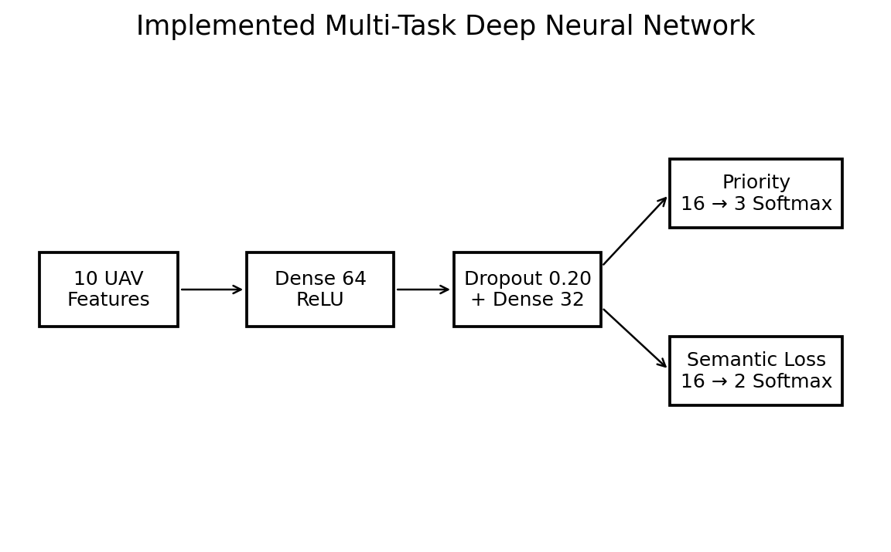

10. Implementation Details
The project implementation is developed in Python using a Jupyter/Colab-style environment. The supplied implementation imports NumPy and Pandas for data processing, Matplotlib and Seaborn for visualization, scikit-learn for preprocessing and baseline models, XGBoost for the boosting baseline, and TensorFlow/Keras for the MT-DNN.

Software / Library | Role
Python 3.10+ | Programming environment
Jupyter Notebook / Colab | Interactive experiment execution
Pandas | Dataset loading and manipulation
NumPy | Numerical operations
scikit-learn | Train/test split, scaling, encoders and metrics
TensorFlow / Keras | MT-DNN construction and training
XGBoost | Baseline comparison
Matplotlib / Seaborn | Plots and confusion matrices

The notebook reports TensorFlow version 2.20.0. The trained model is saved as UAV_MT_DNN_Model.keras after successful execution.

11. Training and Evaluation
The dataset is divided into 9,871 training samples and 2,468 testing samples using an 80:20 stratified split. A StandardScaler is fitted on the training data only, which prevents test-set information from influencing the scaling parameters.
The MT-DNN is trained for 30 epochs with batch size 32 and a validation split of 20% from the training data. The notebook records a final validation priority accuracy of 0.8775 and a final validation semantic-loss accuracy of 0.9641 at epoch 30.
Final test-set evaluation reported by the implementation is shown below.
Task | Accuracy | Precision | Recall | F1-score
Message Priority | 0.8517 | 0.8528 | 0.8517 | 0.8511
Semantic-Loss Tolerance | 0.9656 | 0.9661 | 0.9656 | 0.9655
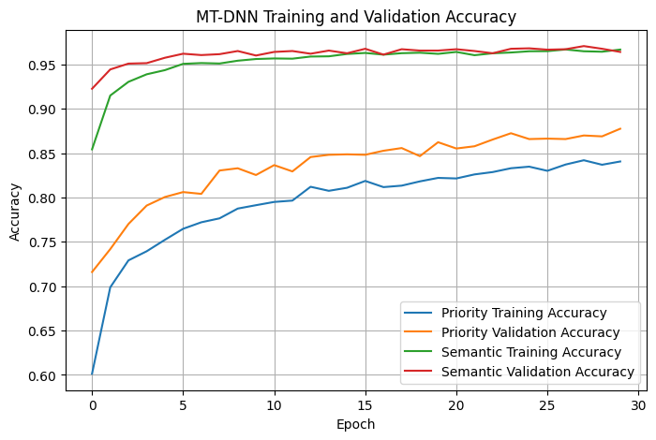
Figure 1. Training and validation accuracy recorded during MT-DNN training.

12. Results and Discussion
The final test results show that the semantic-loss tolerance task achieves substantially higher performance than the priority task. The semantic-loss output reaches 96.56% accuracy with a weighted F1-score of 96.55%, while message priority reaches 85.17% accuracy with a weighted F1-score of 85.11%.
For priority classification, the class-wise report gives F1-scores of 0.81 for High, 0.85 for Low, and 0.87 for Medium. The Medium class has the largest support in the test set, with 1,247 samples.
For semantic-loss tolerance, the High class has precision 0.95, recall 0.98 and F1-score 0.97, while the Low class has precision 0.98, recall 0.95 and F1-score 0.96. The two semantic classes have equal test support of 1,234 samples each.

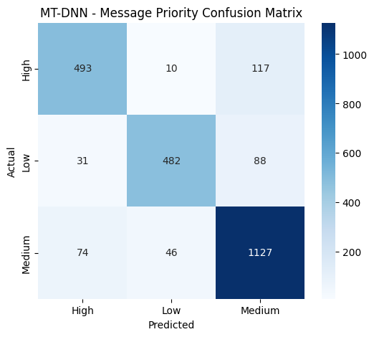
Figure 2. Message-priority confusion matrix.
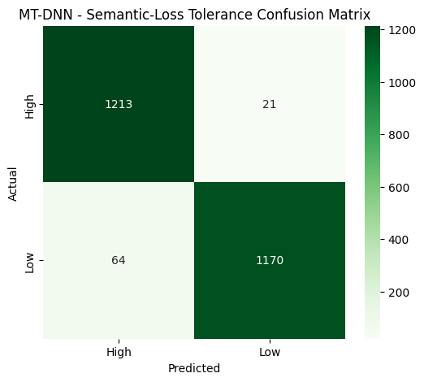
Figure 3. Semantic-loss tolerance confusion matrix.

13. Baseline Comparison
The implementation compares the MT-DNN priority classifier with Logistic Regression, Random Forest, and XGBoost. The recorded comparison is based on priority accuracy.
Model | Priority Accuracy
MT-DNN | 0.851702
Logistic Regression | 0.681524
Random Forest | 0.989870
XGBoost | 0.939222

In the current experiment, Random Forest and XGBoost achieve higher priority accuracy than the MT-DNN. This means the MT-DNN should not be described as the best-performing model for the current proxy-label dataset solely on the basis of priority accuracy.
The value of the MT-DNN lies in the joint multi-task formulation: one model simultaneously produces priority and semantic-loss predictions. The baseline comparison is therefore useful for performance benchmarking, while future experiments should also compare multi-task and single-task models under matched conditions and evaluate both tasks consistently.
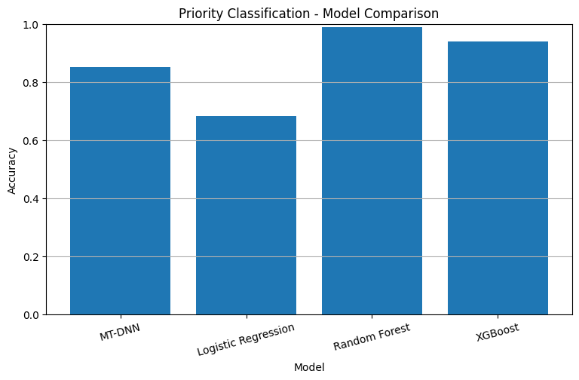
Figure 4. Priority-accuracy comparison recorded by the implementation.

14. Sample Prediction and Interpretation
The completed implementation performs an example prediction using one UAV network record. The input contains ten selected network measurements and is passed through the trained model.
Input Feature | Sample Value
distance_m | 227.998
nb_hello | 36
symmetrical_link | 1
new_link | 0
vel_x | -2.833
vel_y | -8.664
vel_z | -2.34
speed_m_s | 9.411
remaining_energy | 108.221
DataRate_Mbps | 11.0
Prediction | Output
Message Priority | Medium
Semantic-Loss Tolerance | High

The sample demonstrates the intended two-output behavior: a single UAV network observation produces both a priority category and a semantic-loss tolerance category. Because the targets are proxy labels, the prediction should be interpreted as classification of the project-defined operational categories rather than a direct understanding of human emergency-message meaning.

15. Limitations
• The dataset is simulation-based NS-3.40 data rather than field-collected UAV telemetry.
• The two target variables are project-defined proxy labels derived from link lifetime and SNR.
• Proxy-label prediction does not establish real emergency-message urgency recognition or semantic preservation.
• The current experiment uses Scenario 1 only, while the source repository contains multiple scenarios.
• Record-level random splitting may overestimate performance when neighboring observations are correlated.
• Priority accuracy is lower than the Random Forest and XGBoost baselines in the reported comparison.
• The EDA report recommends regenerating distribution plots from the original CSV before final submission when the raw file is available.
• Further validation is needed across separate scenarios and, ideally, real-world UAV communication traces.

16. Future Scope

• Replace proxy labels with expert-annotated emergency-message priority and semantic-loss tolerance labels.
• Validate the model using multiple FANET scenarios instead of Scenario 1 alone.
• Evaluate generalization with scenario-wise or group-wise splits to reduce correlation-related leakage.
• Investigate task-weighting strategies so that priority and semantic-loss objectives can be balanced during training.
• Compare the multi-task network with carefully matched single-task neural networks.
• Study more advanced architectures such as attention-based or recurrent models when message-level temporal information is available.
• Integrate predicted priority and tolerance with an actual UAV resource-allocation or packet-scheduling module.
• Evaluate communication delay, bandwidth utilization, packet delivery, and reliability in addition to classification metrics.
• Test the system using real UAV network traces and emergency communication datasets.

17. Conclusion

This project presents a Multi-Task Deep Neural Network for jointly predicting emergency message priority and semantic-loss tolerance in resource-constrained UAV networks. The implemented model uses shared neural-network layers followed by two task-specific output branches, allowing both outputs to be generated from the same set of UAV network measurements.
Using the FANET Scenario 1 dataset, the implementation processes 12,339 observations with ten selected input features. The MT-DNN achieves a test accuracy of 85.17% for message priority and 96.56% for semantic-loss tolerance. The semantic-loss task shows strong performance, while the priority task remains below the Random Forest and XGBoost baselines in the reported comparison.
The most important conclusion is balanced: the implementation successfully demonstrates the proposed multi-task architecture and experimental workflow, but its current results should be regarded as a proxy-label demonstration rather than proof of real-world emergency-message semantic classification. Future work should use validated message annotations, scenario-wise evaluation, and real UAV communication data to establish practical effectiveness.
Overall, the project provides a foundation for combining message importance and information-loss tolerance in intelligent UAV communication management, with potential to support smarter resource allocation and more reliable information delivery under constrained network conditions.

18. References

[1] R. Caruana, “Multitask Learning,” Machine Learning, vol. 28, pp. 41–75, 1997. DOI: 10.1023/A:1007379606734.
[2] Y. Zhang and Q. Yang, “A Survey on Multi-Task Learning,” IEEE Transactions on Knowledge and Data Engineering, 2021. DOI: 10.1109/TKDE.2021.3070203.
[3] E. Bourtsoulatze, D. B. Kurka, and D. Gündüz, “Deep Joint Source-Channel Coding for Wireless Image Transmission,” IEEE Transactions on Cognitive Communications and Networking, 2019. DOI: 10.1109/TCCN.2019.2919300.
[4] A. Mousaoui and H. Lakhlef, “FANET Dataset: UAV Communication Scenarios in NS-3.40,” Zenodo, 2026. DOI: 10.5281/zenodo.19373220.
[5] Project review presentation: “Multi-Task Deep Neural Network for Emergency Message Priority and Semantic-Loss Tolerance Prediction in UAV Networks,” supplied by the project team.
[6] Dataset and Exploratory Data Analysis Report: “Multi-Task Deep Neural Network for Emergency Message Priority and Semantic-Loss Tolerance Prediction in UAV Networks,” supplied by the project team.
[7] UAV_MT_DNN_Implementation.ipynb — Python/TensorFlow implementation supplied by the project team.

