**SingletonPattern:-**

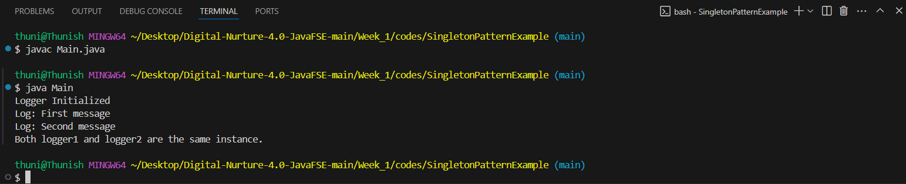

**FactoryMethodPattern:-**

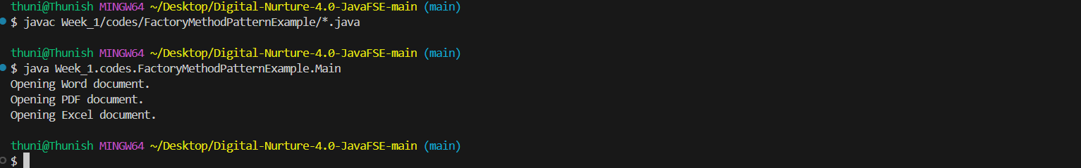

**EcommerceSearchFunction:-**

Best, Average, and Worst-Case (for Search)

| Search Type | Best Case | Average Case | Worst Case |
| --- | --- | --- | --- |
| Linear Search | O(1) | O(n) | O(n) |
| Binary Search | O(1) | O(log n) | O(log n) |

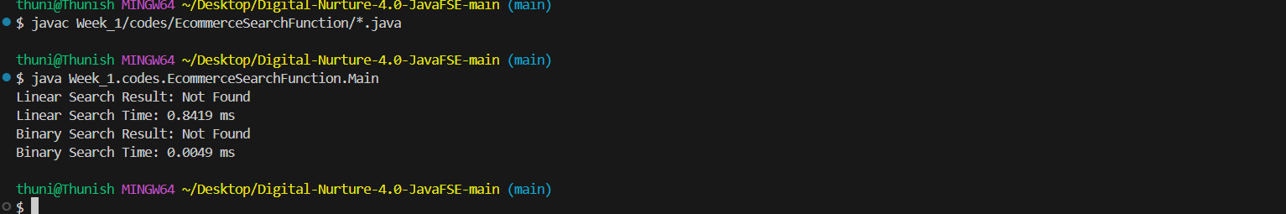

**FinancialForecast**:-

