**PLSQL:-**

Control Structures:-



Stored Procedures:-



**JUnit Testing Exercises:-**

Assertions in Junit:-

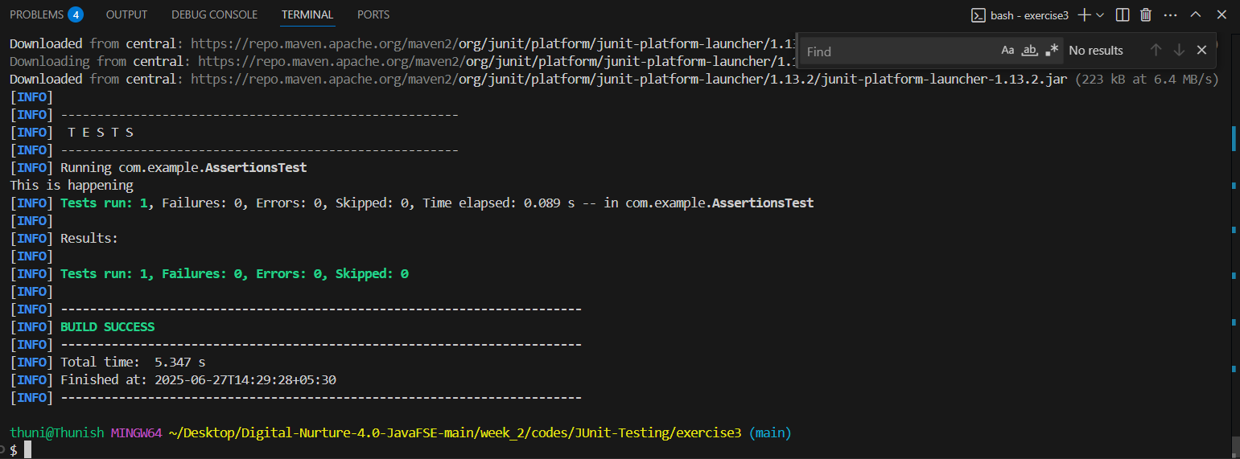

Arrange-Act-Assert (AAA) Pattern, Test Fixtures, Setup and Teardown Methods in Junit:-

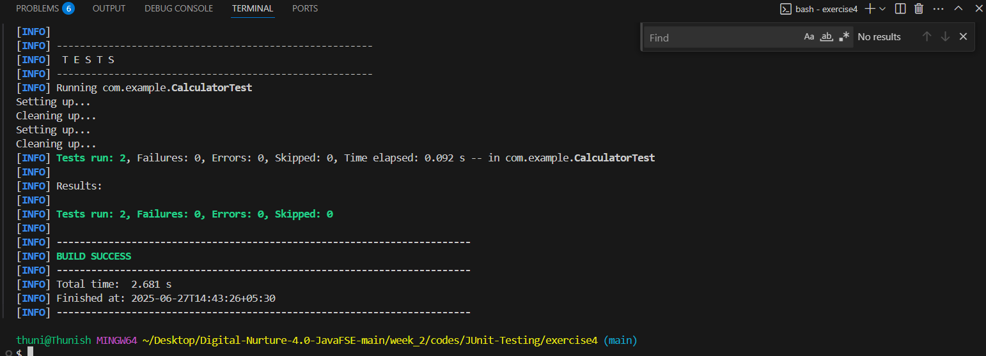

**Mockito:-**

Mocking and Stubbing:-

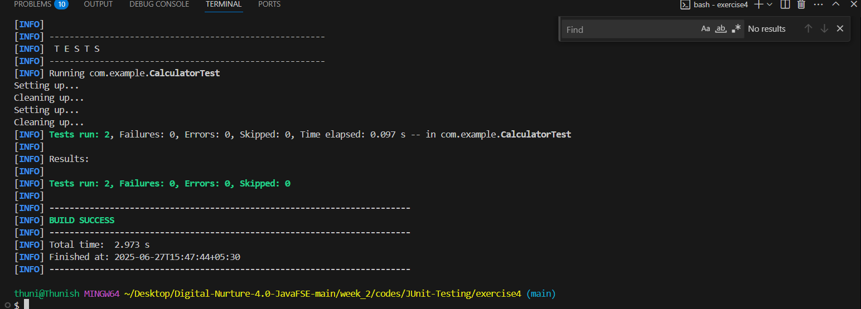

Verifying Interactions:-

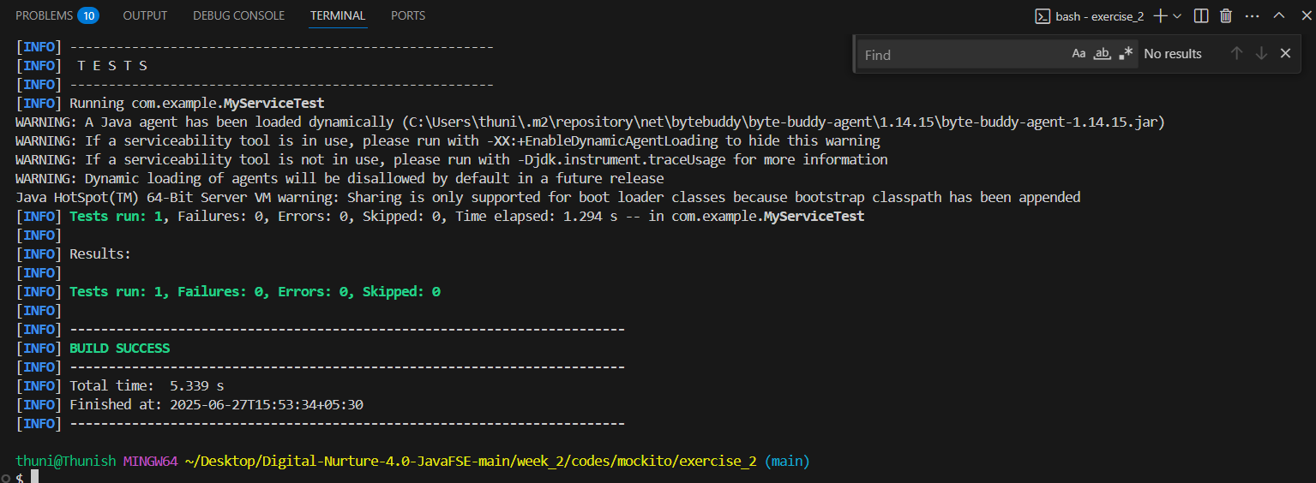

**Logging using SLF4J:-**

