**Spring Core Maven:-**

Exercise1_2:_

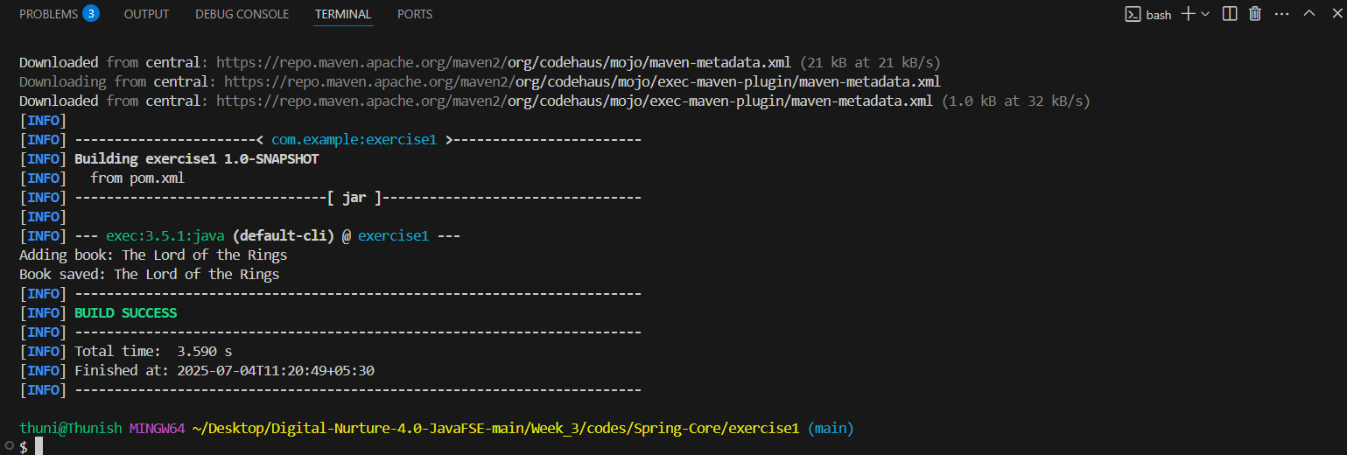

Exercise4:

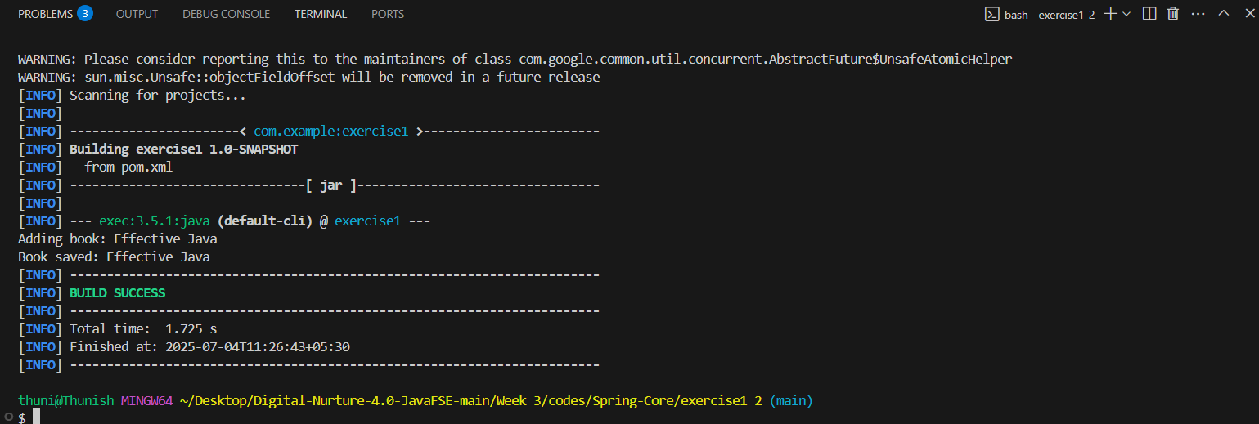

**Spring Data JPA:-**

Output:-

Inside main

Start

countries=[Country [code=IN, name=India], Country [code=US, name=United States of America]]

End