**Create a Spring Web Project using Maven:-**

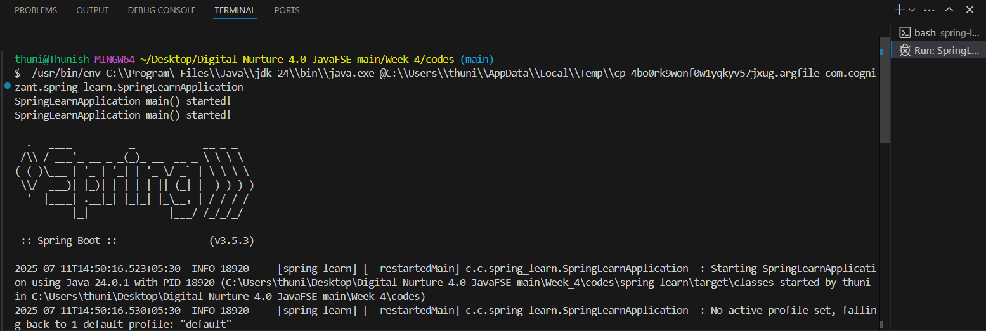

**Spring Core – Load Country from Spring Configuration XML:-**

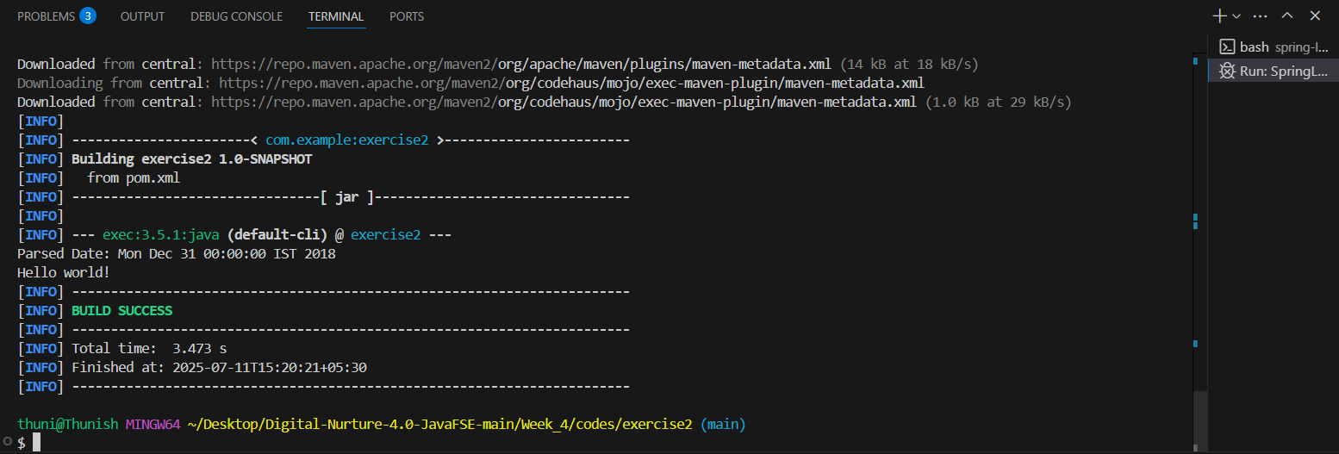

**Hello World RESTful Web Service:-**

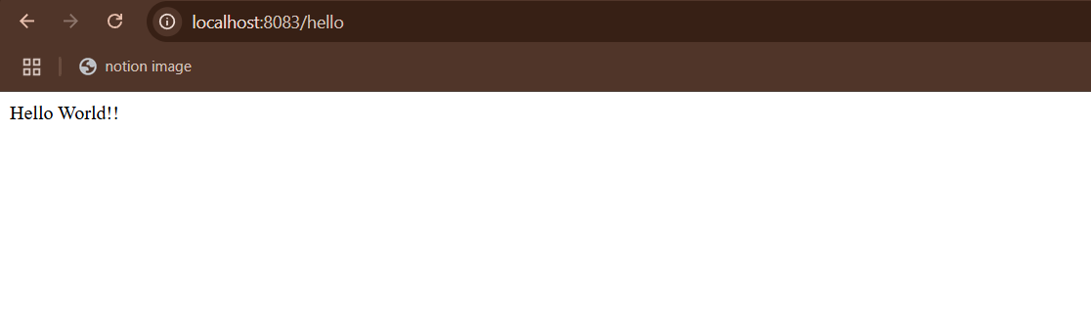

**REST - Country Web Service:-**

