**README VA CCDA Stylesheet v2.8**

**Introduction**

The Veterans Health Information Exchange (VHIE) program which operates under the Department of Veterans Affairs (VA) is contributing the VA Stylesheet, used for the display of Consolidated Clinical Document Architecture (C-CDA) documents (XML format), to the public HL7 Structured Documents Work Group (SDWG) github repository to promote data usability within health information exchange (HIE). The stylesheet is maintained under responsibility of the VHIE Content Management Team (email group: [VHIEContentMgmtTeam@va.gov](mailto:VHIEContentMgmtTeam@va.gov)).

Publications are under [releases](https://github.com/HL7/cda-core-xsl/releases)

* Release Date 3/DD/2024: cda_v2.8.xsl

The intent of the stylesheet is to share with the HIE industry the document display format and user-activated navigation features implemented by the VHIE program to support VA users needing access to native VA clinical data and/or Community Partner clinical data populated in C-CDA documents.

The VA Stylesheet renders C-CDA xml files through the parsing of XPath locations for the

C-CDA Header elements and then renders from the narrative block display for the document’s clinical sections.

Details are provided under section VA Stylesheet Rendering Details.

**License**

None

**Compatibility**

The cda_VA_v2.8.xsl and cda_plain_VA_v2.8.css have been tested to work with major browsers

(MS Edge and Internet Explorer). Effort has been put in to make rendering friendly for visually impaired people, based on the [American Foundation for the Blind Section 508](https://www.section508.gov/manage/laws-and-policies/). Effort has been put in to make the document friendly for screen and for print.

**Warranty**

The cda_v2.8.xsl and cda_plain_v2.8.css represent the document display format and user-activated navigation features implemented by the VHIE program to support VA users needing access to native VA clinical data and/or Community Partner clinical data provided in C-CDA documents. The VA Stylesheet should be used in that fashion without warranty or guarantees of suitability for a particular purpose. The stylesheet should be tested locally by implementers before production usage.

**Package Contents**

The VA Stylesheet package contains two files:

1. cda_v2.8.xsl: main logic
2. cda_plain_v2.8.css: formatting & color scheme

**Applying VA Stylesheet**

* + 1. **Identify VA Stylesheet in the CDA XML Files**

|  |  |
| --- | --- |
|  | **Local Path Method** |
| Step 1 | Add the following lines into the CDA .xml file(s) before the ClinicalDocument element:  <?xml version="1.0" encoding="UTF-8"?>  **<?xml-stylesheet type="text/xsl" href="cda.xsl"?>**  <ClinicalDocument xmlns:xsi="http://www.w3.org/2001/XMLSchema-instance" xmlns="urn:hl7- org:v3" xsi:schemaLocation="urn:hl7-org:v3 CDA.xsd"> |
| Step 2 | Place both VA Stylesheet files in the same location as the xml file(s) to be rendered |

|  |  |
| --- | --- |
|  | **Absolute Path Method** |
| Step 1 | Add the following lines into the CDA xml files before the ClinicalDocument element:  <?xml version="1.0" encoding="UTF-8"?>  **<?xml-stylesheet type="text/xsl"**  **href="http://your_org_url.org/cda/cda_v2.8.xsl"?>**  <ClinicalDocument xmlns:xsi="http://www.w3.org/2001/XMLSchema-instance"  xmlns="urn:hl7-org:v3" xsi:schemaLocation="urn:hl7-org:v3 CDA.xsd"> |
| Step 2 | Place both VA Stylesheet files in specified url location. |

* + 1. **Allow Blocked Content**

With the Local Path Method or the Absolute Path Method, you may be prompted to “Allow Blocked Content.” Agree to “Allow Blocked Content” to proceed.

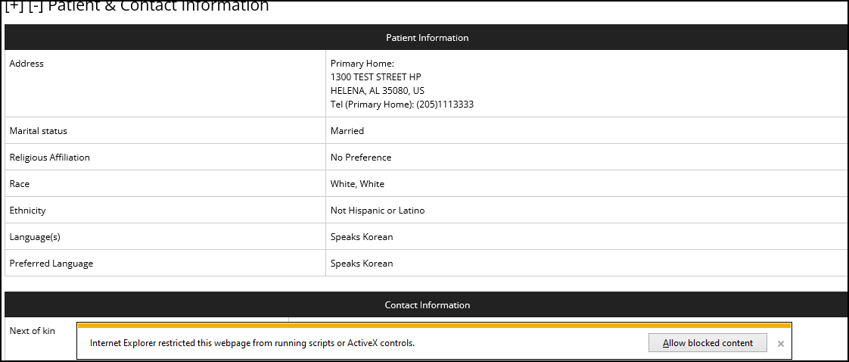

If the VA Stylesheet is launched from within another application, then the launching application must trigger, or allow, the running of the ActiveX scripts.

**VA Stylesheet Navigation Features**

1. **Expand/Collapse the Table of Contents (ToC) Buttons**

The ToC section may be expanded to show all 3 rows of buttons or collapsed to show no buttons. Default view is expanded display.

1. **Expand/Collapse All Sections**

All document sections may be expanded to show all section narrative block content or collapsed to only show the section title. Default view is expanded display.

1. **Table of Content (ToC) Buttons**

The VA Stylesheet provides a predetermined, three row arrangement of the ToC buttons:

|  |  |
| --- | --- |
|  | **Details - Table of Content (ToC) Buttons** |
| Row 1 | Administrative Sections:   * Patient & Contact * Healthcare Providers * Insurance Providers |
| Row 2 | Clinical Sections defined for the CCDA document template:   * These are the named required and optional sections defined for each CCDA document template in the HL7 CCDA R2.1 specifications. * Sections are ordered A-Z. * Sections with clinical entries are displayed with a black outline and black text. * Sections without clinical entries,identified by <section nullFlavor="NI">, are displayed with a gray outline and gray text. * Both black outline and gray outline buttons navigate the user to the start of the section within the document. |
| Row 3 | Clinical Note Sections and any added sections by the document creator as allowed per the “open” HL7 document template designation. |

1. **Expand/Collapse Each Section**

An individual document section may be expanded to show all section narrative block content or collapsed to only show the section title. Default view is expanded display.

1. **Back to Top**

The Back to Top button returns the user to the top of the document display if there has been any downward navigation via the ToC buttons or the vertical scroll bar.

1. **Scroll Bars: Vertical and Horizontal**

Top-Down (vertical) scrolling and Left-Right (horizontal) scrolling is supported.

**VA Stylesheet Rendering Details**

1. **Document Header**

|  |  |
| --- | --- |
| **Page Location** | **Content** |
| Top Left of Page | * Document Title * Document Creation Date |
| Center of Page | * Document Custodian |
| Top Right of Page | * Patient Last Name, First Name (Legal) * Patient Date of Birth * Patient Gender   + - 1st check: display from <code>     - 2nd check: display from <originalText> |

1. **Document Body**

|  |  |
| --- | --- |
| **Sections** | **Content and**  **VA Business Rules** |
| Data Privacy Designation | * Document Confidentiality Code |
| Patient Information | * Patient Address (Home)   + - IF addresses with use = “HP” are present   THEN display address WHERE Current Date  falls with the Useable Period   * + - IF no addresses with use = “HP” are present   THEN display address WHERE use = “PST”   * + - IF no addresses with use = “PST”   THEN display 1st occurrence of address   * Marital Status   + 1st check: display from <code>   + 2nd check: display from <originalText> * Religious Affiliation   + 1st check: display from <code>   + 2nd check: display from <originalText> * Race   + 1st check: display from <code>   + 2nd check: display from <originalText> * Ethnicity   + 1st check: display from <code>   + 2nd check: display from <originalText> * Language(s)   + 1st check: display from <code>   + 2nd check: display from <originalText> * Preferred Language   + 1st check: display from <code>   + 2nd check: display from <originalText> |
| Contact Information | * Contact Type * Contact Name * Contact Address |

**Acknowledgements**

The stylesheet is the cumulative work of the multiple Department of Defense (DoD) and VA organizations committed to providing complete and accurate continuity of care to the Active Duty and Veteran populations as well as efficient and usable tools for DoD and VA healthcare providers and support staff:

* DoD providers and clinical Subject Matter Experts (SME)
* DoD Joint Longitudinal Viewer (JLV) Team
* VA providers and clinical SMEs
* VA Joint Longitudinal Viewer (JLV) Team
* VA MyHealtheVet (MHV) Team
* VHIE Exchange Solutions Management (ESM) Team
* Veterans Data Integration and Federation - Enterprise Platform (VDIF-EP) Development Teams