PoC-CRS

Description:
PoC for nRF5430DK: Customer Requirements Specifications

Snapshot Version: Current
Status: Draft/Edit, assigned to Dragomirescu, Liviu
Last Modified by: Dragomirescu, Liviu
Date Modified: 3/18/2025

History
Version | Date | Responsible | Comment
1.0 | 3/18/2025 | DL | First version

Release
Name / Position | Function | Date | Comments
 | Approval
 | Reviewer

Approvals
The following persons should read this document and approve it. Once signed, the document can only be modified following a documented Engineering Change Request (Issue):

Name | Company | Position | Date | Signature

Table of Contents
1 Introduction 4
1.1 Purpose of this document 4
1.2 Terms and Abbreviations 4
1.3 Naming Convention 4
2 Requirements 4

  - 1 Introduction

1.1 Purpose of this document
The present document is the Customer Requirements Specification, written for the PoC on nRF5340DK system.
For each requirement, acceptance criteria are defined.
1.2 Terms and Abbreviations
PoC: Proof of Concept.

1.3 Naming Convention
Binding character :
Shall is used to indicate a requirement that is contractually binding, meaning it must be implemented, no deviation is permitted.
Should is used to indicate goals and Non-Mandatory requirement, but nice-to-have.

  - 2 Requirements

ID | Description | Req
PoC-01 | The PoC software developed for ST Nucleo-H743ZI2 shall be ported to the nRF5340DK (software will be provided).  Note: PoC software for ST may lack the project files and a few constants (values will be provided for the constants) | Req: Open / Edit, assigned to Dragomirescu, Liviu
PoC-02 | The following high-level functionality (operation cycle) shall be implemented:  1. Power up the system.  2. Emit a beep for 2 seconds ±100ms to indicate that the system is active.  3. Turn on the ON/OFF LED to indicate that the system is active.  4. Wait for the defibrillation launch sequence.  5. Launch sequence detected (simultaneous press of 2 buttons; after 2 seconds, an LED lights up for 1.5 seconds. If both buttons are released during this time, the sequence is initiated; otherwise, the LED turns off, and the user must restart the activation sequence).  6. Emit 2 beeps of 1 second ±100ms, spaced 500ms ±100ms apart, to indicate the sequence is about to begin.  7. Activate the first stage of energy conversion to 15V.  8. Charge the capacitor: set the CHARGE pin to 1.  9. When the measured voltage is greater than or equal to the target voltage (analog-to-digital conversion): emit 5 beeps of 0.5 seconds, spaced at least 100ms apart, to indicate that the discharge will occur in 5 seconds (after the beeps).  10. Wait for 5 seconds.  11. Execute the defibrillation sequence.  12. Fully discharge the capacitor. End condition: voltage across the capacitor is less than or equal to 50V. The discharge is achieved by setting a discharge pin to 0. | Req: Open / Edit, assigned to Dragomirescu, Liviu
PoC-03 | The following signals from ST PoC shall be used on the nRF PoC:  - OUT_IGBT_1 (H-BRIDGE_IGBT_1_CMD, PG14 on ST) --> P1.11? on nRF  - OUT_IGBT_2 (H-BRIDGE_IGBT_2_CMD, PG8 on ST) --> P1.12? on nRF  - OUT_IGBT_3 (H-BRIDGE_IGBT_3_CMD, PF12 on ST) --> P1.14? on nRF  - OUT_IGBT_4 (H-BRIDGE_IGBT_4_CMD, PG4 on ST) --> P1.15? on nRF  - OUT_ENABLE_DISCHARGE (DISCHARGE_CAP_CMD, PE15 on ST) --> P0.21? on nRF  - ADC (capacitor charge measurement, PC3 on ST) --> P0.05 on nRF  - OUT_LV_ENABLE (LV_ENABLE, PC2 on ST) --> P1.06 on nRF  - OUT_HV_ENABLE (HV_ENABLE, PE6 on ST) --> P0.23 on nRF  - IN_DONE_FLAG (DONE_FLAG, PG15 on ST) --> P0.06 on nRF, GPIO  - IN_FAULT_FLAG (PG10 on ST) --> P0.07 on nRF, GPIO  - LED_SHOCK (PD6 on ST) --> P0.31 on nRF  - LD1 (PB0 on ST, green led, sw running) --> P0.28 on nRF  - LED_ERROR (PD1 on ST) --> P0.19 on nRF  - LD2 (PE1 on ST, yellow led, cycle in progress) --> P0.30 on nRF  - OUT_BREATHING_LED (PC7 on ST) --> P0.12 on nRF  - (TBD which is the red led indicating that capacitor is charged)  - OUT_BUZZER (PC6 on ST, PWM) --> P0.29 on nRF (active high, no PWM)  - BTN_1 (PE3 on ST) --> P0.24 on nRF  - BTN_2 (PF1 on ST) --> P0.08 on nRF | Req: Open / Edit, assigned to Dragomirescu, Liviu
PoC-04 | The following charge/discharge sequence shall be implemented:  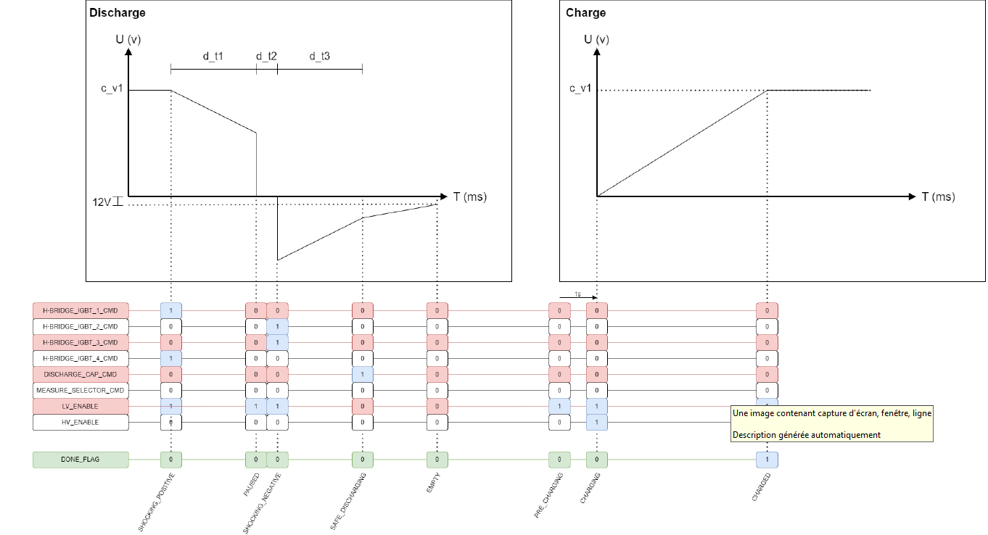 | Req: Open / Edit, assigned to Dragomirescu, Liviu
PoC-05 | The following signals shall be used on the nRF PoC (in addition to the signals listed on PoC-03):  - P1.04 GPIO output, set to high on fw start  - P0.25 GPIO output, set to high on fw start  - P1.06 GPIO output, set the same as P1.05  - P0.29 GPIO output (OUT_BUZZER) shall behave differently from PC6 on ST, no PWM, set high when active  - P0.02? GPIO input, acts also as BTN_1 | Req: Open / Edit, assigned to Dragomirescu, Liviu
PoC-06 | Output state change to serial output (e.g., powered up, start charging, pause N seconds, prepare to apply shock, start discharging, completed discharging) | Req: Open / Edit, assigned to Dragomirescu, Liviu
PoC-07 | The following code shall be ported:  - ST-POC1_firmware-1.0.0\Core\Src\main.c  - ST-POC1_firmware-1.0.0\innpulse\innpulse.c | Req: Open / Edit, assigned to Dragomirescu, Liviu
PoC-08 | The following code should not be ported:  - ST-POC1_firmware-1.0.0\innpulse\comIHM.c | Req: Open / Edit, assigned to Dragomirescu, Liviu

