For this class you need to have your own local installation of MySQL. I cannot provide individual installation help since people have different systems. If you have not yet installed the MySQL software you can go to the MySQL page and get the software. You probably want to install the most recent Generally Available (GA) Community Server version (5.6) . If you have 5.5 that is OK for the class. Start at

http://dev.mysql.com/downloads/mysql/

You can get some installation help from the MySQL documentation ( chapter 2 Installing … MySQL). You might also find web pages that show you screen shots of an installation for your OS.

You should always set a password for the root account. There is info in the book and notes about setting up other user accounts. It helps to know where on your system the software is installed and where your data files are stored- but you can generally accept the default locations.

Macs: This is a link provided by the Mac people last semester- that other people thought was well written.

<http://www.macminivault.com/mysql-mountain-lion/>

Windows : You can generally use the installer program that Mysql provides. If you have your computer connected to the internet, use the web version of the installer.

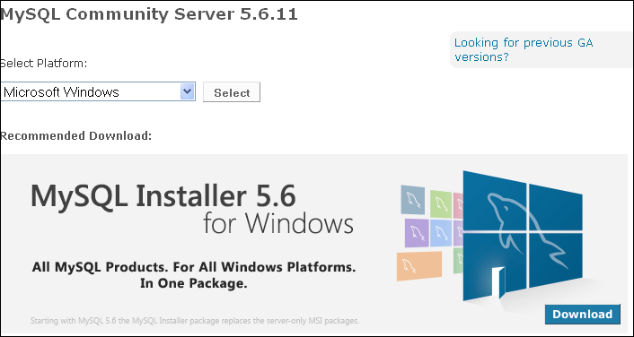

I have just installed this on a windows 7 system and these are some notes. The installer wanted to include applications that work with Excel and Visual Studio- which I do not have on this laptop. If you accept the default Developer system and do not have Excel and/or Visual Studio, then select the Custom install and unselect those two times- we do not use them in class.

I did not install Workbench because I do not like it.

I accepted defaults for everything else.

When the installation was complete, I had an item that runs the MySQL command line client. That opens with a request for the password and it is running as root. You can also run the mysql command line client from a command prompt. In order to do this, you need to use a path to the mysql.exe file.

If I go to a regular command prompt and enter

mysql -u root -p

I get an error message that the program cannot be found. I have two choices. (1) Use the full path to the mysql executable file. On my system that would be a long path- I have used \. . . .\ in the example below to hide part of my path since your path might not be the same. You cannot just copy and paste this. Note the quotes.

"C:\Program Files\Mysql\. . . .\mysql.exe" -u root -p

(2)Set the PATH environment variable; then you can use just the command mysql and your OS will know where to look for that file. Check the details for doing this with your system. Be certain that you edit the path by adding a semicolon and this new path to the PATH variable- do not replace the current path with the path to mysql or other programs on your system will not start up as you want. On my Windows 7 system, I had to log off and on for the change in the Path variable to be effective.

This is a link to the MS page for setting your path.

http://msdn.microsoft.com/en-us/library/ee537574%28v=office.14%29.aspx