Table of Contents

1. Modifying the script file 1

2. Make copies of script file 1

3. Filling the script 2

4. Testing your script-to-spool process 3

Assignments will generally ask you to create a script with 8-10 queries against specific tables. There are some ideas about how to handle the mechanics of creating the scripts for the assignments.

1. Modifying the script file

Start with the template file. You will use this template file for each of the 13 assignments for the class. Because I need to grade a lot of assignments, I need you to follow certain rules for the assignments and using the template makes this easier.

As I mentioned in the previous document, you should create a folder/directory on your local system to save your work. The name of my directory is c:\db_scripts.

Download the template file into that directory and change the name of the file to A01_yourLastName.SQL . Obviously I do not mean to literally use the letters yourLastName, but I did not want to make 100 different copies of this document -one for each student. If you have a common last name, then use A01_yourLastName_yourFirstname.SQL.

Open the file in a text editor and REPLACE the first line with a comment giving your name. For example, if I were a student, I would use the following first line.

-- Rose Endres

The next line is a command that turns warning on. Leave that line in the script.

\W /* enable warnings! */

Next there is a use command; you will need to edit this for each script to start with the proper database. Right now it says

use -- put the database name into this command ;

For A01, you will edit it to

use a_testbed;

For A02, you will edit it to

use a_vets;

Then there is a pair of lines; the first is a comment and the second is a command that will display some information; leave this in the script.

/* TASK 00 */

select user(), current_date(), version(), @@sql_mode\G

Next follows a set of comments for task numbers that corresponds to the tasks in the assignment. Leave these comments in the script and add your SQL after the appropriate task number. Do not change the comment style or wording.

/* TASK 01 */

Save your file. Be certain that the file name extension is SQL. (I don't care about the case of the filename but people seem to notice the upper case letters.)

1. Make copies of script file

Now that you have modified the template with your name, you can go ahead and make 13 copies- one for each assignment. Change the file names to match the assignments.

A01_yourLastName.SQL

A02_yourLastName.SQL

A03_yourLastName.SQL

1. Filling the script

What I usually do when I set up assignments or demo files is have the script file open in a text editor and a window open for the mysql command line client. I enter the sql query in the script file and then copy and paste it into the client window to run and test. The following shows the two windows I am working with.

mysql client window and the text editor windows 
after entering the sql for A10 Task 01.

If my sql works correctly, then I can save the text file and go on to the next task. If the sql query is incorrect then I can correct it in the text editor and copy it again. I am a poor typist and this way it is easier for me to correct errors than if I try to create the queries directly in the client window.

If you have troubles with one of the Tasks, you can skip it temporarily and go on to the next. You can do some of the tasks, save the file and take a short break and then come back to work on other tasks. You need that script file to run the assignment, so it makes sense to me to build it up this way.

You should test the script to spool process occasionally as you build the scripts but the sql you execute in the mysql client window should run the same way with the script-to-spool process. But be certain to test that early enough that if you have a problem you can fix it in time to turn in the assignment on time.

I do get people who turn in a spooled file that is mostly empty and they do not get a chance to correct this. READ YOUR SPOOL FILE.I have to read it; it is only fair that you read it also.

The spooled file should contain

* your name as a comment
* the use command to switch to the correct database
* Task 00 as provided in the template
* the task number for each task as a comment as provided in the template
* the sql query(queries) needed at each step
* the output for each step

If you are using a GUI client that lets you build the script file in the client window that is also ok. But you will still need to run that script from the mysql command line. It is a good idea to test this a few times to be certain your gui client is compatible with the script-to-spool process.

1. Testing your script-to-spool process

You can keep a third window open to a basic command prompt window (what us old folk call a DOS box!) You can run the script-to-spool command from that window when you need to double check the script file. This is a screenshot of that window when I ran the A01 script at this point. It is not very exciting is it?

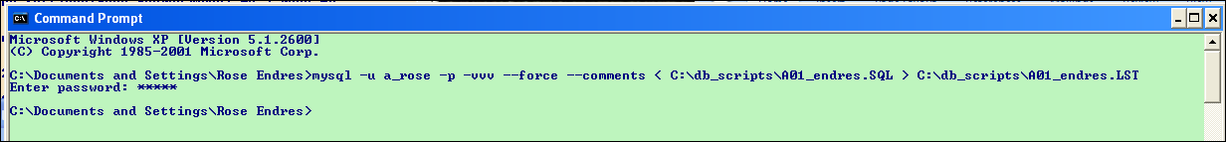

You do not want this window to be exciting. There is a prompt for my password and then the system returns to the command prompt. That is a good thing. I do not want to see error messages here- that would mean that something went wrong with my script.

I can go to the directory and open the LST file and see the results. And, at least for a windows system, you can keep that window open as you build your script and use the up arrow to rerun the command as you improve your script. It will overwrite the LST file.

I also keep a text file with the command lines I run the most often. That is a very long command line and I do not want to rewrite it from scratch. So I have a text file (command_mysql.txt) with copies of the command line and I copy and paste them into the command window changing the names of the file from A01 to A02 etc.

1. Turning in the assignment

After you have written and tested your script and have created the spooled file and have read it for possible problems, then it is time to zip the two files. You can use the windows menu (send to compressed folder) or other file compression techniques that open with 7-Zip . The compressed file should use your name (such as A01_endres.zip)

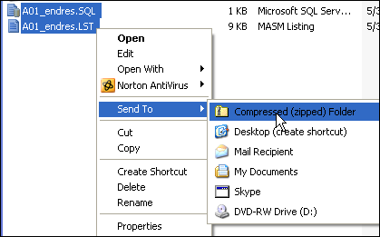

1. File name problems I have seen in the past and do not want to see again

You turn in files with the name A01.txt and A01.1st-- you lose 10 points for having the wrong file extensions and 10 points for the files not including your name. ( did you notice that the extension was a digit 1 and not the letter l?)

You turn in files with the name A01.sql and A01.lst-- -- you lose 10 points for the files not including your name.

There are two people in class with the same last name. You can check the participants listing in Insight and if you have the same last name as another student, please use the naming pattern A01_yourLastName_yourFirstName.SQL

The slq file and the lst fies are named correctly but the zip file has a name such as A01.zip. I down load the zip file and if two files have the same file and overwrite each other, only one person gets the points for the assignment.