You can do all your work in the command line client but you may find a graphical client helpful. You can build and test your queries in the graphical client and build up the script. Then run the script to spool using the command line.

There are a variety of graphical clients you can use for running MySQL queries. They vary in how data is displayed and some students have found them difficult to work with. The only one that I use occasionally is SQL Developer ( because I am more familiar with using this client- not because it is better!)

1. MySQL Query Browser

This is an older GUI client that the VanLans book mentioned. You can probably still find it and you can use it if you want.

1. MySQL Workbench

This is the current GUI client from MySQL. The MySQL Workbench client is a free download from the MySQL site.

There is a tutorial for using this- I would suggest looking at section Chapter 6.7 SQL Editor for techniques relevant to this class. With an interface like this it is generally a good idea to learn how to get started with the simplest query and then go back to the tutorial later to find more tricks.

This will show you some screen shots that might help you decide if you want to use this.

This is the initial screen for MySQL Workbench

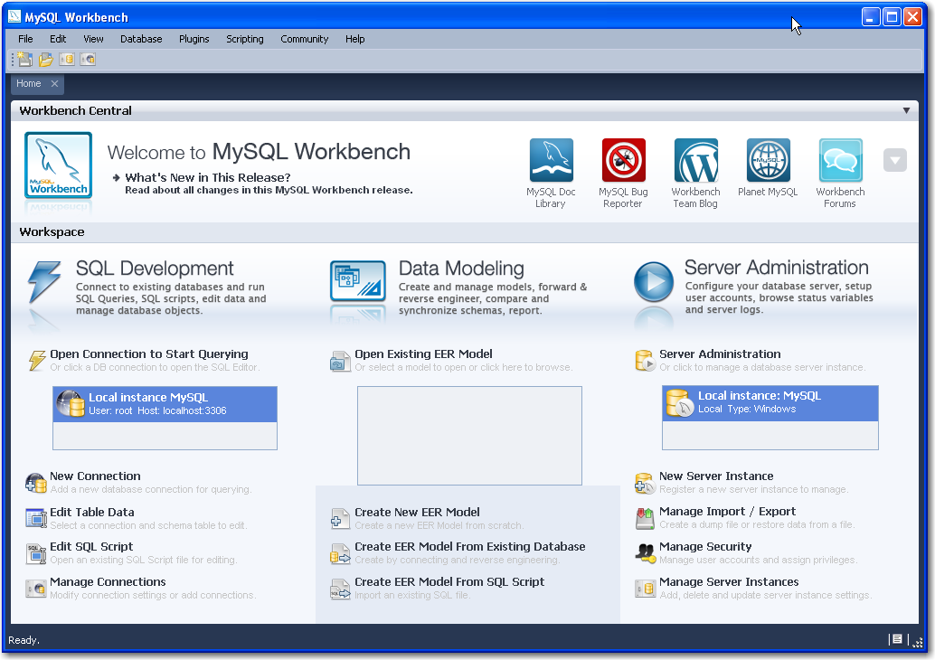

Use the Open Connection to Start Querying and fill in your user name and password when prompted.

The main window- the SQL Editor window is a text editor. This shows the editor window after a use and a select statement

This shows the editor window after a use and a select statement

use a_vets;
Select *
from a_vets.vt_staff;

You can run this script from the toolbar- hold your mouse over the buttons to find the one that says "Execute SQL script…" This is the results window- showing the output in a grid display.

This is the results window- showing  the output in a grid display.
This has column headers and rows in a spreadsheet style display

Clicking on the column headers in the results pane sorts the rows by that column. There also is a button to export the results to a file

You can use the Query menu to produce the output as Text.

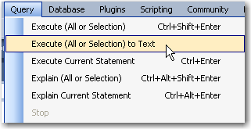

This is the text result of that query. The text display is not always properly aligned.

This is the text result of that query.

Query Output:
>   select *  from a_vets.vt_staff

+ ----------- + ------------------ + ------------------- + ------------------ +
| stf_id      | stf_name_last      | stf_name_first      | stf_job_title      |
+ ----------- + ------------------ + ------------------- + ------------------ +
| 15          | Dolittle           | Eliza               | vet                |
| 20          | Rogers             | Shelia              | clerical           |
| 25          | Wilkommen          | Bridgette           | vet                |
| 29          | Helfen             | Sandy               | vet assnt          |
| 30          | Helfen             | Sandy               | vet                |
| 43          | Halvers            | Pat                 | kennel             |
| 52          | Gordon             | Dexter              | vet assnt          |
| 55          | Marvin             | Lee                 | kennel             |
+ ----------- + ------------------ + ------------------- + ------------------ +
8 rows

Both of these windows can be copied to the clipboard.

You can save the contents of the editor to a file.

You can double click a name of an item in the Object browser to have that name put into the editor window.

Error message are not as obvious with this client.

You also get an Object Browser window which can help you remember the column names.

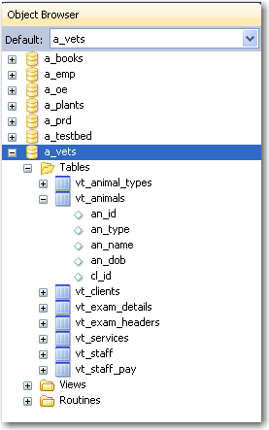

Using the Object browser and the right click menu for a table and the query that was produced

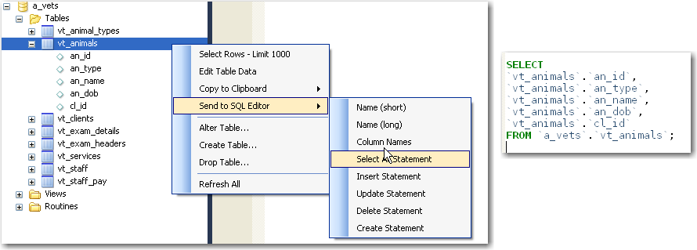

1. dbForge for MySQL

dbForge has a free version of its MSQL client and also paid versions. It includes an Object browser, editing abilities, tabbed windows, code completion. Its interface is similar to that of Visual Studio.

<http://www.devart.com/dbforge/mysql/studio/>

1. Toad for MySQL

This is a free client available from Quest Software ( <http://www.quest.com/toad-for-mysql/>) This runs on Windows.

As with most of these graphical interfaces you can chose to learn to use a few features at a time.

You will find that different clients often display the data with different formats. For example the mysql client shows date values as 1989-06-17 while the Toad client shows 6/17/1989 12:00:00 AM.

This is version 5.0 . As with most graphical interfaces this is a very busy screen. You do not have to learn all of this to make it useful.

1. SQL Developer and MySQL

SQL Developer is a client created by Oracle ( which now owns MySQL). If you are interesting in trying this, email me and I will send you the SQL Developer files from the CS 151A class.

You are not required to use any of these clients and assignments must be turned in using the script-spool techniques.