VIET NAM NATIONAL UNIVERSITY HO CHI MINH CITY
INTERNATIONAL UNIVERSITY
INFORMATION TECHNOLOGY - DEPARTMENT OF COMPUTER SCIENCE


Web Application Development

Report: Bookept (book store web app)

Lecturer: Dr. Nguyen Van Sinh
Team:

Index:
- Introduction
1.1 Overview
1.2 Problems Statement
1.3 Scope
2 Literature Review
2.1 Similar Applications/Systems
2.2 Platform and Tools Review
3 System Design
3.1 System Requirement Specification
3.1.1 Functional Requirement
3.1.2 Non-functional Requirement
3.2 System Design Specifications
3.2.1 Use Case
3.2.2 Sequence Diagram
3.2.3 Entity Relationship Diagram and Database Schema
4 System Implementation

5 Conclusion
5.1 List of accomplish work
5.2 Strenght and Weakness
5.3 Feature work

Introduction

Motivation
Nowadays, the network plays an import role in people’s life. In the process of the improvement of the people’s living standard, people’s demands of the life’s quality and efficiency is more higher. Online book store allows users to search and purchase a book based on title, author and subject. User can browse and purchase items via the shopping interface. On the back end, you can manage inventory, process online orders, and run sales reports. Additionally, all book store transactions are automatically fed into your General Ledger.

Problems Statement
- Customers will use an web based interface to browse books based on categories, search books using keywords. Initially only the title and author of the books are displayed, on click other attributes are displayed. Customers can buy books using their e-purse. The store also displays the number of copies of the book left in stock. Out of stock books cannot be purchased immediately, but can be ordered.
- Customers create accounts in the book store. Each account contains customer profile information: name, age, geographical location, categories of interest, email. Each account has an e-purse. Customers can specify the amount of money to be deposited with the e-purse. Profile and e-purse information can be updated by the customer. Customers will login to the book store using an account name and password.
- All online sales data are recorded in the database with timestamp.

Scope
We are trying to develop an Online Book Store website where clients may shop for things from anywhere using simple activities such as navigating the app's user interface to select items, complete orders, pay bills, and receive their goods through home delivery companies.On the admin side, the admin can sell products from anywhere with simple operations such as setting up the product name, product type, product image, product description and some basic information about the product. When the customer completes the purchase, admin only needs to deliver it to the customer through the home delivery company.

Literature Review
2.1 Similar Applications/Systems
- www.barnesandnoble.com
- www.valorebooks.com
- www.amazon.com
- …
2.2 Platform and Tools Review
- HTML/CSS
- Javascript
- SQL

System Design
3.1 :

3.1.1 Functional Requirement:

Online Book store is an online web application where the customer can purchase books online. Through a web browser the customers can search for a book by its title or author, later can add to the shopping cart and finally purchase using credit card transaction. The user can login using his account details or new customers can set up an account very quickly. They should give the details of their name, contact number and shipping address. The user can also give feedback to a book by giving ratings on a score of five. The books are divided into many categories based on subject Like Software, Database, English, Architecture etc. This project has the following functionalities:

1) A Home page with product catalog
This is the page where the user will be navigated after a successful login. It will display
all the book categories and will have a search keyword option to search for the required
book. It also includes some special sections like recommended titles, weekly special
books.

2) Search
A search by keyword option is provided to the user using a textbox .The keyword to be
entered should be the book title.

3) Advanced Search
Advanced search helps the user to search for a book based on Title, Author, Category and price range. All the books which match the particular search criteria and their total count will be displayed .From here the user can select a book and add to the shopping cart.

4) Book Description
If the user would like to know details about a book he can click on the title from where he will be directed to a Book description page. It includes the notes on the book content and also a link to Amazon.com to get the book review.

5) User Voting
The user can give rating to a book based on his interest. He can rate it by giving a score
of five as Excellent, four for very good, three for good, two for regular and one for
deficient. The final rating of a book will depend on all the individual user rating.

6) Shopping Cart
The user can manage a shopping cart which will include all the books he selected. The
user can edit, delete and update his shopping cart. A final shopping cart summary is
displayed which includes all the items the user selected and the final total cost.

7) Managing user accounts
Each user should have an account to access all the functionalities of website. User can
login using login page and logout using the logout page. All the user sessions will be
saved in the database.

8) Administration
The Administrator will be provided with special functionalities like
• Add or delete a book category
• Add or delete a member
• Manage member orders.

3.1.2 Non-functional Requirement:

3.2 System Design Specifications:

3.2.1 Use Case:
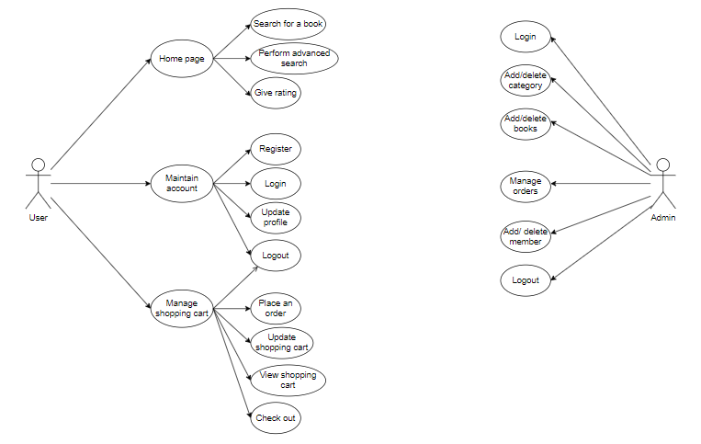

Figure 3.1: Customer and Admin use case diagram.

Use Cases:
Browse Catalog
1) Search for a Book
• Purpose: A user can search for a book of his choice by selecting category and
title. Then a select query is used to retrieve data from the database and display the
selected information.
• Actor: User
• Input: The user will select a category and enter title in a text box provided.
• Output: The system will display the books which matches the selected search
criteria. A dataset is created as a result of select query. Later the dataset is binded
to the data repeater to display the selected data.
2) Perform Advanced Search
• Purpose: If the user wants to perform an advanced search he can search for a
book of his choice by selecting category, title, author and price range. Then a
select query is used to retrieve data from the database and display the selected
information.
• Actor: User
• Input: The user will select a category and enter title, author, and price range in a
text box provided.
• Output: The system will display the books which matches the selected search
criteria. A dataset is created as a result of select query. Later the dataset is binded
to the data repeater to display the selected data.
3) Give rating to a book
• Purpose: If the user wants to give rating according to his opinion for a book he
can select either Excellent, Very good, good, regular or deficient. The final rating
of a book will depend on all the individual user rating.
• Actor: User
• Input: The user will select a rating based on his opinion.
• Output: The system will display the rating of a book and the total number of
votes received. Below is the display for various rating.
***** Excellent
**** Very Good
*** Good
** Regular
* Deficient
Maintain Account
1) Register
• Purpose: If the user doesn’t have an account then he will be asked to register.
• Actor: User
• Input: The user will enter details in the registration form according to the
required fields. The fields include
1. Username
2. Password
3. confirm password
4. first name
5. last name
6. email
7. Address
8. Phone
9. CC details
• Output: After registration the user will be directed to the main home page.
2) Login
• Purpose: If the user wants to get access to all the functionalities of Online Book
Store he should login using his username and password.
• Actor: User
• Input: The user will enter his username and password.
• Output: If it is a successful login the user will be directed to the main home page.
Else if the user enters invalid information he will be asked to check the entered
information.
3) Update Profile
• Purpose: If the user wants to change his personal account information then he can
update his selected fields and the entire data will be updated in the data base
through an update query.
• Actor: User
• Input: The user will update his account information.
• Output: The system will update the entered information in the database using an
update query.
4) Logout
• Purpose: If the user wants to end his session and sign out of the website then he
can use the logout option.
• Actor: User
• Input: The user will click the logout button.
• Output: The user’s account session comes to an end and he should login again if
he wants to enter into the website.
Manage Shopping Cart
1) Place an order
• Purpose: If the user wants to purchase a book then he can place an order by
selecting the add to shopping cart button and entering the quantity required under
the book description.
• Actor: User
• Input: The user will enter the quantity required and click the add to shopping cart
button.
• Output: The order will be added to the user’s shopping cart.
2) Update Shopping Cart
• Purpose: If the user wants to change the quantity of a book or change a book then
he can update his shopping cart.
• Actor: User
• Input: The user will click the details button in the shopping cart summary to edit
and update his order details..
• Output: The updated order details are reflected in the shopping cart summary.
3) View Shopping Cart
• Purpose: If the user wants to view the items he added to the shopping cart then he
can click the shopping cart link at the top of the page.
• Actor: User
• Input: The user will click the shopping cart link at the top of every page.
• Output: The user’s shopping cart summary will be displayed in the form of a
tabular format with all the books and their quantity. A total cost of all the items is
also displayed at the bottom.

Administrator
1) Login
• Purpose: If the Administrator wants to get access to all the functionalities of
Online Book Store he should login using his username and password.
• Actor: Administrator
• Input: The Administrator will enter his username and password.
• Output: If it is a successful login the Administrator will be directed to his menu
page. Else if the Administrator enters invalid information he will be asked to
check the entered information.
2) Add or Delete Category
• Purpose: If the Administrator wants to add or delete a book category then he can
insert or delete a book category using his administration rights and the category
table will be updated in the database.
• Actor: Administrator
• Input: If the Administrator wants to add a book category the he should click the
insert link button in the category page else he can delete a particular selected book
category.
• Output: The updated categories list will be displayed in the main home page.
3) Add or Delete Book
• Purpose: If the Administrator wants to add or delete a book then he can insert or
delete a book using his administration rights and the book table will be updated in
the database.
• Actor: Administrator
• Input: If the Administrator wants to add a book the he should click the insert link
button in the book page and fill the following fields related to the book.
1. Title
2. Author
3. Price
4. Category
5. Notes
6. Product url
If he wants to delete a book he can click the delete button to remove it from the
database.
• Output: The updated books list will be displayed in the main home page under
their particular category.
4) Manage Orders
• Purpose: If the Administrator wants to add or delete an order then he can insert or
delete an order using his administration rights.
• Actor: Administrator
• Input: If the Administrator wants to add an order the he should click the insert
link button in the orders page else he can delete a particular selected order
Output: The updated orders list will be processed to the users.
5) Add or Delete Member
• Purpose: If the Administrator wants to add or delete a book category then he can
insert or delete a book category using his administration rights and the category
table will be updated in the database.
• Actor: Administrator
• Input: If the Administrator wants to add a book category the he should click the
insert link button in the category page else he can delete a particular selected book
category.
• Output: The updated categories list will be displayed in the main home page.
6) Logout
• Purpose: If the Administrator wants to end his session and sign out of the website
then he can use the logout option.
• Actor: Administrator
• Input: The Administrator will click the logout button.
• Output: The Administrator’s account session comes to an end and he should
login again if he wants to enter into the website.

3.2.2 Sequence Diagram:
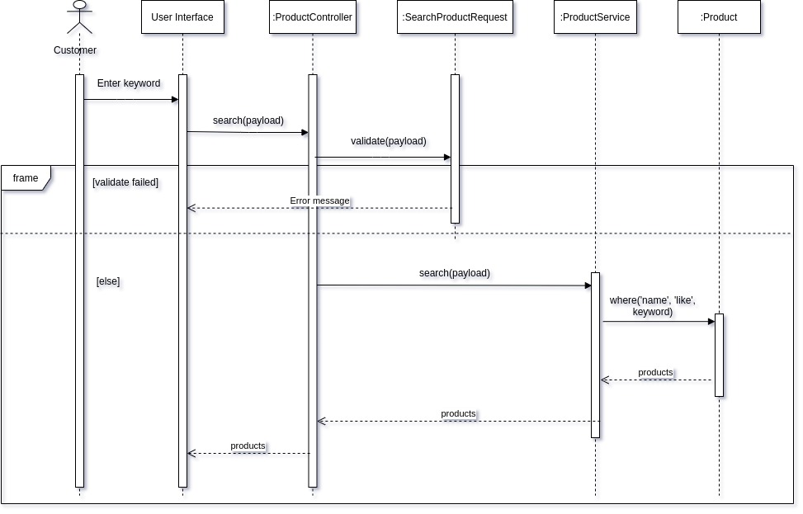
Figure 3.4: Search items sequence diagram.
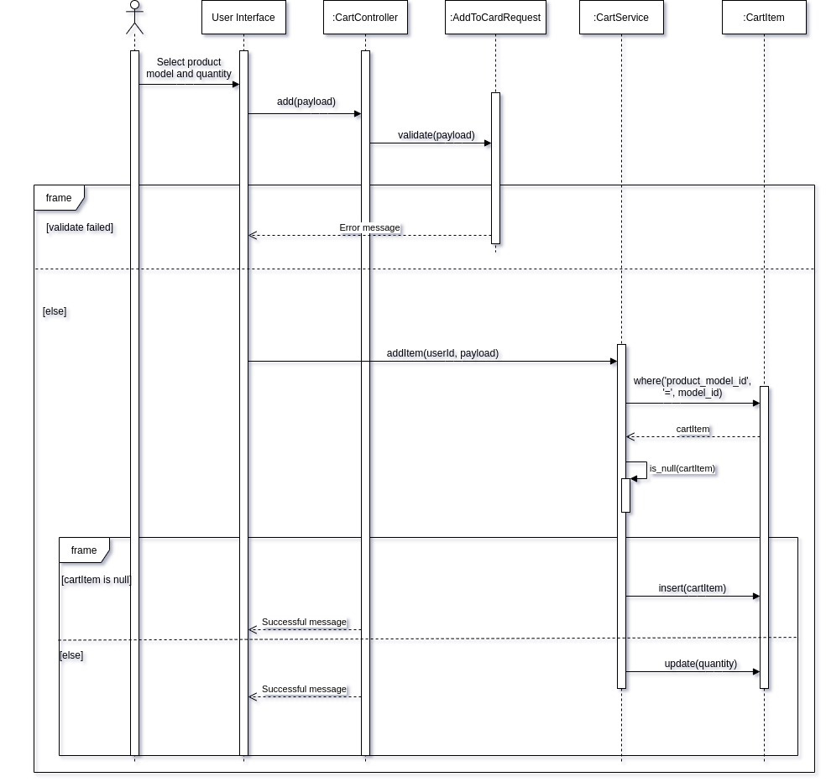
Figure 3.5: Add item to cart sequence diagram.
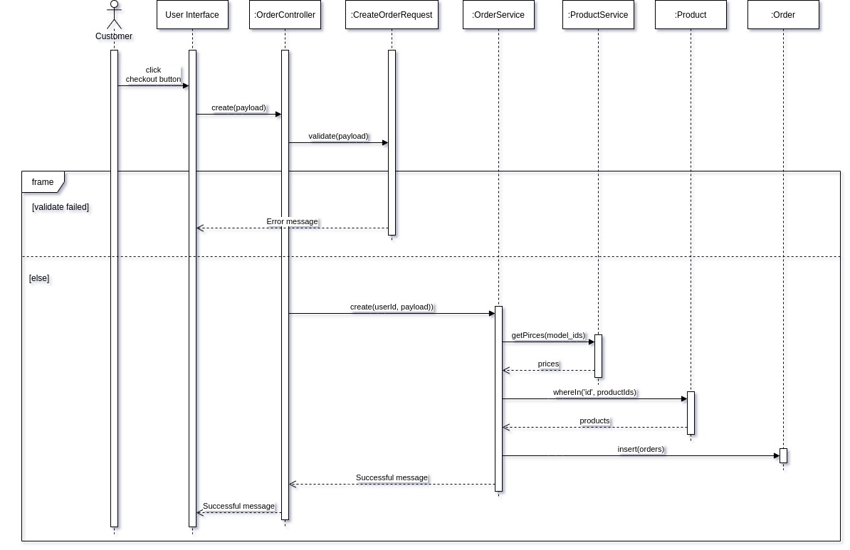
Figure 3.6: Create Order sequence diagram.

3.2.3 Entity Relationship Diagram and Database Schema:

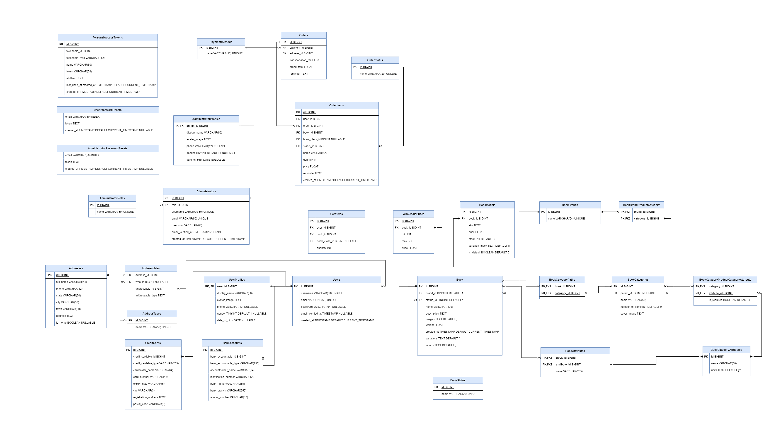 Figure 3.7: Database Schema.
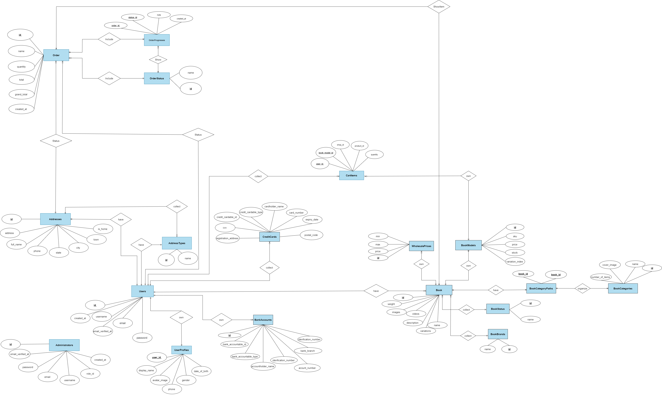

Figure 3.8: ERD diagram.

4 System Implementation

5 Conclution
5.1 List of accomplish work
After a long time of creating and developing book store websites, my team is almost done with the functions and the user interface is quite good to be able to use. Some typical functions include:
• Log in / log out.
• Search product.
• Add/delete product.
• Create/Update/Delete product.
• Update profile for user.
• Create/cancel Order.
• Create/update/delete category.

5.2 Strenght and Weakness
Documentation skills
I always had a feeling that I am not good at documentation .But through this project and suggestions from my committee members I believe that I have improved my documentation skills.
Programming:
The Online Book Store Project helped me to improve my confidence level in Javascript programming. Though I have made many mistakes during the initial phase I have learnt how to use user controls, master pages, data grid, data set and other data base
functionalities.
Weaknesses:
The website is full of core functions, but compared to a real website, I think this website has quite a few functions. Simplicity is a strength but also a weakness. Because in some cases, the simplicity can also be boring for customers to use.

5.3 Feature work:
- In the future, my team will continue to create more functions for the website to be able to create diversity when using.

