- Blue-green-Deployment
Blue-Green Deployment Project
Prerequisites
- Docker Desktop
- Minikube
- kubectl
- Helm
- Node.js
- Git
Project Setup
1. Clone the Repository
git clone <your-repository-url>
cd blue-green-project
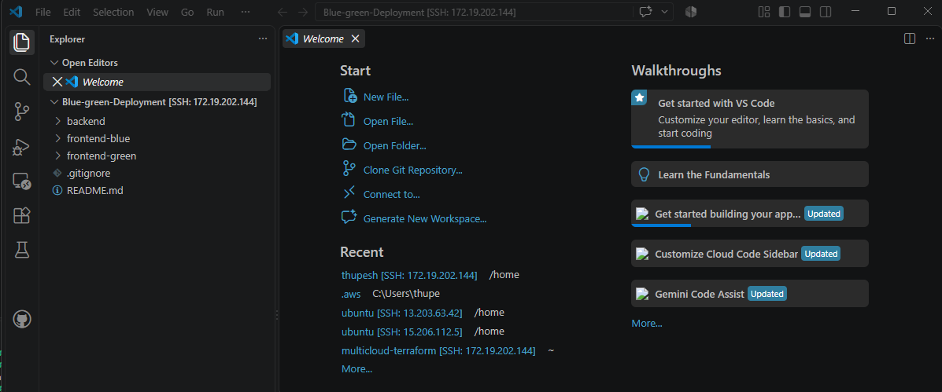
2. Local Development
Backend Setup
- Navigate to backend directory
- Install dependencies
cd backend
npm install

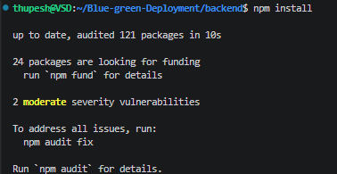
- Create .env file with:
PORT=5000
MONGO_URI=your-mongodb-connection-string
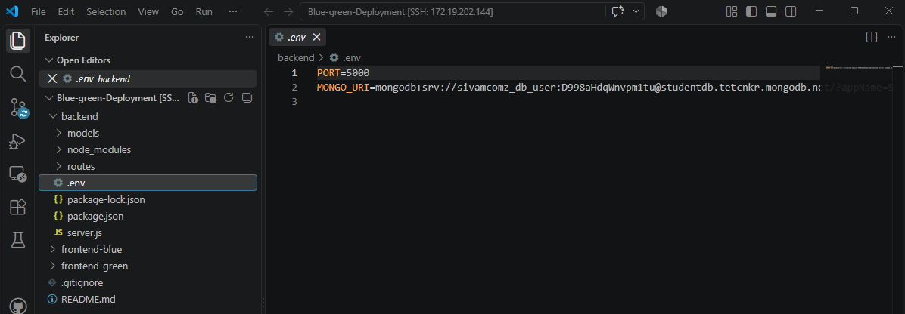
- Start backend server
npm start
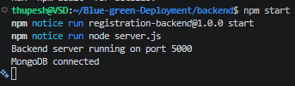

Frontend Setup
- Setup Blue Frontend
cd frontend-blue
npm install
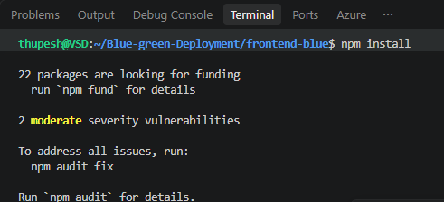
- Create .env file:
PORT=3100
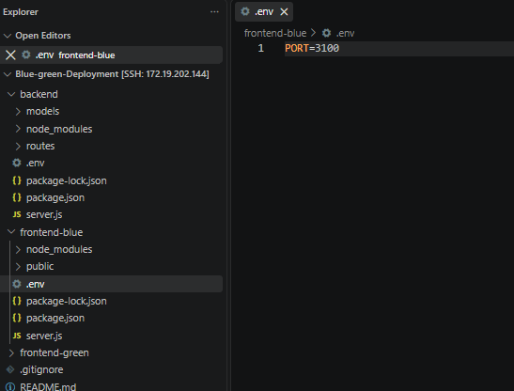
- Start blue frontend
npm start
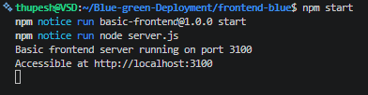
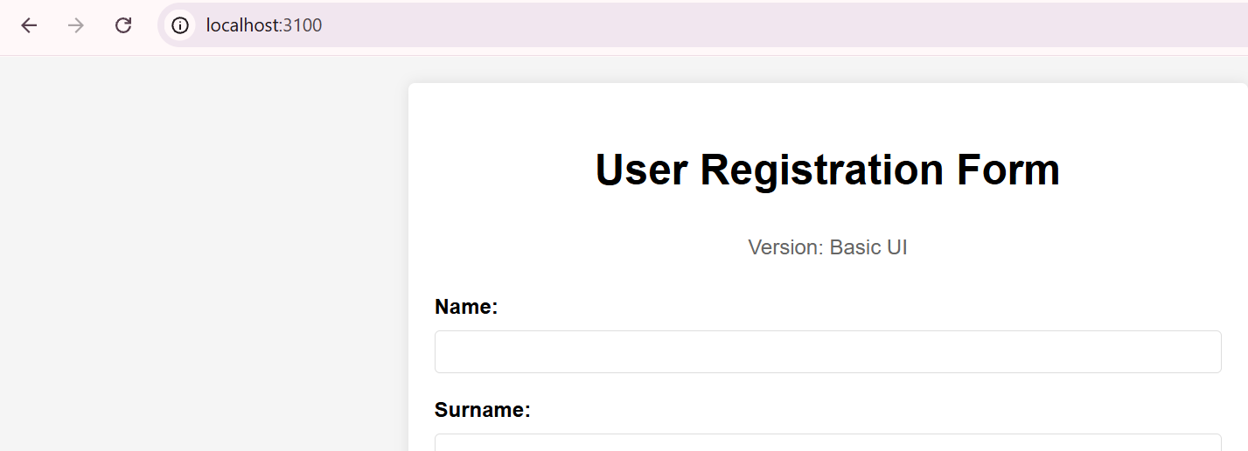
- Setup Blue Frontend
cd frontend-green
npm install
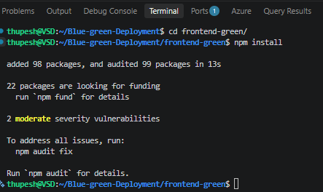
- Create .env file:
PORT=3200
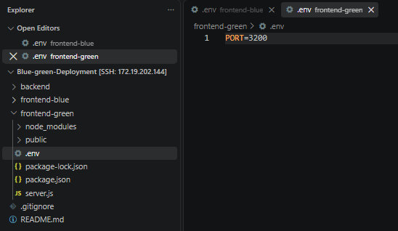
- Start green frontend
npm start
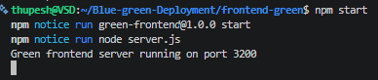
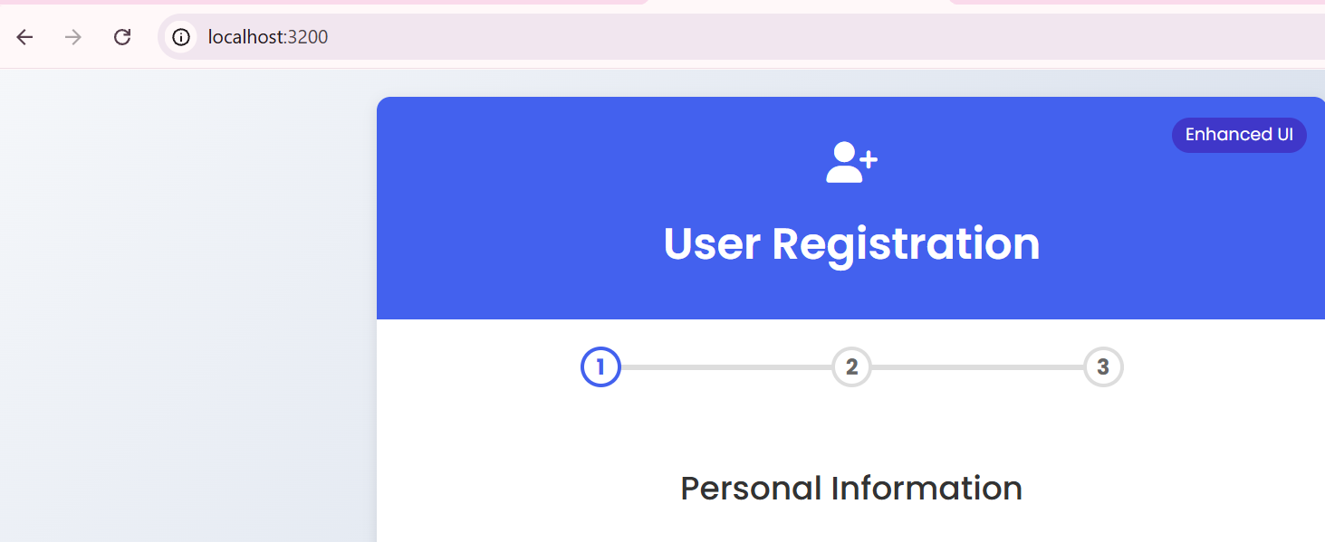

Dockerization
Build Docker Images
# Build Backend Image
docker build -t thupesh/backend:v1 ./backend
# Build Blue Frontend Image
docker build -t thupesh/frontend-blue:v1 ./frontend-blue
# Build Green Frontend Image
docker build -t thupesh/frontend-green:v1 ./frontend-green

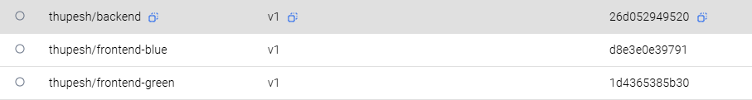
Kubernetes Deployment
Minikube Setup
- Start Minikube
minikube start --driver=docker
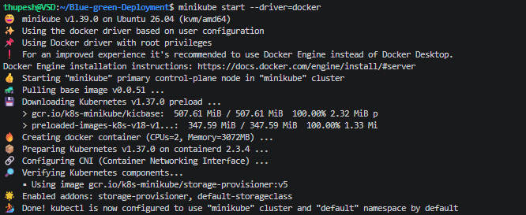
- Enable Required Addons
minikube addons enable metrics-server
minikube addons enable ingress
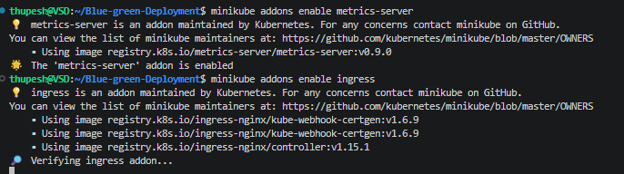
5. Create Kubernetes Manifest Files
Required Manifest Files
Create following files in k8s/ directory:
- backend-deployment.yaml
- frontend-blue-deployment.yaml
- frontend-green-deployment.yaml
- frontend-service.yaml
- ingress.yaml
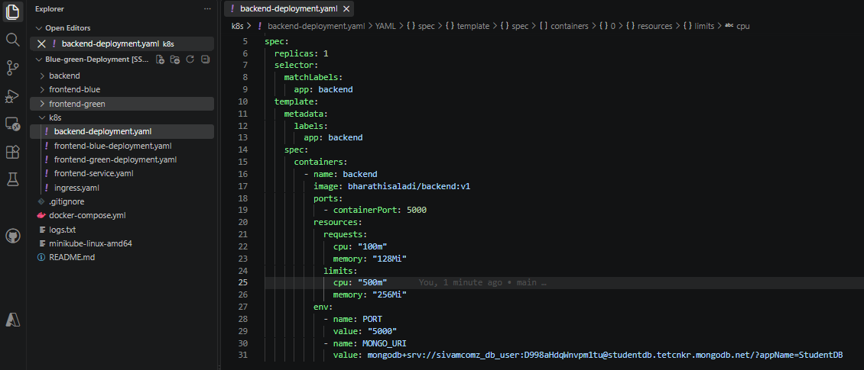
Service File Key Concepts
Your frontend-service.yaml should:
- Use selector to route traffic
- Define version (blue/green)
- Map ports correctly
6. Deploy to Minikube
# Apply all manifests
kubectl apply -f k8s/
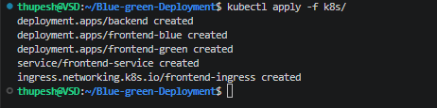
Verify deployments
kubectl get deployments
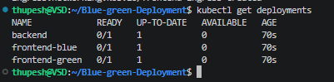
kubectl get services
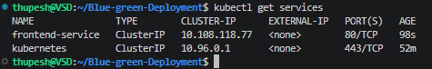
kubectl get pods
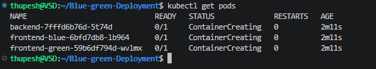
Switch Traffic Methods
- Basic Patch Command
# Switch to Green
kubectl patch service frontend-service -p '{"spec":{"selector":{"version":"green"}}}'
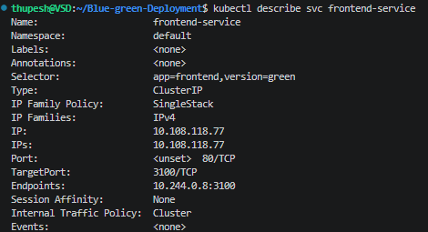
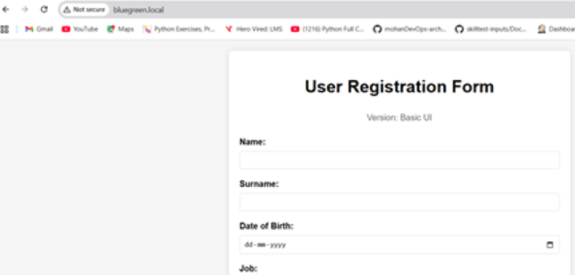
Switch back to Blue
kubectl patch service frontend-service -p '{"spec":{"selector":{"version":"blue"}}}'
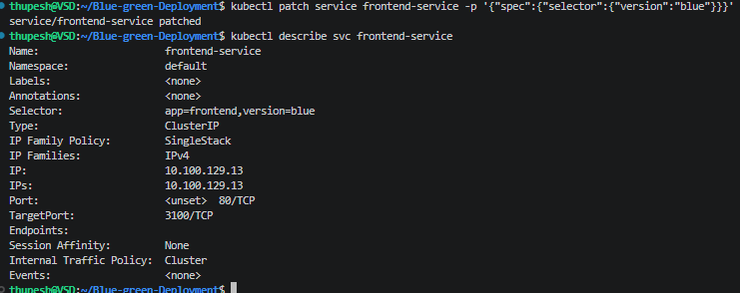
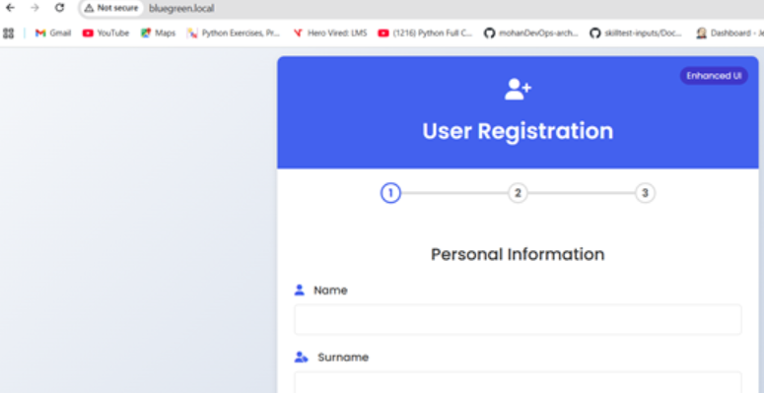
8. Verification
- Check service endpoints
- Verify traffic routing
- Monitor application logs
Troubleshooting
- kubectl get pods - Check pod status
- kubectl logs <pod-name> - View logs
- kubectl describe service frontend-service - Service details
Cleanup
# Remove deployments
kubectl delete -f k8s/
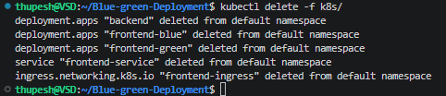
Stop Minikube
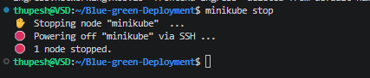
Flow Explanation
- Deploy Current Version (Blue)
  - Blue environment is live and serving production traffic.
  - Users interact with Blue while Green is idle.
- Prepare New Version (Green)
  - Deploy new release to Green environment.
  - Validate functionality, run integration tests, and monitor logs.
- Switch Traffic
  - Update Kubernetes service selector (or load balancer) to route traffic to Green.
  - Users now interact with the new version seamlessly.
- Monitor & Validate
  - Check metrics, logs, and user feedback.
  - Ensure stability and performance.
- Rollback if Needed
  - If issues arise, patch service back to Blue.
  - Instant recovery without downtime.

Best Practices
- Automate Deployment: Use CI/CD pipelines to build, test, and deploy consistently.
- Health Checks: Configure readiness and liveness probes in Kubernetes.
- Monitoring: Use Prometheus, Grafana, or ELK stack to track metrics and logs.
- Database Strategy: Ensure backward-compatible schema changes to avoid breaking migrations.
- Traffic Gradualism: Consider canary releases before full switch.
- Rollback Plan: Always keep Blue environment intact until Green is fully validated.
- Documentation: Record switch commands, troubleshooting steps, and verification procedures.

