Step 1: Sign in and choose the subscription
Step 2: Set variables and 3:Create the resource group
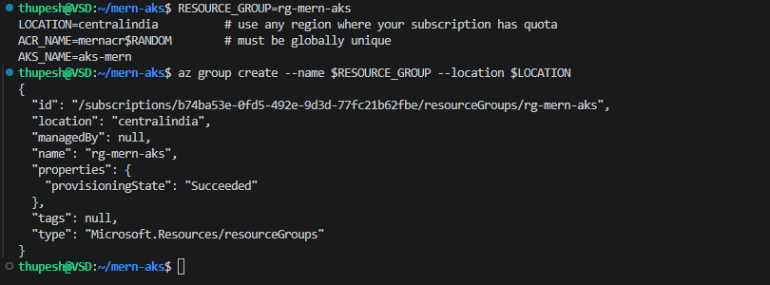
Step 4: Create Azure Container Registry
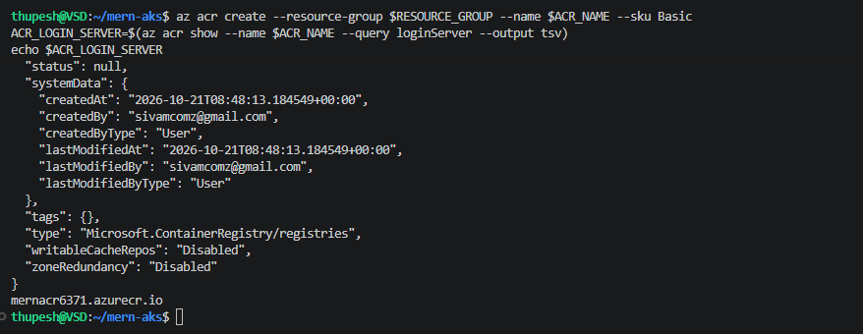
Step 5: Clone this repository
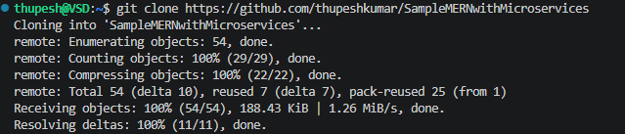

Step 6: Build and push the three images with ACR Tasks
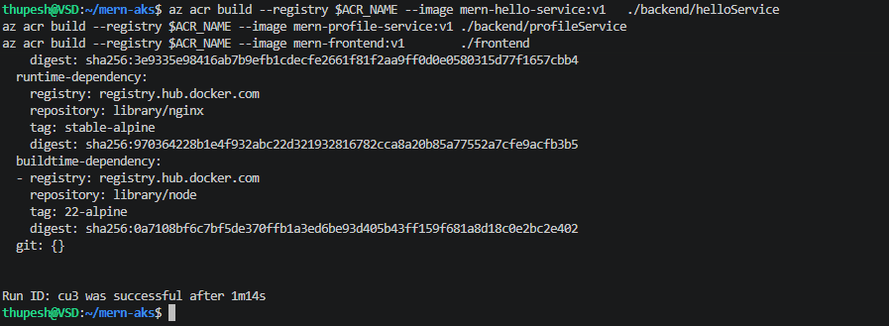

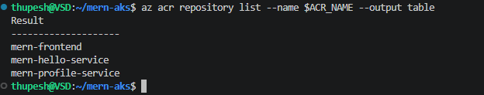
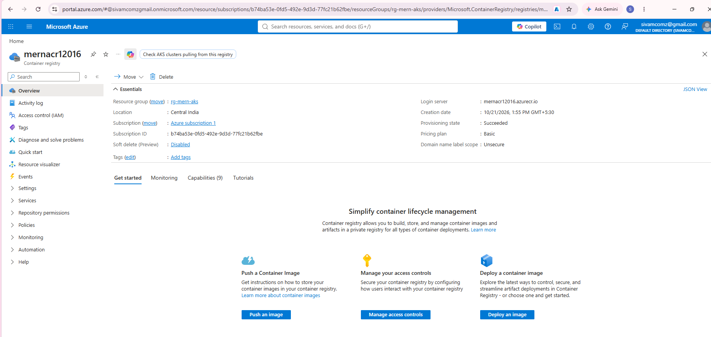

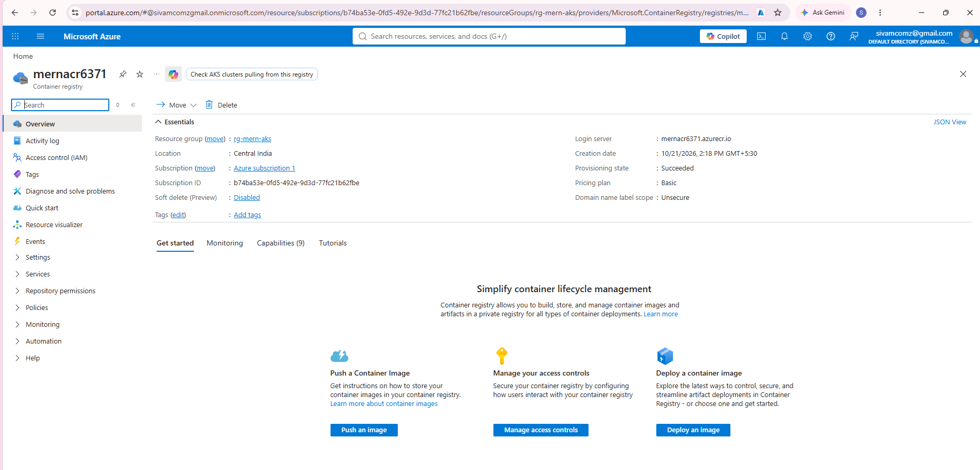

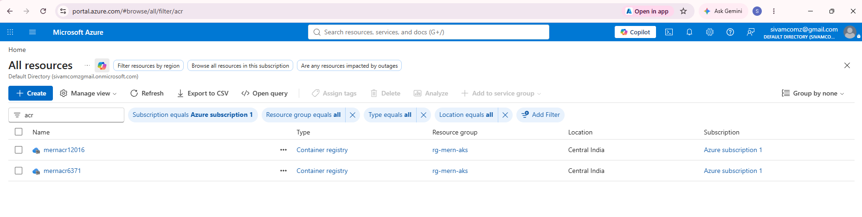
Step 7: Create the AKS cluster
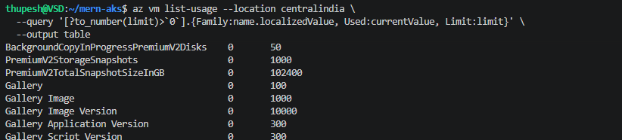

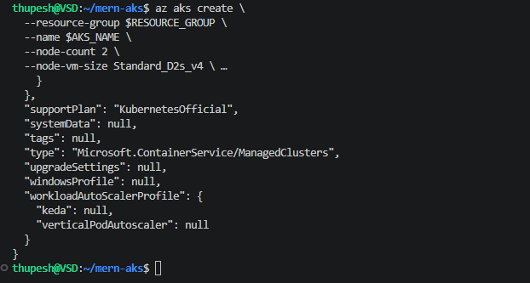
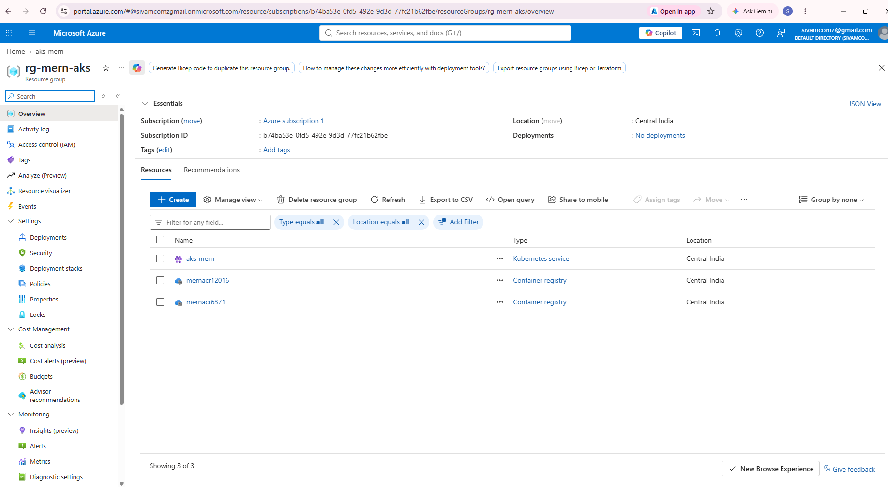
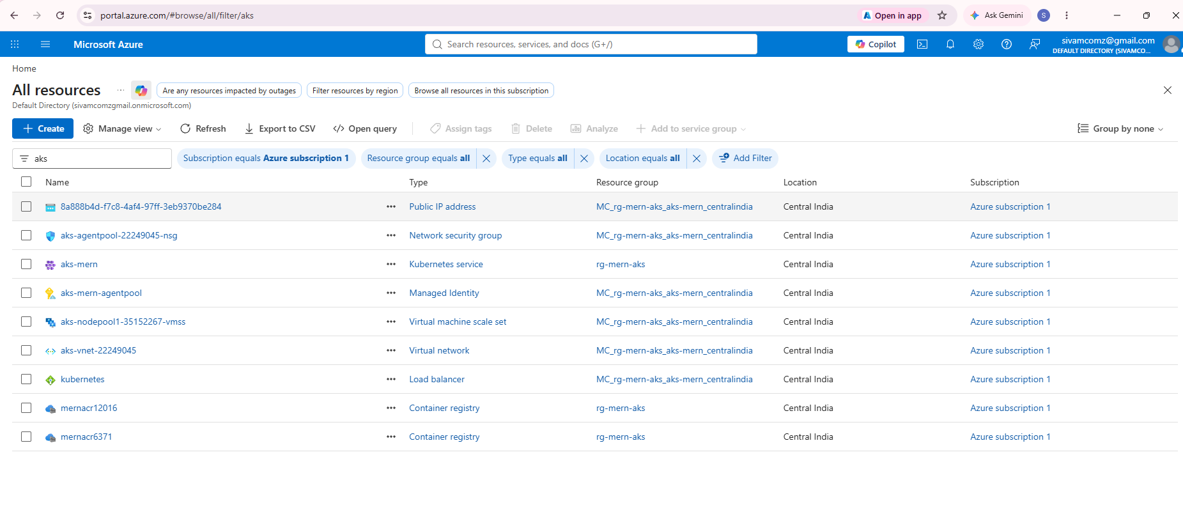
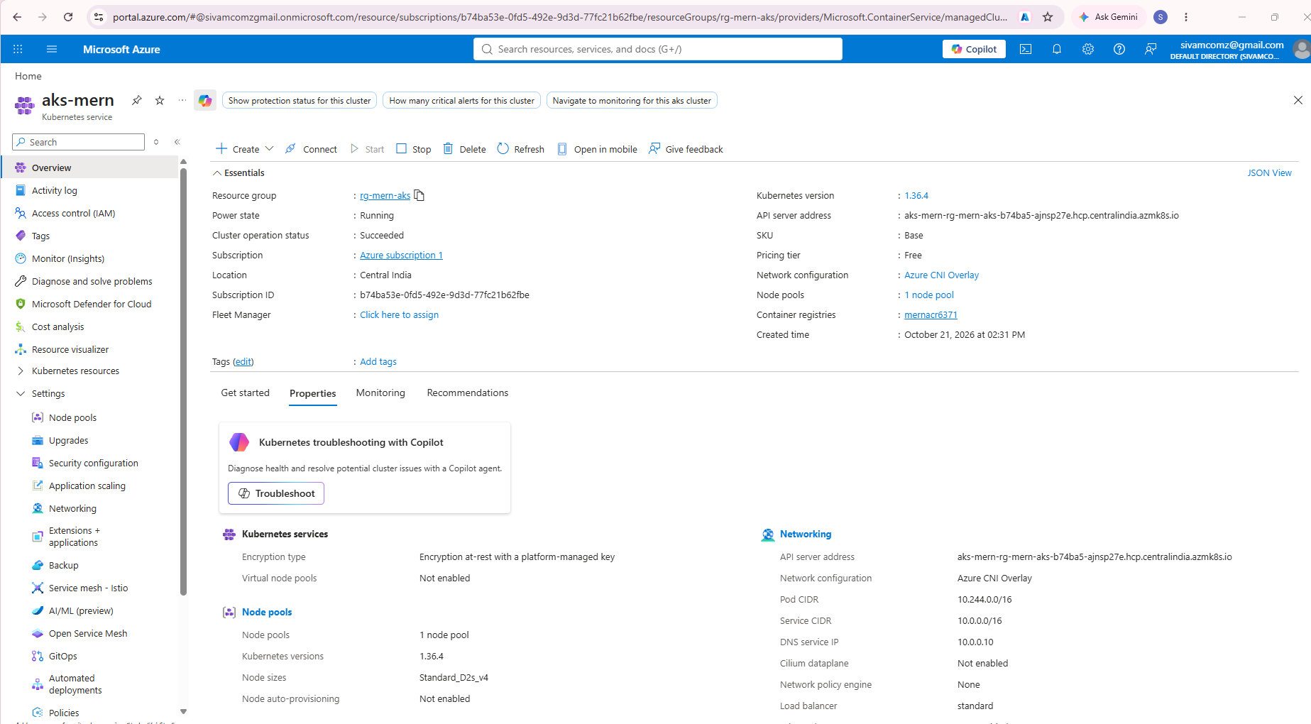
Step 8: Connect `kubectl` to the cluster
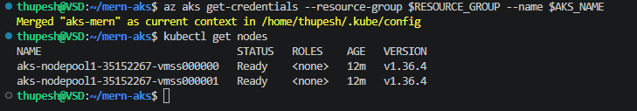

Step 9: Create the namespace and secrets
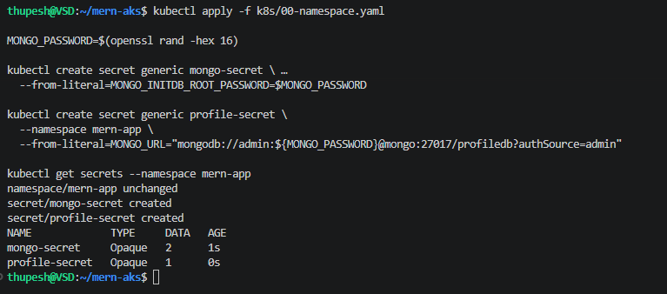
Step 9: namespace and secrets
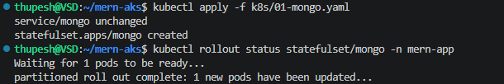
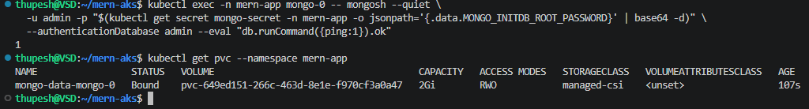
Step 10: MongoDB running with a bound volume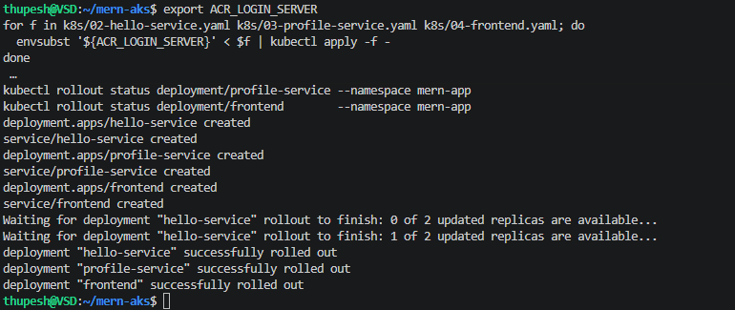
Step 12: Verify all resources
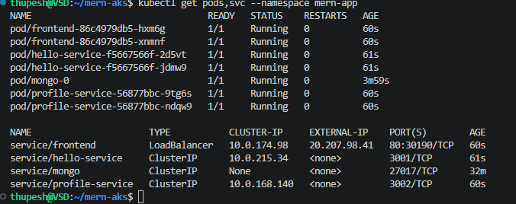
Step 13: Get the public IP
Step 13: external IP assigned
Step 14: Open the application
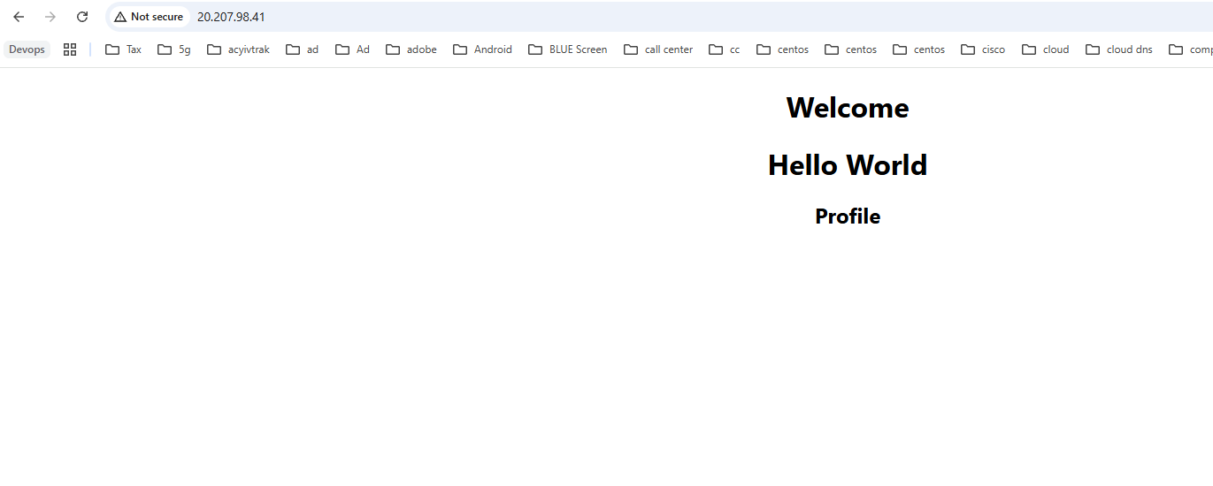
Step 15: Add data and confirm the database works
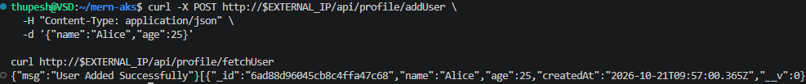
Step 15: Add data and confirm the database works
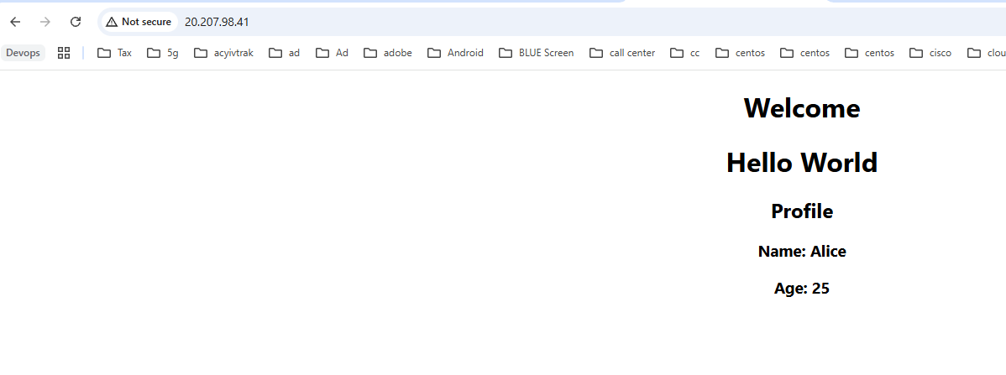
Step 16: Check logs
Step 17: Scale a service
Step 18: Roll out a new version
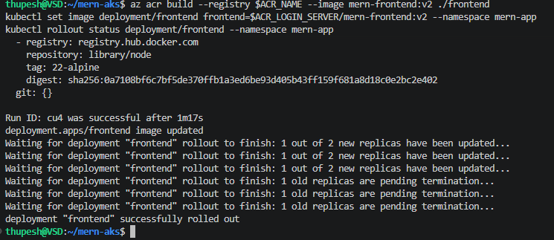

Step 19: Clean up
Deleting the resource group removes the cluster, registry, disks, and load balancer, so nothing keeps billing.

Troubleshooting
| Symptom | Likely cause | What to check |
|---|---|---|
| Pod in `ImagePullBackOff` | Cluster cannot pull from ACR, or wrong image name | `kubectl describe pod <pod> -n mern-app`; confirm the cluster was created with `--attach-acr`, or run `az aks update -g $RESOURCE_GROUP -n $AKS_NAME --attach-acr $ACR_NAME` |
| Image name shows `${ACR_LOGIN_SERVER}/...` | Manifest applied without `envsubst` | Re-run Step 11 |
| `profile-service` in `CrashLoopBackOff` | Cannot reach or authenticate to MongoDB | `kubectl logs deployment/profile-service -n mern-app`; confirm the `mongo-0` pod is `Running` and the secrets exist |
| `mongo-0` stuck in `Pending` | Volume not provisioned | `kubectl describe pvc -n mern-app`; confirm the `managed-csi` storage class exists (`kubectl get storageclass`) |
| `EXTERNAL-IP` stays `<pending>` | Load balancer still being created | Wait a few minutes; `kubectl describe svc frontend -n mern-app` |
| Page loads but Profile is empty / API errors | Backend not reachable from nginx | `kubectl logs deployment/frontend -n mern-app`; check both backend services have endpoints: `kubectl get endpoints -n mern-app` |
| `frontend` pod restarts with "host not found in upstream" | Frontend started before the backend Services existed | Apply Step 11 files together as shown, or `kubectl rollout restart deployment/frontend -n mern-app` |

Notes and limitations

- **MongoDB runs inside the cluster as a single replica.** That is appropriate for this assignment; for production you would use a managed database (Azure Cosmos DB for MongoDB or MongoDB Atlas) and point `MONGO_URL` at it.
- **The site is served over plain HTTP** on the load balancer's public IP. For HTTPS you would add an ingress controller with a certificate and a DNS name.
- Images use a fixed `v1` tag for clarity; in a real pipeline each build would get a unique tag (for example the git commit SHA).

