Multi Cloud Deployment and Management with Terraform
Student names: Thupeshkumar
Submission date: 23 October 2026
Source repository: https://github.com/thupeshkumar/multi-cloud-project
1 Project Overview
This project demonstrates the deployment and management of infrastructure across Amazon Web Services, Microsoft Azure and Google Cloud using Terraform. Provider-specific modules define virtual machines, networking, security rules and object storage. Each virtual machine hosts an Nginx website with a provider-specific health endpoint.
Cloudflare manages DNS for app.thupesh.com. A Python controller running on the local workstation checks the application endpoints and updates the DNS record to select a healthy cloud provider. Prometheus and Grafana run locally through Docker Desktop to collect and display application health and response-time metrics.
The project prioritizes eligible free-tier allowances, trial credits and limited resource usage. Costs depend on each account’s eligibility, resource configuration and usage.
2 Project Objectives
- Automate infrastructure provisioning across AWS, Azure and GCP using Terraform.
- Maintain reusable configurations through separate cloud-provider modules.
- Demonstrate active-passive application failover using health checks and DNS updates.
- Monitor application availability and response time through a centralized dashboard.
- Demonstrate PostgreSQL backup and storage across multiple cloud providers.
- Maintain source-code history and automatic configuration checks through GitHub Actions.
- Document deployment restrictions, recovery behavior and cost considerations.
3 Revised Architecture
Layer | Implementation
Public application endpoint | http://app.thupesh.com
DNS provider | Cloudflare Free DNS with one DNS-only A record
Failover controller | Local Python script using the Cloudflare API
Primary application origin | AWS EC2 in us-east-1
Secondary application origin | Azure VM in West US 2
Third application origin | GCP Compute Engine in us-central1
Application | Nginx website with a provider-specific /health endpoint
Backup storage | Private AWS S3, Azure Blob Storage and Google Cloud Storage
Monitoring | Prometheus, blackbox exporter and Grafana running locally through Docker Desktop
Version control and validation | GitHub and GitHub Actions
Application routing preference: AWS → Azure → GCP.
The controller selects one origin at a time. This provides active-passive DNS failover rather than simultaneous traffic distribution across all three clouds.
Cloud Resource Configuration
Provider | Region | Compute Resource | Storage | Database Scope
AWS | us-east-1 | EC2 t3.micro | Private S3 bucket | RDS PostgreSQL is an optional managed database exercise
Azure | West US 2 — westus2 | VM Standard_D2als_v7 with an x86-64 Ubuntu image | Private Blob Storage container | Azure SQL is an optional managed database exercise
GCP | us-central1 | Compute Engine e2-micro | Private regional Cloud Storage bucket | PostgreSQL 16 running in Docker on the VM
Managed databases are separate from the baseline static website. Their deployment and successful testing should be supported by screenshots and recorded results before being reported as completed features.
4 Azure Region and VM Configuration Change
The original Azure design used East US with Standard_B1s. Deployment failed because the requested VM size was unavailable due to capacity restrictions.
An alternative size, Standard_B2pts_v2, was also blocked because the subscription’s Bpsv2-family CPU quota was zero in East US.
The revised design therefore uses West US 2 with Standard_D2als_v7. This AMD-based VM requires an x86-64 Ubuntu image rather than an ARM image. The virtual network, network interface, public IP address, network security group and virtual machine must use compatible regional configurations.
Standard_D2als_v7 is outside the advertised free VM allowance. Its usage must be covered by eligible trial credits or the project budget. Regional availability and sufficient CPU quotas must be checked before deployment.
5 Cost Optimization and Service Restrictions
Component | Cost Optimization Approach | Restriction or Consideration
AWS | Use a small EC2 instance, limited storage and short demonstration periods. | Confirm current account allowances and credits. Compute, public IPv4, storage, database services and transfers may incur charges.
Azure | Use the available VM configuration for the demonstration and review spending regularly. | The selected D-series VM is not covered by the advertised free VM allowance. Disks and public IP addresses require separate cost checks.
GCP | Use an eligible regional e2-micro configuration and a small dataset. Run PostgreSQL in Docker on the VM. | Compute allowances do not automatically cover all networking, storage or transfer costs. The database shares the VM’s limited resources.
Cloudflare | Use Free DNS and implement failover decisions in a local Python controller. | Cloudflare’s managed Load Balancing and automatic health-based failover are separate paid capabilities.
Prometheus and Grafana | Run both locally through Docker Desktop. | Monitoring depends on the local computer, Docker Desktop and internet connectivity remaining available.
Object storage | Store small dummy backup files in private buckets and containers. | Storage allowances are usage limits, not reserved bucket capacities. Operations and transfers may also be charged.
Credentials | Use authenticated cloud CLI sessions and keep secrets outside version control. | Vault is not implemented in the baseline project and is not claimed as a completed feature.
Budget alerts provide spending notifications and should not be treated as guaranteed spending caps. Unneeded resources should be removed after the demonstration.
6 DNS Failover Design
Cloudflare hosts a single DNS-only A record for app.thupesh.com. The local controller probes each cloud VM directly and validates its HTTP response.
The required health responses are:
Provider | Expected Response
AWS | healthy aws
Azure | healthy azure
GCP | healthy gcp
The controller requires three consecutive successful checks before qualifying an origin and three consecutive failed checks before abandoning the active origin. A cooldown reduces frequent switching.
During the recorded AWS outage test, the controller selected Azure after three consecutive AWS failures while Azure and GCP remained healthy. Client-visible recovery must be verified separately because DNS caching can delay when users reach the new destination.
If all origins are unhealthy, the controller leaves the existing DNS record unchanged. The system therefore depends on at least one healthy origin and an operational local controller.
7 Local Monitoring and Alerting
To reduce project costs, Prometheus and Grafana run locally in Docker containers using Docker Desktop instead of additional cloud-hosted servers.
The blackbox exporter probes the AWS, Azure and GCP application endpoints. Prometheus collects the results, and Grafana presents them in a centralized dashboard.
The dashboard displays:
- Application health for each cloud provider.
- HTTP probe duration and response status.
- Availability history and observed successful-probe percentage.
- Monitoring scrape health and alert state.
These metrics describe application reachability and response time. CPU, memory, disk, database, object-storage and billing metrics require additional exporters or cloud integrations.
Slack notifications can be configured through a Grafana contact point and Grafana-managed alert rules. Successful notification delivery should be demonstrated before being recorded as a completed integration.
8 Backup and Recovery Scope
The database exercise uses PostgreSQL 16 running in Docker on the GCP VM. A database dump can be copied to the local workstation and uploaded to private storage in AWS, Azure and GCP.
Backup verification includes checking the archive, comparing file checksums and restoring into a separate empty PostgreSQL database to validate the recovered rows.
Backup copies do not provide continuous database replication. PostgreSQL and Azure SQL use different database engines, so a PostgreSQL dump cannot be restored directly into Azure SQL. Application DNS failover and database recovery are evaluated separately.
9 Repository Structure
multi-cloud-project/
├── .github/
│ └── workflows/
│ └── validate.yml
├── .gitignore
├── bootstrap/
│ ├── aws.sh
│ ├── azure.sh
│ └── gcp.sh
├── terraform/
│ ├── main.tf
│ ├── versions.tf
│ ├── terraform.tfvars.example
│ └── modules/
│ ├── aws/
│ ├── azure/
│ └── gcp/
├── failover/
│ ├── failover.py
│ └── origins.example.json
├── monitoring/
│ ├── compose.yml
│ ├── prometheus.yml
│ ├── blackbox.yml
│ └── alerts.yml
├── database/
│ └── compose.yml
├── tests/
│ └── test_failover.py
└── README.md
GitHub maintains the project’s version history. The supplied GitHub Actions workflow checks Terraform formatting and configuration validity on pushes and pull requests. Cloud deployment is initiated manually after reviewing the Terraform plan.
Credentials, private keys, Terraform state, saved plans and database backups are excluded from version control.
10 Project Limitations
The implementation is an educational prototype with one application VM per cloud. It depends on a local workstation for failover decisions and monitoring. DNS changes are subject to caching, and existing connections are not transferred between providers.
The baseline does not provide managed load balancing, continuous cross-cloud database replication, complete infrastructure usage monitoring or production availability guarantees. Deployment screenshots, alert notifications, backup restores and recovery measurements provide the evidence needed to assess each implemented feature.

ssh-keygen -t rsa -b 4096 -f "$HOME/.ssh/multicloud"
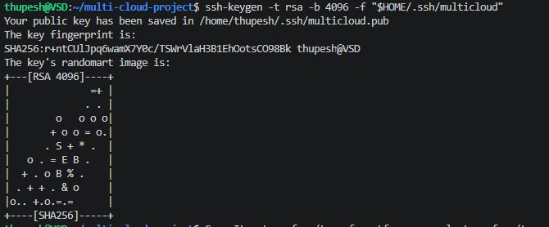
cp -r terraform/terraform.tfvars.example terraform/terraform.tfvars
terraform init
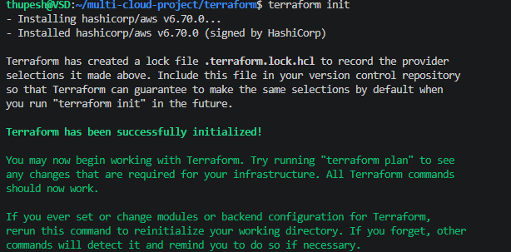

terraform validate
terraform plan -out=lab.tfplan
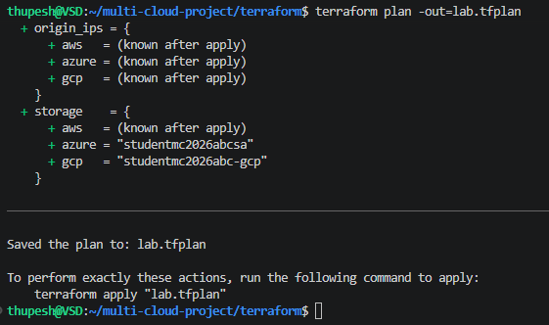
terraform show lab.tfplan
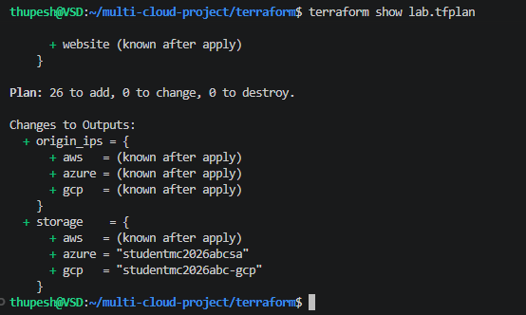

Azure Region and VM Configuration Change
The Azure deployment was initially planned for East US using Standard_B1s. Deployment failed because this VM size was unavailable due to capacity restrictions. An alternative, Standard_B2pts_v2, was also blocked because the subscription’s Bpsv2 CPU quota was zero in East US.
The revised deployment targets West US 2 using Standard_D2als_v7, which was identified as available. This VM requires the Ubuntu x86-64 image rather than the ARM image. Deployment remains subject to sufficient regional and VM-family quotas.
Standard_D2als_v7 is outside the advertised free VM allowance, so its cost must be covered by eligible trial credits or the project budget. Deployment and test results will be recorded after successful verification.
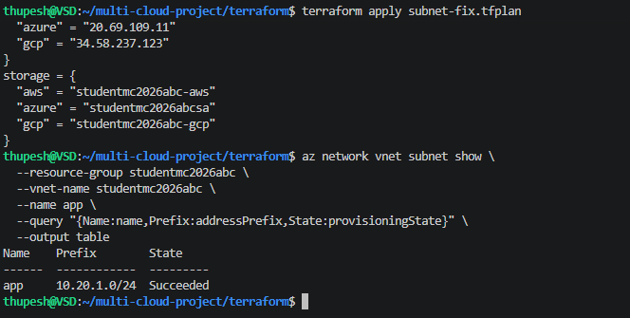
terraform output origin_ips
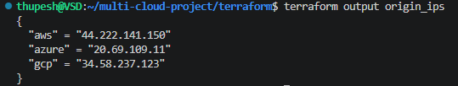
terraform output storage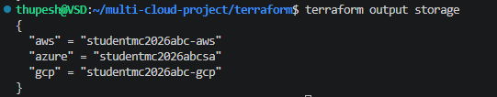
Check all three web servers
curl --max-time 10 http://184.197.92.35/health
curl --max-time 10 http://20.69.109.11/health
curl --max-time 10 http://34.41.25.119/health
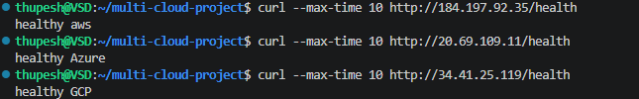
Configure Cloudflare DNS
- Add your existing domain to Cloudflare Free and complete the registrar nameserver change. Wait for the zone to be active. Preserve existing email and other DNS records.
- Add exactly one dedicated A record: name app, IPv4 = AWS origin, proxy status DNS only (grey cloud), TTL 60 seconds or the lowest supported value. Use a test subdomain, not an existing production name. Remove conflicting test AAAA or CNAME records at this same name.
- Create a Cloudflare API token with Zone → DNS → Edit, limited to this zone. Add zone read only if your discovery method needs it. Store the token locally for the session; never commit it.
- Copy Zone ID from the zone overview. To discover the record ID, use the API listing below. Keep the token out of screenshots and logs.
Add thupesh.com to Cloudflare
- Open the Cloudflare dashboard.
- Select Add a domain or Onboard a domain.
- Enter thupesh.com.
- Choose the Free plan.
- Review imported DNS records. Preserve existing website, email, MX and TXT records.
- Cloudflare will assign nameservers. At your domain registrar, replace the existing authoritative nameservers with the exact names Cloudflare provides.
- Wait until Cloudflare shows the domain as Active
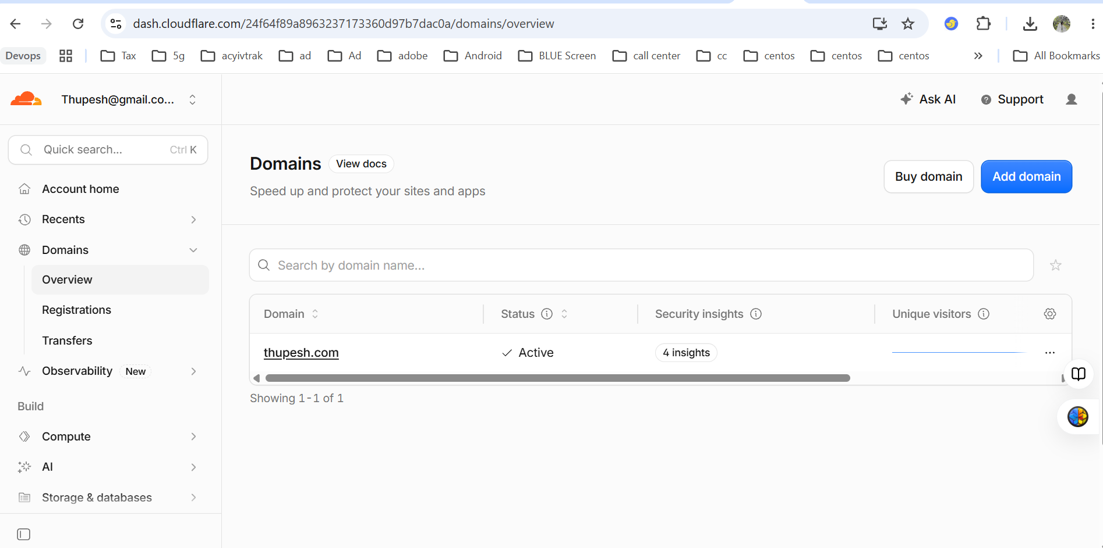
Create the project DNS record
Open thupesh.com → DNS → Records → Add record.
Enter:
Setting | Value
Type | A
Name | app
IPv4 address | 44.222.141.150
Save the record.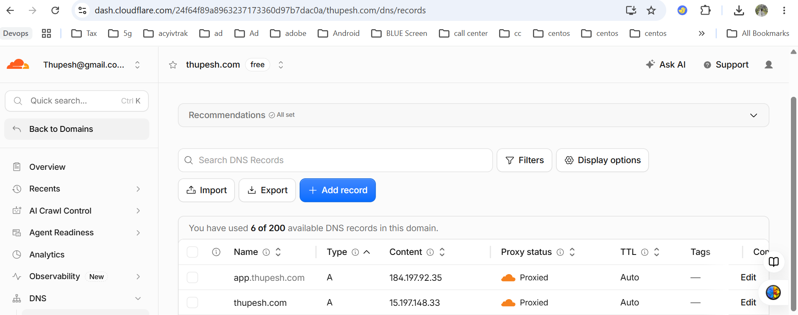
Create a scoped API token
The failover script needs permission to update your DNS record.
- Open your Cloudflare profile → API Tokens.
- Select Create Token.
- Choose Edit zone DNS → Use template.
- Set the permission to Zone → DNS → Edit.
- Under Zone Resources, select:
  - Include
  - Specific zone
  - thupesh.com
- Continue to summary and create the token.
- Copy it securely; do not paste it into this chat or your report.
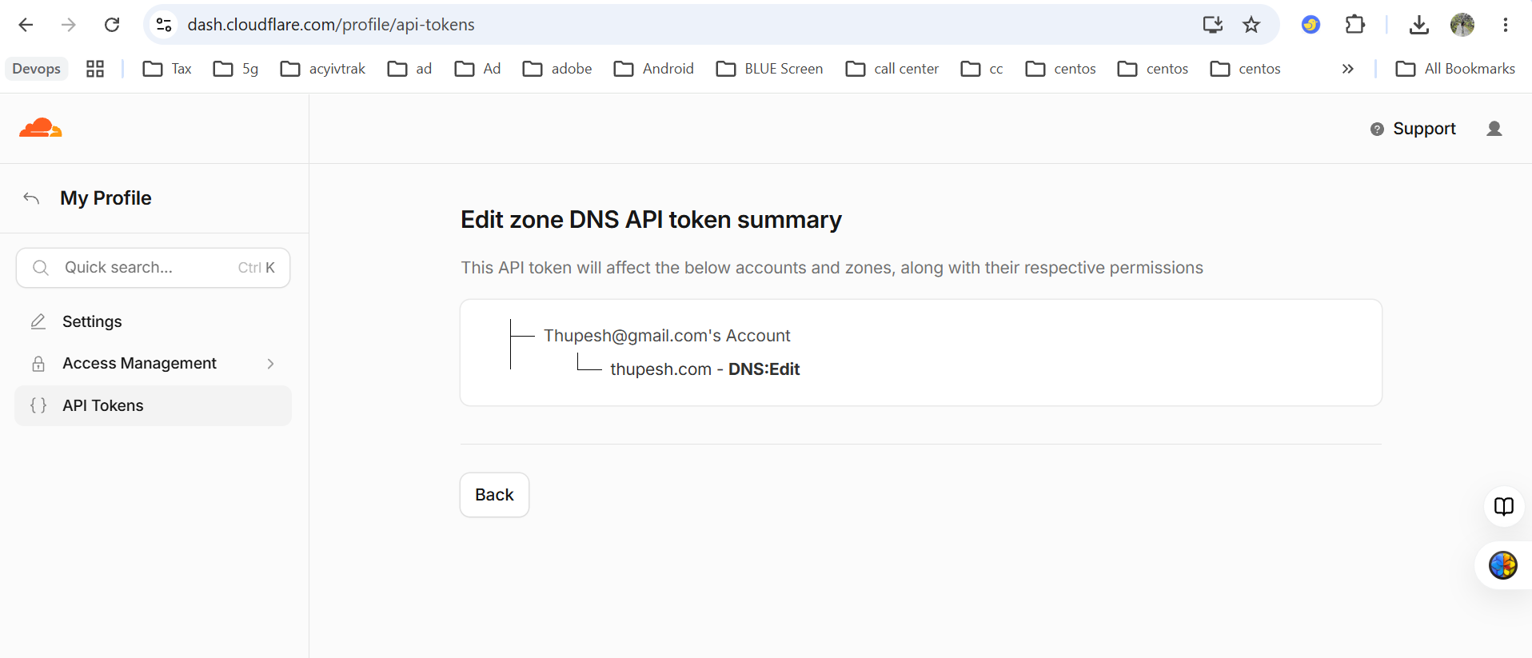
Set the token and Zone ID
Find Zone ID on the domain’s Overview page.
In your Linux terminal:
read -rsp "Cloudflare API token: " CF_API_TOKEN
echo
export CF_API_TOKEN
export CF_ZONE_ID='PASTE_YOUR_ZONE_ID'
export CF_RECORD_NAME='app.thupesh.com'
Replace only PASTE_YOUR_ZONE_ID. The token entry is hidden
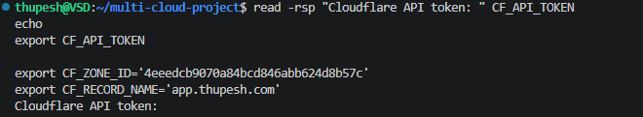
Find the DNS Record ID
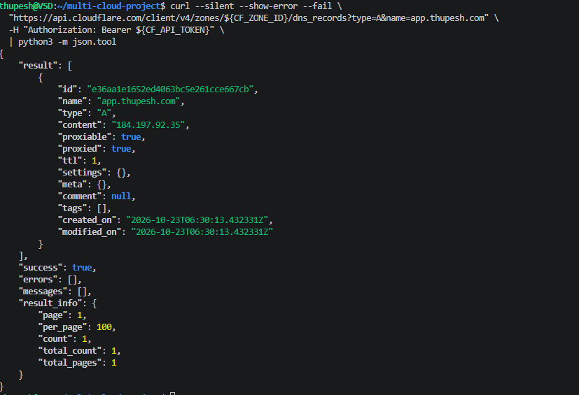
Configure three origins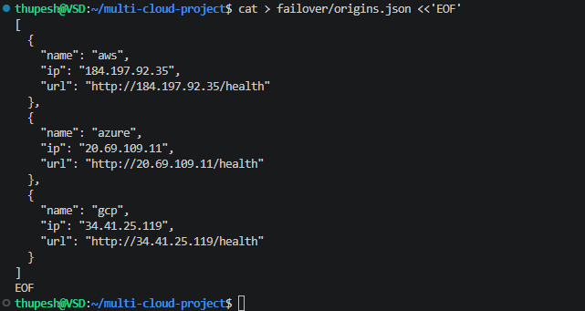
Start with a dry run
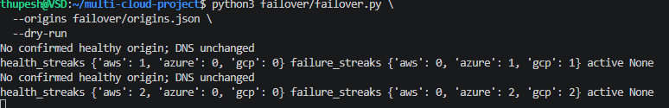
Test failover
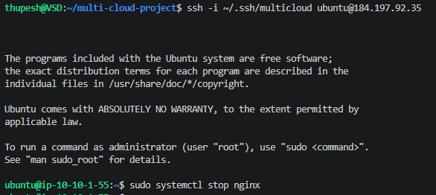
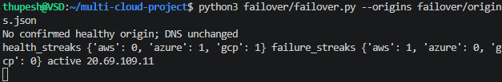
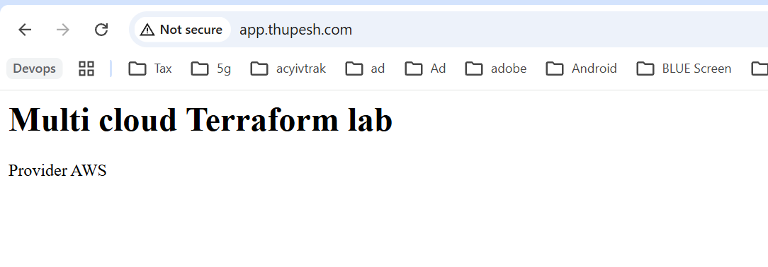
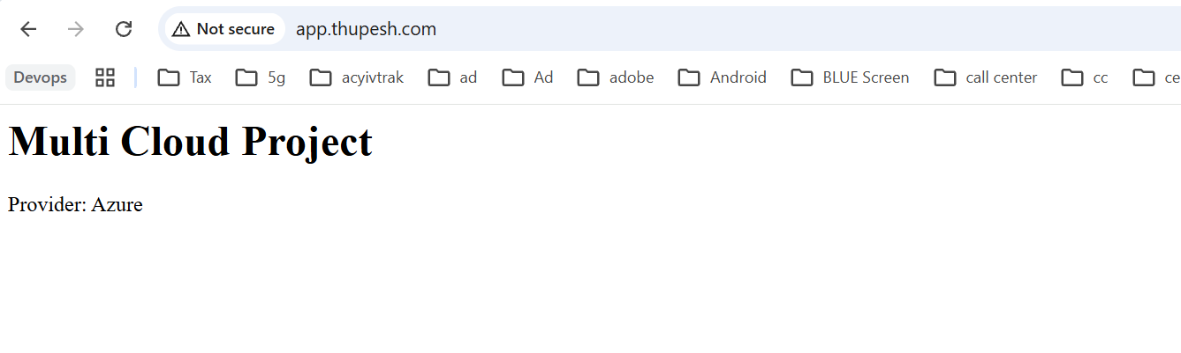
Prometheus and Grafana
To reduce project costs, Prometheus and Grafana run locally in Docker containers using Docker Desktop instead of on additional cloud-hosted servers. Prometheus collects health and response-time metrics from the AWS, Azure and GCP application endpoints, while Grafana displays them in a centralized dashboard. Monitoring remains available while the local computer and Docker Desktop are running.

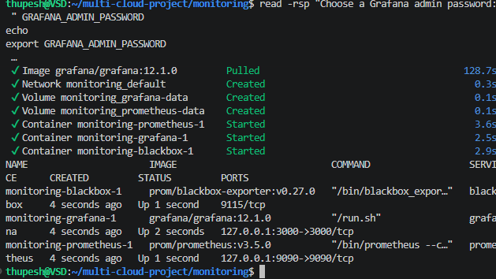
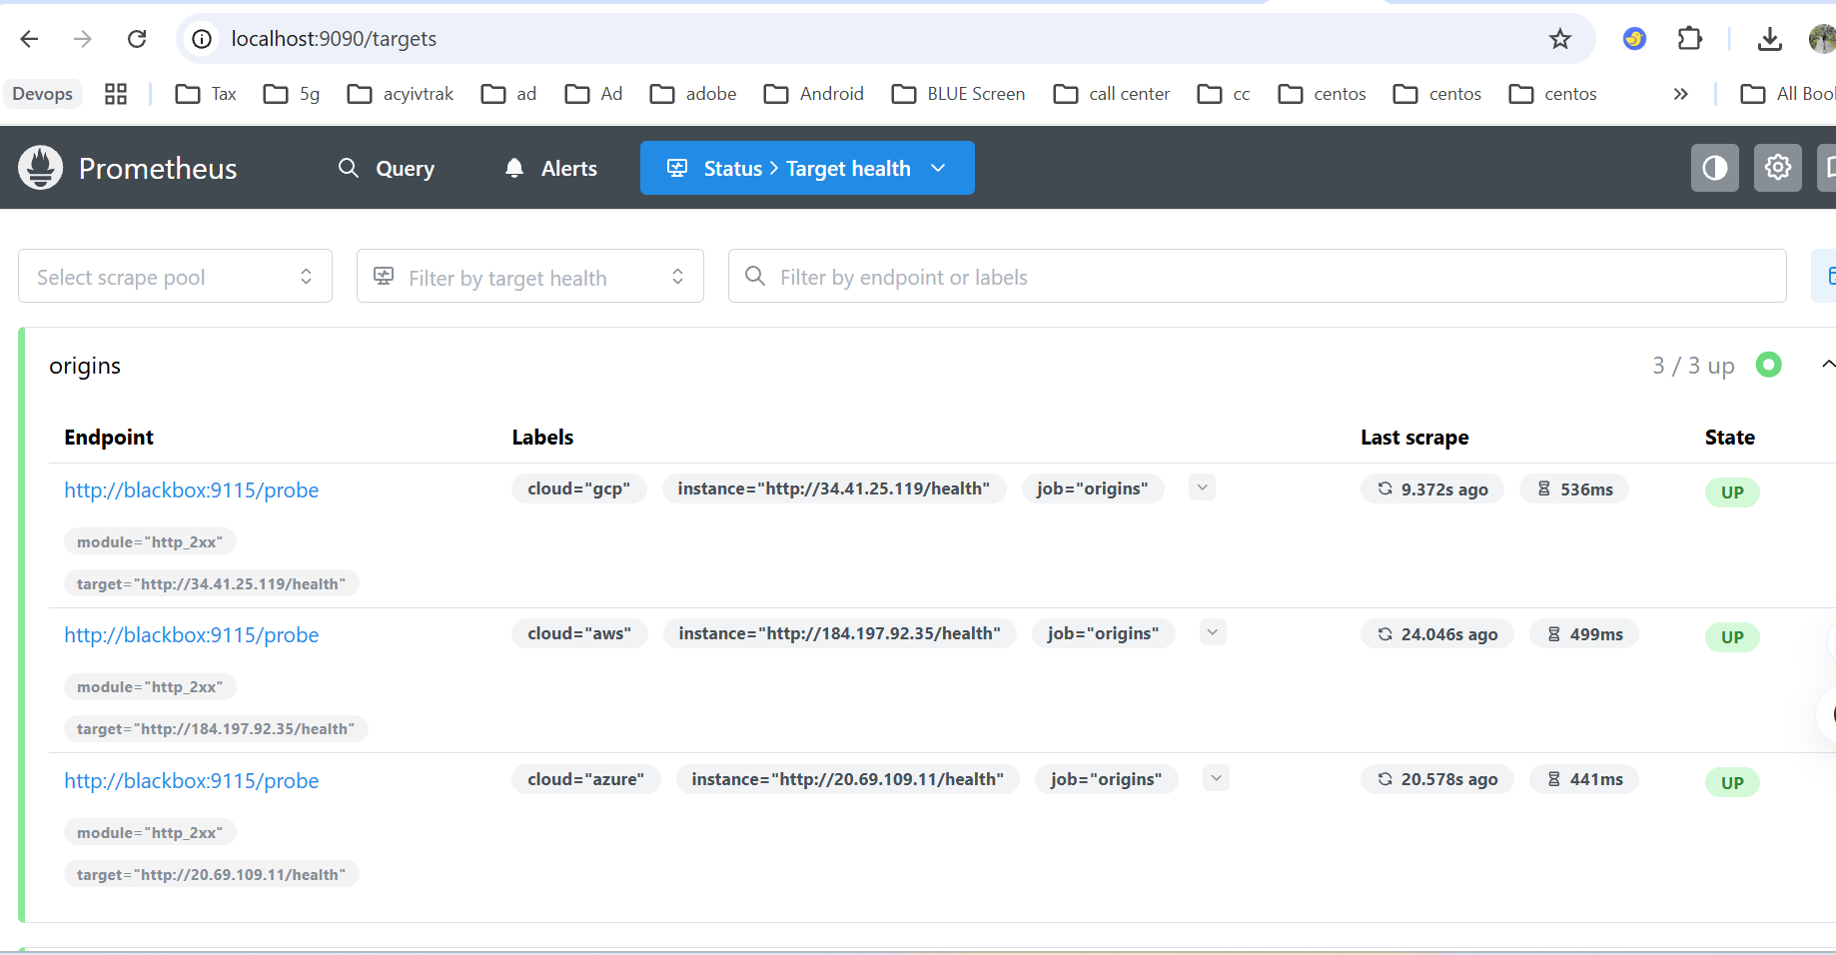
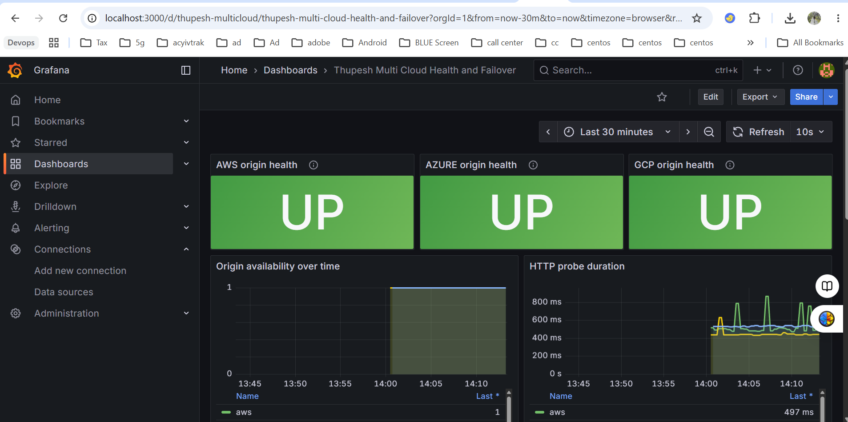
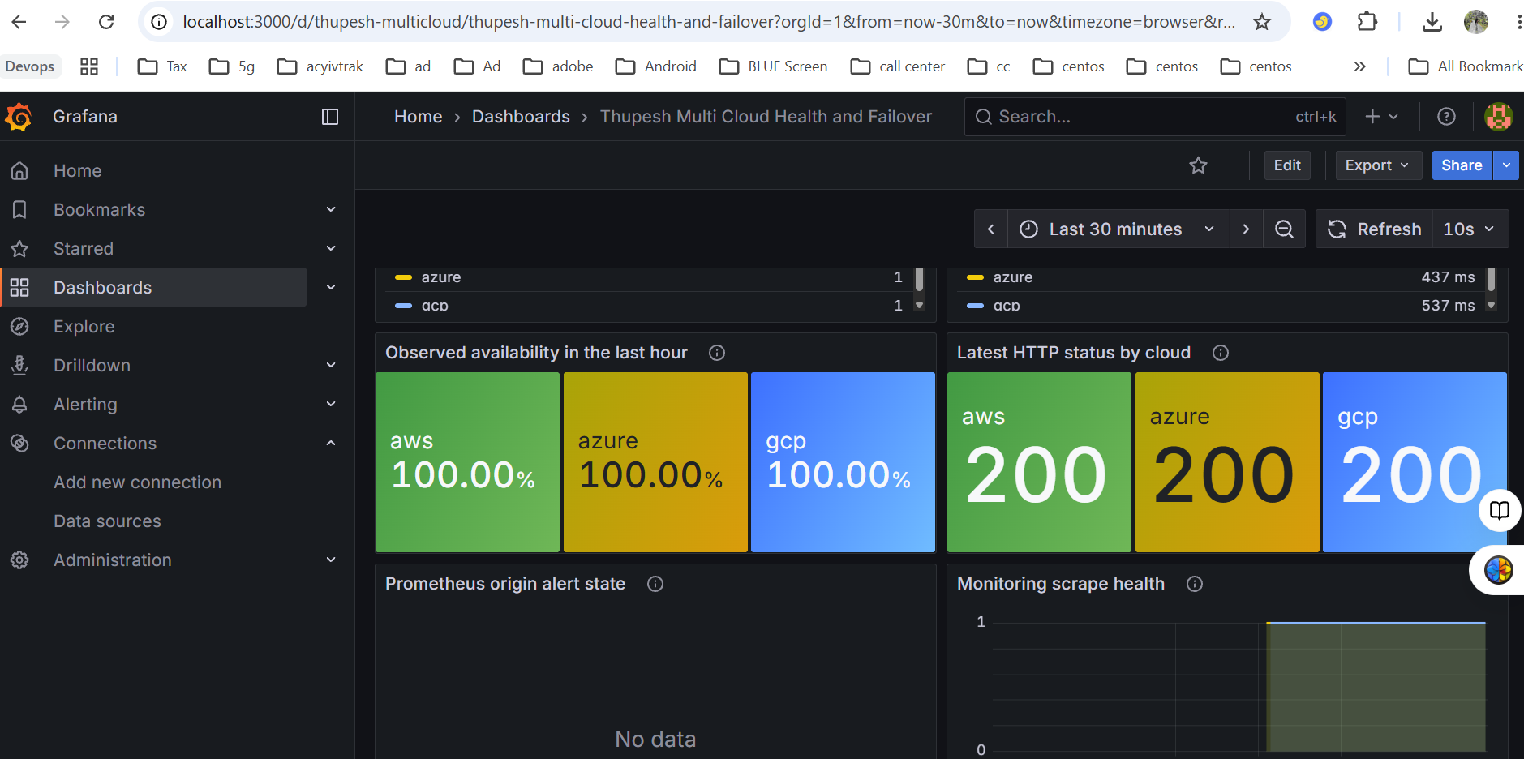
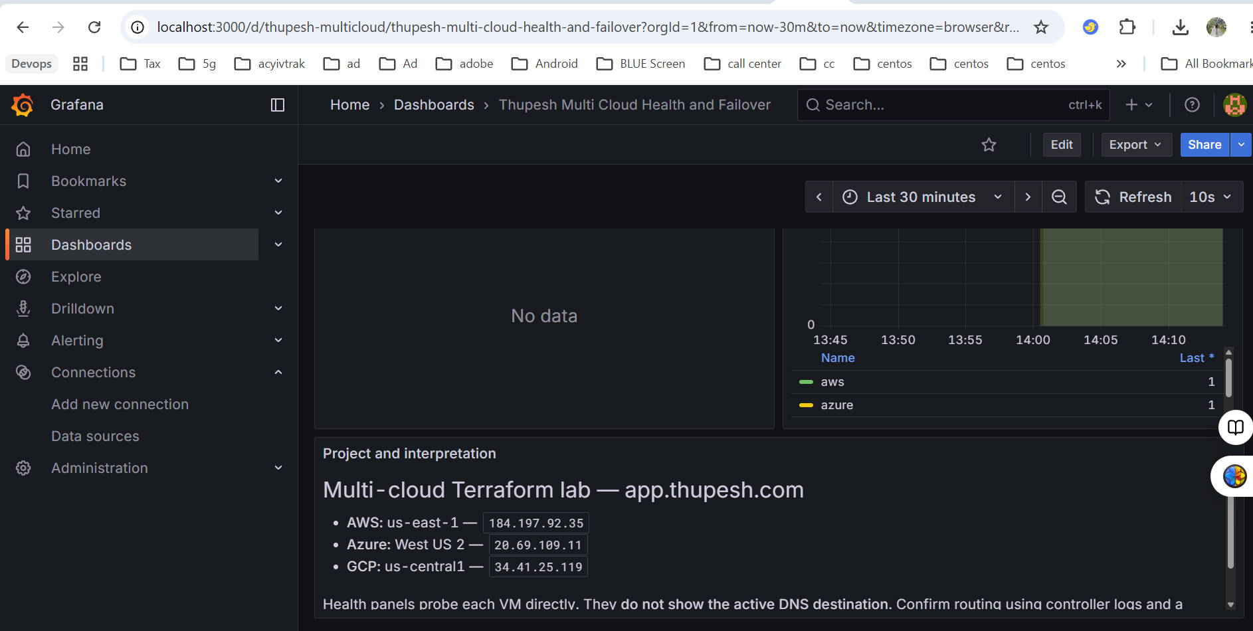

Enable disaster recovery by replicating resources and databases across clouds and testing failover capabilities

AWS SQL
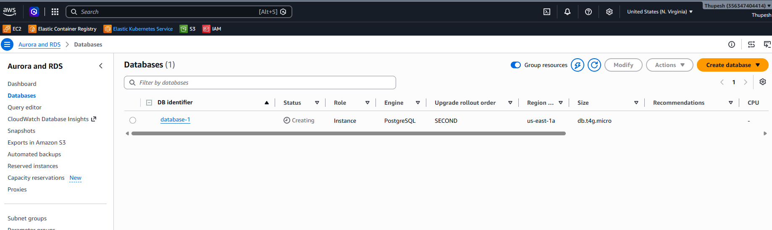
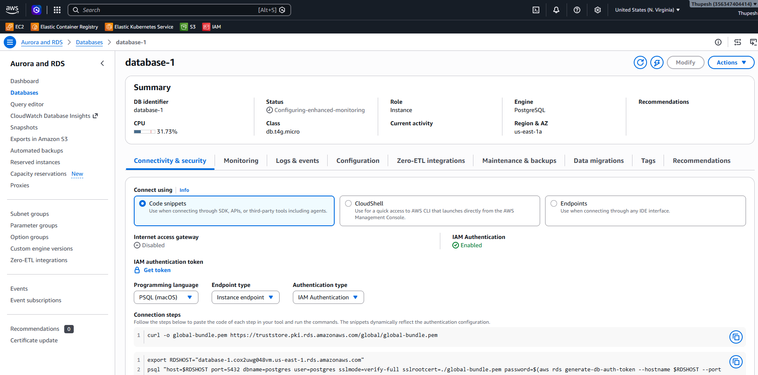
Azure SQL
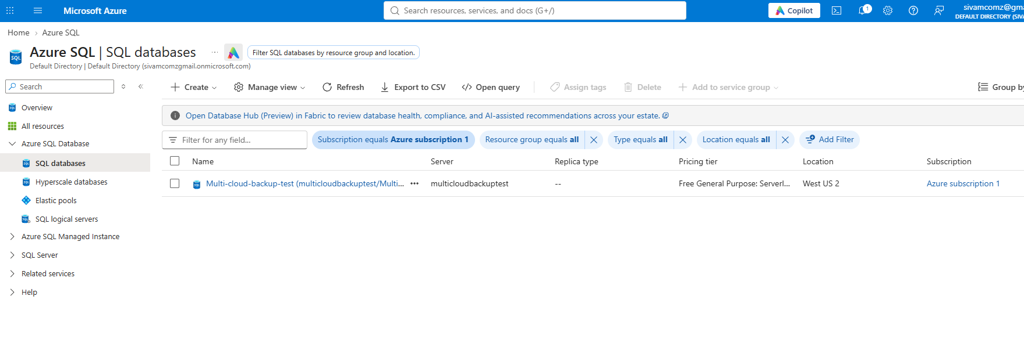
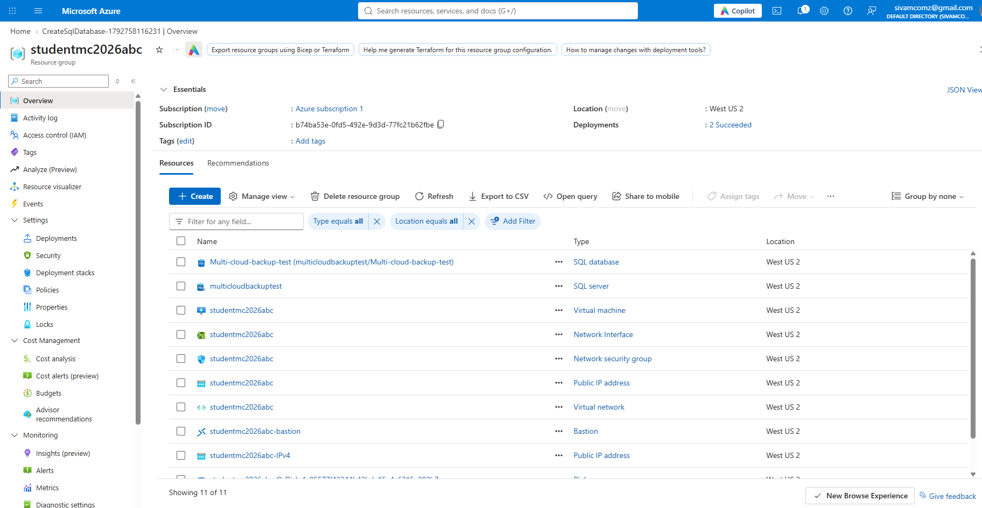

GCP
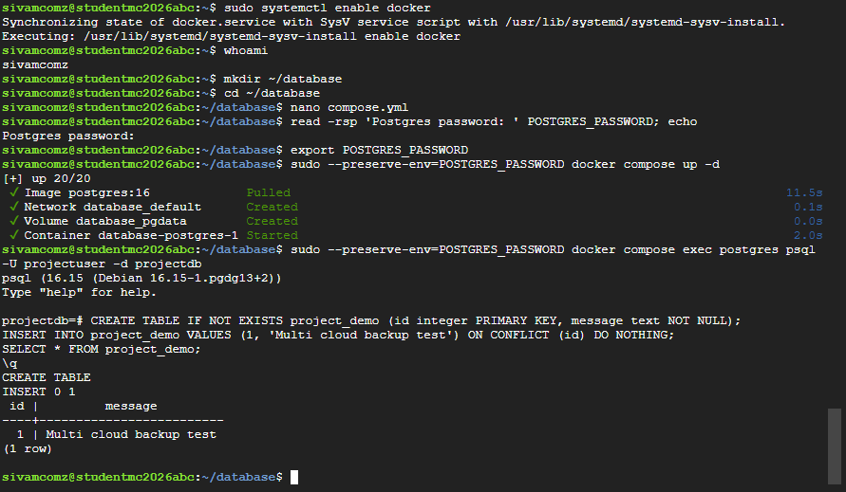

Disaster Recovery and Backup Replication Install and configure

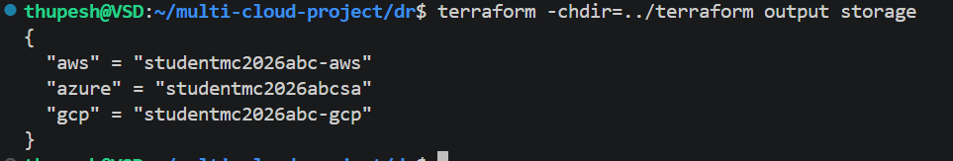
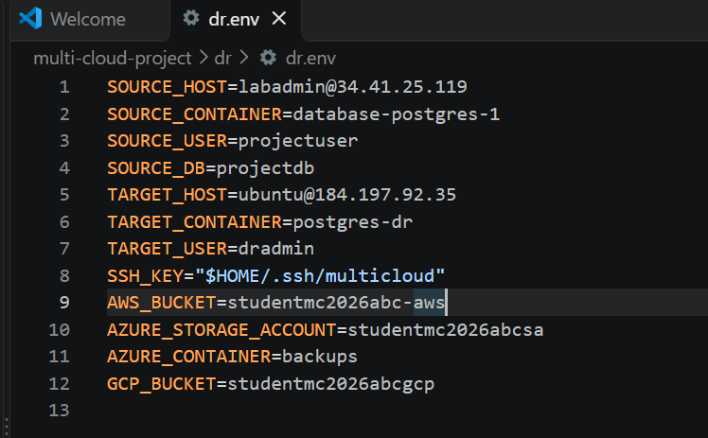
Prepare an independent AWS recovery target
Gcp

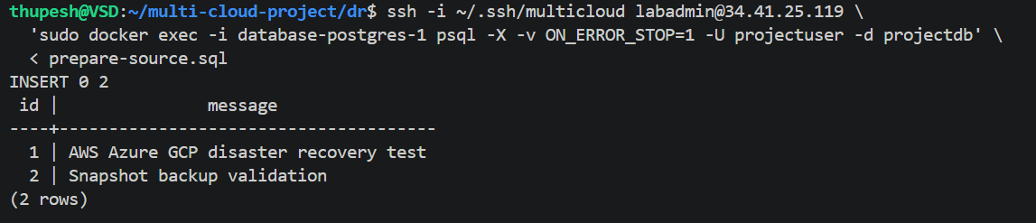
Create and replicate the first backup
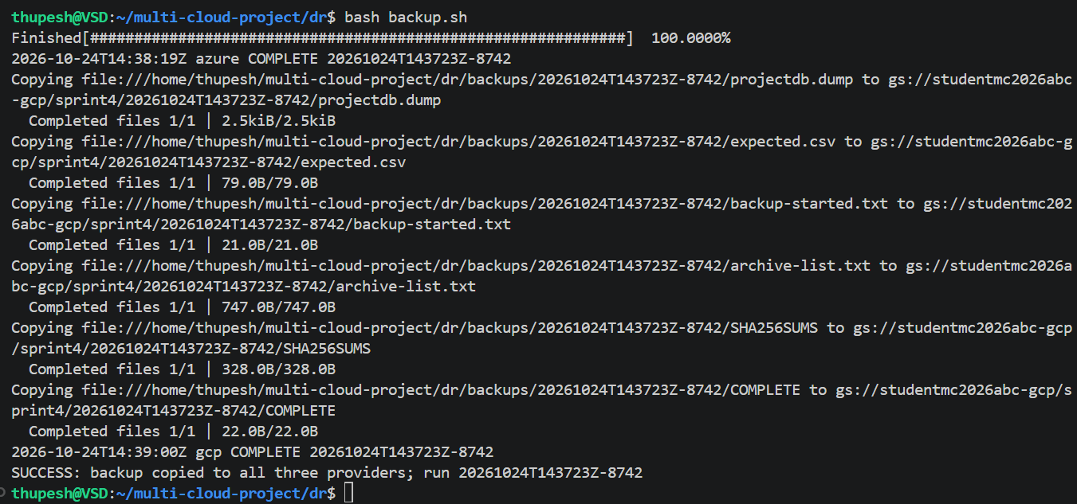

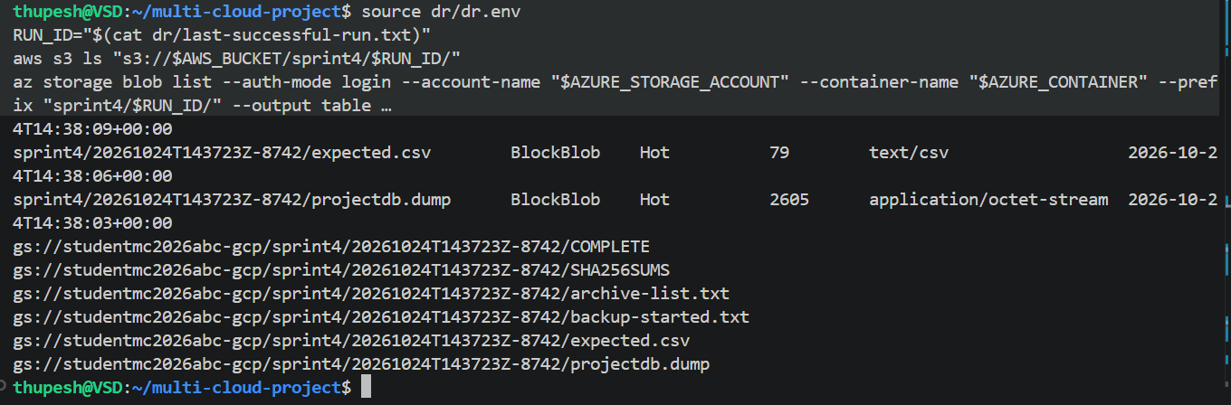

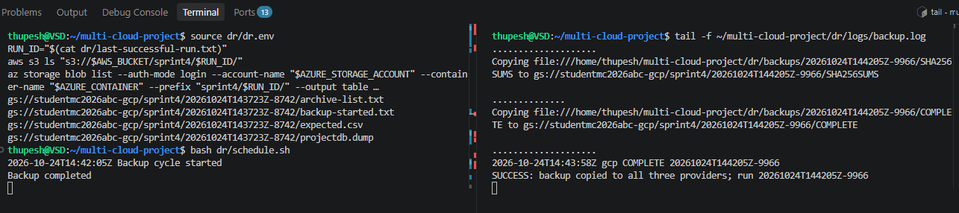

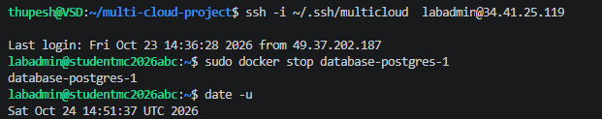

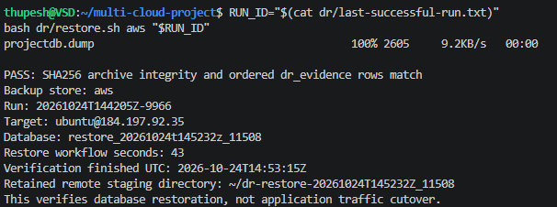

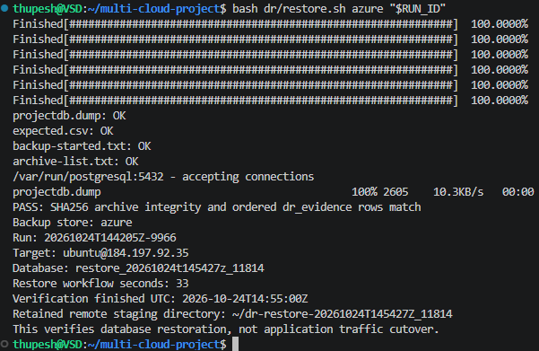

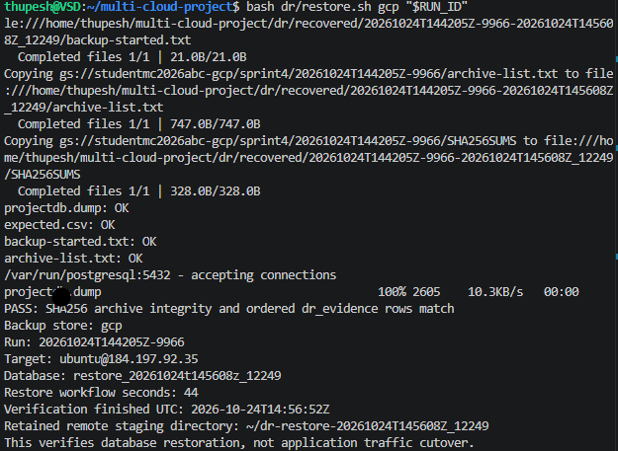

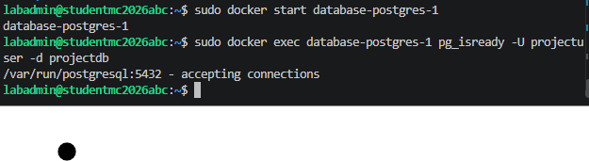

Schedule automated backup replication
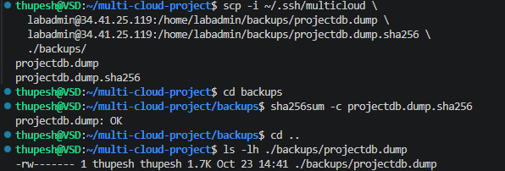

GitHub stores the Terraform modules, startup scripts, monitoring configuration and failover controller, providing version history for project changes. GitHub Actions automatically checks Terraform formatting and configuration validity on pushes and pull requests. Infrastructure deployment is performed from an authenticated workstation after reviewing the Terraform plan to control costs. The current pipeline implements continuous integration; automated cloud deployment remains a future enhancement.

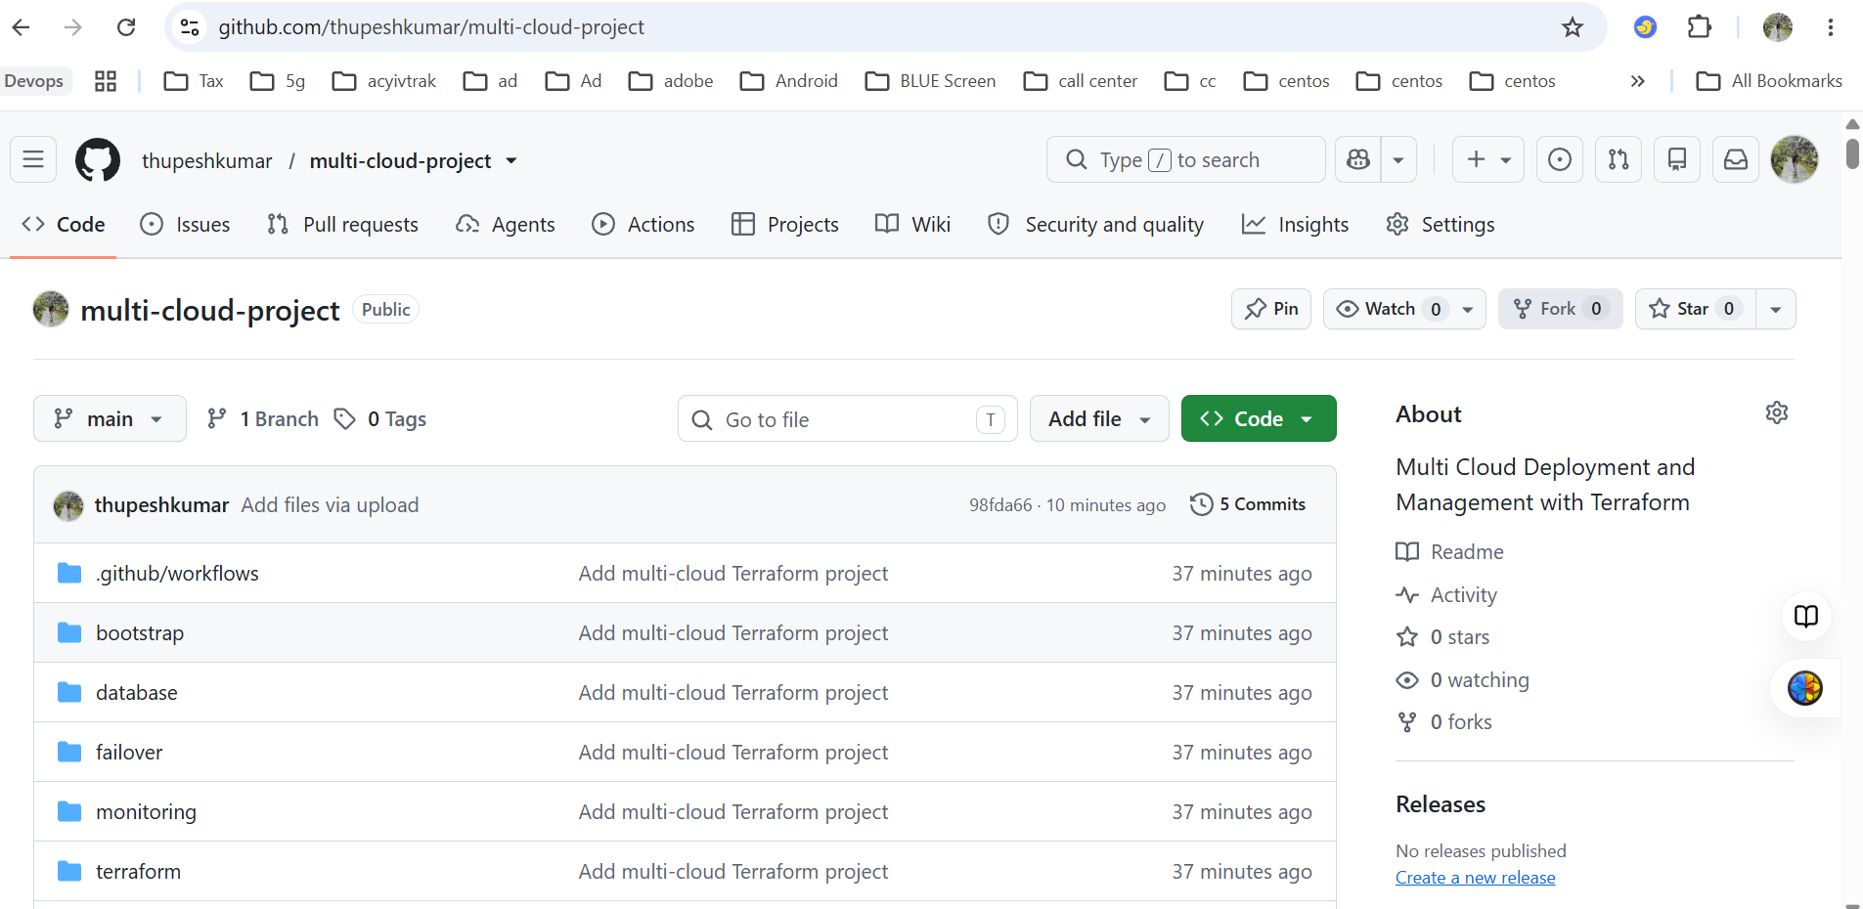
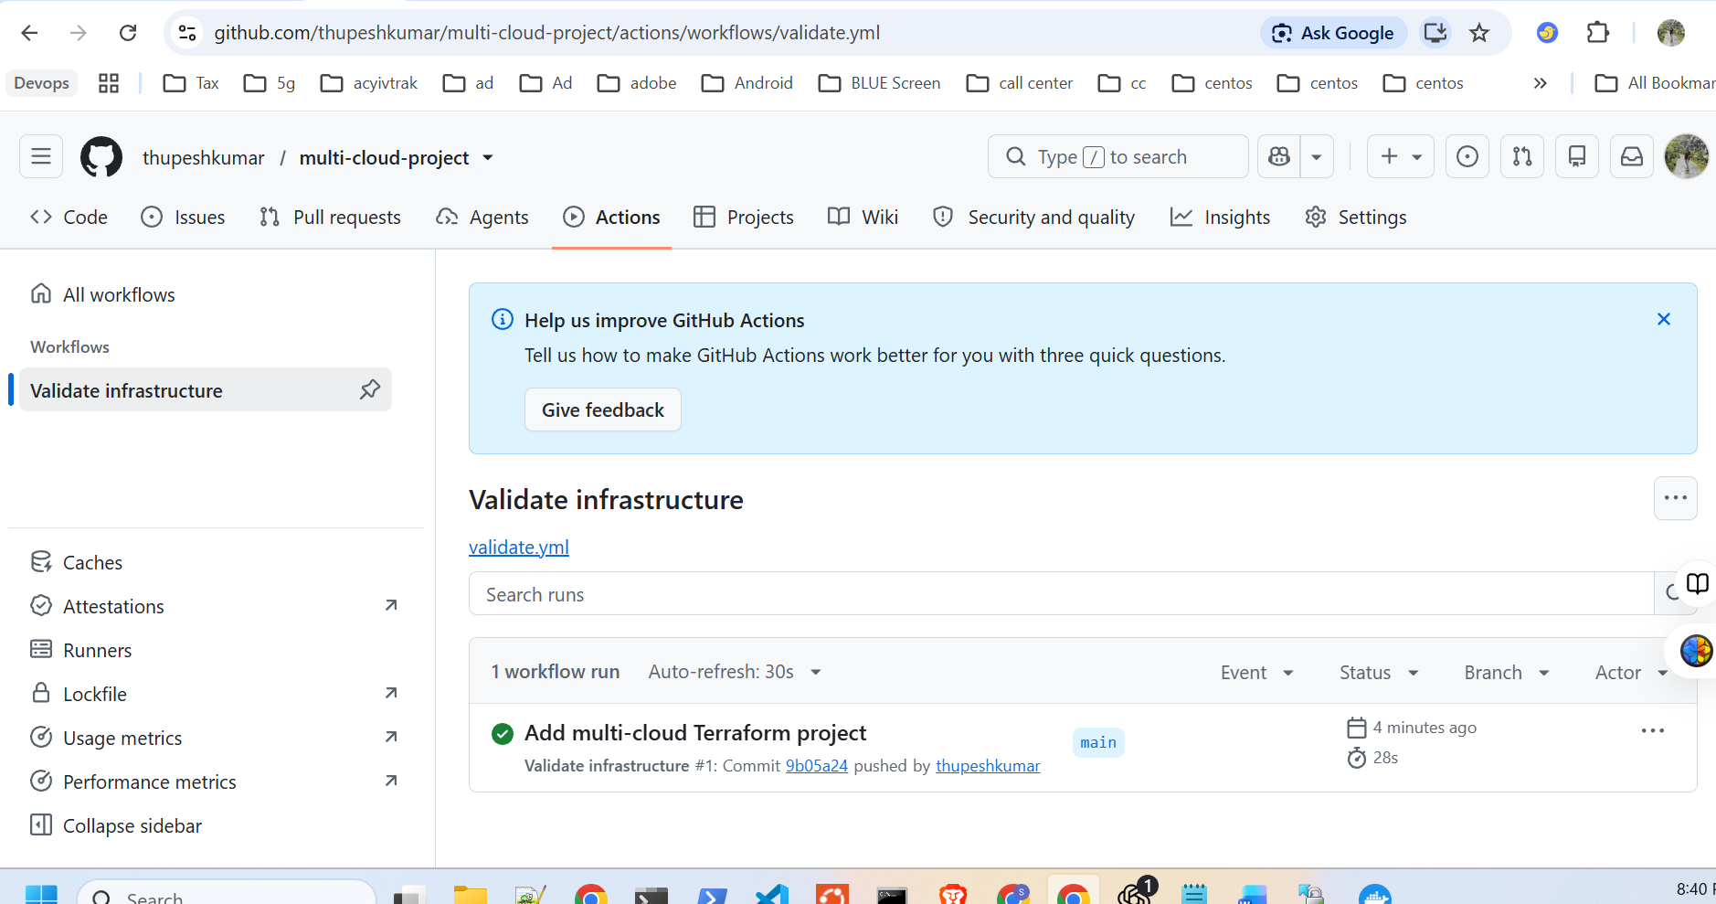

Alerting: Slack API for real-time alerts on cloud resource status and usage
Connect Grafana to Slack
In Grafana:
- Open Alerting → Contact points.
- Select Add contact point.
- Name it Slack Multi Cloud Alerts.
- Choose Slack as the integration.
- Enter the Webhook URL.
- Send a Test notification, confirm receipt, then save.

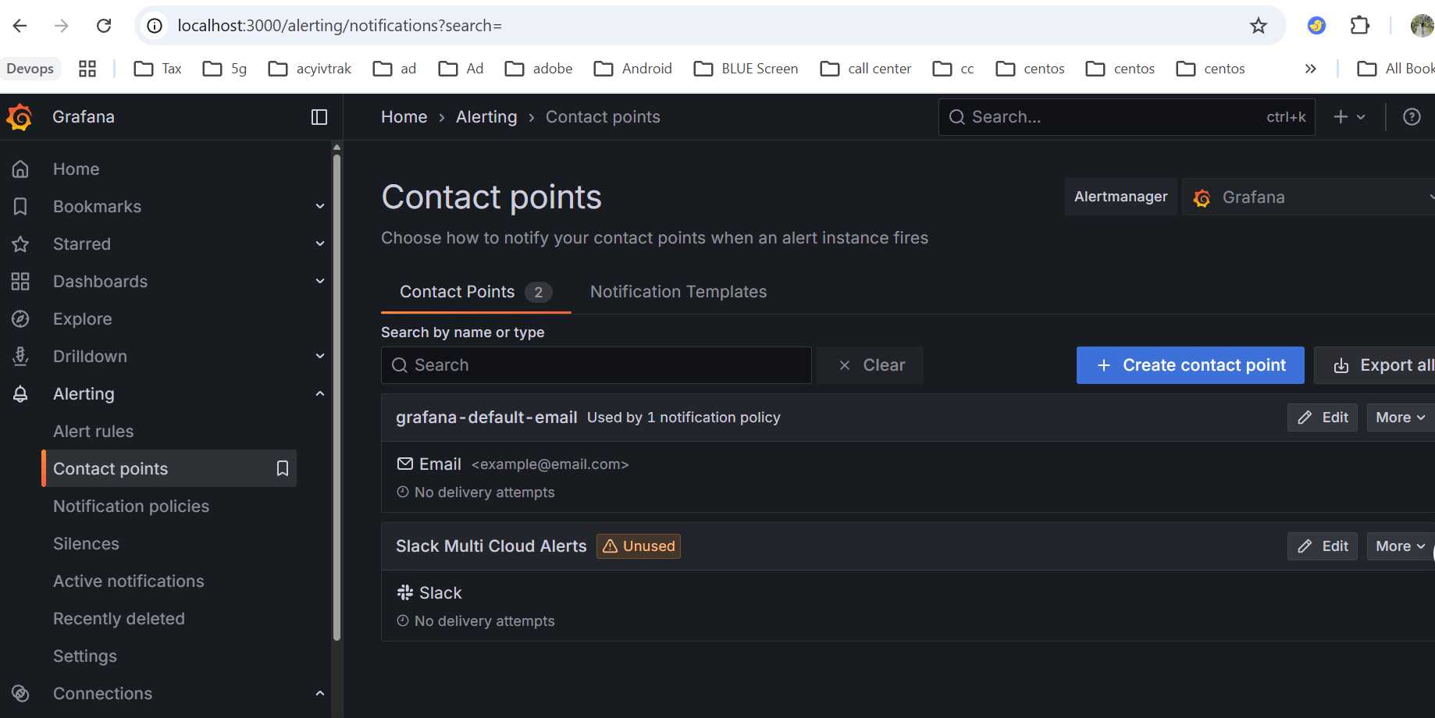
Create an outage alert
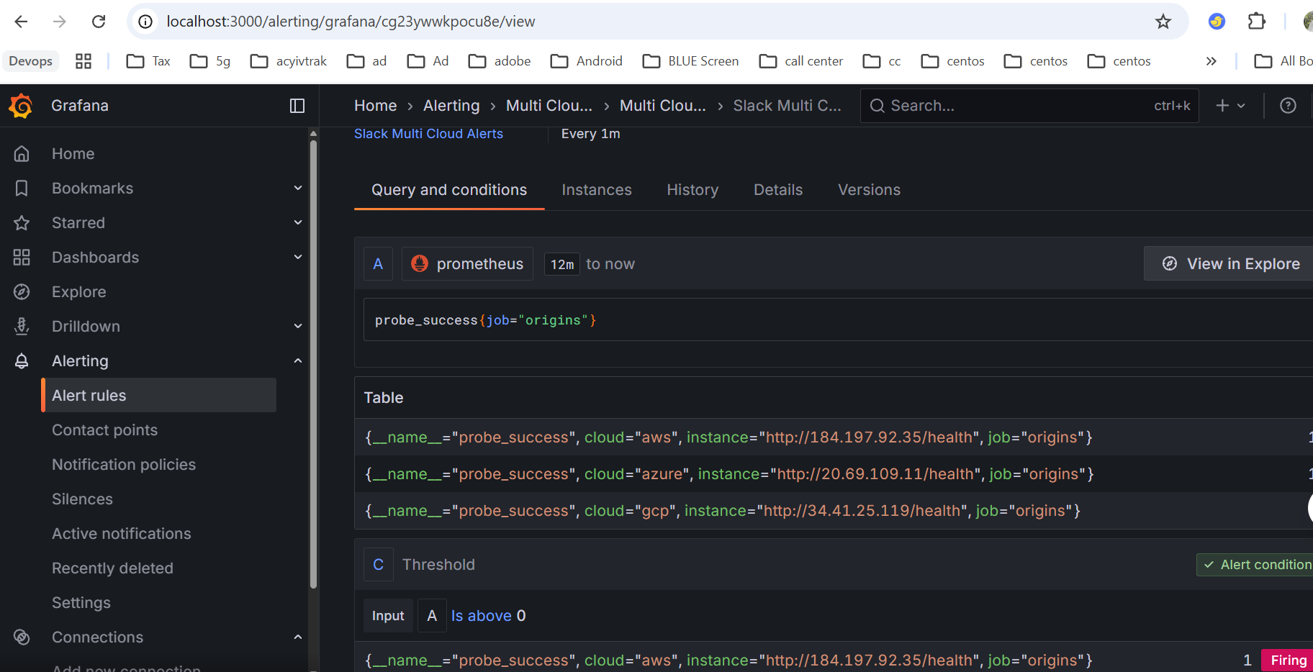

Create a Slack webhook
- Create a Slack channel, such as #multi-cloud-alerts.
- Create a Slack app for your workspace.
- Enable Incoming Webhooks.
- Select Add New Webhook to Workspace and authorize the channel.
- Copy the webhook URL securely.

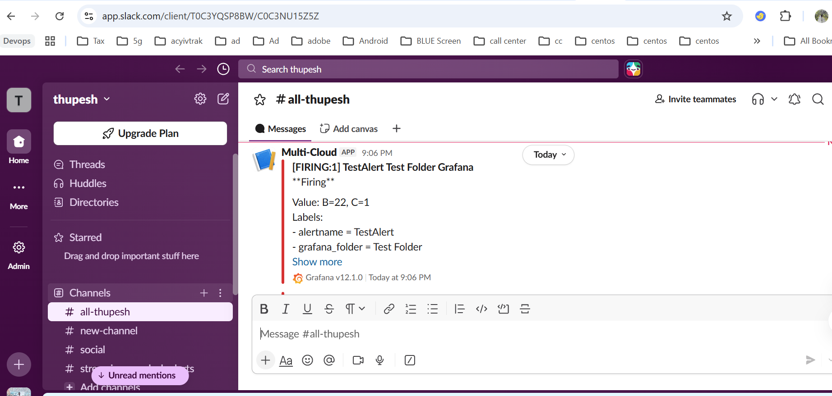

Setting up persistent Vault on Docker Desktop, store your project credentials in its KV secrets engine, and load them into your terminal when running Terraform or failover.
This setup is for your local student lab. It uses localhost HTTP and manual unsealing; it is not a production Vault deployment.

Vault configuration
https://developer.hashicorp.com/vault/docs/configuration
Create vault/config/vault.hcl
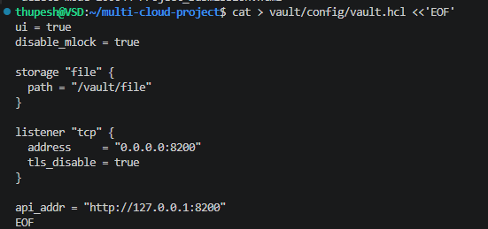

Create vault/compose.yml
