|  |  |  |
| --- | --- | --- |
| **Computer Programming Laboratory** |  | |
| **Laboratory 1:** Flowchart and Pseudocode and Hello World | **School of Information Technology** | |
| **Name:** | **ID:** | **Section:** |

**Objectives**

* To understand the concept of Flowchart and Pseudocode.
* To design Flowchart and Pseudocode.
* To write a first program C#

**Instruction: Study the given examples and answer all questions.**

1. Perform the following practices using any IDE.

**Sending Method:**

* Submission files are listed as follow:
  + Save this document file that contains all answers as “**Lab01_YourID.pdf**”

**Practice I – Designing pseudo code and flowchart by fill in the answers in the boxes**

**Question 1 :** Design Pseudo code and corresponding Flowchart to ask user to input a number. If a number is positive, print “positive”. Otherwise print “zero or negative”.

**Input:** number

**Process:** check condition of number

**Output:** show message of “positive” or “zero or negative”.

**Answer Pseudo code here.**

|  |
| --- |
| 1. __________ “Enter a number”  2. READ ________  3. IF (_________) THEN  PRINT “___________”  _______  _______ “Zero or Negative” |

**Paste the flowchart from https://app.diagrams.net/ to the box below;**

|  |
| --- |
|  |

**Question 2 :** Design Pseudo code and corresponding Flowchart to transform the degree of Fahrenheit to Celsius and display it on the screen.

**Formula:** ***Celsius = (Fahrenheit - 32) * 5/9***

**Input:** fahrenheit

**Process:** calculate a degree of Celsius

**Output:** "Degree of celsius is " + celsius

**Answer Pseudo code here.**

|  |
| --- |
|  |

**Paste the flowchart from https://app.diagrams.net/ to the box below;**

|  |
| --- |
|  |

**Practice II – Use Visual Studio 2022 to develop, compile and run program**

This practice shall give you the step to develop source code, compile and run Hello World program using **Visual Studio 2022 IDE** as a developer tool

**Launch Visual Studio 2022**



**Create Project**

1. Select menu *File > Create a new project*

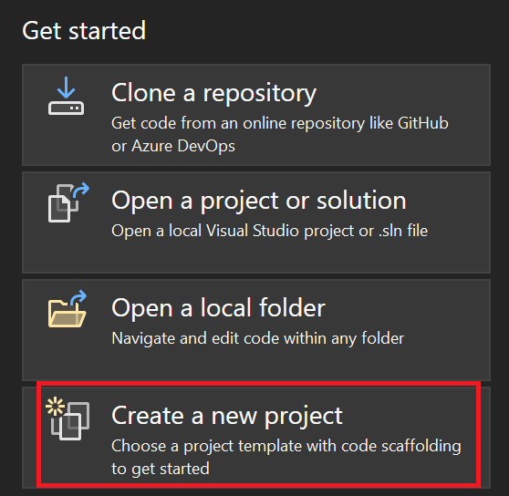

1. Choose *C#* and *Console App* *(.Net Framework)*

1. Enter Project Name: **your ID-Lab01**
2. Click *Create* button and then the program auto generates create a Program file.

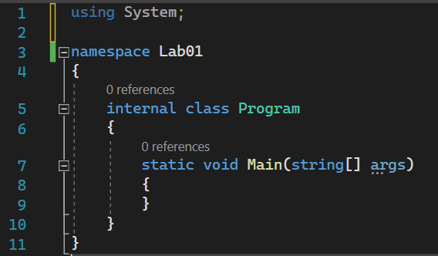

1. Write the program to show the output “Hello World”
2. Then click run program.

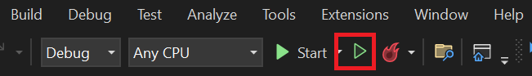

**Question 1 :** Write the program to show the output is “My name is ___Your name_____”

**Answer your code here.**

|  |
| --- |
| using System;  _________ Lab01  {  _______ Program  {  static void Main(____________)  {  ____________________("My name is _________");    }  }  } |

**Question 2 :** Write the program to show the output is “My favorite food is ___name of your favorite food_____”

**Answer your code here.**

|  |
| --- |
|  |