Th9x
MANUAL Eurgle th9x NG
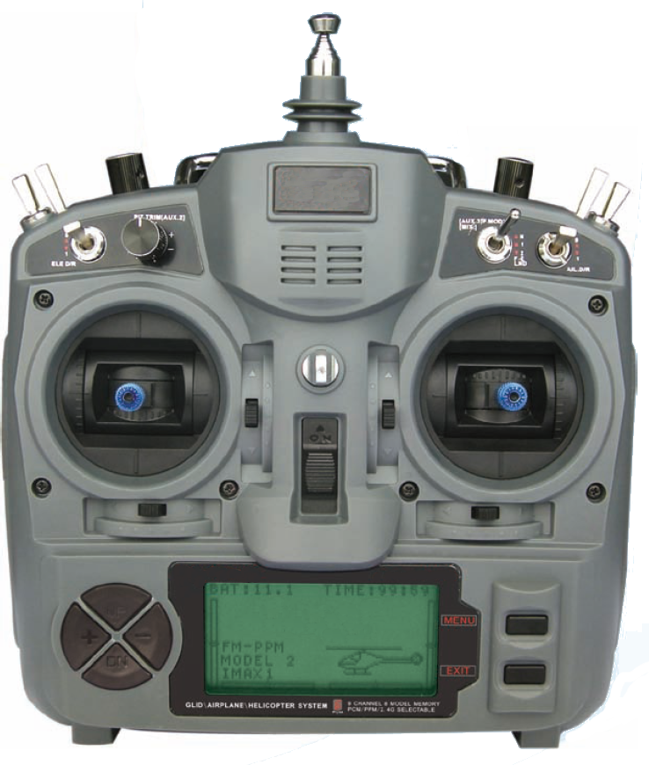

Author: Thomas Husterer, Josef Glatthaar
Version: V1.1
V1.2 Firmware r46
V1.3 Firmware r59
©2010 Thomas Husterer

Contents
Chapter 1: Introduction 5
Chapter 2: Performance 6
Chapter 3: Menu structure 7
3.1 Basic concepts 7
3.2 Main screen 8
3.3 Model-specific Setup 9
Model selection 1/7 9
Model basic setup 2/7 10
Expo function 3/7 11
Expo function Details 12
setup trim values 4/7 12
Mixer 5/7 13
Edit Mixer 14
Curve 6/7 15
Edit Curve 15
Limits 7/7 15
3.4 Global setup, diagnosis and calibrating 16
Global Setup I 16
Global Setup II (Options) 17
Trainer Mode 17
Software Version 18
key diagnosis 18
Diagnosis of Analogue inputs and calibrating of battery voltage measurement 19
Calibrating the sticks 19
Chapter 4: Function 21
4.1 Power on sequence 21
4.2 Data flow 21
Calibrating 22
Expo 22
Trim 24
Mixer 24
Curves 24
Limits 25
4.3 Trainer mode 25
4.4 Flash programming 25
Programmierstecker anschließen 25
Fuse Bits 26
4.5 LCD Backlight 26
Chapter 5: Programming examples 28
5.1 Motorsegler bzw. Motormodell mit Seitenruder, Höhenruder und Querruder 28
Besondere Steuerfunctionen: 29
Erläuterung: 29
5.2 Segler mit 4 Klappen Flügel 29
Besondere Steuerfunctionen: 30
Erläuterung 30
5.3 Motormodell mit Einziehfahrwerk und Fahrwerksklappen 31
5.4 Heli with 120° Swash Plate 31
5.5 Heli with 120° Swash Plate and mit Pitch 31
5.6 Flugphasenschalter 32

Introduction
The remote control Eurgle th9x, also sold under some other labels like Imax, Turborix or Turnigy manufactured by FlySky is a very low cost 2.4GHz radio with impressive hardware-features but with a less convincing firmware.

Performance
- 16 model memories
- two stage mixer allows any combination of input-channels to form output signals
- adjustable signal delay for each mixer line even with different values for up and down movement
- 4 pitch curves with 5 or 9 nodes
- dynamic memory management
- servo reverse feature and tunable servo range limits
- expo and dual rate features
- tunable battery warning
- support for lighted display (hardware upgrade necessary)
- trainer mode with selectable channel behavior
- stick calibration
- timer with three modes
- option-switches for several features.

Menu structure

Basic concepts
six buttons are available for operator interface.
key |  | function
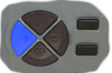 | key left | - move to previous menu  - ore move cursor left, or decrease a value
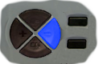 | key right | - move to next menu  - or move cursor right or increase a value
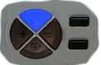 | key up | - move cursor up  - or increase a value
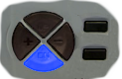 | key down | - move cursor down  - or decrease a value
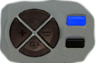 | key menu | - open a submenu  - or confirm an action
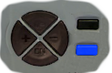 | key exit | - exit current menu and return to the calling menu. This is onlyvalid when the cursor is positioned at the top right edge  - else move the cursor to the top right edge
LONG | key exit | - return immediately to the uppermost screen

- Key can be pressed short or long or very long and each time another action can be triggered
- Most actions appear immediately after a sort key-press.
- When a key is pressed for long time, then an action is repeated
- In some cases a long-time key press is required to trigger the action. This behavior is used for preventing unintentional operations in the standard screen.
- There is no undo functionality. If you change a value or remove something by mistake then you have to re-edit the former values manually.
- Attention!! Values are stored to the EEPROM-Memory with a short time-delay after the last keypress. The storage procedure is announced by some buzzer-beeps

Main screen

Screen contents:
- the current model name (NURI)
- a cursor selection either at Th9x or at the model name
- the battery voltage (6.9V)
- the remaining timer value
- the output values by numbers..
- ..or in a grafical representation
- the trimmer values in a grafical representation.
key | function
LONG | Open menu-set 'Global Setup'
LONG | Open menu-set 'Model-specific Setup'
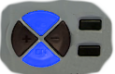LONG | Move to menu 'Timing statistic'
 | Change output view mode from grafical view to numeric view
Trim  keys | Change the Trim Values.  Attention!! the values are evaluated in a non linear manner.
 | move cursor left
 | move cursor right
LONG | Open menu-set 'Global Setup'  or Open menu-set 'Model-specific Setup'
LONG | reset timer
 | stop timer alarm.

Model-specific Setup
This set of menus does handle any settings which are related to one unique model. All menus are consecutively numbered and they are cycled by pressing the left or right key. The menu 1/7 is used to select one of 16 memory slots which holds any setup-data related to one model.

key | function
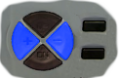 | cycle through the model menus

Model selection 1/7

Select one of 16 memory-slots by cursor movement up or down. Then activate this slot by pressing exit or by cycling to the next model-menu.
Please notice the free memory value in the title line. If this value gets lower than about 200 bytes then you should remove some model slots. Properly storage operation is only guaranteed if enough memory is available.

key | function
 | Select memory slot by cursor movement.
 | cycle to next menu
 | back to main screen
 | select current line for edit commands.(model name is blinking)
 | move current line up ur down.
 | duplicate the selected model into next free memory-slot.

Model basic setup 2/7

- In edit field 'Name' you can change the model name. Move the cursor right to a character position and then change the value.
- In field 'Proto' you can select one of several transmitter protocols. Normaly you select PPM here.
- In field Timer you can preset a count down start value and a count down mode. This value is then decremented according to the selected mode OFF / ABS / THR / THR%.
  - OFF: no decrementing.
  - ABS: always count down.
  - THR: only count down when the Throttle Stick is not in its neutral position.
  - THR%: like before, but count down more or less fast dependent to the THR-position.
- When the cursor is positioned to RM then the whole model memory can be removed by pressing menu

 | key | function
1. |  | move cursor up and down
2. |  | move cursor left rigth
3. | oder | change vlaues
4. |  | reset cursor to the upper right edge
5a |  | leave this menu
5b |  | cycle to the next menu
 | LONG | Remove this model memory. Only valid if Cursor is positioned at RM.

Expo function 3/7

In this menu you can set up an exponential behavior for each of the four sticks. Select a value between -100 up to +100.
You can open a submenu 'Expo function Details' to see even more settings like a dual-Rate-switch and a dual rate expo function.

 | key | function
1. |  | move cursor up and down
2. |  | change vlaues
3a |  | open menu Expo function Details
3b |  | reset cursor to the upper right edge
4a |  | leave this menu
4b |  | cycle to the next menu

Expo function Details

You can change the two expo values and the expo switch in this menu. In the diagram you see the shape of the expo function.

.

setup trim values 4/7

Here you can swap the trim values to a base value. After this operation, the trim values in the main screen are repositioned to zero.

 | key | function
1. |  | move cursor up and down
2a. |  | add the trim value to the base value and reset the trim value to zero
2b. |  | reset the base value,
3. |  | reset cursor to the upper right edge
4a |  | leave this menu
4b |  | cycle to the next menu

Mixer 5/7

This menu is the most important menu of the whole arrangement. You can combine here several Inputs like stick values, poti-values or constants into each one of the output channels. Additionaly there are four Helper channels which are used as temporary values X1-X4. These values are calculated first, and can then be used as inputs.

Each mixer line can contain a weight, an input channel, an optional switch, a curve and some delay values. Switches are available in a normal or in an inverted style.

Curves:
There are 8 kinds of curves: -- , >0 , <0 , |x| , cv1, cv2, cv3 und cv4
  - - : no curve, bzw. y=x
  - >0 : y=x | x>0, else y=0
  - <0 : y=x | x<0 else y=0
  - |x| y=|x|
  - Cv1..Cv4 Use one of four user defined curves.
Cv1 and Cv2 have 5 nodes at x=-100, -50, 0, 50, 100;
Cv3 and Cv4 have 9 nodes at x=-100, -75, -50, -25, 0, 25, 50, 75, 100

 | key | function
1. |  | move cursor at or between two lines
2a. |  | change weight value.
2b. |  | Open menu 'Edit-Mixer'. if the cursor was positioned between two lines, then a new line is generated, else the curent line is edited.
3. |  | reset cursor to the upper right edge
4a |  | leave this menu
4b |  | cycle to the next menu

Edit Mixer

In this menu you can adjust all the details of one single mixer line.
- SRC: select the input channel RUD, THR, ELE, AIL, P1, P2, P3, X1, X2, X3, X4, MAX FUL.
with MAX you can emit a constant value 0 or +100%
with FUL you can emit a constant value -100% or +100%
- PRC: weight from -125% to +125%
- CURVE: one of eight curve types.
- SWTCH: a switch. Dependent from the SRC-Value the switch acts in two different manners.
When SRC=MAX or FUL then the switch selects one of two fixed values as input values and the line is calculated with the whole set of parameters.
When SRC!=MAX or FUL then the switch can switch on the whole line or it can switch off the whole line. In the last case none of the remaining parameter has any effect.
- SPEED: These two values determine the speed in which rising or falling input values are propagated to the output channel
- RM: This field is used to remove the whole mixer-line.

 | key | function
1. |  | move cursor up and down
2a. |  | change vlaues
2b |  | remove whole line,. Tis is only valid when cursor is at RM.
2c |  | edit curve. This is only valid when cursor is at CV1-CV4
3. |  | leave menu

Curve 6/7

Edit Curve

 | key | function
1. |  | move cursor up / down
3. |  | - change value.  - select predefined curve. This is only valid if cursor is at PRESET
4 |  | leave menu

Limits 7/7

In this menu you can revert output channels and you set up the output value limits.

 | key | function
1. |  | move cursor up / down
2. |  | move cursor to a column.
3. |  | change value.
4 |  | reset cursor to the upper right edge
5a |  | leave menu
5b |  | cycle to the next menu

Global setup, diagnosis and calibrating
In this group of menus is combined any setups that are not model specific. The menus are numbered as well and can be cycled with the left and right keys as the group above.

key | function
 | Cycle through the menus. This is only valid if the cursor is positioned at the upper right edge.

Global Setup I

In this menu you can change some global values.

Screeen contents:
- The contrast value.
- The warning level for the battery voltage alarm.
- A switch which is used to control the lcd-backlight.
Attention! This feature requires a hardware extension..
- The mode selection is used to assign a specific function to any input stick. At the end it changes the labels which are shown in all other menus where input values are selected.

 | key | function
1. |  | move cursor up / down
2. |  | change values
3. |  | reset cursor to the upper right edge
4a. |  | leave this menu
4b |  | cycle to the next menu

Global Setup II (Options)
In this menu you can select several options like warnings or the key-beep.

Trainer Mode

Here you can decide how each Input stick is handled in trainer mode.
Each line shows:
- RUD the input channel in the trainer radio
- off no student activity
- += trainer and student values are both added and then used as input signal
- := only the student controls this channel
- 98 the students values are weighted by this value
- ch1 this is the channel number which is received from the students radio. In the students radio this channel has to be connected to one single stick.
- RUD Here you can define a switch which controls this trainer line
- Cal: This line shows the input values which are received from the stu dents radio. If you press Menu, then the current values are defined as reference values for the student inputs.

Software Version

Shows the current software version

 | key | function
1a. |  | leave this menu
1b |  | cycle to the next menu

key diagnosis

Show the current levels of any key,switch or trim-switch

 | key | function
1a. |  | leave this menu
1b |  | cycle to the next menu

Diagnosis of Analogue inputs and calibrating of battery voltage measurement

Shows the values of all analogue inputs with 10 bit resolution. The stick-values are also shown in %.
Value number eight shows the battery voltage. Here you can also calibrate the shown voltage level.

 | key | function
1. |  | move cursor up and down
2. |  | change shown battery voltage.
3. |  | reset cursor to the upper right edge
4a. |  | leave this menu
4b |  | cycle to the next menu

Calibrating the sticks

With the help of this menu you can calibrate the values of all four sticks in a four step procedure.
The procedure requires moving the sticks to a given position and then press cursor down while holding the sticks in this position ..

 | key | function
1. |  | - move cursor to SetMid  - move all sticks into the center-position and hold them
2. |  | - move cursor to SetLow  - move all sticks to the lower left edge and hold them.
3. |  | - move cursor to SetHigh  - move all sticks to the upper right edge and hold them.
4. |  | - move cursor to Ready  - now its finished
5 |  | change to previous menu and check the shown percentage values.

Function

Power on sequence
During power on sequence some important tests are executed.
First the EEPROM data is loaded and verified. In case of fault a warning is given and the whole EEPROM is formatted.
After this it is checked if free memory is enough to store at least one additional model memory. In case of fault a warning is given.
After this it is checked the throttle stick is located at its initial position. In case of fault a warning is given.
Then switches are checked. If any switch is in an on position then the warning screen is shown that displays the switch values.
Each warning screen can be left with the exit key.

Data flow
How we mentioned earlier, this radio works with a very simple calculation model. Any stick value and any switch value is considered to calculate the value of the outputs. Special attention is taken to handle any input with the same priority and without any special function dependent meaning.

Data-flow Diagram:

Calibrating
This first block changes the 10bit AD-value into a symmetrical value from -512 up to +511. It is guaranteed that the center position of the sticks leads to the value 0.
Potentiometer-values are handled according to this.

Expo
The expo function transfers the linear input values into some output values with non linear behavior. This means that the sensitivity of a stick is dependent on the working position of this stick.
As an approximation to the expo-function the following polynomial is used.
y = f(x) = x^3 *k + x * (k-1) with 0 < k < 1

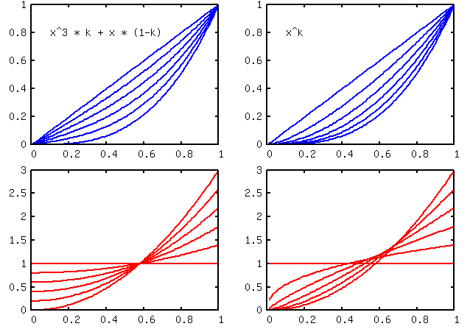
y = f(x) = x^k with 1<=k<=3

This diagram shows both curves, the polynomial and the original expo-function in a blue colored line. The lines in red show the derivation of the blue line. Therefore you can recognize the sensitivity of the stick at several working positions..
The polynomial was used in the implementation because we can evaluate it without usage of any floating point arithmetic's.

#define RESX 512ul
#define RESK 100ul
uint16_t expou(uint16_t x, uint16_t k)
{
// k*x*x*x + (1-k)*x
return ( (unsigned long)x * x * x / 0x10000 * k /
(RESX*RESX/0x10000)
+ (RESK-k) * x + RESK / 2 ) / RESK;
}

This implementation needs only one real 32-bit Integer-Division.

Trim
This block adds the current trim-value to the associated input value..
This trim value is generated by pressing the trim-keys. The range of this trim -value is -31 to +31. This value is directly shown in the graphical representation in the main screen. To extend this value range at up to +/. 512 we use a quadratic polynomial..
This polynomial allow a resolution of 1 in the mid range and it reduces the resolution in outer ranges. At the same time we can reach the whole value range in 31 steps.

Mixer
The mixer block combines several input channels to the output channels. The inputs are weighted by some percentage-value and they are assigned to the outputs. In addition to this weight we can assign a user defined curve to this value and we can assign some delay-values to one mixer line.

Curves

  - - : no curve,. y=x
  - >0 : y=x | x>0, else y=0
  - <0 : y=x | x<0 else y=0
  - |x| y=|x|
  - Cv1..Cv4 use one of four user defined curves.
Cv1 and Cv2 use 5 nodes at x=-100, -50, 0, 50, 100;
Cv3 and Cv4 use 9 nodes at x=-100, -75, -50, -25, 0, 25, 50, 75, 100

Limits
Before this output values are sent to the receiver, they are checked against the maximum limitations given by the limits menu. Additionally each channel can become reversed.

Trainer mode
To use trainer mode, we need two separate radios..One radio works as a students radio and the other works as a trainer radio Please note that the students radio must have the power-button switched off..
- Power-Off is students radio, no sender module necessary.
- Power-On is trainer radio.
Both radios become connected with a stereo cable. After connecting the radios, the students radio gets powered by a small switch inside of the connection-plug.
Now change to the trainer menu and look for the students stick values..
Any further computations are done in the trainer device. Student and trainer values can be exclusive or added to each other.

Flash programming

Programming plug connections
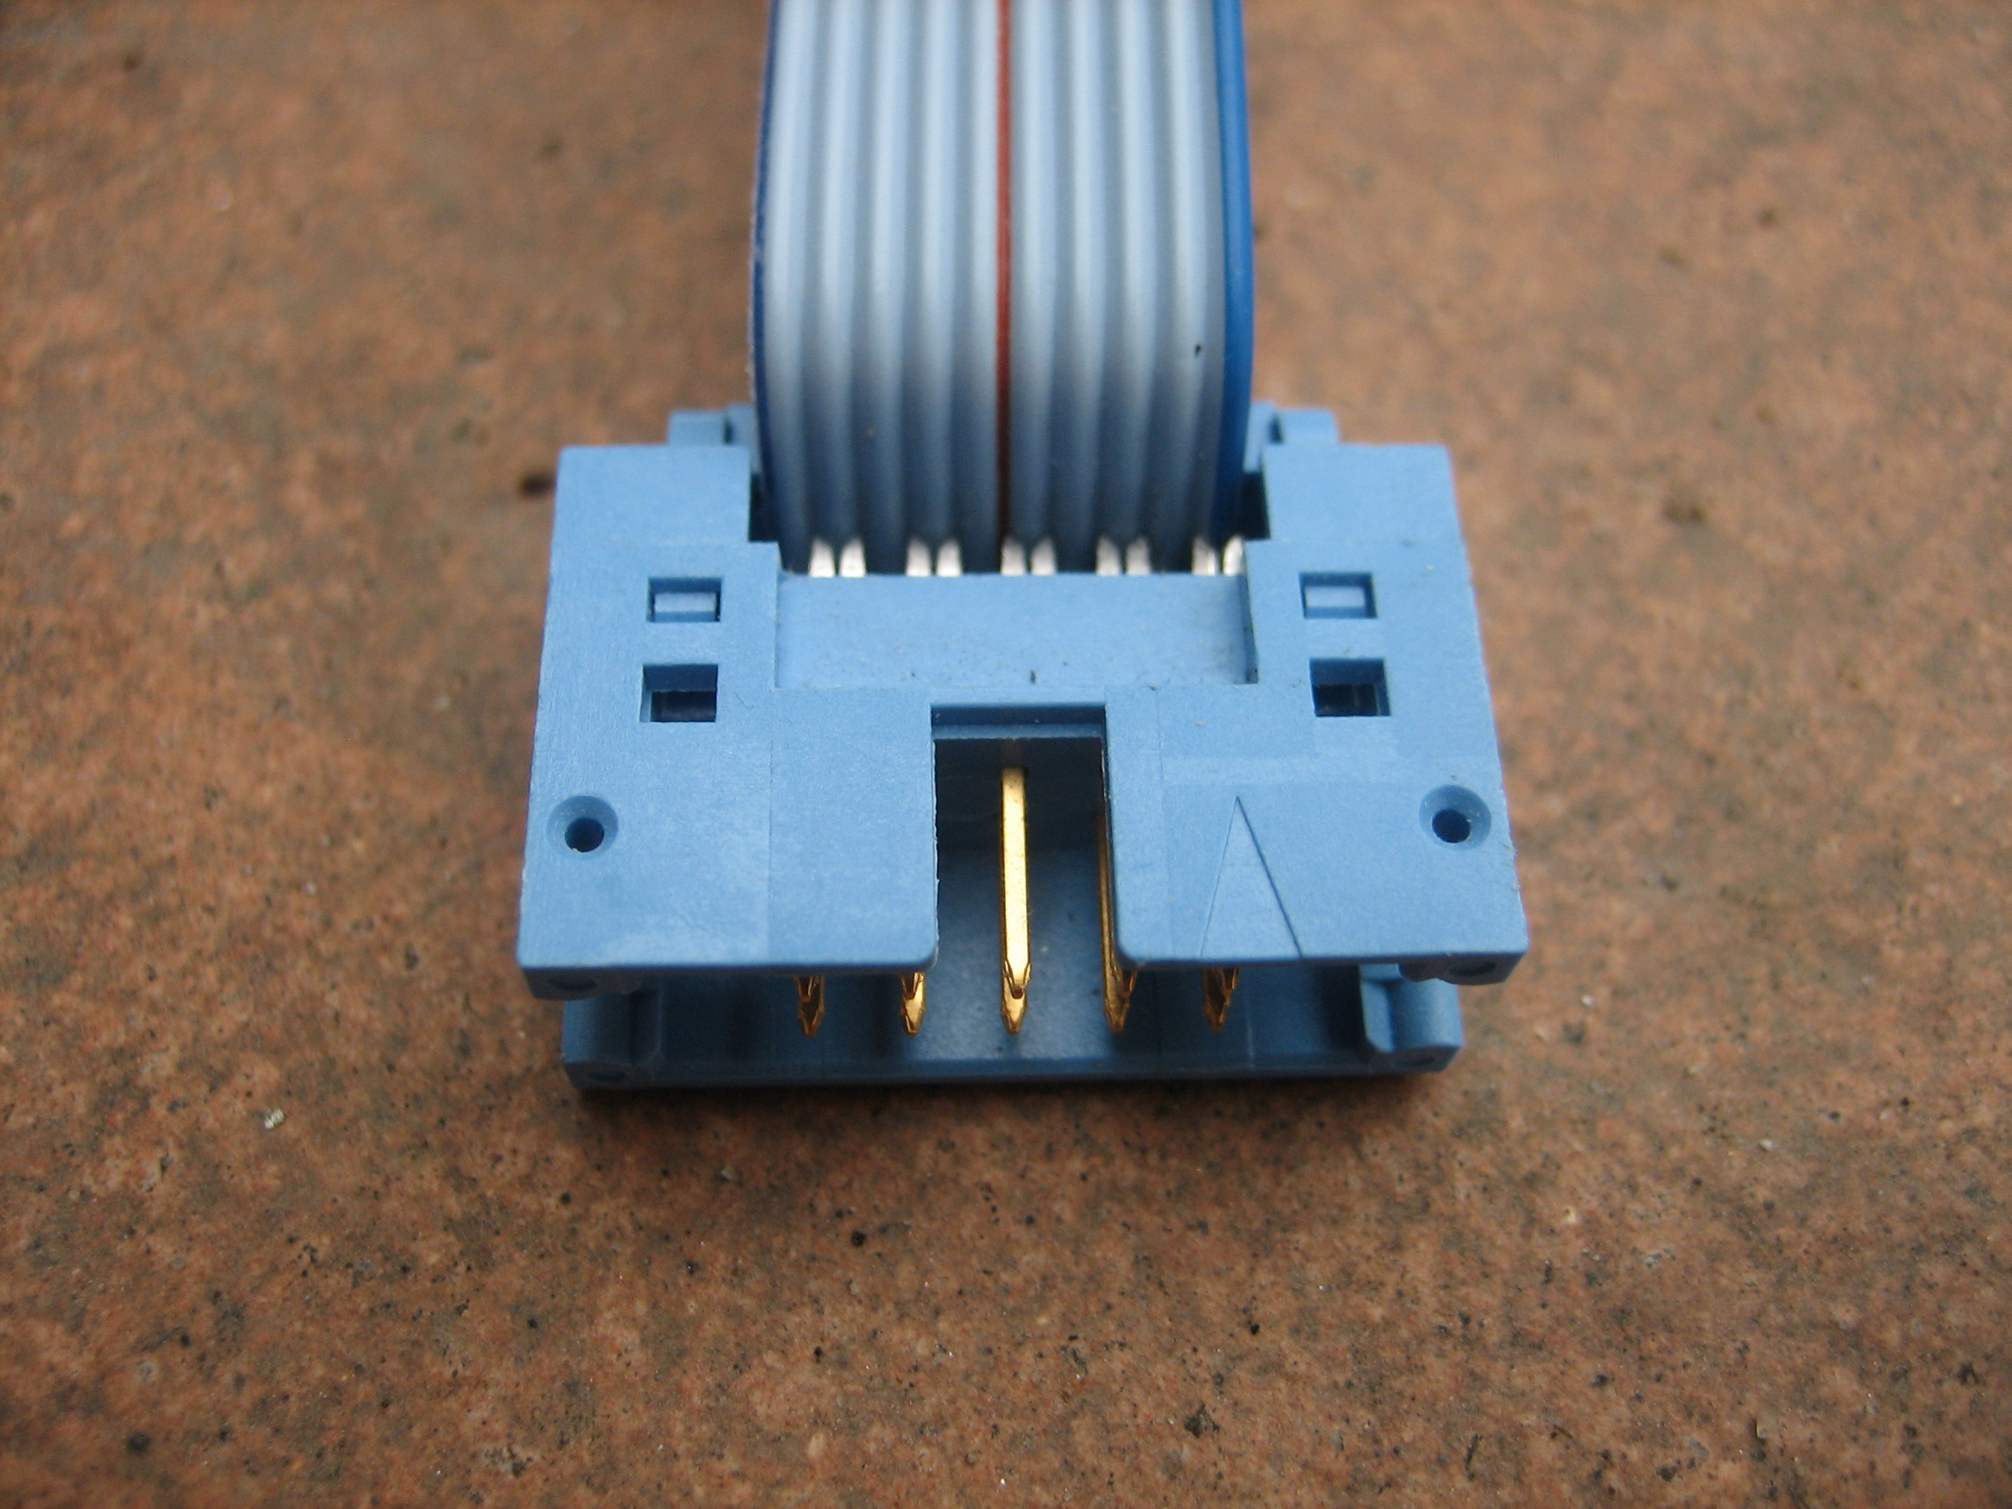  1  9  5  7 | - MOSI  - -  - -  - -  - RESET  - -  - SCK  - -  - MISO  - GND

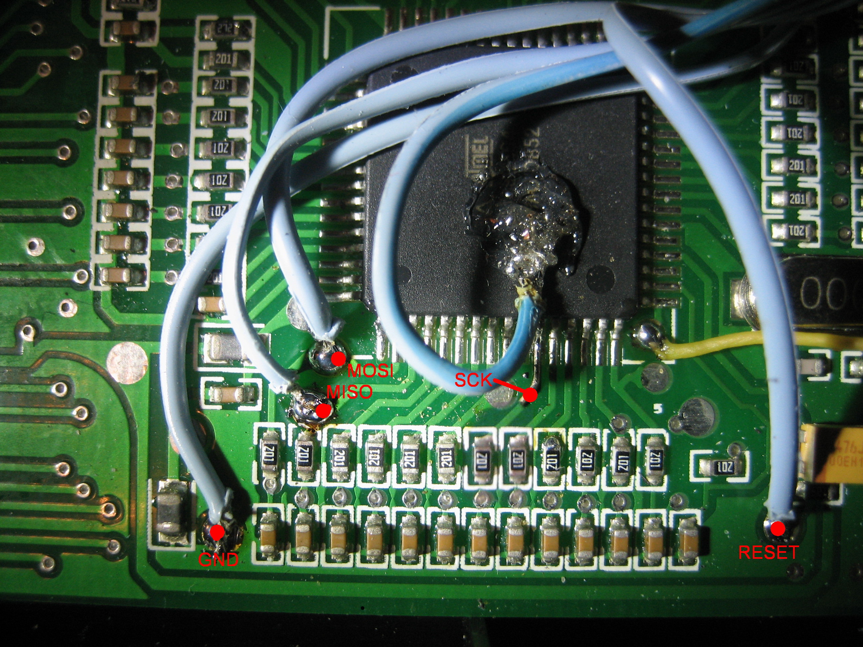

Fuse Bits
When you reload the firmware you do not need to change the fuses in any way. If this does happen I have listed my original values:

sig=1e,96,02,ff Atmel AVR ATmega64
Lock Bits: 0xff 0b11111111
Fuses low: 0x0e 0b00001110
Fuses high: 0x89 0b10001001
Fuses ext: 0xff 0b11111111

LCD Back light
In rcline-forum its described how to install an EL-Backlight behind the LCD-Display
see here:
http://www.rclineforum.de/forum/thread.php?threadid=239048&sid=&threadview=0&hilight=&hilightuser=&page=22
The th9x is prepared to switch on and off this back light by means of an unused port Bit of the controller (Pin PB7). You need only a few additional components. In the schematic diagram you see an example how to connect the controller via one single FET (BS170) to a 5V-Inverter and then to the EL-Back light. In case of using an inverter with another input voltage, you have to change the diagram at the VC-side of the inverter. The FET remains the same. In the picture you see a yellow cable which connects to the PB7 of the controller.

Programming examples
Basics:
Unlike other radios, there are no ready-mixed programs (Plane, Heli). This makes the programming more complex, but less restrictive. The solution shown here is very flexible. However, setting the model with the desired functions may take a little more thought, but the system is very easily understood.
You can use all 8 outputs for arbitrary functions (servos). So there is no specific assignment, as with other computer radios.

Glider or powered plane with rudder, elevator and aileron

Assignment of the channels

Channel 1: | Rudder
Channel 2: | Elevator
Channel 3: | left aileron
Channel 4: | right aileron
Channel 5: | Motor

Special control functions:
Each aileron with a separate servo controlled so that they can be used with P1 as air brakes.

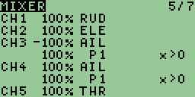

Explanation
The control functions RUDder, ELEvator and THRottle are transferred 1:1 to the outputs 1, 2 and 5..

P1 (airbrakes) will output both channel 3 as well as 4. Here only positive values are taken into account because otherwise the negative values of P1 would result in brake movement into the wrong direction.

The ailerons are mixed one positive and the other negative, so that they move in opposite directions.

Channel 1: | Rudder | 1:1 Stick Rudder
Channel 2: | Elevator | 1:1 Stick Elevator
Channel 3: | Aileron left | -100% Stick Aileron  1:1 airbrakes P1
Channel 4: | Aileron right | 1:1 Stick Aileron  1:1 airbrakes P1
Channel 5: | Motor | 1:1 Stick THROTTLE

Glider with 4 flaps
Assignment of the channels:
Channel 1: | Rudder
Channel 2: | Elevator
Channel 3: | Aileron left outside
Channel 4: | flaps left inboard
Channel 5: | Aileron right outside
Channel 6: | flaps right inboard

Special control functions:
  - Inboard flaps shall be used as airbrakes and for aileron assistance
  - All flaps shall be used for different flight-phases which are selected by some switches.
  - when airbrakes is set, then elevator shall be changed after a delay time
  - during landing we use butterfly-mode. e.g. inner flaps down, outer flaps up.

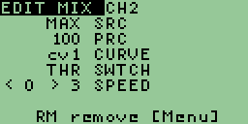
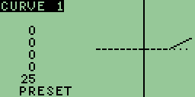
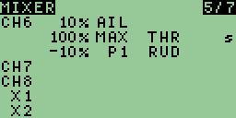
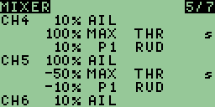
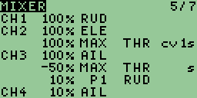

Explanation
Butterfly-mode is activated with THR-switch
The flight-phases are selected with the RUD-switch and the intensity is selected with P1.

Channel 1: | Rudder | 1:1 Stick Rudder
Channel 2: | Elevator | 1:1 Stick Elevator  25% when airbrakes are active; this is delayed by Curve1 and the speed-settings
Channel 3: | Aileron left outside | 1:1 Stick Aileron  -50% Butterfly inverse  10% P1 during flight-mode (RUD-switch)
Channel 4: | flaps left inboard | When THR is set then the flaps are deployed slowly  10% Aileron is added  10% P1 during flight-mode (RUD-switch)
Channel 5: | Aileron right outside | 1:1 Stick Aileron  -50% Butterfly inverse  -10% P1 during flight-mode (RUD-switch)
Channel 6: | flaps right inboard | When THR is set then the flaps are deployed slowly  10% Aileron is added  -10% P1 during flight-mode (RUD-switch)

Motormodell mit Einziehfahrwerk und Fahrwerksflaps
tbd

Heli with 120° Swash Plate

CH1 | 72% |  | ELE |  | 1
CH2 | -36% |  | ELE |  | 2 50% of 1
 | 62% |  | AIL |  | 3 86% of 1
CH3 | -36% |  | ELE |  | 4 50% of 1
 | -62% |  | AIL |  | 5 like 3

Heli with 120° Swash Plate and Pitch

CH1 | 72% |  | ELE |  | 1
 | 30% |  | THR |  | 2
CH2 | -36% |  | ELE |  | 3 50% of 1
 | 62% |  | AIL |  | 4 86% of 1
 | 30% |  | THR |  | 5 like 2
CH3 | -36% |  | ELE |  | 6 50% of 1
 | -62% |  | AIL |  | 7 like 4
 | 30% |  | THR |  | 8 like 2

Flugphasenschalter
Wie im Beispiel 5.3.2 erläutert kann über einen Schalter, in Verbindung mit einem Poti oder einem festen Wert, ein Offset auf jeden Channel gerechnet werden. Über die SPEED- function kann dies LONGsam und die CURVE- function verzögert realisiert werden.

