**Cucumber TestNG Command**

Runner class:

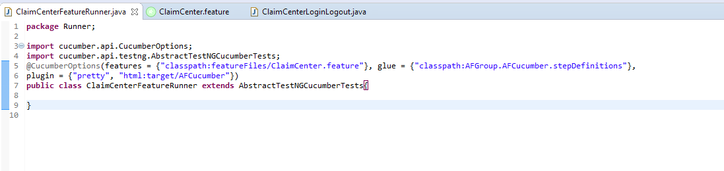

@CucumberOptions(features = {"classpath:featureFiles/ClaimCenter.feature"}, glue = {"classpath:AFGroup.AFCucumber.stepDefinitions"},

plugin = {"pretty", "html:target/AFCucumber"})

**public** **class** ClaimCenterFeatureRunner **extends** AbstractTestNGCucumberTests{

}

Intructor Comments:

