**Project Report (No page limit)**

* **Title**, **Author(s)**
* **Abstract**: It should not be more than 300 words
* **Introduction**: This section introduces your problem, contribution, and the overall plan for approaching your expected outcome
* **Background/Related Work**: This section discusses relevant literature for your project
* **Approach**: This section details the proposed pipeline/framework of your project. Be specific, which means you may want to include equations, figures, plots, etc.
* **Experiment**: This section begins with what kind of experiments you are doing, what kind of dataset(s) you are using, and what is the way you measure or evaluation your results, if applicable. It then shows in details the results of your experiments. By details, we mean both quantitative evaluations (include numbers, figures, tables, etc.) as well as qualitative results (include images, example results, etc.)
* **Conclusion**: What have you learned? Suggest future ideas.
* **References**: This is absolutely necessary (Use **APA** citation style: <https://pitt.libguides.com/citationhelp>)
* **Appendix**: You may include all figures and code snippets that you have not included in the report, if you find it useful for boosting the impression of your project.
  + Font: Times New Roman, Font size: 12, and Spacing: 1.5 lines
  + Supplementary material, such as codes, is not counted toward the page limit. Since there is no page limit, you do not have to worry about this ;-)

**Draft**

**Deep Learning based Land Cover Classification for Satellite Images of Sri Lanka**

**using Convolutional Neural Networks (CNN)**



ESR512 - Numerical Algorithms and Python Programming Group No 02

**Group Members Registration Number Capacity**

**Sathira Hettiarachchi 2022/07 Team Leader**

**Chamila Darshana 2022/05**  **Team Member**

**Prabath Ganegoda 2022/ Team Member**

**Athula Bulathgama 2022/01 Team Member**

**Praneeth Wijetunga 2022/ Team Member**

**Ranga Wijesekara 2022/ Team Member**

# Table of Content

**Abstract**

1. Introduction
   1. Remote Sensing
   2. Land Cover and Land Use
   3. Deep Learning and Convolutional Neural Networks
2. Background/Related Work
3. Experiment
4. Conclusion
5. References
6. Appendix

**Abstract**

Remote Sensing is the method of deriving information about the earth without a physical contact. Most widely used remote sensing method is Satellite Images. These images are widely used in many areas such as Urban Planning, Agriculture, Defense, Forestry, Fisheries etc. in this repot our team has developed a convolutional Neural Network (CNN) to classify the Satellite Images of Sri Lanka according to 3 Land Cover classes, Urban, Vegetation and Water. Dataset which was used to train the model were consisted of 5000 images (Urban – 2000, Vegetation – 2000 and Water – 1000). At the end of the training, overall accuracy of the model was 72.6%. As for the future work, the team wish to continue this project up to image segmentation, where we can classify and cluster the landcover and assign a color for a particular class for a given larger satellite or a drone image.

# Introduction

## 1.1 Remote Sensing

Remote Sensing is defined as the acquisition of information about an object without being physical contact with it. Our five sensors act as remote sensors in the human body. If we take our eyes, they can see an object and identify it with in nano seconds. But when it comes to geospatial science; remote sensing is defined as deriving information about earth surface using images which contain the reflected or emitted electromagnetic radiation. This electromagnetic radiation can be in one or more regions of electromagnetic spectrum. E.g.- visible light (Lidar, Earth Observation Satellites), Radar and Synthetic aperture Radar etc.

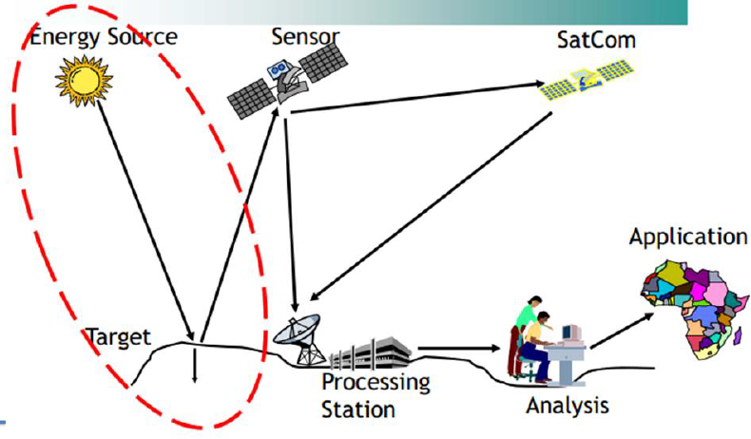

Figure 1 - Remote Sensing Process

Among many remote sensing methods, widely used method is Satellite Systems. There are 4 main types of satellite systems in the world.

* Communication Satellites
* Weather Satellite
* Navigational Satellites
* Earth Observation Satellites

The first earth resource satellite was launched was launched in 1972 (Landsat – 1). Since then, remote sensing has come a long way with the advancement of technology. Satellite images play major role in deriving information about earth’s surface. Just having these images are not enough. We need to interpret these images so that we can make better decisions.

Satellite Images are consisting of pixels. It is the smallest spatial measurement, the minimum size of objects distinguishable on the earth surface. Images where are only large features are visible are said to have low resolution. In high resolution images, small objects can be detected. Spatial resolution is defined the size of a pixel size. These data should be gone through processing and analysis and at the end information are acquired for management purpose. When processing the satellite images, we should be considering about below mention concerns.

* What information do you want?
* How much detail you need?
* What type of details are needed?
* How frequently do you need this information?

Due to these factors, awareness has increased worldwide of having access to reliable, detailed, timely and affordable geospatial data and data processing methods.

## 1.2 Land Cover and Land Use

Landcover is a physical characteristic of the earth surface. It addresses what materials covers the land at a certain place? (Grass, building, tress, corn fields, concrete highways, bare soil, water)

Land use describes people’s activities at a certain position which addresses what is the function of this piece of land? (Residential, recreational, industrial, educational, agricultural, vacant)

Even though land cover can be determined by analyzing satellite and aerial imagery, land use cannot be determined from satellite imagery.

|  |  |  |
| --- | --- | --- |
| No | Level 1 | Level 2 |
| 1 | Urban | Residential, Commercial, Industrial |
| 2 | Agricultural Land | Crop Land |
| 3 | Forest | Deciduous Forest, Mixed Forest |
| 4 | Water | Streams and Canal, Lakes, Reservoir |
| 5 | Barren Land | Beach, Sand Areas, Bare Area |

## 1.3 Deep Learning and Convolutional Neural Networks

Recently deep learning has become a trend in data analysis and has been widely applied in many fields. Such as Natural language processing, Image Classification, Voice synthesis etc. This is a subset of Machine learning and one of the key pillars of Artificial Intelligence. Building block of the deep leaning is Artificial Neural Network, which was inspired by the architecture of the brain. Just like a neuron in the brain processes and transmits information throughout the body, artificial neurons, or nodes in CNNs take inputs, processes them, and sends the result as output.

Figure 1- Biological Neuron vs ANN

Neural networks are composed of 3 types of layers: a single Input layer, Hidden layers, and a single output layer. Input layers are made of nodes, which take the input vector's values and feeds them into the dense, hidden layers. The number of hidden layers could be quite large, depending on the nature of the data and the classification problem. The hidden layers are fully connected in that a single node in one layer is connected to all nodes in the next layer via a series of channels. Input values are transmitted forward until they reach the Output layer. The Output layer is composed of nodes associated with the classes the network is predicting. Convolutional Neural Network or CNN is a type of artificial neural network, which is widely used for image/object recognition and classification.

The way in which we perceive the world is not an easy feat to replicate in just a few lines of code. We are constantly recognizing, segmenting, and inferring objects and faces that pass our vision. Subconsciously taking in information, the human eye is a miracle. Computer Vision deals in studying the phenomenon of human vision and perception by tackling several 'tasks', to name just a few:

* Object Detection
* Image Classification
* Image Reconstruction
* Face Recognition
* Semantic Segmentation

Image Classification attempts to connect an image to a set of class labels. It is a supervised learning problem, wherein a set of pre-labeled training data is fed to a machine learning algorithm. This algorithm attempts| to learn the visual features contained in the training images associated with each label, and classify unlabeled images accordingly

Suppose we have a 32-pixel image with dimensions [32x32x3]. Flattening this matrix into a single input vector would result in an array of 32 X 32 X 3 nodes and associated weights.

This could be a manageable input for a regular network but applying this for high resolution satellite images may not be so manageable. Flattening its dimensions would result millions in value. Time and computation power simply do not favor this approach for image classification.

Convolutional Neural Networks (CNNs) have emerged as a solution to this problem. You'll find this subclass of deep neural networks powering almost every computer vision application out there! High-resolution photography is accessible to almost anyone with a smartphone these days.

# 2.Background and Related Work