**Ruby and Rails Rest API Sample**

**You can Run with Postman**

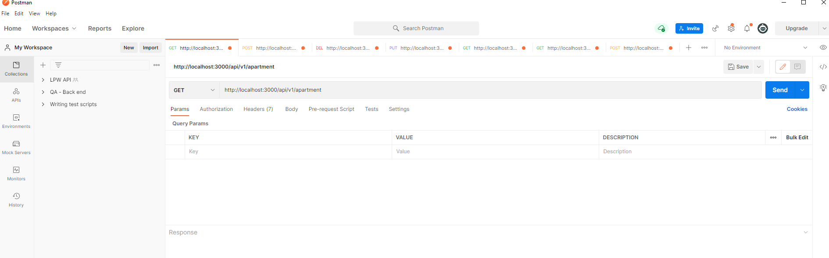

**1.Apartment List**

End point: <http://localhost:3000/api/v1/apartment>

Method: GET

Out Put:

{

    "status": "SUCESS",

    "message": "Loaded Apartment",

    "data": [

        {

            "id": 6,

            "name": " Sky Touch Villa",

            "description": "Penthouse apartment with sky line view",

            "price": " 40 Million",

            "location": " Huge City, Sand Island",

            "created_at": "2022-01-11T05:15:52.143Z",

            "updated_at": "2022-01-11T05:15:52.143Z"

        },

        {

            "id": 5,

            "name": " Sky Touch Villa",

            "description": "Penthouse apartment with sky line view",

            "price": " 40 Million",

            "location": " Huge City, Sand Island",

            "created_at": "2022-01-11T05:15:52.136Z",

            "updated_at": "2022-01-11T05:15:52.136Z"

        },

]

}

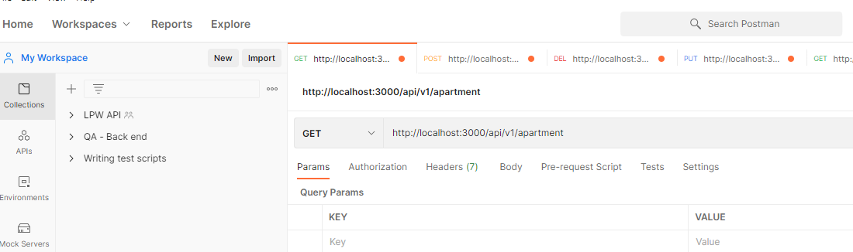

**2.Apartment Detail**

End point: <http://localhost:3000/api/v1/apartment>/1

Method: GET

Out Put:

{

    "status": "SUCESS",

    "message": "Loaded Apartment",

    "data": {

        "id": 1,

        "name": " Blue Jeans Villa",

        "description": "This is the beginner level apartment with basic amenities include",

        "price": "10 Million",

        "location": " Big City, Coral Island",

        "created_at": "2022-01-11T05:15:52.107Z",

        "updated_at": "2022-01-11T05:15:52.107Z"

    }

}

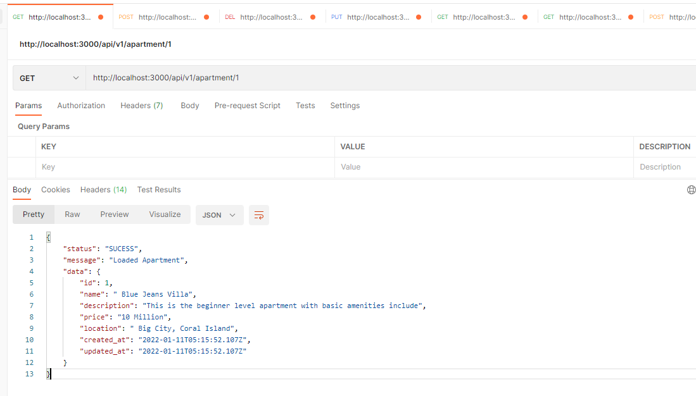

**3.Add New Apartment Detail**

End point: <http://localhost:3000/api/v1/apartment>

Method: POST

Headers : Content-Type: application/json

In Put: Body

{

"name":"test 111",

"description":"jhkjhkjhkjh",

"price":"2222",

"location":"jhkjhkjhkjh"

}

Output:

{

    "status": "SUCESS",

    "message": "Apartment saved",

    "data": {

        "id": 7,

        "name": "test 111",

        "description": "jhkjhkjhkjh",

        "price": "2222",

        "location": "jhkjhkjhkjh",

        "created_at": "2022-01-11T18:47:58.314Z",

        "updated_at": "2022-01-11T18:47:58.314Z"

    }

}

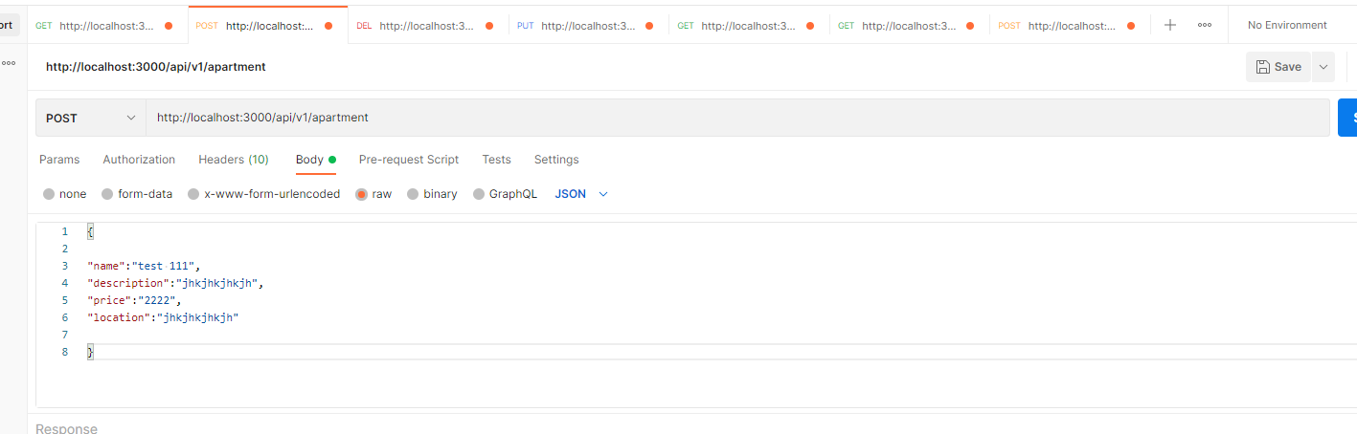

**4.Delete Apartment Detail**

End point: <http://localhost:3000/api/v1/apartment>/1

Method: DELETE

{

    "status": "SUCESS",

    "message": "Apartment deleted",

    "data": {

        "id": 5,

        "name": " Sky Touch Villa",

        "description": "Penthouse apartment with sky line view",

        "price": " 40 Million",

        "location": " Huge City, Sand Island",

        "created_at": "2022-01-11T05:15:52.136Z",

        "updated_at": "2022-01-11T05:15:52.136Z"

    }

}

**4.Update Apartment Detail**

End point: http://localhost:3000/api/v1/apartment/2

Method: PUT

Headers : Content-Type: application/json

In Put: Body

{

"name":"kalinga",

"description":"asd",

"price":"222ww",

"location":"asdaaa"

}

Booking Reservation

**1.Booking List**

End point: <http://localhost:3000/api/v1/booking>

Method: GET

Out Put:

{

    "status": "SUCESS",

    "message": "Loaded Bookings",

    "data": [

        {

            "id": 1,

            "booking_date": "3",

            "booking_time": "jhkjhkjhkjh",

            "appartment_id": "3",

            "client_name": "jhkjhkjhkjh",

            "client_email": "sdsadasd44",

            "isbook": "1",

            "created_at": "2022-01-11T05:19:08.423Z",

            "updated_at": "2022-01-11T05:19:08.423Z"

        }

    ]

}

**2.Booking Details**

End point: http://localhost:3000/api/v1/booking/1

Method: GET

Out Put:

{

"status": "SUCESS",

"message": "Loaded Bookings",

"data": [

{

"id": 1,

"booking_date": "3",

"booking_time": "jhkjhkjhkjh",

"appartment_id": "3",

"client_name": "jhkjhkjhkjh",

"client_email": "sdsadasd44",

"isbook": "1",

"created_at": "2022-01-11T05:19:08.423Z",

"updated_at": "2022-01-11T05:19:08.423Z"

}

]

}

**3.Add New Booking Detail**

End point: <http://localhost:3000/api/v1/booking/>

Method: POST

Headers : Content-Type: application/json

In Put: Body

{

"booking_date":"3",

"booking_time":"jhkjhkjhkjh",

"appartment_id":"3",

"client_name":"jhkjhkjhkjh",

"client_email":"sdsadasd44",

"isbook":"1"

}

Out Put

{

    "status": "SUCESS",

    "message": "Apartment Booking saved",

    "data": {

        "id": 2,

        "booking_date": "5",

        "booking_time": "jhkjhkjhkjh",

        "appartment_id": "3",

        "client_name": "jhkjhkjhkjh",

        "client_email": "sdsadasd44",

        "isbook": "1",

        "created_at": "2022-01-11T19:02:16.842Z",

        "updated_at": "2022-01-11T19:02:16.842Z"

    }

}

when trying to book an apartment that has been already booked ,system given error.

Error:

{

    "status": "ERROR",

    "message": "Unable To booking !selected date alredy Booked!!!... Time Try Anther Day"

}