**Date: 08th October, 2021**

**Celebration of IEEE Day**

IEEE Student Branch celebrated **“IEEE Day”** on 8th October 2021.

The event started at 9:30 am on 8th October in the B C Lingaiah Hall (TAP Seminar Hall). The event began with Ms. Mandara Adiga, Secretary of Toastmasters VVCE, singing the invocation song. The Guests of Honour were Dr. Bindu A Thomas and Dr. Parameshachari B D. The HODS of CS and EC department, Dr. Ravikumar V and Dr. Chandrashekar Patil along with the guest of Honours performed lighting of the lamp. Mrs Bindu A Thomas, Chair of IEEE Mysore subsection, educated the students on the advantages of joining IEEE as members and the benefits of being a volunteer. Dr. Parameshachari B D, Chair Elect of IEEE Mysore subsection, continued the session further with further explanations on the benefits of being an IEEE member. The event was hosted by Chair of IEEE Computer Society Student Chapter. The event was conducted as a collaboration of all subsections of IEEE Student Branch Chapter of VVCE namely IEEE Computer Society Student Chapter, Robotics and Automation Society, Power and Energy Society and Women in Engineering. The event continued with an online session from Mrs. Usha Rengaraju, Kaggle Grandmaster, on Data Analytics.

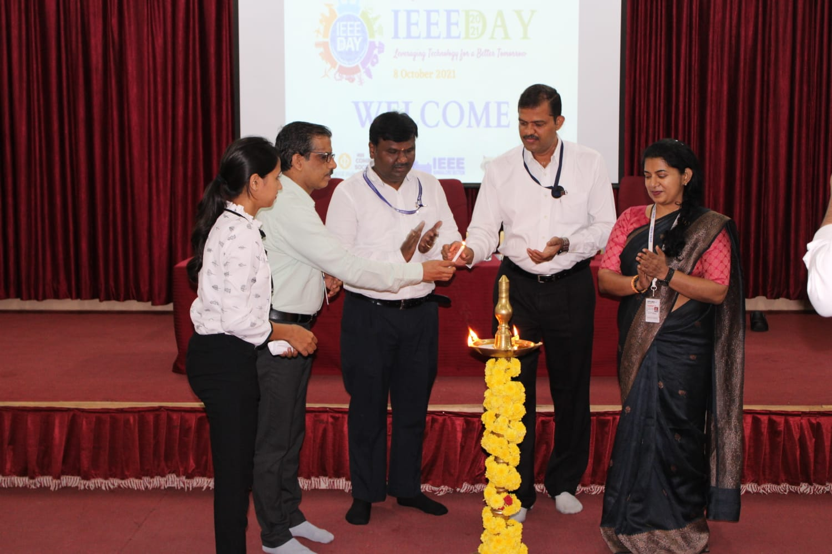**Snap shot of the Event:**

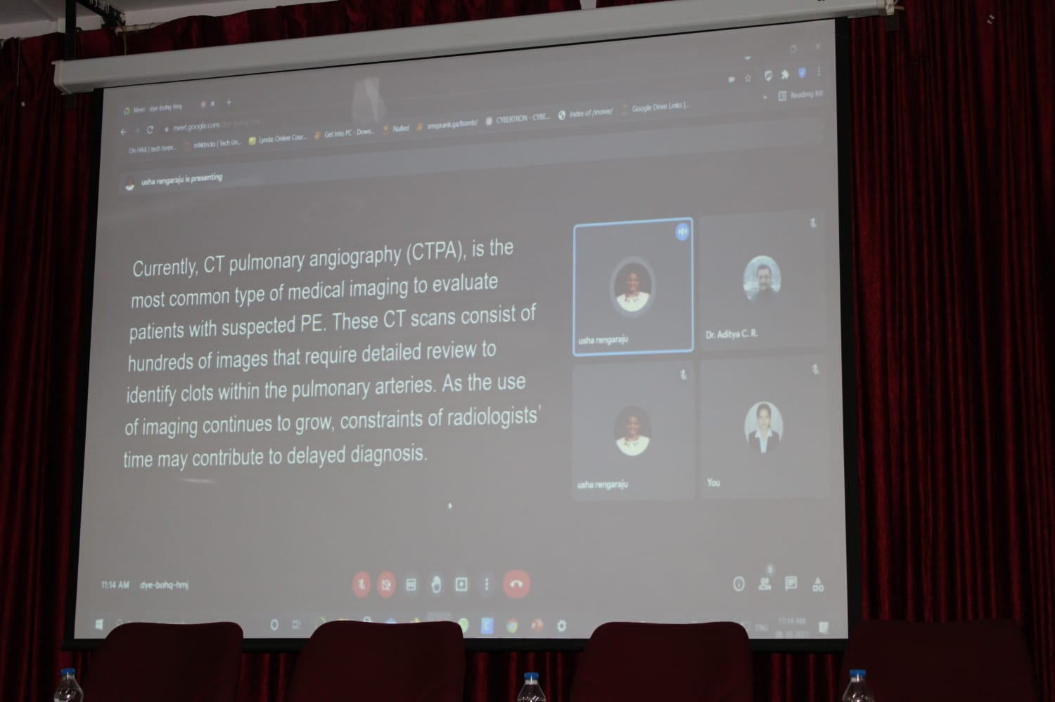

IEEE Day is a way to celebrate the togetherness of thousands of IEEE members in local communities join together to collaborate on the ideas that leverage technology for a better tomorrow.

**Coordinators (Advisors) Dr. Ravi Kumar V**

Dr. Ramakrishna Hegde Professor and Head

Dr. Aditya C R Dept. of CSE, VVCE.

Prof. Chethana H T

Prof. Harshitha K

Prof. Anusha KS