



KARNATAKA STATE COUNCIL FOR SCIENCE AND TECHNOLOGY
Indian Institute of Science campus, Bengaluru
Telephone: 080 -23600978, 23341652 || Email: spp@kscst.org.in
Website: www.kscst.iisc.ernet.in/spp.html or www.kscst.org.in/spp.html
FORMAT FOR STUDENT PROJECT PROPOSAL FOR THE
45th SERIES OF STUDENT PROJECT PROGRAMME
(Handwritten proposals will not be accepted, please fill all the details in this MS word file, insert images / diagrams wherever necessary. Convert to pdf file, get it approved from the project guide / head of the department and principal of your institution. Keep ready the scanned pdf file of 1) Declaration and Endorsement 2) details of processing fees made and fill-up the Google Form. Send the softcopy of the project proposal including the three scanned pages and send the proposal (All information in one pdf file) by email to spp@kscst.org.in
https://forms.gle/9wriMyaKhBaGaWpw7
Name of the College: Vidyavardhaka College of Engineering

Project Title: GreetMate – a human computer interface for edible refreshment industry.

Branch: Computer Science & Engineering

Theme (as per KSCST poster): User friendly devices for aged or physically challenged people.
(The project proposals shall mandatorily be from one of the broad themes / areas. Visit website www.kscst.org.in/spp.html)

Name(s) of project guide(s):
- Name: Dr. Pooja M.R
Email id: pooja.mr@vvce.ac.in
Contact No.:+91 98868 19448
- Name: Prof. / Dr. / Mr. / Mrs.
Email id:
Contact No.:
Name of Team Members (Strictly not more than four students in a batch): (Type names in Capital Letters as provided in your college)
(Please paste the latest passport size photograph adjacent to your respective names)
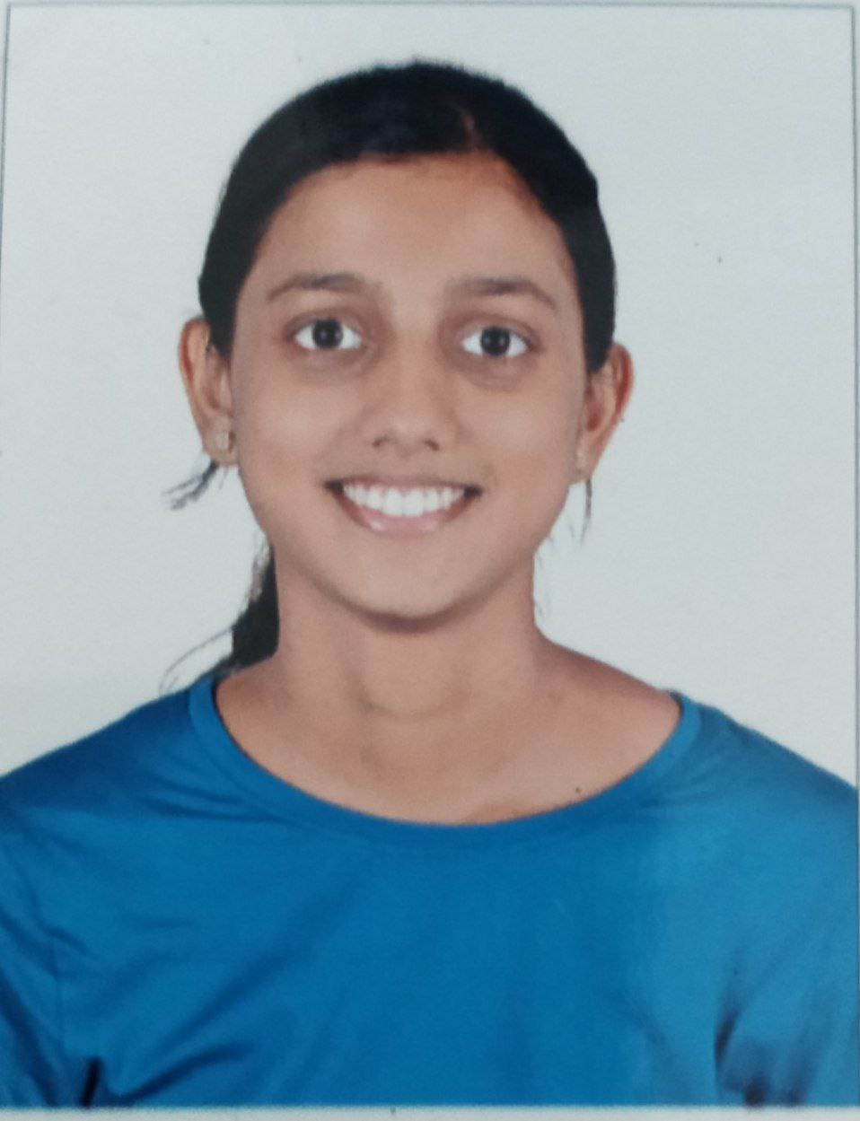
Name: Soujanya N
USN No.:4vv18cs138
Email id: soujanya2016@gmail.com
Mobile No:+91 88610 76096

Name: Sourabha G
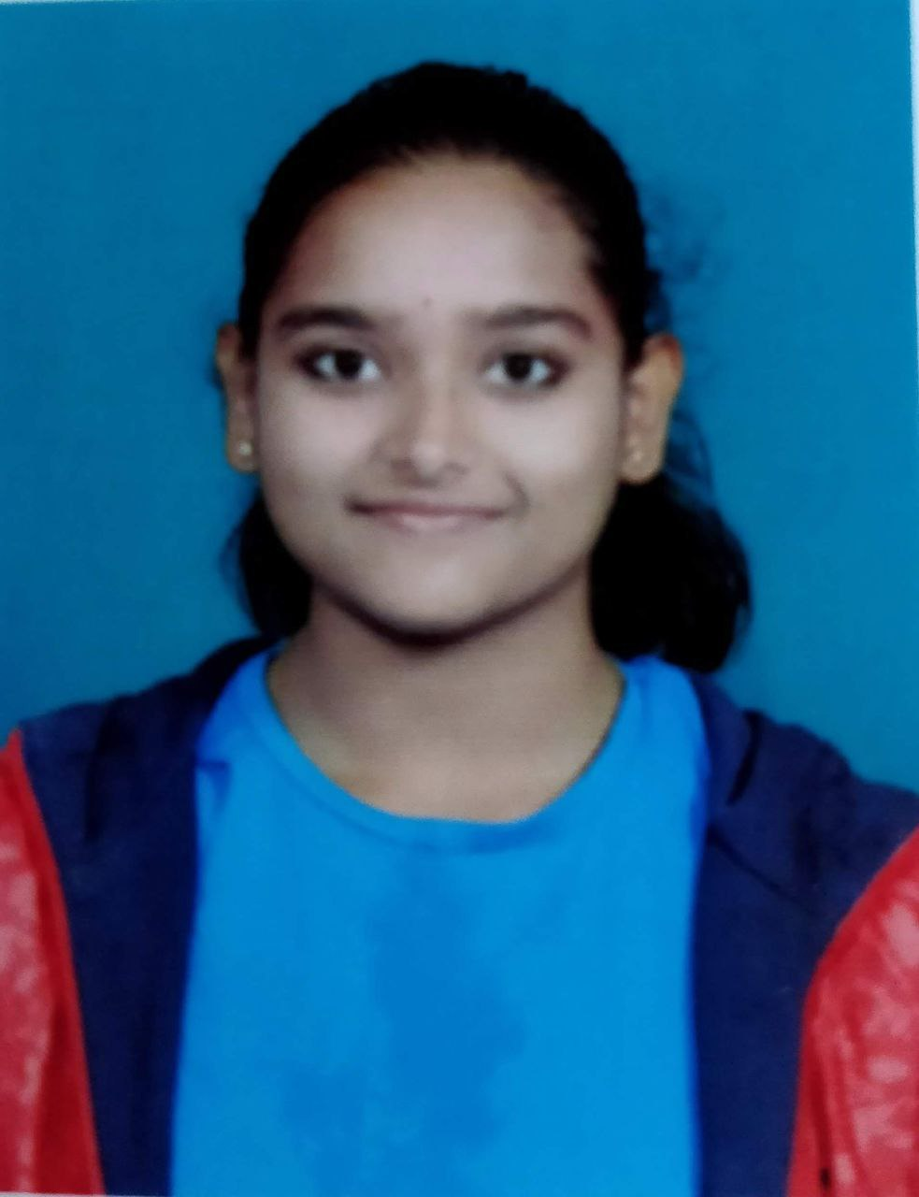
USN No.:4vv18cs140
Email id: sourabhayoga@gmail.com
Mobile No.:+91 98806 19820

Name: Jeevitha C B
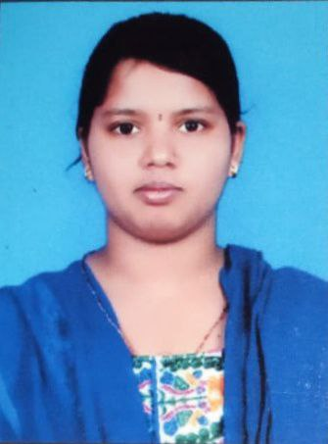
USN No.:4vv19cs409
Email id:jeevitha.jhanvi@gmail.com
Mobile No.:9483370329

Team Leader of the Project:
Name: Soujanya N
USN No.:4vv18cs138
Email id:soujanya2016@gmail.com
Mobile No.: 88610 76096
Processing Fee Details (Through Online Payment only):
(processing fee of Rs. 1000/-)
Please furnish the payment made details provided in the last page of this proposal.
Note: (The student team shall furnish the details in the Google Form. It is informed to the students to 1) keep ready the project proposal and 2) make the payment made details for processing fees and 3) Enter the details in the Google Form on the same day of payment made to KSCST by NEFT / UPI payment).
Date of commencement of the Project: 01/10/2021

Probable date of completion of the project: 30/05/2022

Scope / Objectives of the project:
- To create a Human-computer interaction program to make it more user friendly in capitalizing the edible refreshment industry.
To implement the concept of CNN.
To design a desktop application that can recognize an individual’s basic features
- This is also to create a more pleasant and understandable environment for not just normal customers but specially challenged customers also.

Methodology:
In this growing era of reduced human to human communication, interaction between human and computer has a higher scope in the contact-less edible refreshment industry. To increase human to computer interaction, a desktop application prototype of a vending machine that uses an individual's basic human features like age and gender will be built using the technologies such as python, computer vision and convolution neural network to greet a customer who uses the vending machine.
We aim to provide the customers of the vending machine to have a welcoming user experience that will give them a slightly higher chance of better mental health. This project is also in preference for specially challenged customers who would like to be at the receiving end of a contact-less edible refreshment industry.

Note: In case of fabrication work in the project, an engineering drawing with dimensions / detailed design should be attached to the proposal.
Expected Outcome of the project:
We aim to build a desktop application that greets the customer of a vending machine based on age and gender. The ideologies in which this project will be built is based on the importance given to mental health of the customers that are a part of this industry and the specially challenged customers getting a more easily understandable translation of the products that are a part of the industry.

Is the project proposed relevant to the Industry / Society or Institution?

Yes / No: Yes
proposed relevant to the Industry / Society
If Yes, please provide details of the Industry / institution and contact details:
Vidyavardhaka college of engineering
Phone : +918214276200

(Note: Preference will be given to those projects relevant to the industry / institution. Hence be specific in giving detailed information). Is the industry extending support - technology / funds / use the final product, please specify.
Can the product or process developed in the project be taken up for filing a Patent?
Yes / No:
Yes

Prior Art search done?
Yes/No: No
Note: If your answer is “Yes”, you may contact Patent Information Centre of KSCST. For more details, email: pic@kscst.org.in
Budget details (break-up details should be given):
Note: KSCST will provide nominal grant support for carrying out the project by students if selected by the project selection committee.
Budget | Amount
a) Materials / Consumables | 5500.00
b) Labor | 500.00
c) Travel | 500.00
e) Miscellaneous- Reports | 500.00
Total | 7000.00

Any other technical details (Please specify):
Nil.

SPP Coordinator (Identified by the college):
Note: To be identified by the principal of the institution. The project proposals must be submitted to KSCST through SPP coordinator designated by the Principal.

Name: Dr. G B Krishnappa
Email id:gbk@vvce.ac.in
Contact No.:+91 92435 28200

Name of the Project Guide:Pooja M R | Name of the HOD: Ravi Kumar
Email id:pooja.mr@vvce.ac.in | Email id:ravikumarv@vvce.ac.in
Contact No.:+91 98868 19448 | Contact No.:+91 99005 01968

DECLARATION
(From Project Students)
(To scan this page and enclose in the project proposal)

We, the project team hereby declare that the details enclosed in the project proposal (Title of the Project: Greetmate, Branch: Computer science and engineering, College: Vidyavardhaka College of engineering) are true and correct to the best of our knowledge and belief and we undertake to inform KSCST of any changes therein in the project title, students name will be intimated immediately through project guide. In case any of the above information is found to be false or untrue or misleading, we are aware that we may be held liable for it. We hereby authorize sharing of the project information with this project proposal with the Karnataka State Council for Science and Technology, Bangaluru.
We are aware that the project team must exhibit / demonstrate the project in the nodal centre and interact regarding project with the experts and to exhibit the project in the State Level Seminar and Exhibition (if selected). If the student team fails to attend the evaluation in nodal centre or fails to attend the State Level Seminar and Exhibition, the supported project amount will be returned to KSCST.
We also hereby, enclose the endorsement form to KSCST, Bengaluru.

Name of the students with USN No. Signature with date
- Soujanya (4vv18cs140)
- Sourabha (4vv18cs138)
- Jeevitha C B(4vv19cs409)
Dr.Pooja M R  (Name & Signature of Project Guide with Seal) | Dr.Ravi Kumar V  (Name & Signature of HOD with Seal)
Email id: pooja.mr@vvce.ac.in | Email id: ravikumarv@vvce.ac.in
Contact No.: 98868 19448 | Contact No.:+91 99005 01968

ENDORSEMENT
(From College, endorsement to be taken in the institution / Department Letter head)
(To scan this page and enclose in the project proposal)

This is to certify that 1) Ms. Soujanya N, 2) Ms. Sourabha G, 3) Ms. Jeevitha C B, are bonafide student(s) of Department of computer science and engineering, in the degree program of our institution. If the project proposal submitted by these students under the 45th series of Student Project Programme is selected by KSCST, we will provide the requisite laboratory / Computer / infrastructure support in our college / Institution. Further we also take necessary steps to see that the project team will exhibit / demonstrate their project in the nodal centre and in the State Level Seminar and Exhibition (if selected). If the student team fails to send the completed project report or fails to attend the evaluation in nodal centre or fails to attend the State Level Seminar and Exhibition, the supported project amount will be returned to KSCST.

Dr.Pooja M R  (Name & Signature of  Project Guide with Seal) | (Signature of HOD with Seal) | (Signature of the Principal with Seal)
Email id:pooja.mr@vvce.ac.in | Email id:ravikumarv@vvce.ac.in | Email id: principal@vvce.ac.in
Contact No.: 98868 19448 | Contact No:99005 01968 | Contact No.:+91 99456 50016

DETAILS OF PROCESSING FEES MADE THROUGH
NEFT / UPI PAYMENT
(Note: Include this page in the softcopy of the student project proposal. The student team shall furnish the details in the Google Form. It is informed to the students to 1) keep ready the softcopy of the project proposal and other documents and 2) Furnish the payment made details as processing fees and 3) update the details in the Google Form on the same day of payment made to KSCST by NEFT / UPI payment).

- TITLE OF THE PROJECT | : | GreetMate- a human computer interface for edible refreshment industry.
- NAME OF THE TEAM LEADER | : | Soujanya
- EMAIL ID | : | soujanya2016@gmail.com
- CONTACT MOBILE NO. | : | 88610 76096
PAYMENT MADE DETAILS
- BANK REF. NO. / UTR NO. / UPI No. (12 digits) | : | 200614970829
- TRANSACTION ID | : | CICAgODR5qvtCg
- NAME OF THE SENDER / ACCOUNT HOLDER and CONTACT NUMBER | : | Sourabha G  8317409674
- NAME OF THE BANK | : | SBI
- PROCESSING FEES | : | Rs. 1000/-
- DATE OF PAYMENT MADE | : | 6/1/2022
- TIME | : | 2:30pm
- MODE OF PAYMENT MADE  (NEFT / UPI, PLEASE SPECIFY) | : | UPI

(Name & Signature of  the team leader) | (Name & Signature of  Project Guide or HOD with Seal)
KARNATAKA STATE COUNCIL FOR SCIENCE AND TECHNOLOGY
Indian Institute of Science campus, Bengaluru
45th SERIES OF STUDENT PROJECT PROGRAMME (SPP)
(Note: This page is for information about bank details of KSCST to the student team and college / institution and not to include this page in the project proposal softcopy)

BANK ACCOUNT DETAILS OF KSCST
Name and address of the Institution | Karnataka State Council for Science and Technology, IISc Campus, Bangalore -560012
Account holder’s name / Designation | Secretary, Karnataka State Council for Science and Technology
Bank Account No. & Name of the bank | Current A/C No. 0683201000024  Canara Bank, IISc Campus Branch, Bangalore-560012
IFSC Code | CNRB0000683
MICR Code | 560015023
Bank Branch Address | Canara Bank, Indian Institute of Science, Bangalore-560012

