Data-Driven Marketing and Sales Optimization for SmartTech Solutions

A proposal report for the BDM Capstone Project

THUSHAR K NIMBALKAR

21F1006297



IITM Online BS Degree Program, Indian Institute of Technology, Madras, Chennai Tamil Nadu, India 600036

Executive Summary

SmartTech Solutions is a mid-sized B2C smartphone retail company, and is facing challenges in managing inventory and maximizing sales efficiency in a competitive market. This capstone project aims to address these issues by analyzing sales data to identify seasonal trends, high-demand products, and customer preferences.

Implementing solutions to these business problems requires time series analysis, product performance analysis, and Pareto analysis, through which the project will provide actionable insights for improving inventory management, reducing stockouts, and enhancing customer satisfaction.

Through data-driven strategies, SmartTech Solutions expects to optimize operations, improve profitability, and create a robust foundation for sustainable growth.

Organization Background

SmartTech Solutions was started in 2017, to cater to a broad range of consumers, from tech enthusiasts to everyday smartphone users. It is located in a shopping district, and has steadily grown its customer base over the past few years by offering a diverse selection of smartphone brands and models.

SmartTech operates both as a physical retail outlet and an online store, and is accessible to customers looking for quality products and reliable after-sales service. The store employs a dedicated team across customer service, inventory management, and operations.

SmartTech offers a wide variety of products including but not limited to:

1. Mobiles: Flagship, Midrange, Budget Phones and Tablets
2. Mobile Accessories: Batteries, Chargers, Covers, Power banks
3. Other Accessories: Headset, Smart Watch, Earphones, Cables

Problem Statement

SmartTech Solutions faces operational and sales challenges in adapting to evolving customer demands, which impacts product availability and sales potential. The main issues include:

1. **Sales Performance Variability**: Significant fluctuations in sales performance across smartphone models have made it challenging for SmartTech to maintain a balanced product lineup. The data reveals that while certain high-end models experience strong initial sales, their popularity often wanes quickly as new models enter the market. Conversely, some mid-range and budget options maintain consistent sales but lack timely promotion, resulting in missed growth opportunities.
2. **Customer Demand Insights**: Rapidly changing customer purchasing habits and preferences make it difficult to forecast demand across product categories accurately. Factors such as brand loyalty, seasonal demand spikes, and the popularity of specific features further complicate these predictions. The current approach lacks the data-driven insights needed to align marketing and inventory strategies with customer expectations, increasing the risk of stockouts for high-demand items and surplus inventory for slower-moving products.

Background of the Problems

**Sales Performance Variability**: SmartTech faces challenges in maintaining a balanced product lineup across its diverse smartphone offerings. Without precise insights into product sales trends, the company risks misallocating its marketing efforts and product focus. High-demand models often experience rapid sales peaks that fade quickly, while consistent sellers in mid-range categories miss timely promotional opportunities. Effective analysis of sales performance variability is essential to align marketing strategies, maximize product visibility, and capture growth opportunities, ultimately optimizing revenue and meeting customer demand more effectively.

**Customer Demand Insights**: SmartTech lacks detailed insights into customer purchasing trends across its diverse customer base. Without a structured analysis of these trends, the company struggles to predict demand accurately and align stock levels with customer needs. Better demand insights would allow SmartTech to anticipate seasonal trends, high-demand periods, and product preferences, helping to enhance customer satisfaction and optimize sales.

Problem Solving Approach

To address these challenges, a structured data analysis approach will be implemented:

1. **Descriptive Statistics**: Initial analysis of sales data will provide insights into overall sales volume, average transaction values, and variability across product categories. This foundational step will help quantify the general sales performance and highlight patterns.
2. **Time Series Analysis**: Examining sales data over time will reveal trends and seasonality, such as high-demand periods (e.g., during holidays or promotions). Decomposing time series data into trend and seasonal components will enable more accurate demand forecasting.
3. **Product Performance Analysis**: By evaluating each product’s contribution to total sales, we can identify high-performing items. This analysis will consider metrics like growth rate, revenue share, and customer preferences, aiding SmartTech in prioritizing stock and marketing efforts.
4. **Pareto Analysis**: Applying the 80/20 rule will pinpoint the top 20% of products driving 80% of revenue. This insight will support resource allocation, enabling SmartTech to focus on key products and reduce investment in low-demand items.
5. **Correlation Analysis**: Exploring correlations between variables like promotions, seasonality, and sales volume will shed light on factors influencing purchasing patterns, supporting promotional strategy adjustments.
6. **Percentage Growth Analysis**: This analysis will measure product sales growth over different periods, guiding inventory decisions by identifying emerging and declining products.

**Tools to be used**

* Excel: Used for data entry, organization, and performing statistical analysis. Excel’s functionality is ideal for handling smaller datasets and conducting basic analyses, providing the company with a quick and effective way to perform initial data assessments and identify key trends.
* Python: Several Python libraries are applied for advanced data analytics and visualization tasks, including demand forecasting and trend analysis.

Expected Timeline

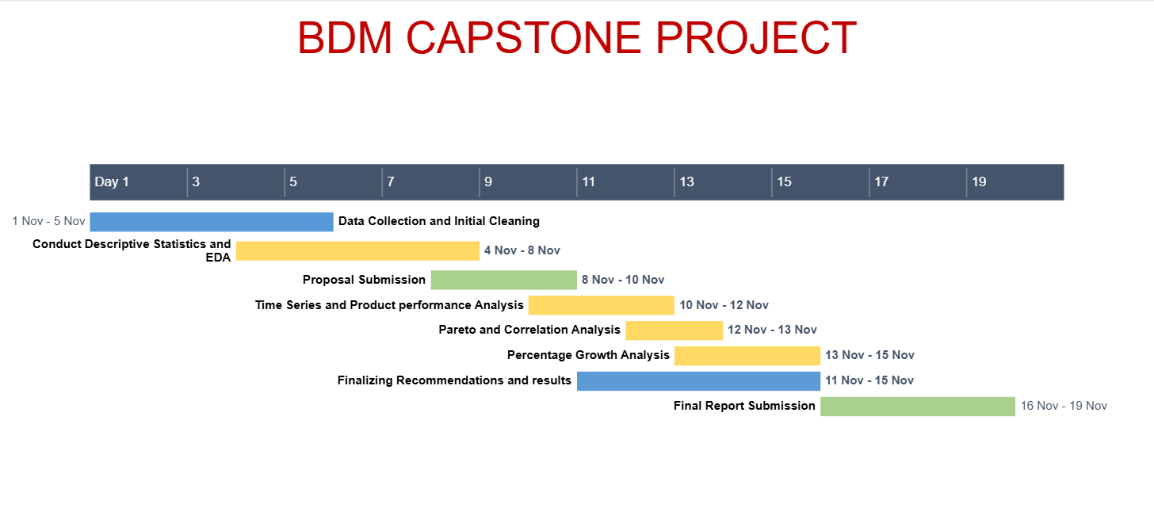

NOVEMBER 2024

Expected Outcome

The analysis of SmartTech Solutions’ sales data will yield actionable insights that address the identified challenges in sales performance variability and customer demand insights. Expected outcomes include:

1. **Optimized Product Lineup**: By examining sales trends, SmartTech can refine its product range, ensuring high-performing models are consistently available while minimizing surplus stock of slower-moving items. This will enhance inventory efficiency and align products with customer demand.
2. **Targeted Marketing Strategies**: Understanding sales variability across different categories will allow SmartTech to craft targeted marketing campaigns. Promotions can be timed with high-demand models or adjusted to boost visibility for steady sellers in mid-range or budget segments, maximizing revenue.
3. **Improved Demand Forecasting**: Customer demand insights will enable better anticipation of future trends based on customer preferences, seasonal factors, and feature popularity.

In summary, these insights will help SmartTech optimize its product offerings, marketing strategies, and inventory management to align with actual customer demand, ensuring smoother retail operations.

Secondary Data Source: https://www.kaggle.com/datasets/shubham2703/smartphone-retail-outlet-sales-data/data