**ICOCA CARD**

An ICOCA cards are rechargeable smart cards which can be used to ride JR west trains or busses without buying tickets by touching the electric ticket gate or electric ticket machine and you can pay money in a shop around city displaying ICOCA marks. It is an electric card which helps people to buy tickets easily and saves time and it reduces lots of pressure of getting changes in japan.

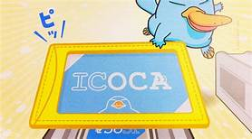

**How to purchase an ICOCA card?**

Buying an ICOCA card is very easy if you don’t understand Japanese language then also you can buy an ICOCA card easily. Anyone can buy this cards form JR-WEST station ticket vending machine easily with an ICOCA marked ticket vending machine.

**Procedures to buy an ICOCA cards**

1.Firstly change the language setting from Japanese to English .

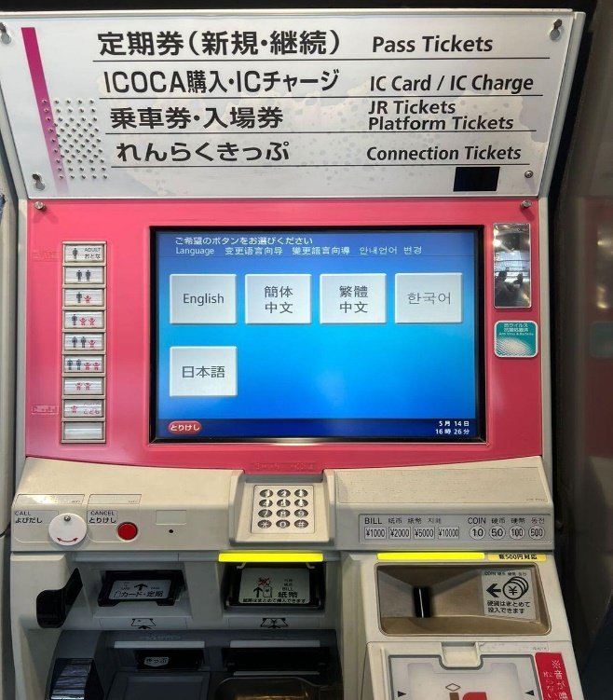

2.Secondly press purchase an ICOCA card icon.

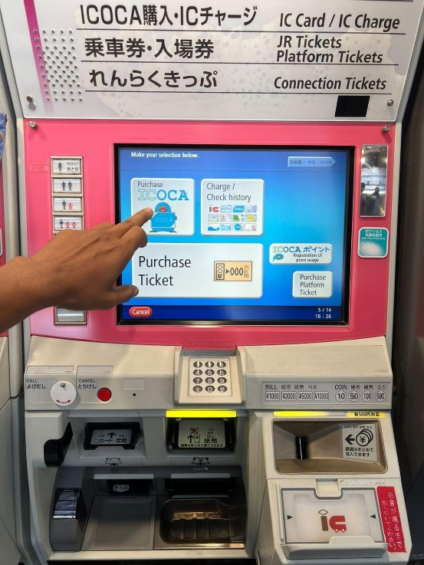

3. Thirdly you can choose purchase amount as much as you want.

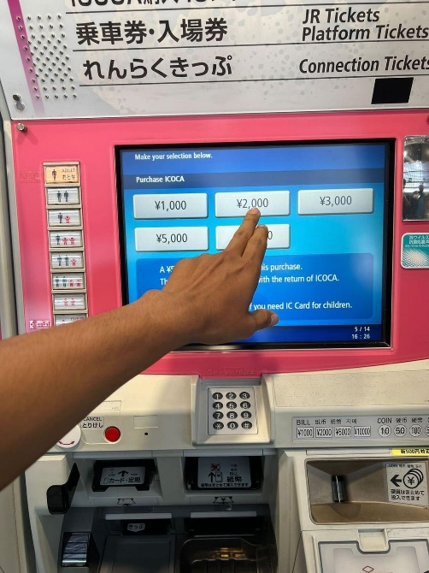

4. Lastly you will get your card after required amount is inserted.

**How to recharge an ICOCA card?**

For recharging any an ICOCA cards you need to go to the ticket vending machine or fare adjustment machine in a train station same machine where you buy your an ICOCA card follow these instruction to top up your card.

1.Place your card in a machine where IC icon shown.

2.Click charge/check history icon.

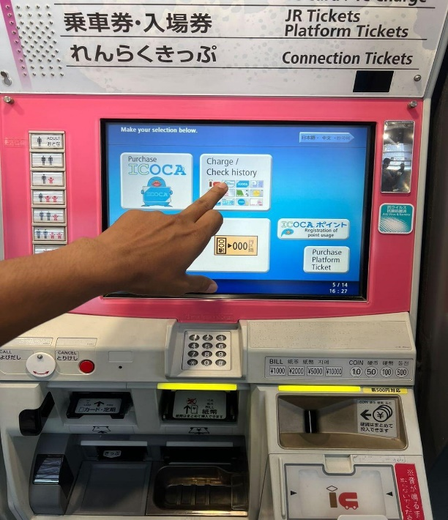

3.Click charge by cash icon.

3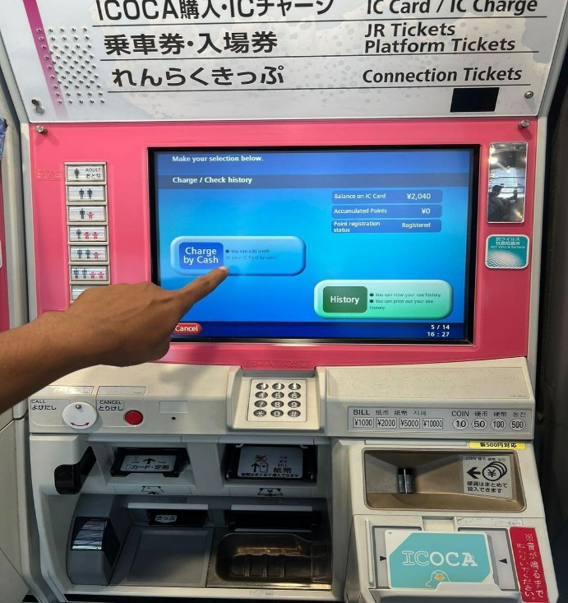

4. Select money which you want to top up.

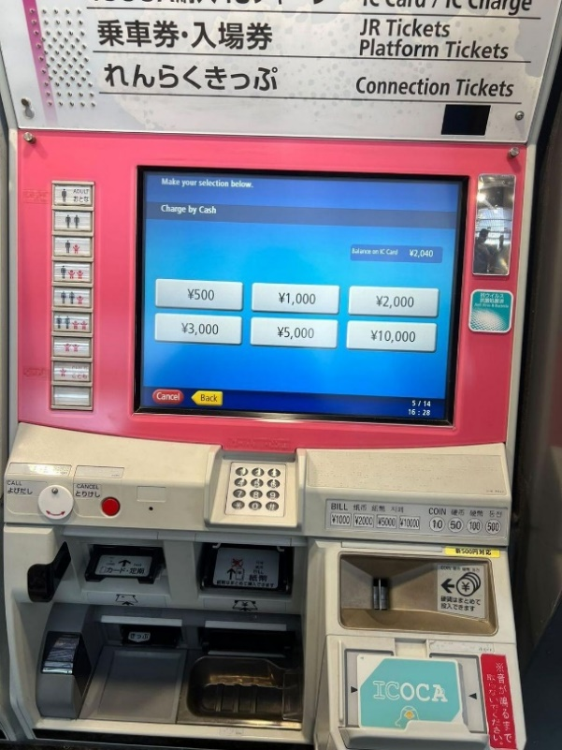

**How to use an ICOCA cards on a trains or busses and stores?**

You can use an ICOCA cards on trains as well as buses. Just tap your card in an entry gate in a station and when you exit that machine will show you your total balance.

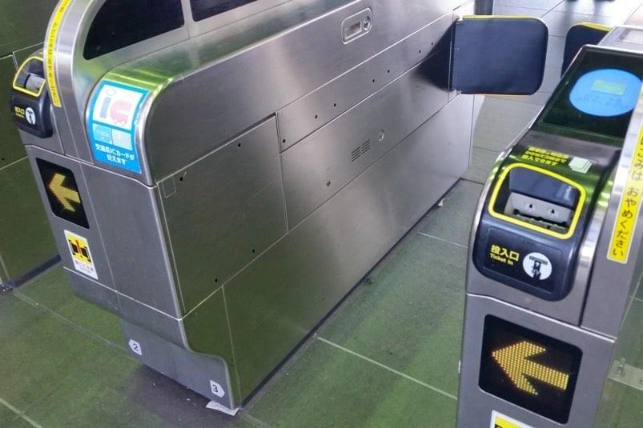

On a busses you can tap card on a card reader on the top of fare machine while exiting from the bus.

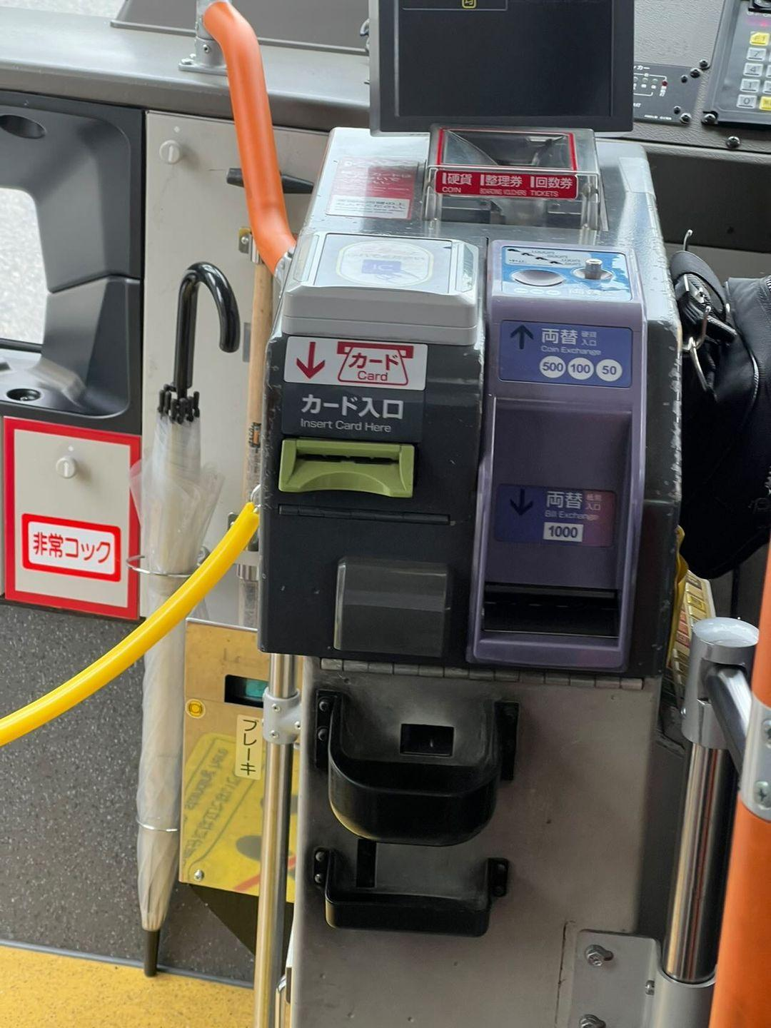

You can also use your card in a stores restaurant to pay your bills in those stores you can see the stickers showing the main cash counter.