TECHNICAL EXCELLENCE AWARD
CATEGORY 04 | METROPOLITAN EXCELLENCE AWARDS 2026
SUPPORTING EVIDENCE REPORT
Nominee: Thusitha Dhananjaya • Assistant Manager – Technical Support
32  PEER RESPONSES | 4.78 / 5  AVERAGE RATING | 28 / 32  RATED 5/5 | 45  DASHBOARD SECTIONS

1. Purpose and evidence sources
This report consolidates the nominee's supplied professional details, screenshots, award-ceremony photographs and a Google Form summary of 32 technical-colleague responses. Peer feedback is presented as peer-reported evidence, not an independent audit or formal customer satisfaction survey. Dashboard results shown in photographs are examples of displayed source data, not independently verified business outcomes.
2. Peer rating snapshot
Rating | Responses | Share
5/5 | 28 | 87.5%
4/5 | 3 | 9.4%
3/5 | 0 | 0.0%
2/5 | 0 | 0.0%
1/5 | 1 | 3.1%
Average rating: 4.78/5 (153 total rating points ÷ 32 responses). 28 respondents (87.5%) rated 5/5; three rated 4/5; one rated 1/5. All submitted ratings are included.
3. What colleagues highlighted
- Technical troubleshooting across Canon copier/printer hardware, networking, computer hardware/software, scan-to-folder/scan-to-email and uniFLOW-related issues.
- Remote, practical step-by-step guidance, including willingness to help outside normal office hours and during extended troubleshooting calls.
- Knowledge sharing and patient coaching for experienced engineers and newer technical staff.
- Peer-reported cases involving Huawei, Shangri-La, Synergy, scan-folder configuration, PC connectivity, Windows errors and new-machine network setup.
- One colleague reported more than three hours of telephone support for a difficult case; another reported approximately six hours while working with Canon Singapore support.
4. Innovation evidence — Canon TechSuite Pro v1.8
The screenshots identify Canon TechSuite Pro v1.8 as a Field Engineering Suite created by Thusitha Dhananjaya. The supplied screens show:
- Scan Fix (SMB): authentication choices, destination folder selection, folder creation/sharing and a guided sequence for environment/network checks, firewall alignment, authentication/share security and final path verification.
- Scan to Email: SMTP details and setup guidance, including Gmail/Google configuration, with language selection for English, Sinhala and Tamil.
- About screen: description of functions for SMB network fixes, Windows 11 Protected Print troubleshooting, installed-device port scans, SMTP setup and e-Maintenance/monitoring deployment guidance.
- Intended benefit: make common field troubleshooting steps easier to understand and repeat, supporting technical officers/field engineers across different language preferences.
The nominee reports that the tool was tested in different environments and is designed to help resolve routine issues within minutes. No independent test log, adoption figure, or measured reduction in resolution time was supplied; attach these if available.
Evidence image A — Canon TechSuite Pro
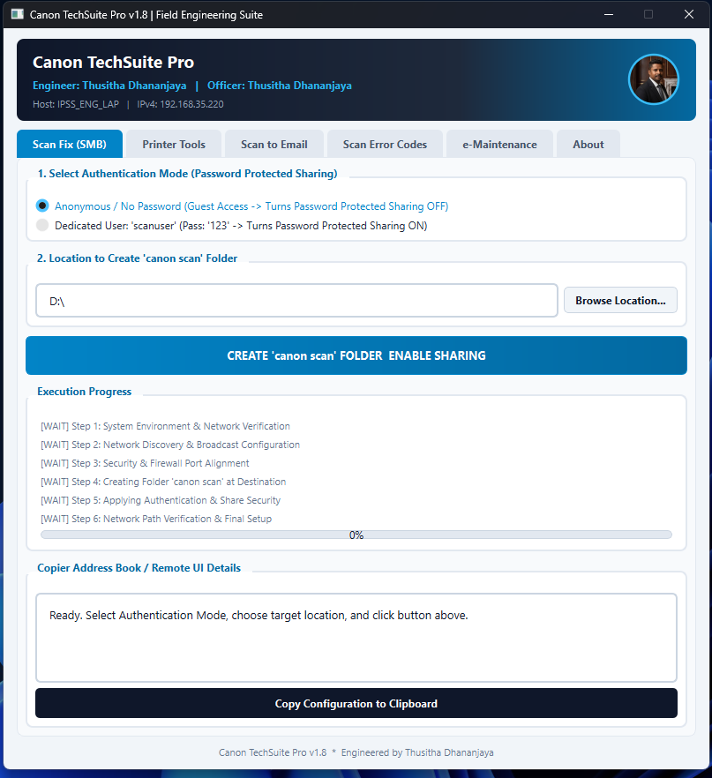
SMB Scan Fix screen
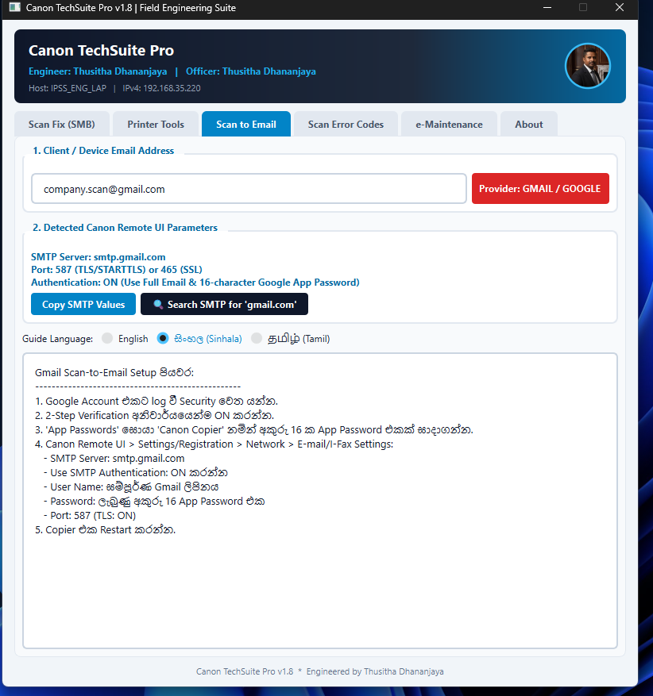
Scan-to-email setup guidance with English, Sinhala and Tamil options
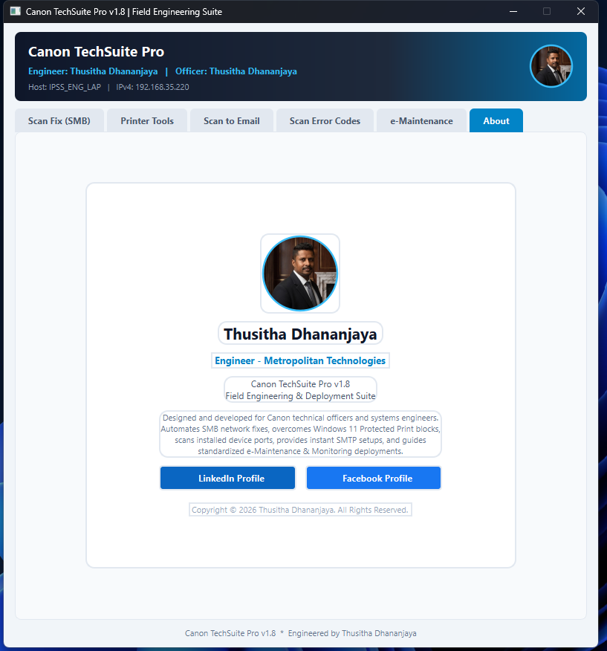
About screen describing the field engineering suite
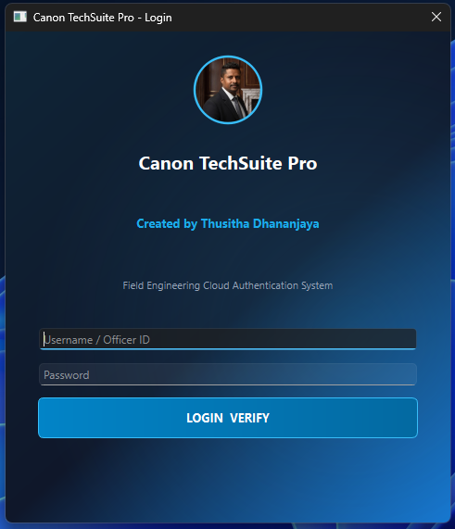
Software login and author identification
5. Innovation evidence — Smartboard performance dashboard
The nominee reports creating a 45-section dashboard for daily performance monitoring in Metropolitan's Customer Support & Base Marketing SBU, displayed on a Smartboard. The supplied photographs show examples of technician target attainment, AMC budget performance, open receivables and ageing, pending estimate pipeline, and management priorities. The system is still being tested; therefore, the report does not describe it as fully deployed or claim verified performance improvements.
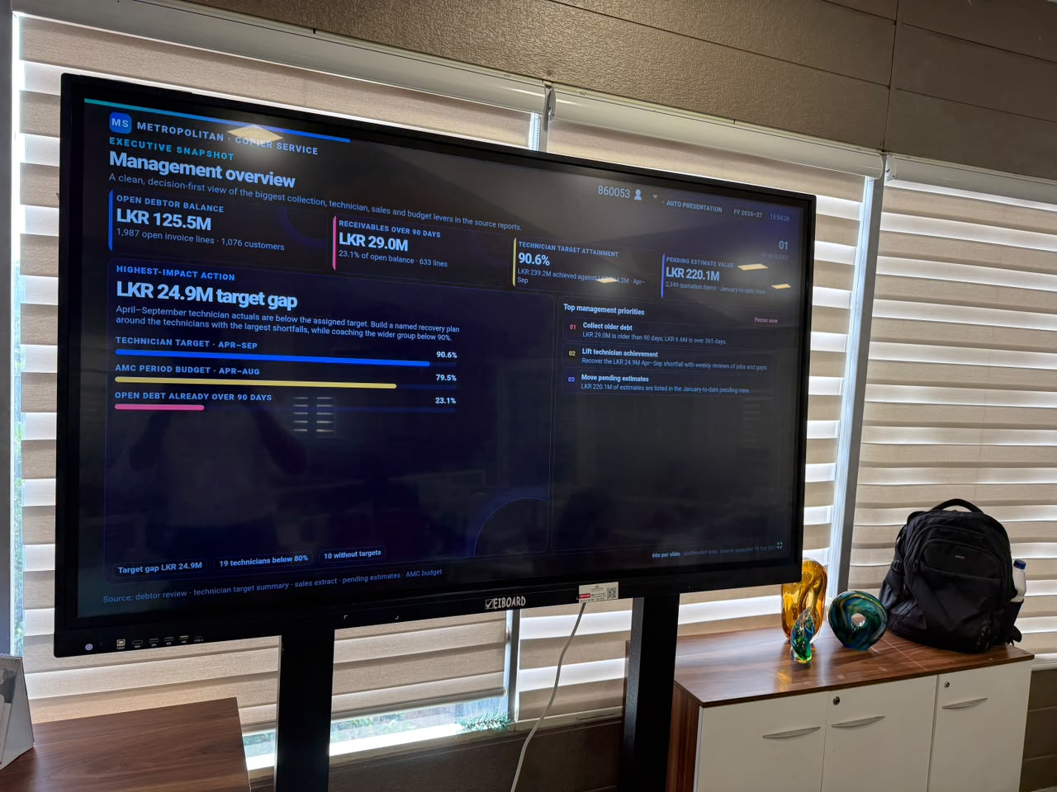
Dashboard view: technician target gaps and AMC budget performance
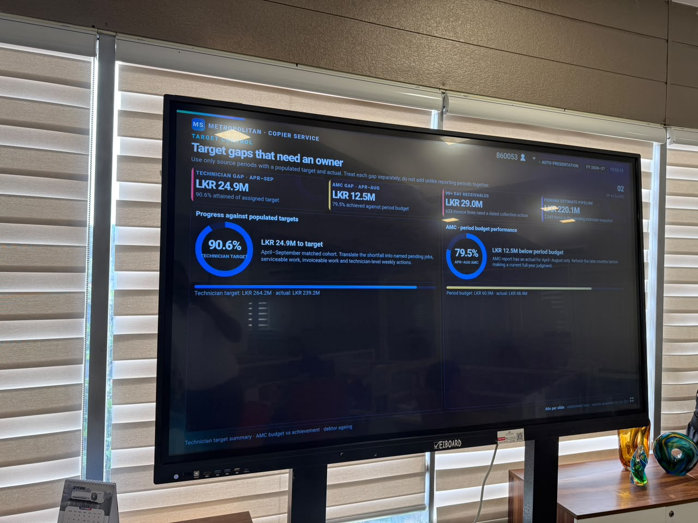
Dashboard view: receivables and ageing distribution
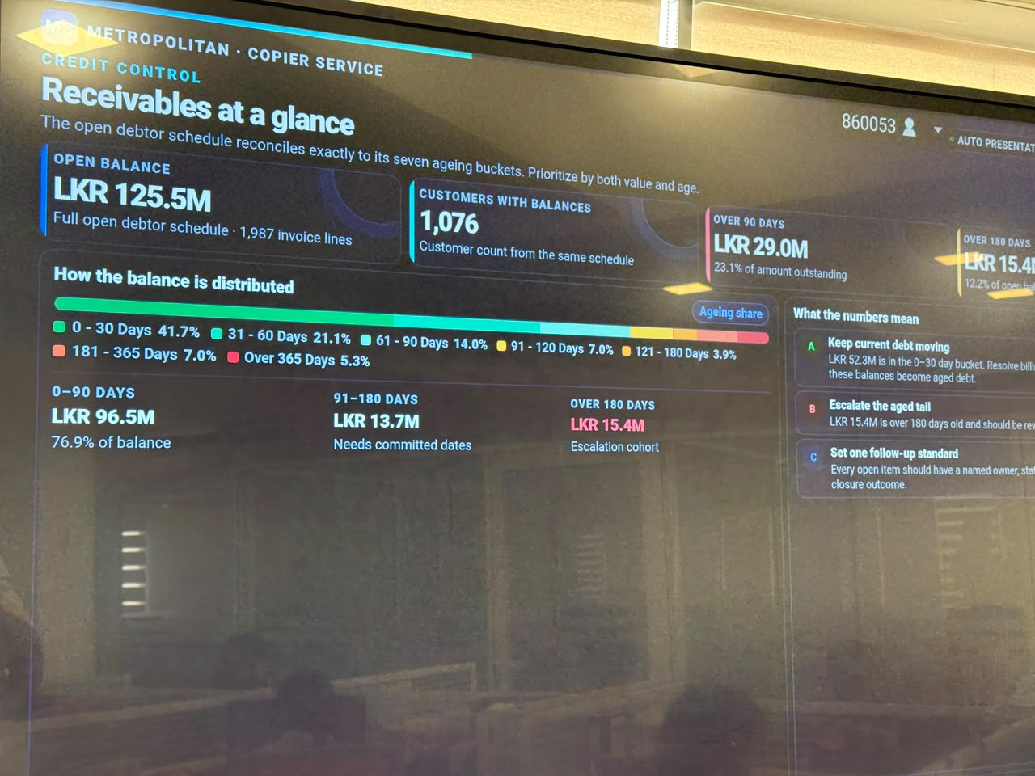
Dashboard view: management overview and operational priorities
6. Knowledge sharing and training
The nominee reports training copier technical staff and field engineers before and after attending Canon training, sharing practical knowledge from his own experience and later from Canon training sessions. Suggested attachments: training agendas, slides, invitations, attendance records, certificates and participant feedback. These records were not supplied with the current package.
7. Contribution beyond normal responsibilities — multimedia
For the 2024–2025 Annual Awards Ceremony on 22 November 2025, the nominee's supplied LinkedIn post describes his contributions as the ceremony introduction video, winner animations for 67 award recipients, LED video-wall visuals, 3D stage animations and idle motion graphics, budget presentation and achievement videos, a visual presentation of technical-building improvements and future goals, and a special recognition video for the Canon Service Meister 2024 achievement. He also reports creating a Customer Support SBU profit-analysis video and multimedia work for 2024–2026 award ceremonies.
The nominee reports that all requested deliverables were completed within five days of being informed and without additional production cost to the company. This should be supported, if available, by dated requests, delivery messages, final video files and confirmation of no additional production spend.
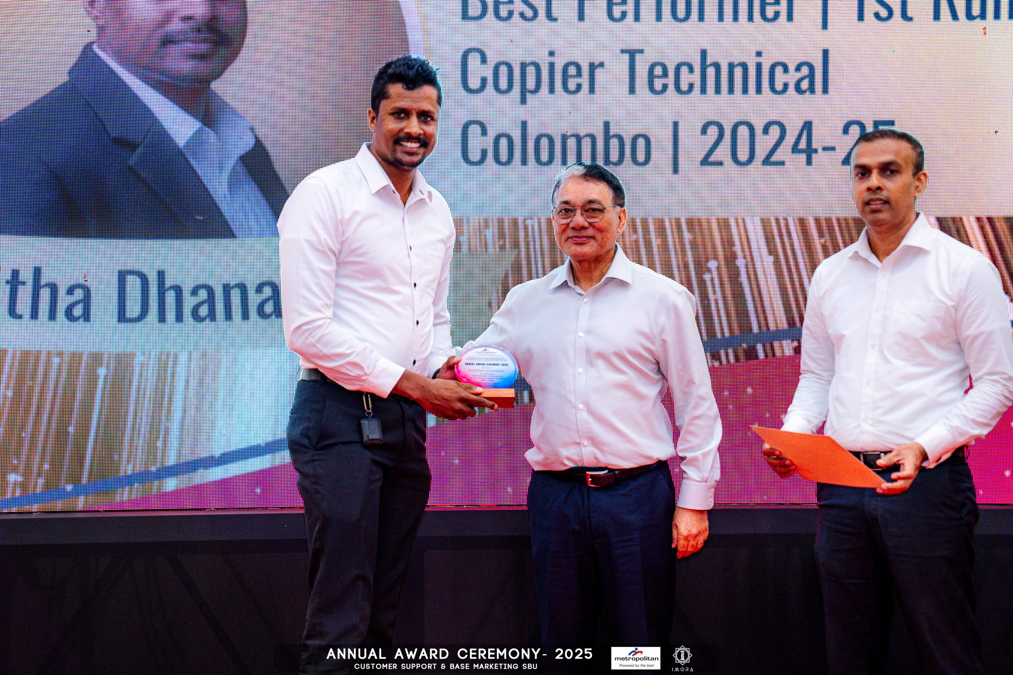
Photograph supplied as evidence of award recognition at the 2025 ceremony
8. Evidence mapped to official award criteria
Criterion / weight | Evidence and verification needs
Technical Quality and Accuracy — 30% | Peer feedback describes strong troubleshooting across Canon copier/printer hardware, computer hardware/software, networking, scan-to-folder, scan-to-email and uniFLOW-related issues. Colleagues report receiving step-by-step remote guidance for complex faults, including extended phone support. Supporting evidence: 32-response Google Form summary; Canon TechSuite Pro v1.8 screenshots; specific case records should be attached where available. A measured first-time-fix rate or rework KPI was not supplied.
Project Completion / Service Delivery Performance — 25% | The nominee provides remote support and knowledge-sharing to technical officers and field engineers across customer environments. He reports developing a 45-section Smartboard dashboard for daily performance monitoring; this remains in testing. For the 2024–2025 Annual Awards Ceremony, he reports delivering the introduction video, winner animations for 67 recipients, LED-wall visuals, 3D stage animations, budget/achievement videos and a Canon Service Meister 2024 recognition video. He reports completing requested multimedia work within five days of notification and without additional production cost. Attach final deliverables and dated request/approval records to verify timeline and cost.
Problem Solving and Innovation — 20% | Canon TechSuite Pro v1.8 is presented as a purpose-built field-engineering suite for recurring day-to-day issues. The screenshots show SMB scan-folder setup steps, authentication choices, network/firewall checks, scan-to-email SMTP guidance and language options for English, Sinhala and Tamil. The nominee reports testing it in different environments before use. The Smartboard dashboard has 45 sections and displays examples of technician target attainment, budget performance, receivables and management priorities; it is still being tested. Attach a demo, test checklist and version history if available. Resolution-time savings have not been independently measured in the supplied evidence.
Customer Satisfaction — 15% | Peer responses describe support in cases involving Huawei, Shangri-La, Synergy and other customer environments, including scanning, PC connectivity and network configuration. One colleague reported that a customer appreciated service during an extended support case. This is peer-reported feedback rather than a formal customer survey. Attach customer emails, case closure records or verified commendations where available; no formal customer satisfaction score was supplied.
Compliance and Safety Record — 10% | The supplied peer feedback and screenshots do not establish a formal safety/compliance score, incident rate or completion status for mandatory training. The nominee's manager/HR should confirm applicable compliance and safety records, required training and any relevant corrective actions before submission. No unsupported zero-incident claim is made.
9. Professional profile
- Current role: Assistant Manager – Technical Support, Metropolitan Technologies (Pvt) Ltd.
- Experience: more than 11 years at Metropolitan, as reported by the nominee.
- Education: BSc (Hons) in Computing (Cyber Security), University of Greenwich, UK — Second Class Honours (1st Division), awarded 16 July 2026; Higher National Diploma in Network Engineering.
- Technical focus: Canon printing and document-management solutions, uniFLOW Online and On-Premises, scanning workflows, network/PC troubleshooting, technical escalation and field-engineer support.
- Prior recognition reported: Engineer of the Year 2022 at Metropolitan; award photograph supplied for First Runner-up — Best Performer 2024–25, Colombo, Copier Technical.
10. Recommended attachments and verification checklist
- ☐ Google Form response export/screenshots, retained for verification; do not include respondent NICs or personal contact details in the public-facing report.
- ☐ Canon TechSuite Pro demo, version history, test checklist and any evidence of adoption or time saved.
- ☐ Smartboard dashboard test status, data-source description, validation checks and approval to share financial/receivables screens.
- ☐ Training slides, agendas, attendance records and Canon training certificates.
- ☐ Award ceremony videos/animations, Customer Support SBU profit-analysis video and dated request/delivery evidence.
- ☐ Relevant service records, customer commendations, case closure evidence and validated service KPIs.
- ☐ Manager/HR confirmation of safety, compliance, required training, employee number, nominator details and endorsement.
11. Evidence limitations and accuracy note
This report is based on the nominee's supplied information, photographs/screenshots and 32 Google Form peer responses. The report intentionally excludes respondents' names, email addresses, phone numbers and NIC details. It does not claim independently audited service outcomes, a measured first-time-fix rate, verified downtime savings, quantified dashboard impact or a zero-incident safety record. The Smartboard dashboard is described as under testing. Confirm employee/contact/nominator details and obtain manager/HR validation before final submission.

