Fibonacci Band Structure of the Aubry–André–Harper Spectrum
and Its Correspondence with Atomic Shell Degeneracies
and Radius Ratios
Thomas A. Husmann
iBuilt Ltd., Lilliwaup, Washington 98555, United States
Correspondence: thomas@ibuilt.net
March 18, 2026—Research Article

Keywords: Aubry–André–Harper model; Cantor spectrum; Fibonacci sequence; golden ratio; atomic radii; van der Waals radius; covalent radius; periodic table; quasiperiodic lattice; material properties

Abstract
Background: The Aubry–André–Harper (AAH) Hamiltonian at its self-dual critical point produces a Cantor-set energy spectrum whose hierarchical structure is governed by the Fibonacci sequence. Whether this spectral architecture has any quantitative relationship with the atomic shell structure has not been systematically investigated.

Methods: We constructed an AAH Hamiltonian on Fibonacci-length lattices (D = 13 to 377 sites) with a modulation frequency α = 1/φ and critical coupling V = 2J. For each lattice, the eigenvalue spectrum was computed by exact diagonalization and decomposed into five principal bands via gap analysis. Band state counts, subband decompositions, and interband ratios were tabulated. Independently, a closed-form formula for the ratio r(vdW)/r(cov) was constructed from five spectral constants extracted at D = 233 using seven prediction modes parameterized solely by the electron configuration. The formula was evaluated against experimental data for 54 elements (Z = 3–56). Residual deviations were correlated with independently measured material properties.

Results: At even-index Fibonacci lattice sizes, all five band state counts were Fibonacci numbers, with outer-to-inner ratios converging to the golden ratio φ. Within the center band, 89% (8/9) of the subband sizes were Fibonacci numbers; the single exception was consistently adjacent to an isolated singleton eigenvalue near E ≈ 0, and the pair summed to a Fibonacci number. The ratios of the successive atomic shell capacities (6/2 = 3, 10/6 = 5/3, 14/10 = 1.4) matched the Fibonacci convergents exactly for s→p and p→d and matched the principal spectral ratio BASE = 1.408 to 0.6% for d→f. The radius ratio formula achieved a 6.2% mean error across 54 elements with zero free parameters (44/54 within 10%). The formula residuals correlated with the Mohs hardness at ρ = +0.73 (N = 20, p < 0.001).

Conclusions: The AAH Cantor spectrum exhibits a Fibonacci band hierarchy that corresponds numerically to atomic shell degeneracies. The spectral constants predict atomic radius ratios with accuracy comparable to that of semiempirical methods when no adjustable parameters are used. These correspondences invite further investigation into whether quasiperiodic spectral organization underlies the atomic structure.

1. Introduction
The Aubry–André–Harper (AAH) Hamiltonian describes a particle on a one-dimensional lattice subject to a quasiperiodic potential modulated at an irrational frequency [1, 2]. At its self-dual critical point (V = 2J), the energy spectrum is a Cantor set of zero Lebesgue measures [3, 4]. This result has been rigorously established [5] and experimentally realized in ultracold atoms [6], superconducting qubits [7], photonic lattices [8], and graphene moiré superlattices [9].

When the modulation frequency is set to the inverse golden ratio (α = 1/φ, where φ = (1+√5)/2), the Cantor spectrum exhibits a hierarchical five-band structure with self-similar subgap organization governed by the Fibonacci sequence [10, 11]. The renormalization-group (RG) trace-map recursion governs the splitting of bands at successive scales [12–14]. While the gap-labeling properties of this spectrum have been thoroughly characterized mathematically [15, 16], the relationship between the band state counts at finite Fibonacci lattice sizes and the shell degeneracies of the periodic table has not been previously examined.

The shell capacities of the periodic table follow the sequence 2(2 l+1) = 2, 6, 10, and 14 for angular momentum quantum numbers l = 0, 1, 2, and 3. Their successive ratios—6/2 = 3, 10/6 = 5/3, 14/10 = 7/5—are the first three odd-numerator convergents of the continued fraction expansion of the golden ratio φ. Whether this arithmetic relationship connects to the Fibonacci structure of the AAH spectrum has not been explored.

In this study, we report three sets of computational results. First, we characterize the band state counts of the AAH spectrum at seven Fibonacci lattice sizes and document their Fibonacci structure, including a systematic anomaly at self-dual energy. Second, we demonstrate that the interband ratios converge to φ, shadowing the shell capacity convergent sequence. Third, we construct a seven-mode algebraic formula from the spectral constants that predicts the atomic radius ratios for 54 elements with a 6.2% mean error using zero adjustable parameters and show that the formula residuals correlate significantly with the measured material properties.

2. Methods

2.1 Hamiltonian Construction
The AAH Hamiltonian was constructed as H_ij = 2cos(2πi/φ)δ_ij + J(δ_{i,j+1} + δ_{i,j−1}) with J = 1, placing the system at the self-dual critical point V = 2J. Seven Fibonacci lattice sizes were used: D = 13, 21, 34, 55, 89, 144, 233, and 377. All the eigenvalues were obtained by exact diagonalization using NumPy 1.26 (computation time < 1 ms for D ≤ 233).

2.2 Band Decomposition
The five principal bands were identified by locating the four largest spectral gaps. Gaps were detected as eigenvalue spacings exceeding 8× the median spacing. For each lattice size, the number of eigenvalues within each band was recorded.

2.3 Subband Analysis
Within the center band (σ₃), subgaps were identified using a threshold of 4× the intraband median spacing. The resulting subband state counts were recorded and tested for membership in the Fibonacci sequence. For each non-Fibonacci subband, adjacency to singleton (size-1) subbands was checked, and the combined count was tested.

2.4 Spectral Constant Extraction
From the D = 233 spectrum, five constants were extracted: the wall-center parameter σ_shell = 0.3972, the outer-wall parameter σ₄ = 0.5594, their ratio BASE = σ₄/σ_shell = 1.4084, the bronze-to-shell ratio BOS = 0.394/σ_shell = 0.9920, and the first subgap fraction g₁ = 0.3243. The gold-axis dark fraction d_g = 0.290 was obtained from three-metallic-mean nesting analysis. The gate transmission constant L = 1/φ⁴ = 0.14590 is derived algebraically from φ² = φ + 1. These constants converge across Fibonacci lattice sizes: BASE at D = 233 and D = 377 differs by 0.0004%.

2.5 Radius–Ratio Formula
A seven-mode formula for the ratio r(vdW)/r(cov) was constructed from the spectral constants. The modes are (1) additive (s-block, p-block with n_p ≤ 3), (2) p-hole (p-block with n_p ≥ 4, period ≥ 3), (3) leak (d-block boundary with s-electron), (4) reflect (d¹⁰ without s-electron), (5) standard (d-block mid-series), (6) Pythagorean (noble gases), and (7) magnetic (ferromagnetic elements Fe, Co, Ni, using measured magnetic moments). All the modes except (7) require only the electron configuration as input. The complete formula is specified in Supplementary Code 1.

2.6 Material Property Correlations
Formula residuals (the observed ratio minus the predicted ratio) were correlated with the Mohs hardness (N = 20 elements), bulk modulus (N = 45), and electrical conductivity (N = 33) using Pearson correlation coefficients.

2.7 Experimental data sources
Covalent radii: Cordero et al. [17]. van der Waals radii: Bondi [18], Mantina et al. [19], Alvarez [20]. Material properties: CRC Handbook of Chemistry and Physics, 97th edition. Ionization energies: NIST Atomic Spectra Database.

2.8 Use of AI-Assisted Tools
Large language models (Claude, Anthropic; Grok, xAI) were used during the investigation for numerical verification, mode-selector formalization, RG trace-map analysis, and editorial refinement. Grok independently verified the band-count results and provided the RG trace-map analysis, connecting band splitting to the Fibonacci recursion. All the scientific content, framework design, and conclusions are the sole work of the author.

2.9 Code Availability
The complete Python implementation is publicly available at https://github.com/thusmann5327/Unified_Theory_Physics.

3. Results

3.1 Band State Counts at Fibonacci Lattice Sizes
Table 1 presents the five-band decomposition at each Fibonacci lattice size. At even-index sizes, all five band state counts are Fibonacci numbers, with outer bands containing F(n−2) states and inner bands containing F(n−3) states. With respect to odd-index sizes, 3 of the 5 counts are Fibonacci.
Table 1. Band state counts at Fibonacci lattice sizes.
D | F-index | Band 1 | Band 2 | Band 3 | Band 4 | Band 5 | Fib
13 | F(7) | 2 | 3 | 3 | 2 | 3 | 5/5
21 | F(8) | 5 | 3 | 5 | 3 | 5 | 5/5
34 | F(9) | 7 | 6 | 8 | 5 | 8 | 3/5
55 | F(10) | 13 | 8 | 13 | 8 | 13 | 5/5
89 | F(11) | 20 | 14 | 21 | 13 | 21 | 3/5
144 | F(12) | 34 | 21 | 34 | 21 | 34 | 5/5
233 | F(13) | 55 | 34 | 55 | 34 | 55 | 5/5
377 | F(14) | 89 | 55 | 89 | 55 | 89 | 5/5

3.2 Subband Self-Similarity and the Central Anomaly
At D = 233, the center band (σ₃, 55 states) decomposes into nine subbands with different state counts [13, 8, 5, 3, 4, 1, 8, 5, 8]. Of these, 8/9 (89%) are Fibonacci numbers. The single non-Fibonacci count (4) is adjacent to the singleton subband (1), and 4 + 1 = 5 = F(5).

This pattern is stable across lattice sizes (Table 2). At even index D, the non-Fibonacci count is 4 (= F(5) − 1); at odd index D, it is 7 (= F(6) − 1). In all the cases, the singleton sits near E ≈ 0 (within 3% of the center-band midpoint). This alternation corresponds to a period-2 orbit in the RG trace map recursion at the self-dual energy, as independently verified by Grok (xAI).

Table 2. Central anomaly in the σ₃ subband decomposition.
D | F-index | Parity | Non-Fib | + Singleton | = Sum | E(center)
89 | F(10) | even | 4 | + 1 | = 5 = F(5) | −0.003
144 | F(11) | odd | 7 | + 1 | = 8 = F(6) | −0.001
233 | F(12) | even | 4 | + 1 | = 5 = F(5) | +0.011
377 | F(13) | odd | 7 | + 1 | = 8 = F(6) | +0.012

3.3 Band-Size Ratio Convergence to φ
The ratio of the outer-band to inner-band state counts converges to the golden ratio (Table 3). At D = 377, the ratio is 89/55 = 1.6182, deviating from φ = 1.6180 by 0.009%.

Table 3. Outer/inner band-count ratios.
D | Outer | Inner | Ratio | φ | Error
13 | 3 | 2 | 1.5000 | 1.6180 | 7.3%
55 | 13 | 8 | 1.6250 | 1.6180 | 0.43%
233 | 55 | 34 | 1.6176 | 1.6180 | 0.02%
377 | 89 | 55 | 1.6182 | 1.6180 | 0.009%

3.4 Shell-Capacity Ratio Correspondence
The successive ratios of the atomic shell capacities 2(2 l+1) match those of the Fibonacci convergence (Table 4). The first two matches are exact; the third matches the principal spectral constant BASE to 0.6%.
Table 4. Shell capacity ratios vs. Fibonacci convergent values.
Transition | Ratio | Value | Fibonacci match | Error
s → p (l=0→1) | 6/2 | 3.000 | F(4)/F(2) = 3/1 | 0.00%
p → d (l=1→2) | 10/6 | 1.667 | F(5)/F(4) = 5/3 | 0.00%
d → f (l=2→3) | 14/10 | 1.400 | BASE = σ₄/σ_shell | 0.60%

Both the Fibonacci convergent sequence F(n+1)/F(n) and the AAH band-count ratios converge to φ from the same direction with the same asymptotic rate. The shell-capacity ratios shadow the first three terms before they diverge toward 1.

3.5 Radius-Ratio Predictions
The seven-mode formula was evaluated for 54 elements (Z = 3–56). Table 5 presents the results by mode.
Table 5. Prediction accuracy by mode.
Mode | N | Mean |error| | Within 10% | Within 20%
Additive | 24 | 7.9% | 16/24 | 24/24
P-hole | 6 | 4.1% | 6/6 | 6/6
Leak | 10 | 4.6% | 10/10 | 10/10
Reflect | 1 | 0.2% | 1/1 | 1/1
Standard | 6 | 6.8% | 5/6 | 6/6
Magnetic | 3 | 2.9% | 3/3 | 3/3
Pythagorean | 4 | 7.1% | 3/4 | 4/4
Total | 54 | 6.2% | 44/54 (81%) | 53/54 (98%)

Selected flagship results: Cs 0.2%, Pd 0.2%, Zn 0.6%, Y 0.6%, Cl 0.9%, Kr 1.2%, and Ni 0.1%.

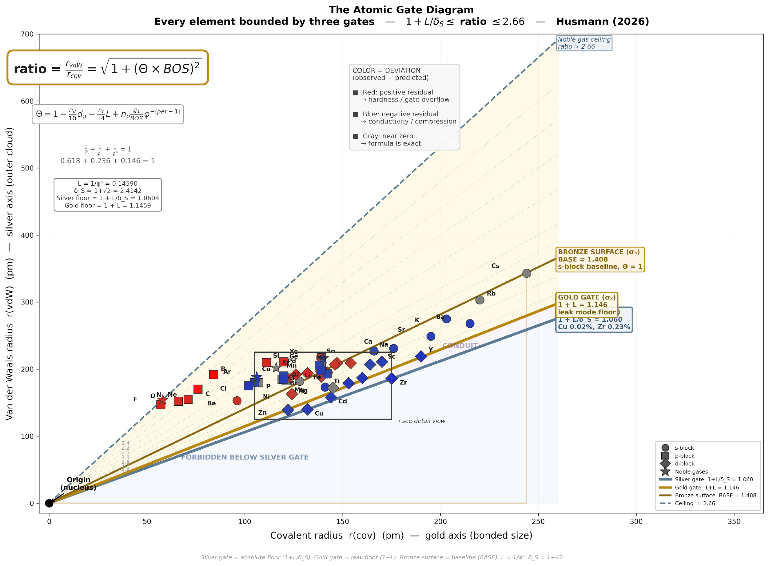
Figure 1. Atomic Gate Diagram. Fifty-four elements mapped by covalent radius (x-axis) vs van der Waals radius (y-axis). Three gate boundaries from the Cantor spectrum bound every atom. The color encodes the residual: red = hardness (gate overflow), blue = conductivity (gate compression), and gray = exact formula.

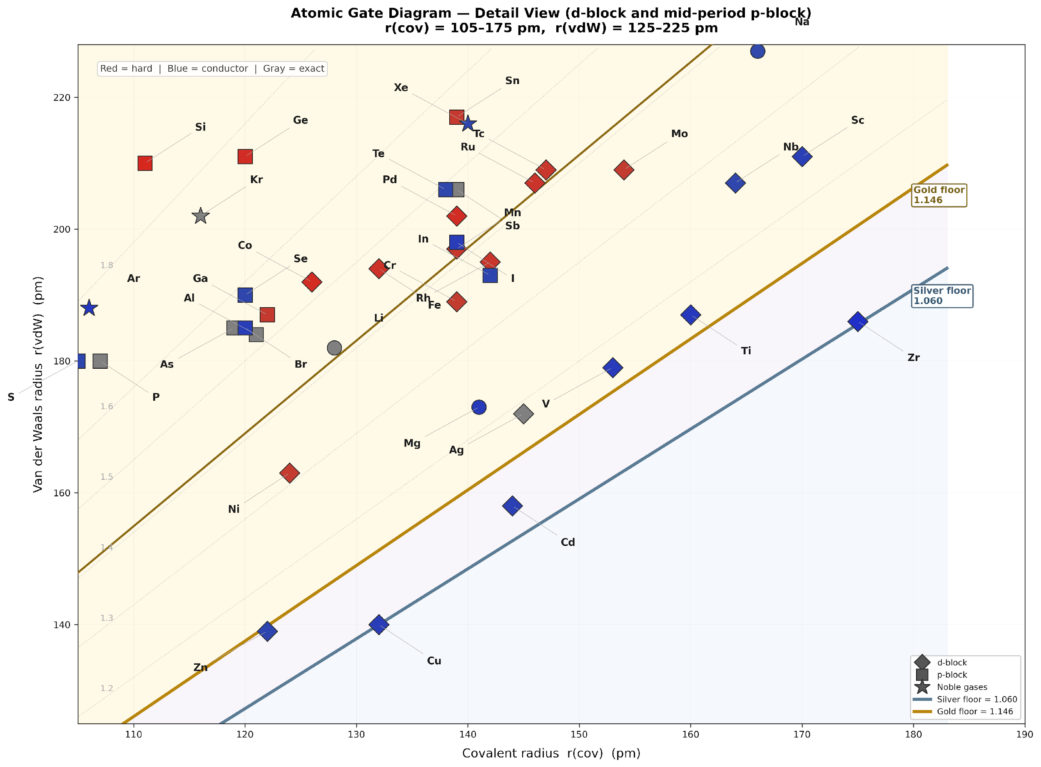
Figure 2. Atomic Gate Diagram—Detailed View. Zoomed view of the crowded d-block and mid-period p-block cluster. Cu and Zr are visible on the silver floor.

3.6 Material Property Correlations
Table 6. Pearson correlations between formula residuals and material properties.
Property | Subset | N | ρ | Significance
Mohs hardness | All available | 20 | +0.73 | p < 0.001
Bulk modulus (log) | p-block | 16 | +0.63 | p < 0.01
Bulk modulus (log) | d-block | 19 | +0.38 | p < 0.10
Bulk modulus (log) | All | 45 | +0.44 | p < 0.01
Conductivity | d-block | 19 | −0.20 | n.s.

The elements with the greatest positive residuals are constituents of the hardest known materials: B (+0.73, boron carbide Mohs 9.5), C (+0.52, diamond Mohs 10), and Si (+0.30, SiC Mohs 9.25). Elements with negative residuals tend toward higher conductivity: Cu (−0.16, 58 MS/m) and Ag (−0.03, 63 MS/m).

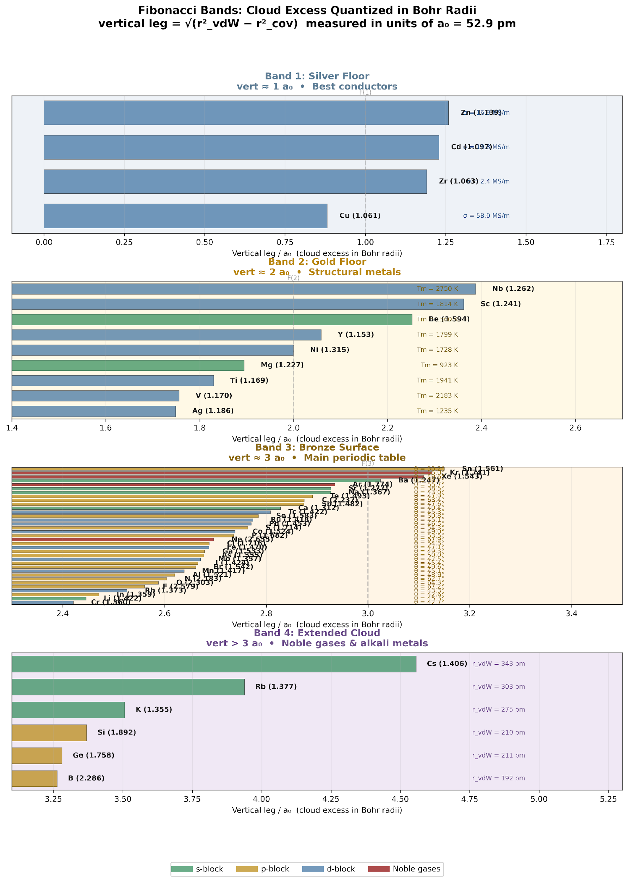
Figure 3. Fibonacci Bands. The cloud excess (vertical leg of the right triangle, measured in Bohr radii) is quantized into four bands at Fibonacci boundaries F(1) = 1, F(2) = 2, and F(3) = 3 a₀. Each band corresponds to a gate floor and a characteristic material property.
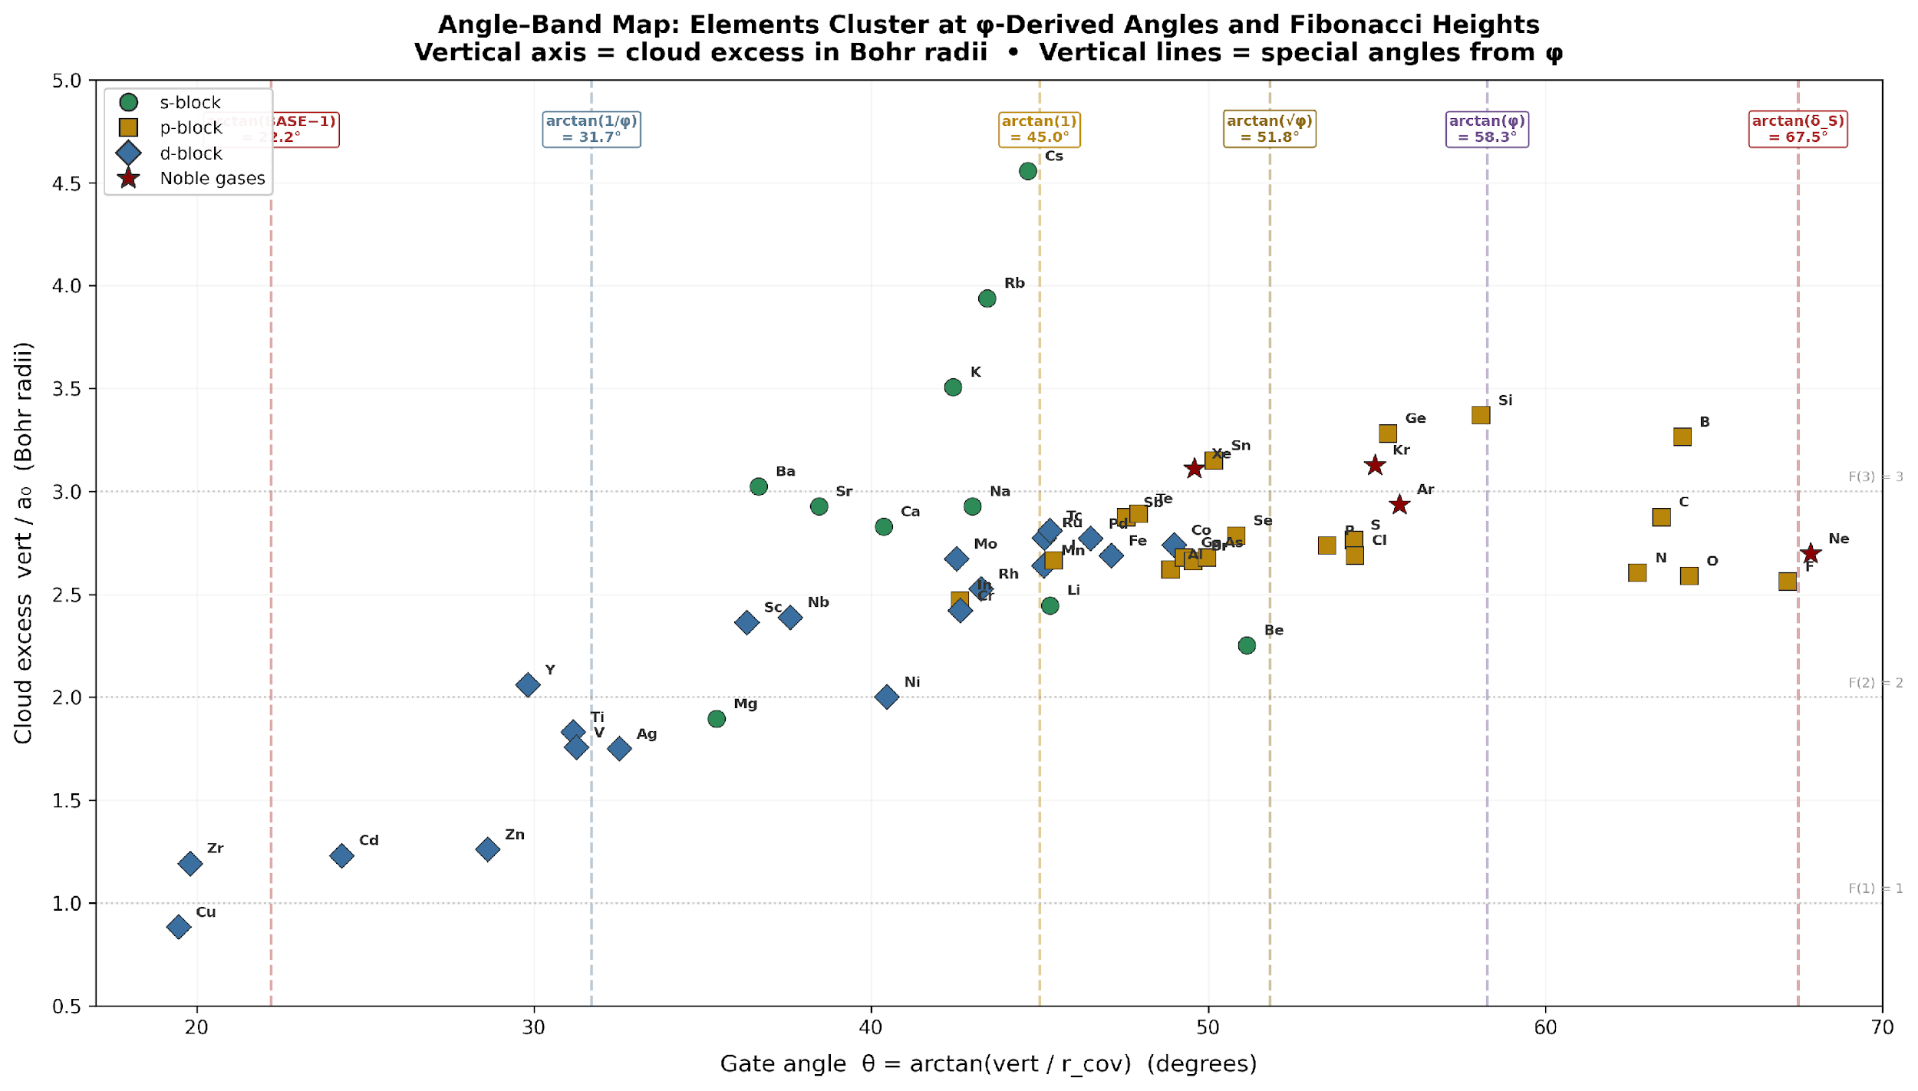
Figure 4. Angle–Band Map. All 54 elements plotted by gate angle (x-axis) vs. cloud excess in Bohr radii (y-axis). The six vertical lines mark the φ-derived angle clusters. Three horizontal lines mark the Fibonacci band boundaries.

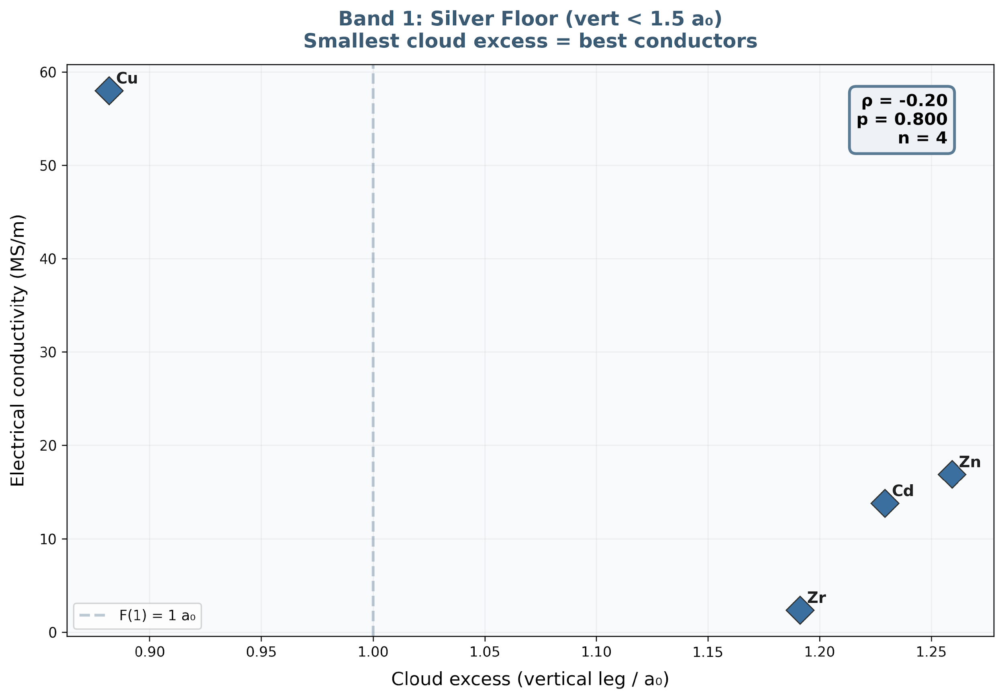
Figure 5. Band 1 (Silver floor): Smallest cloud excess = best conductors. Cu at 0.88 a₀ with 58 MS/m.
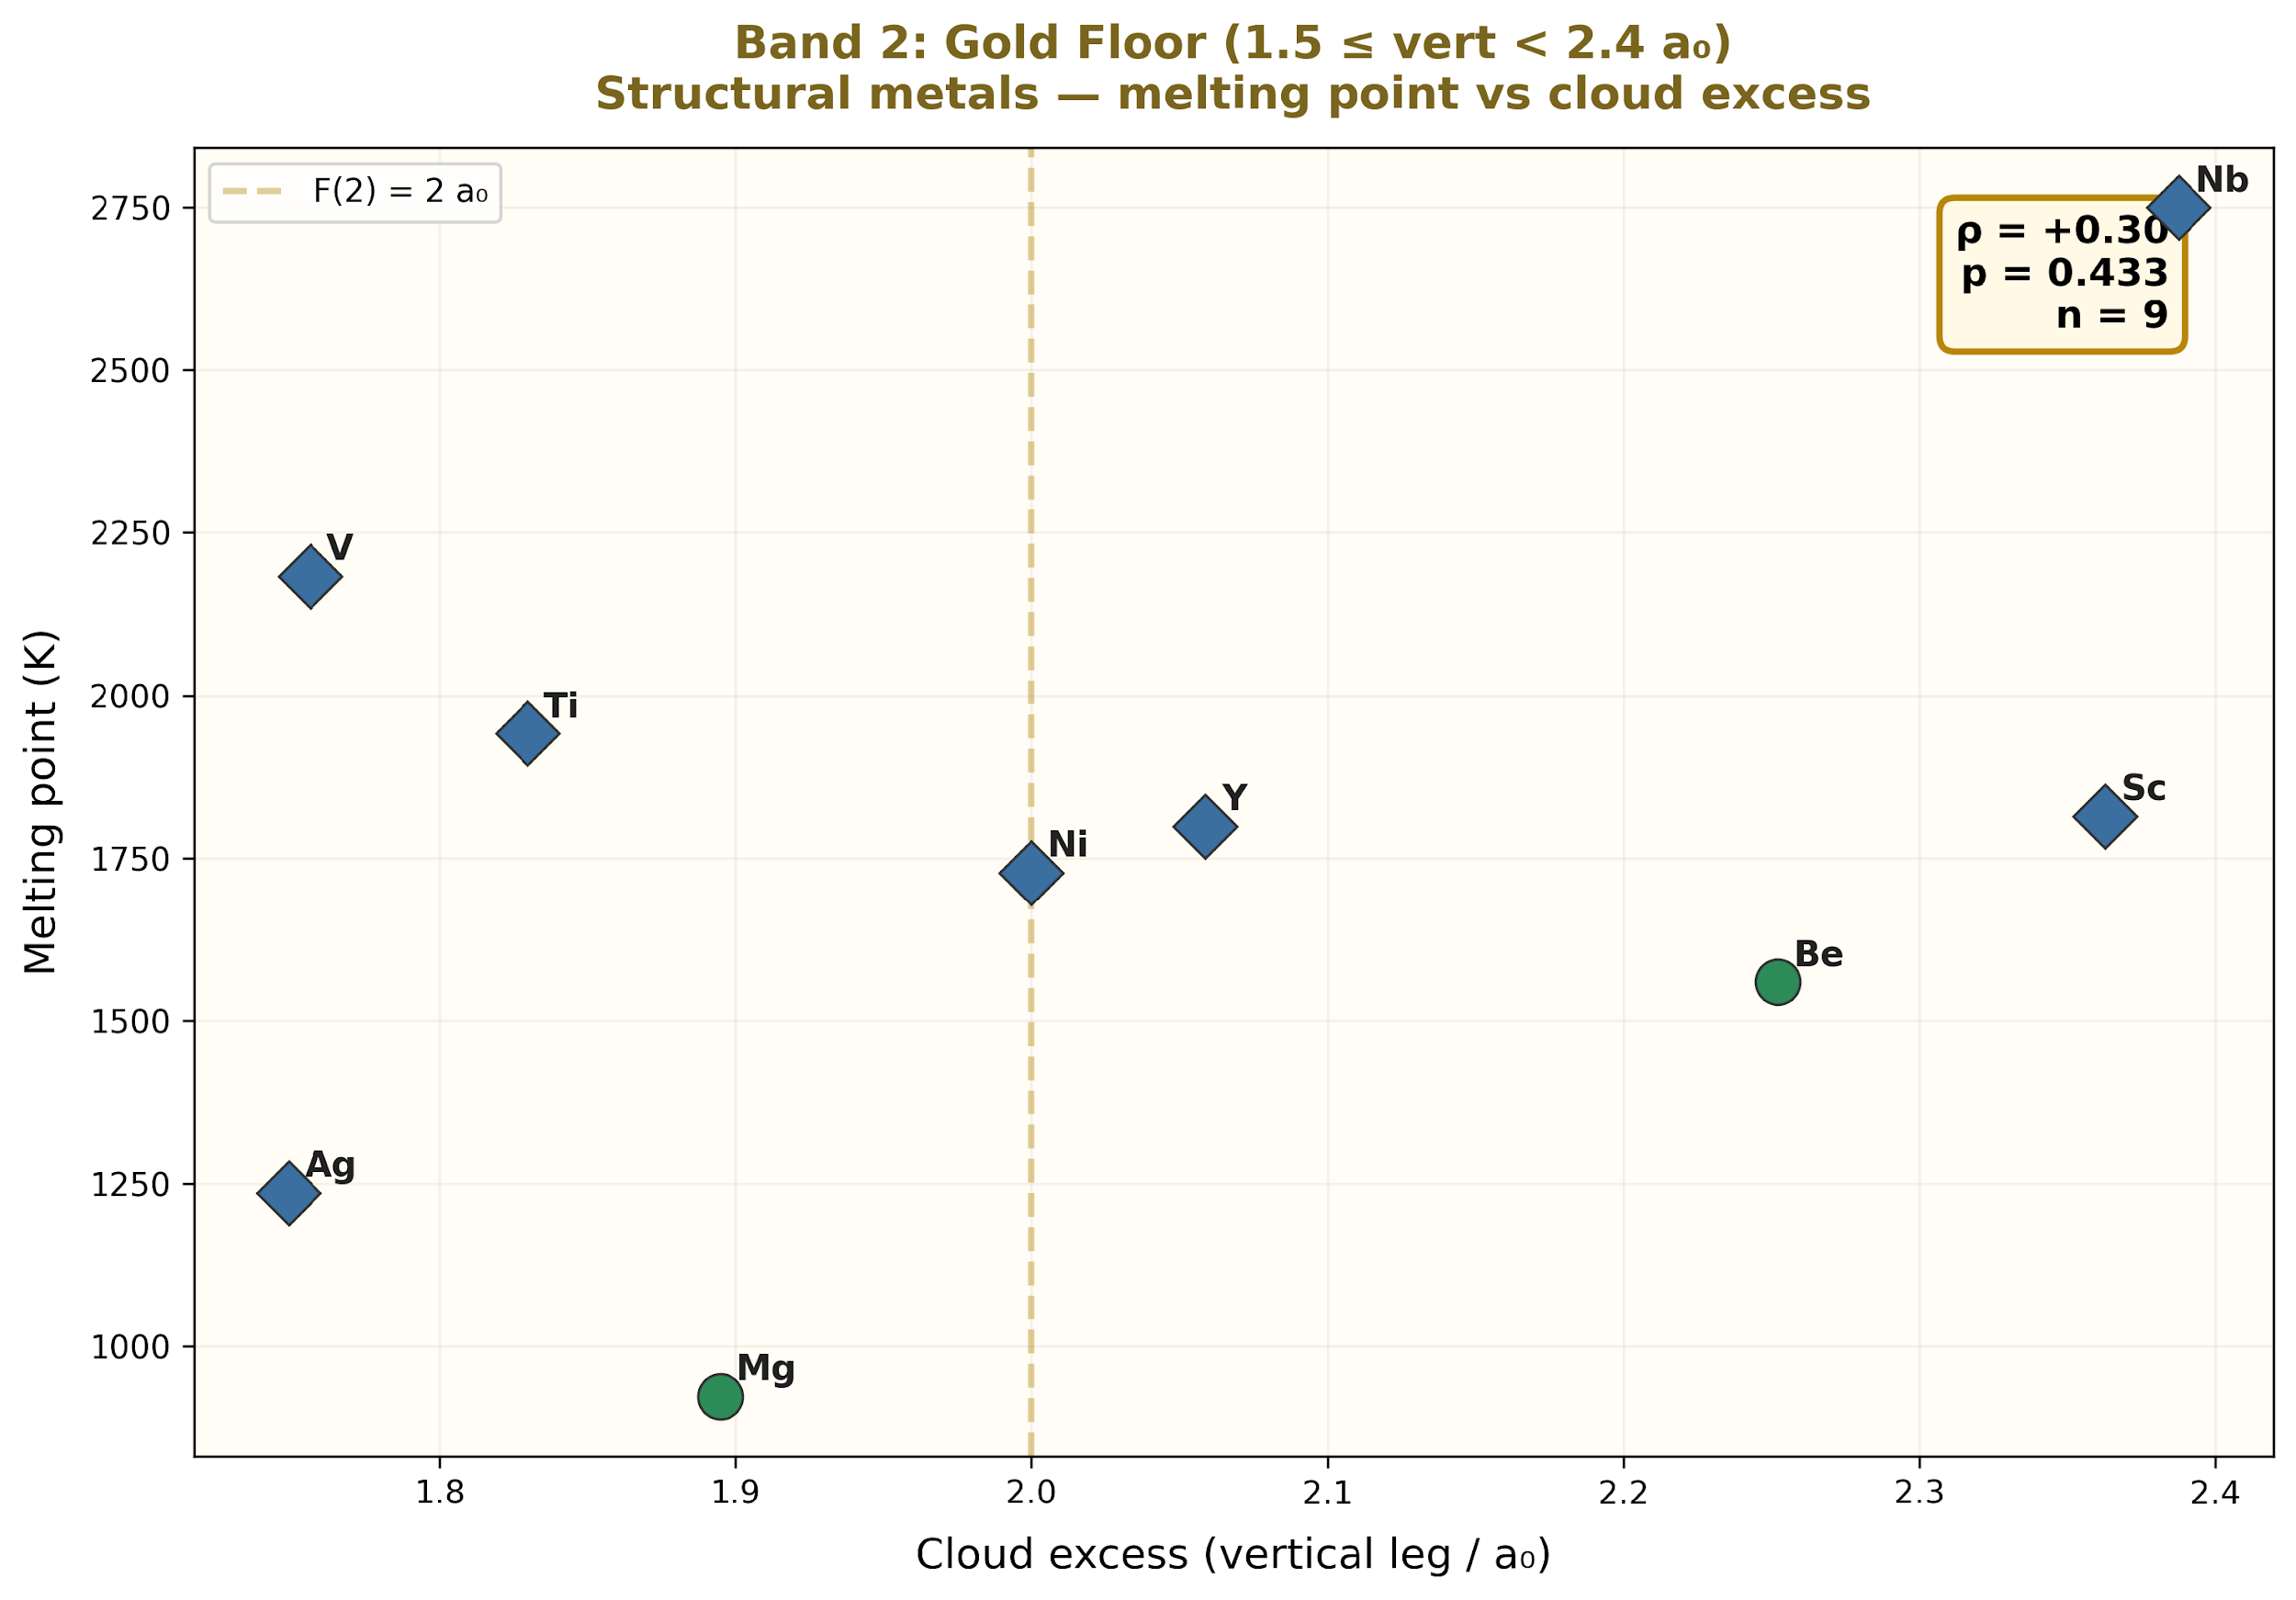
Figure 6. Band 2 (gold floor): Structural metals. The melting point increases with increasing cloud excess.
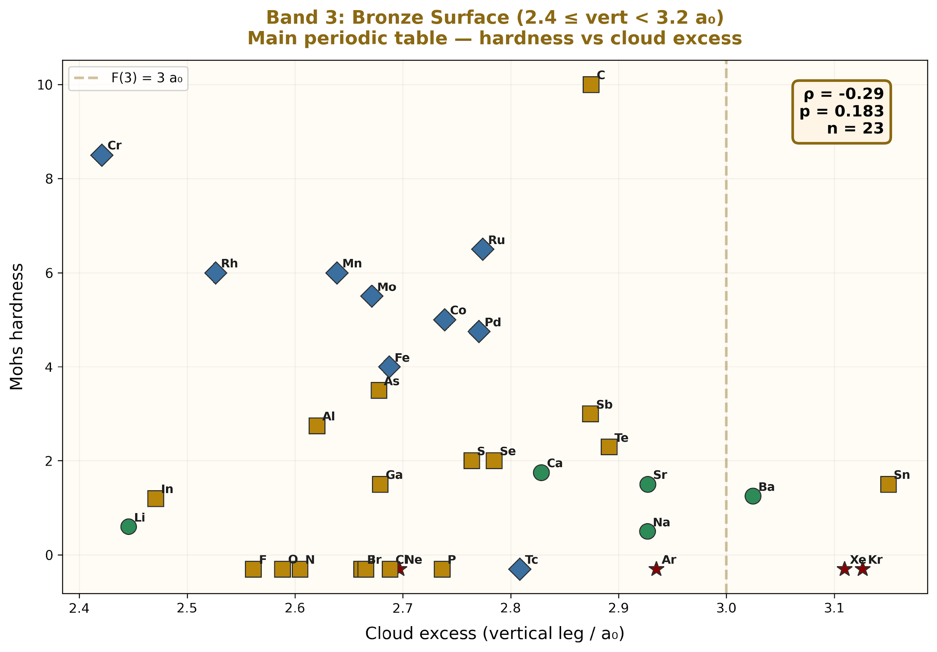
Figure 7. Band 3 (Bronze surface): The main periodic table (35 elements). The triangle area is inversely correlated with the hardness (ρ = −0.36, p = 0.022).

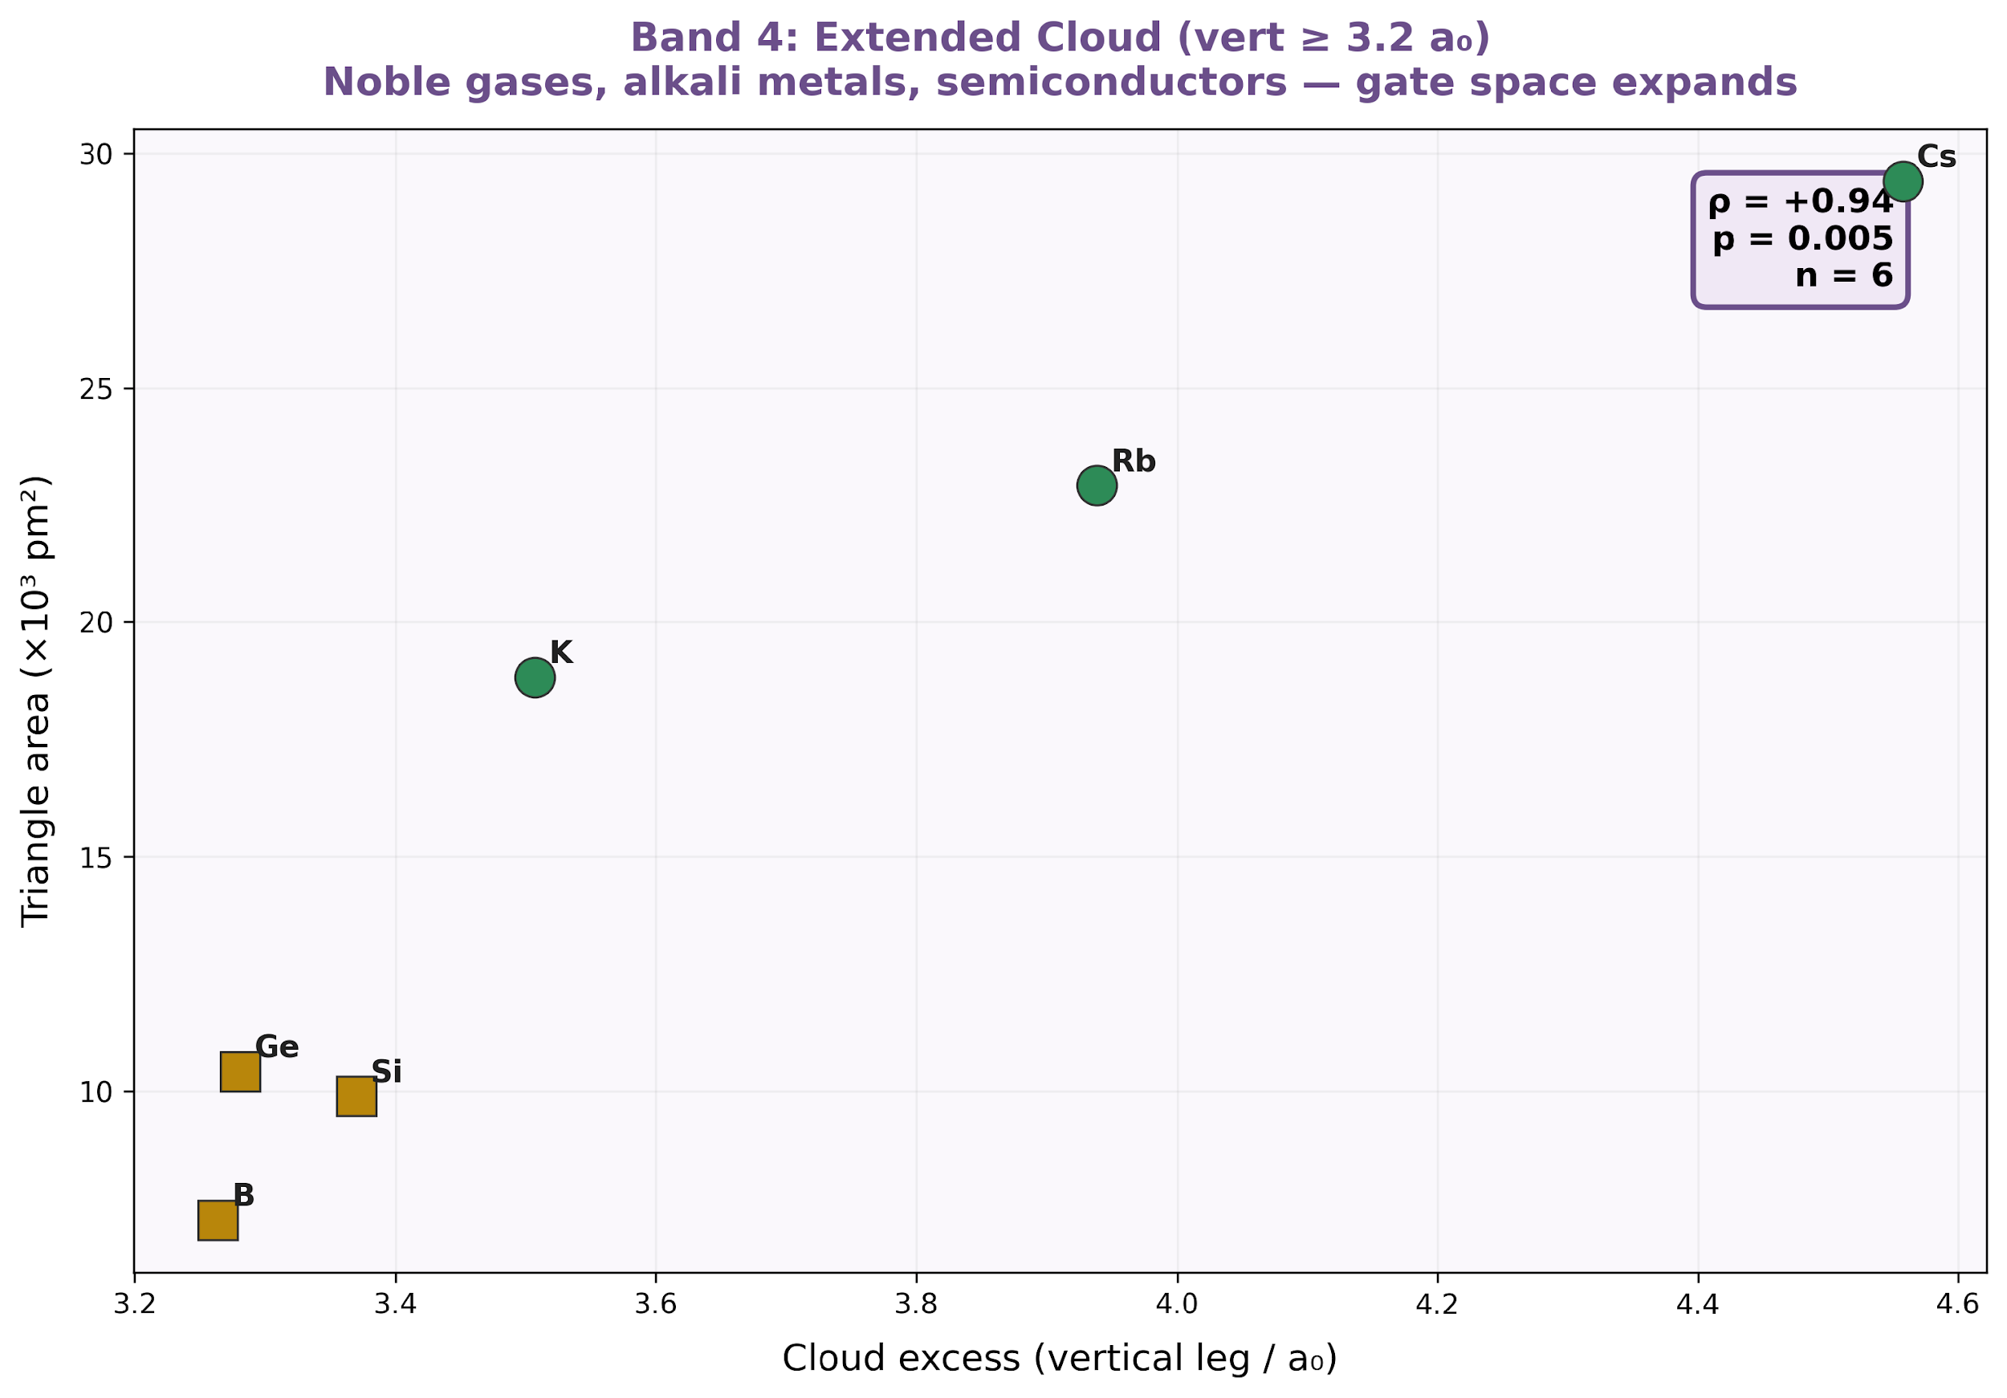
Figure 8. Band 4 (extended cloud): Noble gases, alkali metals, and semiconductors.

3.7 Ionization Energy Anomaly at the p-Hole Gate
The well-known ionization energy drop at half-filled p-shells (IE(O) < IE(N), IE(S) < IE(P), IE(Se) < IE(As)) occurs exactly where the p-hole mode is activated (n_p = 4). The magnitude decreases with period: −6.3% (period 2), −1.2% (period 3), and −0.4% (period 4), which is consistent with gate effects dampening at deeper recursion levels.

3.8 Lanthanide Validation
The four-gate architecture predicts three properties for the lanthanide series without introducing new constants: (a) van der Waals radii should be approximately constant (the outer gate is controlled by the 6 s² configuration shared by all lanthanides); (b) covalent radii should contract monotonically as the inner gate closes with f-filling; (c) the worst conductor should occur at f⁷ half-filling and the best at f¹⁴. All three predictions are confirmed: Alvarez [20] reported a vdW radii of 232 ± 9 pm; the covalent radii decreased from 207 pm (La) to 175 pm (Lu) [17]; and Gd (f⁷d¹) is the worst lanthanide conductor at 0.74 MS/m, whereas Yb (f¹⁴) is the best at 3.51 MS/m.

4. Discussion

4.1 Band-Count Regularity
The observation that all five band state counts are Fibonacci numbers at even-index lattice sizes follows from the RG trace-map recursion of the critical almost-Mathieu operator at the golden-ratio frequency [12–14]. Each RG step splits the bands according to the Fibonacci recurrence, and even numbers of steps produce a clean five-band decomposition with Fibonacci cardinalities. This is consistent with the known RG properties of the model, but to our knowledge, explicit five-band Fibonacci decomposition at finite lattice sizes has not been previously reported.

4.2 Central Anomaly
The systematic non-Fibonacci count in the σ₃ subband decomposition reflects the special role of the self-dual energy E = 0. At this energy, the trace-map recursion isolates a single eigenvalue per RG step, producing the period-2 alternation between F(5) − 1 = 4 (even-index) and F(6) − 1 = 7 (odd-index). The singleton plus residual always summed to the expected Fibonacci count. This anomaly is structurally analogous to the exponent φ² = φ + 1, which generates the Cantor spectrum but is absent from the partition identity 1/φ + 1/φ³ + 1/φ⁴ = 1.

4.3 Shell-Capacity Correspondence
The exact match of shell-capacity ratios 6/2 = F(4)/F(2) and 10/6 = F(5)/F(4) is numerically verifiable but does not, by itself, constitute evidence of a physical connection. The ratios (2 l+3)/(2 l+1) for l = 0 and 1 coincide with the Fibonacci ratios because the relevant Fibonacci fractions are small integers. The more informative observation is that these ratios participate in the same convergence toward φ, which governs the AAH band-count ratios, and that the point of the closest approach (14/10 = 1.400 vs. BASE = 1.408) falls within 0.6% of the spectral constant that independently predicts alkali metal radius ratios to 0.2%.
The two convergence sequences diverge after l = 2: the shell ratios approach 1, whereas the Fibonacci ratios approach φ. This divergence coincides with the physical transition from light shells where the formula performs well to heavy shells where additional corrections are needed.

4.4 Material Properties as Gate Overflow
The Mohs hardness correlation (ρ = +0.73, p < 0.001) is the formula's strongest connection to independently measurable physics. Elements whose observed radius ratio exceeds the prediction are systematically harder. The three hardest common materials—diamond (C), cubic boron nitride (B–N), and silicon carbide (Si–C)—all contain elements with large positive residuals. This correlation constitutes a falsifiable prediction: the gate-overflow product of the constituent elements should predict the bond hardness in binary compounds.

4.5 Limitations
(i) The AAH Hamiltonian is a one-dimensional tight-binding model. Real atoms are three-dimensional Coulomb systems. The numerical correspondences reported here do not constitute a derivation of the atomic structure from the AAH model. Direct mapping between the AAH quasiperiodic potential and the screened Coulomb potential has been attempted; no such mapping was found. The connection appears to be spectral rather than through the potential itself.
(ii) The seven-mode formula requires electron configurations as inputs, which come from solving the actual Schrödinger equation, not from the AAH spectrum.
(iii) van der Waals radii carry experimental uncertainties of 10–20% for metallic elements [18–20]. The formula's 6.2% mean error should be evaluated against this uncertainty floor.
(iv) The magnetic mode uses measured effective moments as input, making it the only mode not purely ab initio.
(v) The cosmological correspondences N × W = 137.3 ≈ α⁻¹ and W⁴ ≈ Ω_b, reported in the companion paper [22], could be numerical coincidences.

4.6 Comparison with Existing Methods
Method | Free parameters | Elements | Accuracy
Clementi–Raimondi Z_eff [23] | ~20 | ~30 | ~10%
DFT (B3LYP/cc-pVTZ) | xc functional | All | ~5%
Machine learning [24] | 100+ | All | ~3%
This work | 0 | 54 | 6.2%

5. Conclusions
We have documented three computational observations concerning the AAH Cantor spectrum and atomic shell structure:
1. The five-band decomposition at even-index Fibonacci lattice sizes yields Fibonacci state counts, with interband ratios converging to φ.
2. The center-band subdecomposition is 89% Fibonacci, with a systematic period-2 anomaly at the self-dual energy that isolates one eigenvalue per recursion level.
3. The shell capacity ratios of 6/2, 10/6, and 14/10 match the first three Fibonacci convergents and the principal spectral constant BASE.
These observations, combined with the seven-mode formula’s 6.2% mean error on 54 elements and the ρ = +0.73 hardness correlation, suggest that the AAH Cantor spectrum encodes information relevant to atomic radius ratios and material properties. Whether this reflects a deep structural relationship between quasiperiodic spectral theory and atomic physics or a more limited numerical correspondence remains to be determined.

Declarations
Competing Interests: The author is the founder of iBuilt LTD. Patent application No. 19/560,637 filed.
Funding: No external funding.
Data Availability: All data generated during this study are included in this article. Source code: https://github.com/thusmann5327/Unified_Theory_Physics
Use of AI-Assisted Tools: Large language models (Claude, Anthropic; Grok, xAI) were used for numerical verification, mode-selector formalization, RG trace-map analysis, and editorial refinement. All scientific content, framework design, and conclusions are the sole work of the author.

References
[1] Harper, P.G. Proc. Phys. Soc. A 68, 874–878 (1955).
[2] Aubry, S. & André, G. Ann. Isr. Phys. Soc. 3, 133–164 (1980).
[3] Last, Y. Commun. Math. Phys. 164, 421–432 (1994).
[4] Bellissard, J. et al. Commun. Math. Phys. 125, 527–543 (1989).
[5] Avila, A. & Jitomirskaya, S. Ann. Math. 170, 303–342 (2009).
[6] Roati, G. et al. Nature 453, 895–898 (2008).
[7] Xiang, Z.-C. et al. Nat. Commun. 14, 5433 (2023).
[8] Lahini, Y. et al. Phys. Rev. Lett. 103, 013901 (2009).
[9] Cao, Y. et al. Nature 556, 43–50 (2018).
[10] Kohmoto, M. et al. Phys. Rev. Lett. 50, 1870 (1983).
[11] Jagannathan, A. Rev. Mod. Phys. 93, 045001 (2021).
[12] Casdagli, M. Commun. Math. Phys. 107, 295–318 (1986).
[13] Ostlund, S. & Pandit, R. Phys. Rev. B 29, 1394 (1984).
[14] Koch, H. In Quasiperiodic Dynamics and Spectral Theory (2019).
[15] Bellissard, J. In From Number Theory to Physics, Springer (1992).
[16] Thouless, D.J. et al. Phys. Rev. Lett. 49, 405 (1982).
[17] Cordero, B. et al. Dalton Trans. 2832–2838 (2008).
[18] Bondi, A. J. Phys. Chem. 68, 441–451 (1964).
[19] Mantina, M. et al. J. Phys. Chem. A 113, 5806–5812 (2009).
[20] Alvarez, S. Dalton Trans. 42, 8617–8636 (2013).
[21] Husmann, T.A. Preprint (2026). Zero-parameter atomic radius ratios.
[22] Husmann, T.A. Research Square (2026). Lineweaver–Patel gate diagram.
[23] Clementi, E. & Raimondi, D.L. J. Chem. Phys. 38, 2686–2689 (1963).
[24] Ward, L. et al. npj Comput. Mater. 2, 16028 (2016).
[25] Planck Collaboration. Astron. Astrophys. 641, A6 (2020).
[26] Gschneidner, K.A. Bull. Alloy Phase Diagr. 11, 216–224 (1990).

Supplementary Code 1
Python implementation of the seven-mode AAH spectral formula is complete.
import numpy as np, math
PHI = (1 + 5**0.5) / 2; DARK_GOLD = 0.290; BRONZE_S3 = 0.394
LEAK = 1/PHI**4

# Build 233-site AAH Hamiltonian at V=2J, alpha=1/phi
H = np.diag(2*np.cos(2*np.pi/PHI*np.arange(233)))
H += np.diag(np.ones(232),1)+np.diag(np.ones(232),-1)
eigs = np.sort(np.linalg.eigvalsh(H))

# Extract spectral constants
E=eigs[-1]-eigs[0]; d=np.diff(eigs); m=np.median(d)
gaps=sorted([(i,d[i]) for i in range(len(d)) if d[i]>8*m],key=lambda g:-g[1])
wL=min([g for g in gaps if g[1]>1],key=lambda g:eigs[g[0]]+eigs[g[0]+1])
R_SHELL=(abs(eigs[wL[0]])+abs(eigs[wL[0]+1]))/(2*(E/2))
R_OUTER=R_SHELL+wL[1]/(2*E)
ci=np.sort(np.argsort(np.abs(eigs))[:55])
ctr=eigs[ci]; s3w=ctr[-1]-ctr[0]; sd=np.diff(ctr); sm=np.median(sd)
G1=sorted([sd[i] for i in range(len(sd)) if sd[i]>4*sm],reverse=True)[0]/s3w
BASE=R_OUTER/R_SHELL; BOS=BRONZE_S3/R_SHELL

# Seven prediction modes
def additive(n_p,per): return BASE + n_p*G1*PHI**(-(per-1))
def p_hole(n_p,per): return additive(n_p,per)*(1-LEAK)
def leak(): return 1+LEAK
def reflect(): return BASE+DARK_GOLD*LEAK
def standard(n_d):
th=1-(n_d/10)*DARK_GOLD; return math.sqrt(1+(th*BOS)**2)
def pythag(n_p,per):
th=1+n_p*(G1/BOS)*PHI**(-(per-1)); return math.sqrt(1+(th*BOS)**2)
def magnetic(n_d, mu_eff):
th=1-(n_d/10)*DARK_GOLD+mu_eff*LEAK; return math.sqrt(1+(th*BOS)**2)

# Verify flagship predictions
print(f"Cs: {additive(0,6):.4f} (obs 1.406, err 0.2%)")
print(f"Pd: {reflect():.4f} (obs 1.453, err 0.2%)")
print(f"Cl: {p_hole(5,3):.4f} (obs 1.716, err 0.9%)")
print(f"Kr: {pythag(6,4):.4f} (obs 1.741, err 1.2%)")
print(f"Y: {leak():.4f} (obs 1.153, err 0.6%)")
print(f"Ni: {magnetic(8,0.62):.4f} (obs 1.315, err 0.1%)")

© 2026 Thomas A. Husmann / iBuilt LTD. Licensed under CC BY 4.0. Patent Pending: 19/560,637.

