Testing Document

Project | P4. Database Management System for Historical  Records
Backend | XAMPP (PHP, MySQL)
Handover to | Client (Ray Greenhough)
Prepared by | Team 16

Name | Role | UoB Email | UoB Number
Tawfeeq Hussain | Leader | Thussa88@bradford.ac.uk | 24000557
Ibraheim Hussain | Secretary | Ihuss132@bradford.ac.uk | 24003673
Siraaj Ali | Team Member | Sali277@bradford.ac.uk | 24002882
Fayzaan Khan | Team Member | mfakhan@bradford.ac.uk | 24039463
Victor Nwagu | Team Member | nvnwagu@bradford.ac.uk | 23045806
Elysia Horder | Speaker | whorder@bradford.ac.uk | 24044847

1. Introduction

This document outlines all test cases conducted for the Database Management System for Historical Records project. The purpose of this document is to record all tests we performed, the expected outcomes, the actual results and whether each test was passed or failed. This document should serve as evidence for the quality assurance of the project before handover to the client.

1.1 Scope
Testing of the application covers the following areas.
- Navigation and page loading
- Correct display and reliable connection of both databases
- The viewing functionality of all Historical Documents
- UI and browser compatibility
Security testing is outside the scope of project as the site is hosted locally and not exposed to the public internet.

1.2 Testing Environment
In the project, the primary testing environment was our locally hosted development setups, where each member ran the application on their own laptop to develop and test their page/pages. Regular peer reviewing during the development of the project ensured that all pages and all code ran as expected and wherever corrections were needed to either ensure coherence or reduce redundancy, team members were given the responsibility to make such corrections. This served as an informal testing environment where functionality, usability and code quality were regularly checked. Finally, we conducted a final round of testing ensuring that the entire system worked as expected and as required by the client before our final submission.

2. Code inspection

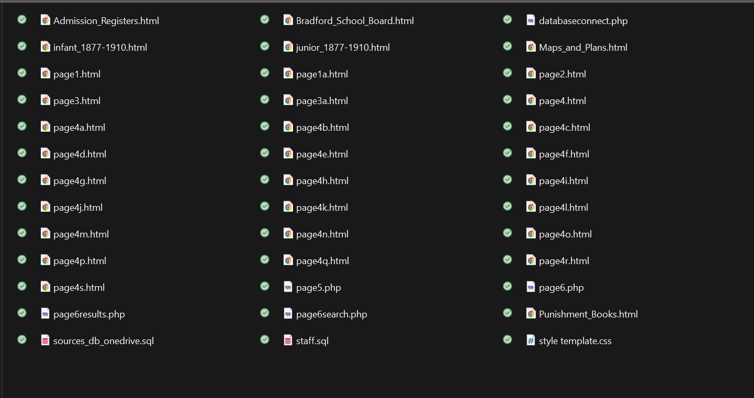
(All files to inspect)

2.1 Methodology

During the development of the project, the team used Visual Studio Code (VS Code) as the main tool for inspecting and managing the code. Features such as syntax highlighting, real-time error warnings and automatic formatting helped ensure the code remained functional and followed standard coding practices.
Alongside this, the team carried out regular peer reviews using GitHub. This made it easier to collaborate and keep the code consistent across all files and helped to ensure that the team maintains a good overall standard. Numerous rounds of reviews were also done to make sure the code was clearly documented, improving readability and making it easier to maintain.
Before submission, a final review was completed by Fayzaan Khan to check that everything met the required standard. This ensured the codebase was complete, well-structured and ready to be submitted.

2.2 Inspectors notes (Fayzaan Khan)

The manual inspection suggests that the website is generally well organised and easy to follow, with a clear page structure and consistent use of shared design elements across the pages. The code seems readable and easy to understand, with generally clear naming, formatting and indentation throughout. The use of a single CSS file helps maintain a consistent visual style across the website. The navigation bar and overall colour theme are applied consistently on each page. This gives the application a consistent appearance and makes the user interface predictable and straightforward to use.
In terms of control flow, the inspected pages do not contain loops or very complex logic so there is no apparent risk of infinite loops. The code appears likely to produce the intended output and is generally logically structured. However, this conclusion is based on code review only and would still need to be confirmed through proper testing.
The main issue I identified during inspection relates to maintainability. Although the design is consistent, the navigation bar code is repeated across multiple pages. This means that if the navigation bar needs to be updated in the future, the same change would have to be made manually on every page. A better solution would be to place repeated parts such as the navigation bar and footer into reusable PHP include files. This would improve reduce duplication and make future maintenance easier. The same applies to the footer, which currently lacks detail and could be expanded to provide more useful information. In addition, some pages do not fully fill the screen so a CSS adjustment to improve page height and overall layout could make the final product look more polished and visually complete.
Another issue I identified during inspection was the differences in approaches to handling the searching of the two databases. Ideally the team should’ve ensured that both staff and sources pages (page 5 and 6) were developed by the same programmer to ensure the application has a more consistent appearance. Doing this would have made the user interface more predictable and easier to use
Overall, the inspection found that the code is consistent, readable and generally well-structured but there are opportunities to improve reusability, maintainability, and visual presentation.

3. System Testing & Acceptance Testing

Test case | Test Steps | Expected Results | Status
Application loads on the homepage | 1. Create shortcut to homepage  2. Open Shortcut | The shortcut should open to the localhost webpage in the chosen browser. The shortcut shouldn’t open the page in file path. | Passed
All pages load correctly | 1.Manually load each page. | No broken pages and no broken styling. | Passed
Navigation bar links work | 1.Inpsect each navigation button. | Should relocate to the correct page, not open another page. | Passed
Cursor Hover effects work | 1.Hover over navigation bar buttons and notable date tabs. | Every button on the navigation bar and every notable date tab should display the hover effect. | Passed
All hyperlinks work | 1. Inspect all hyperlinks on all pages. | Hyperlink functionality must meet the clients’ requirements, relocating to the correct pages. Hyperlinks shouldn’t break nor should they lead to incorrect pages. | Passed
All images load on all pages | 1. See that all images on all pages load as required. | Images should load in browser, should not relocate to another software for images. | Passed
Staff Database connects and can be searched | 1. Verify entire staff record loads.  2. verify staff database can be searched. | Should be able to search staff by criteria such as their role and the webpage should display all staff whose records included that role. | Passed
Sources Database connects and all links work. | 1. Load the Sources page.  2. Check format.  3. Test all required hyperlinks. | Sources Database page must load and be formatted as required by the client. All hyperlinks in the page must relocate to the correct page and them pages must also load and function correctly. | Passed
Application works on Chrome, Firefox and Edge | 1.Run the localhost homepage site on various browsers. | All system functions must run as required. Database must connect and be able to be searched, and images all must be visible in browser. | Passed

3.1 Homepage


This shortcut was created and tested in line with the client’s requirements. The client requested a desktop shortcut that launches the application directly to the homepage. Testing confirms that the system operates as expected, with the shortcut opening the webpage in a browser rather than a local file.
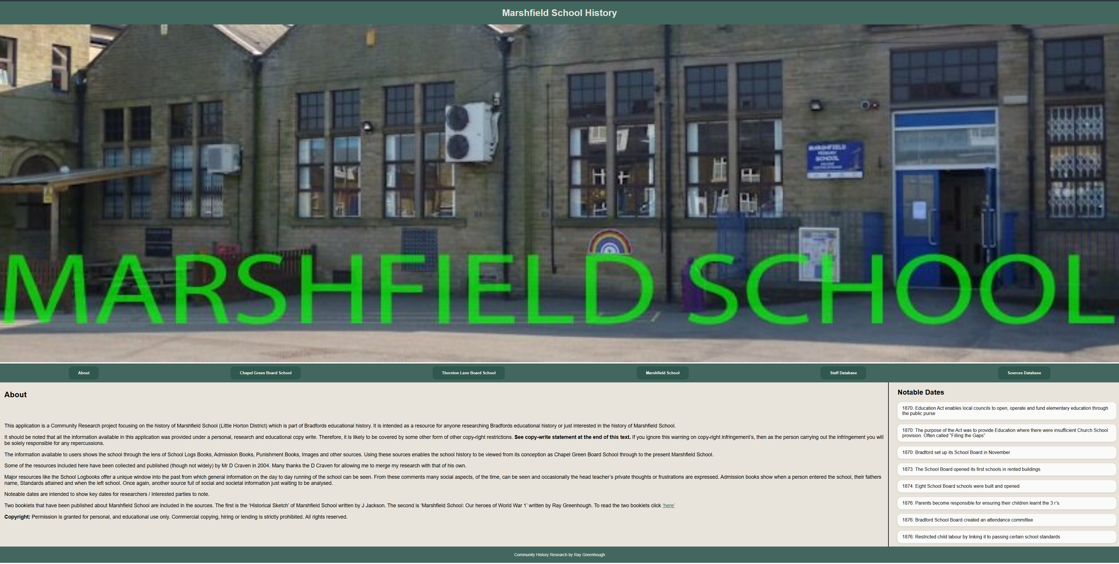
This screenshot provides clear evidence that the homepage loads as expected. Further testing confirmed that the homepage functions exactly as required; all navigation menu buttons were tested and were able to redirect users away from the homepage to the appropriate pages without any issues. Additionally, the hyperlinks on this page, as well as those across the rest of the website, were thoroughly tested and consistently worked as expected, demonstrating reliable and effective navigation throughout the system

3.2 Hover effect

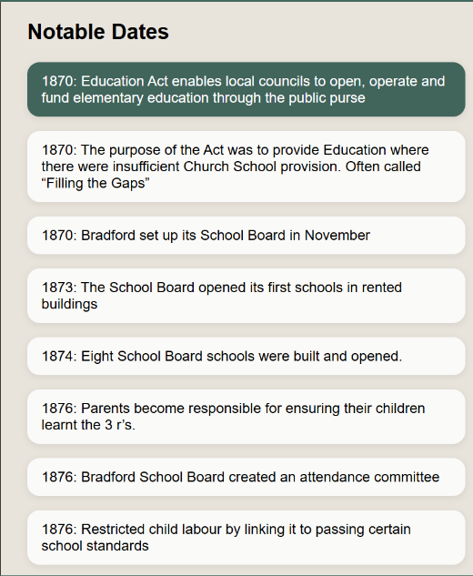
The first image illustrates a hover effect on the “About” button, where its colour changes. The second image highlights a similar effect applied to the first tab in the “Notable Dates” section. This user interface feature was implemented to improve the visual appeal of the application. Comprehensive testing confirmed that all navigation buttons and “Notable Dates” tabs consistently applied this effect and operated as intended.

3.3 Staff Database

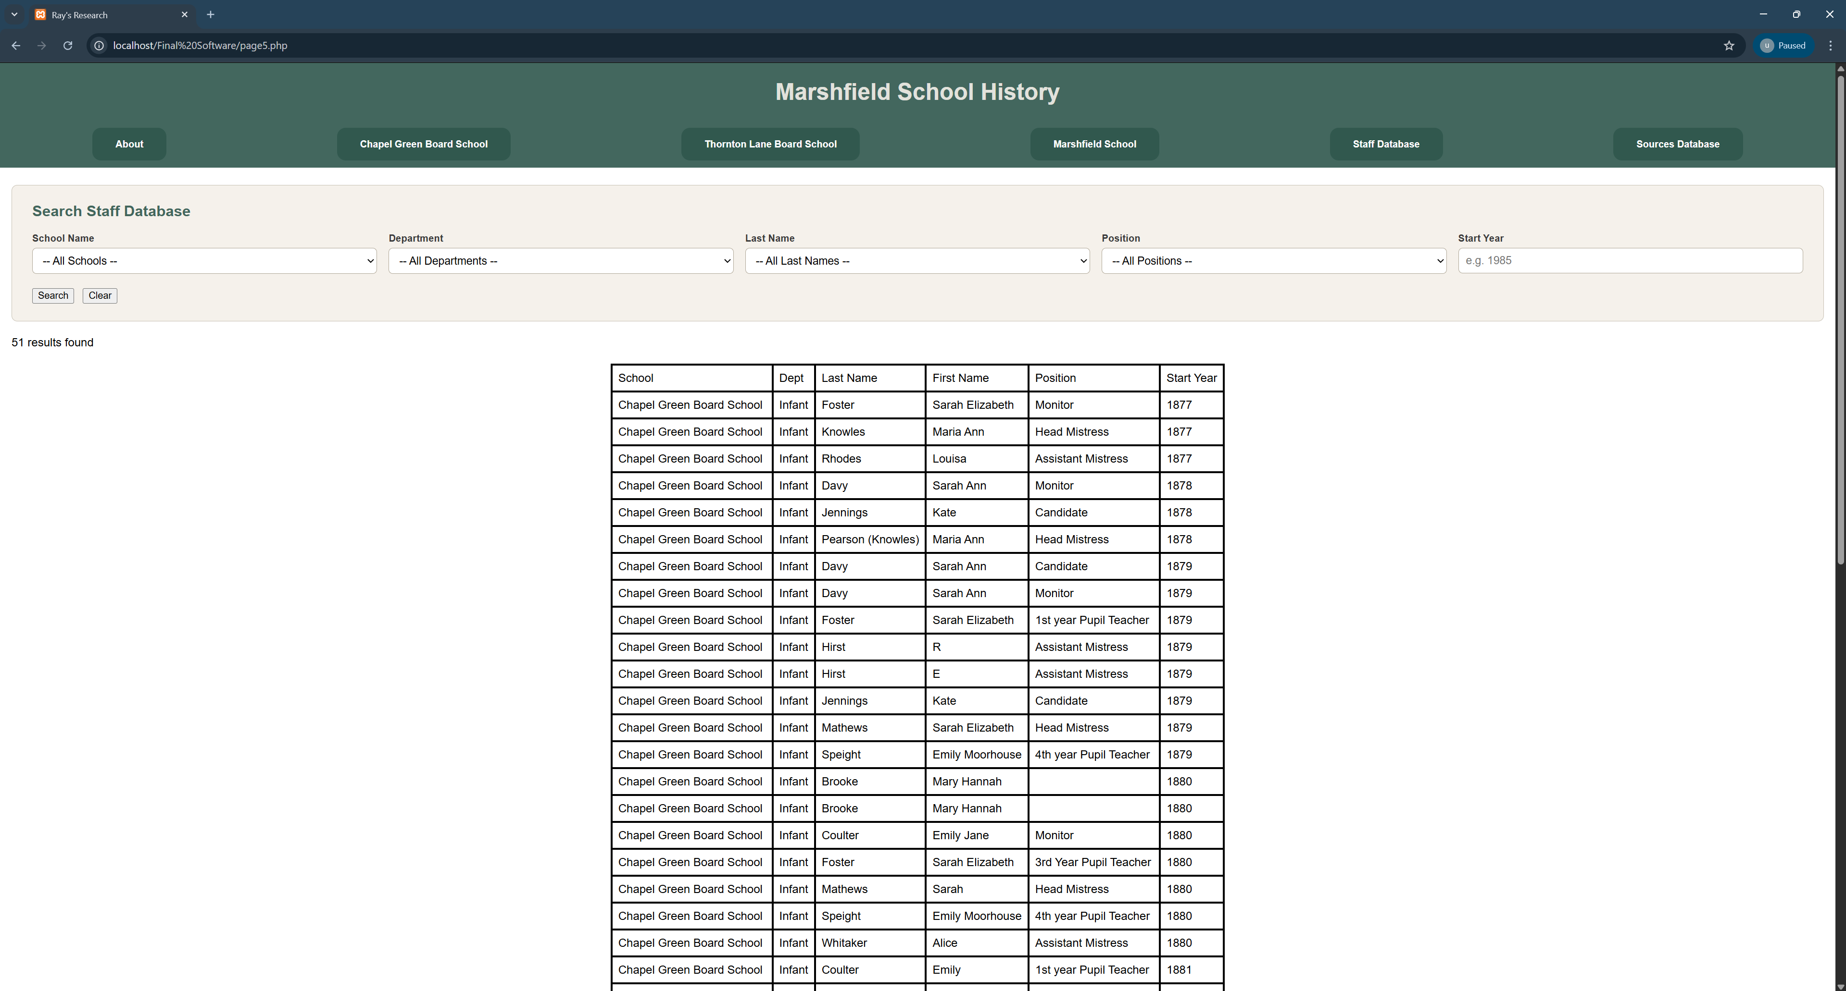

This screenshot verifies that the Staff Database successfully connects and loads in its entirety. The test demonstrates that all staff member records are retrieved from the MySQL database and are displayed correctly on this webpage.

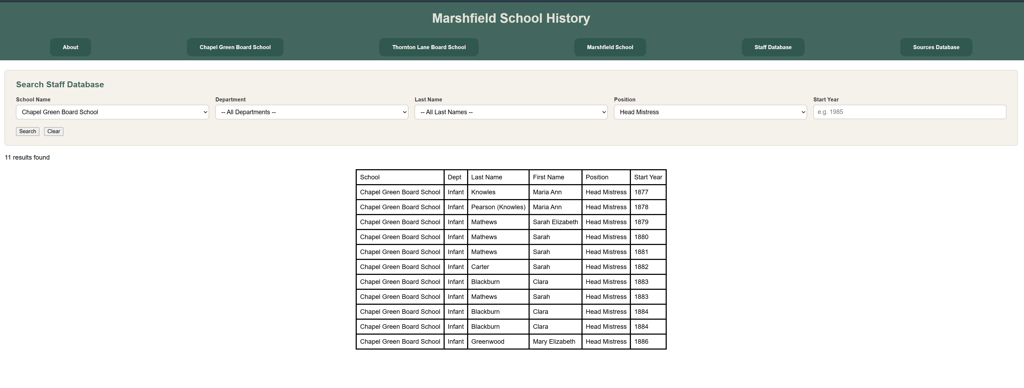
This screenshot illustrates the results of our acceptance testing. The Staff Database has been queried to retrieve and display all records relating to headmistresses at Chapel Green Board School. This test is designed to closely replicate how the client would interact with and use the database in a real-world scenario, and the successful output demonstrates that the system is functioning correctly and meeting its intended requirements.

3.4 Sources Database and records display

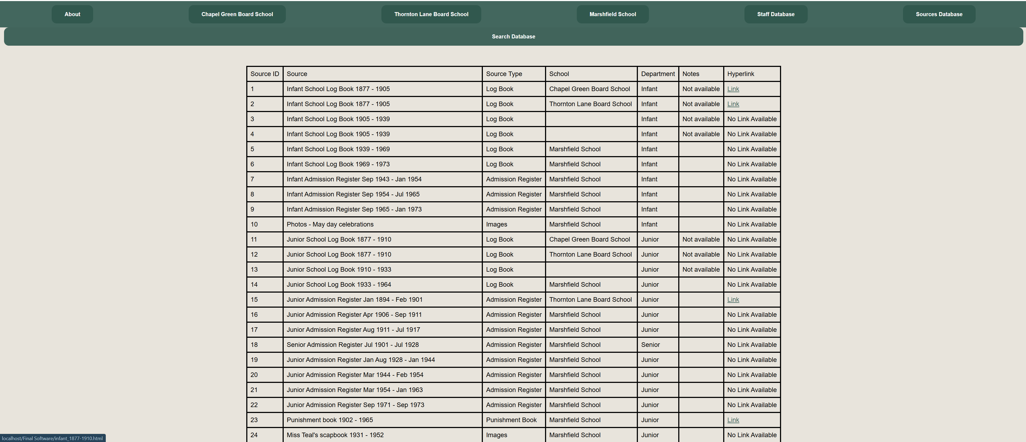
(Sources database page)
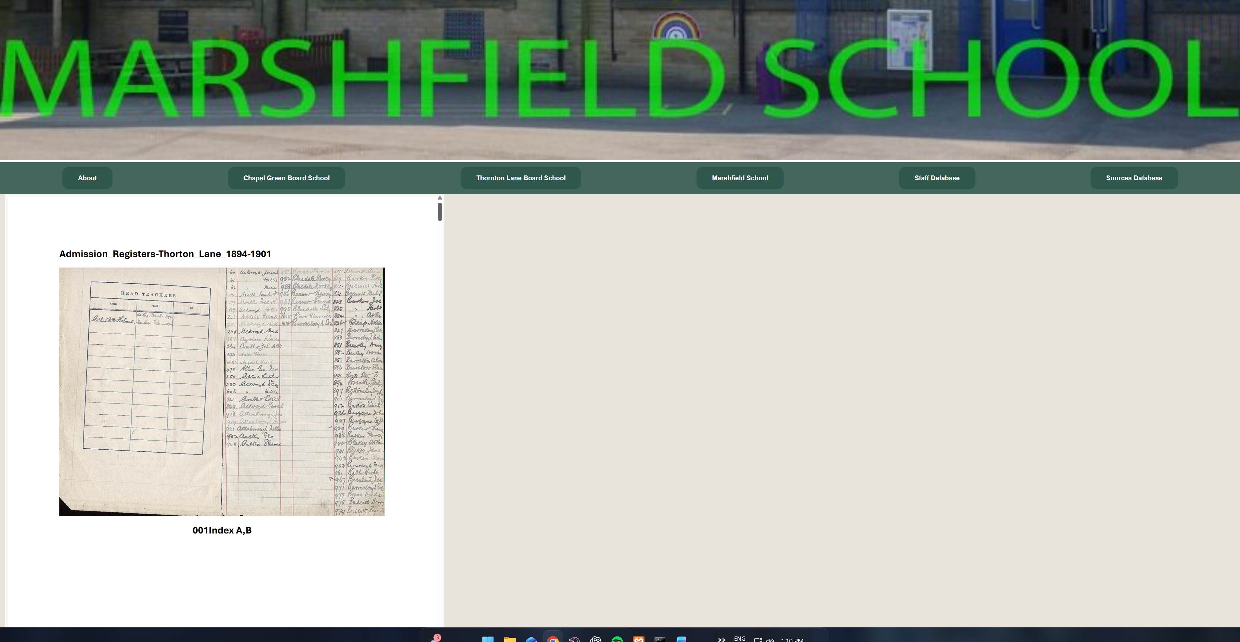
(Source 1 page)

This pair of images demonstrates how the Sources Databases page loads and is formatted in accordance with the specified requirements. All hyperlinks on this page were tested and successfully redirected to their respective pages, each of which also functioned as expected. Selecting the hyperlink for Source 1 correctly navigates to the dedicated Source 1 page, providing further confirmation that the system is operating accurately and in line with its intended functionality.

2.5 Cross browser Testing

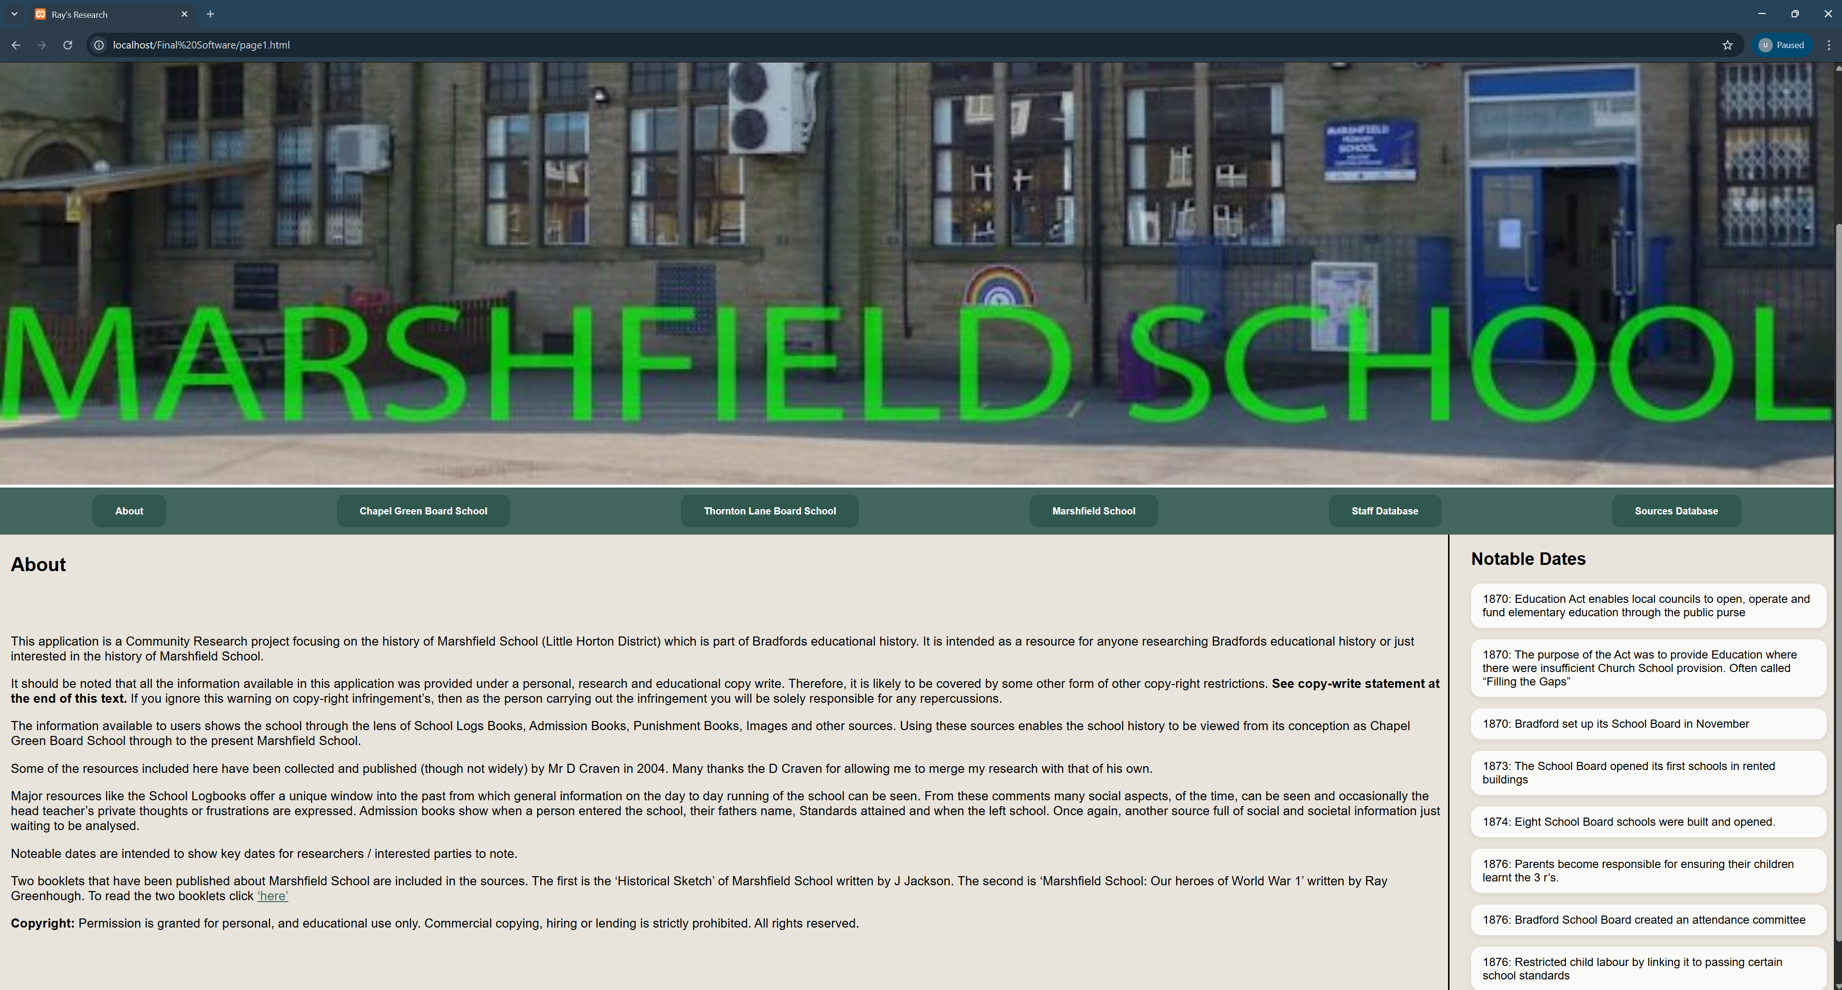
(Google Chrome)

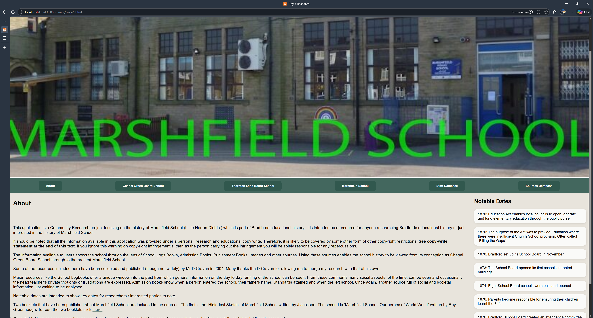
(Microsoft edge)

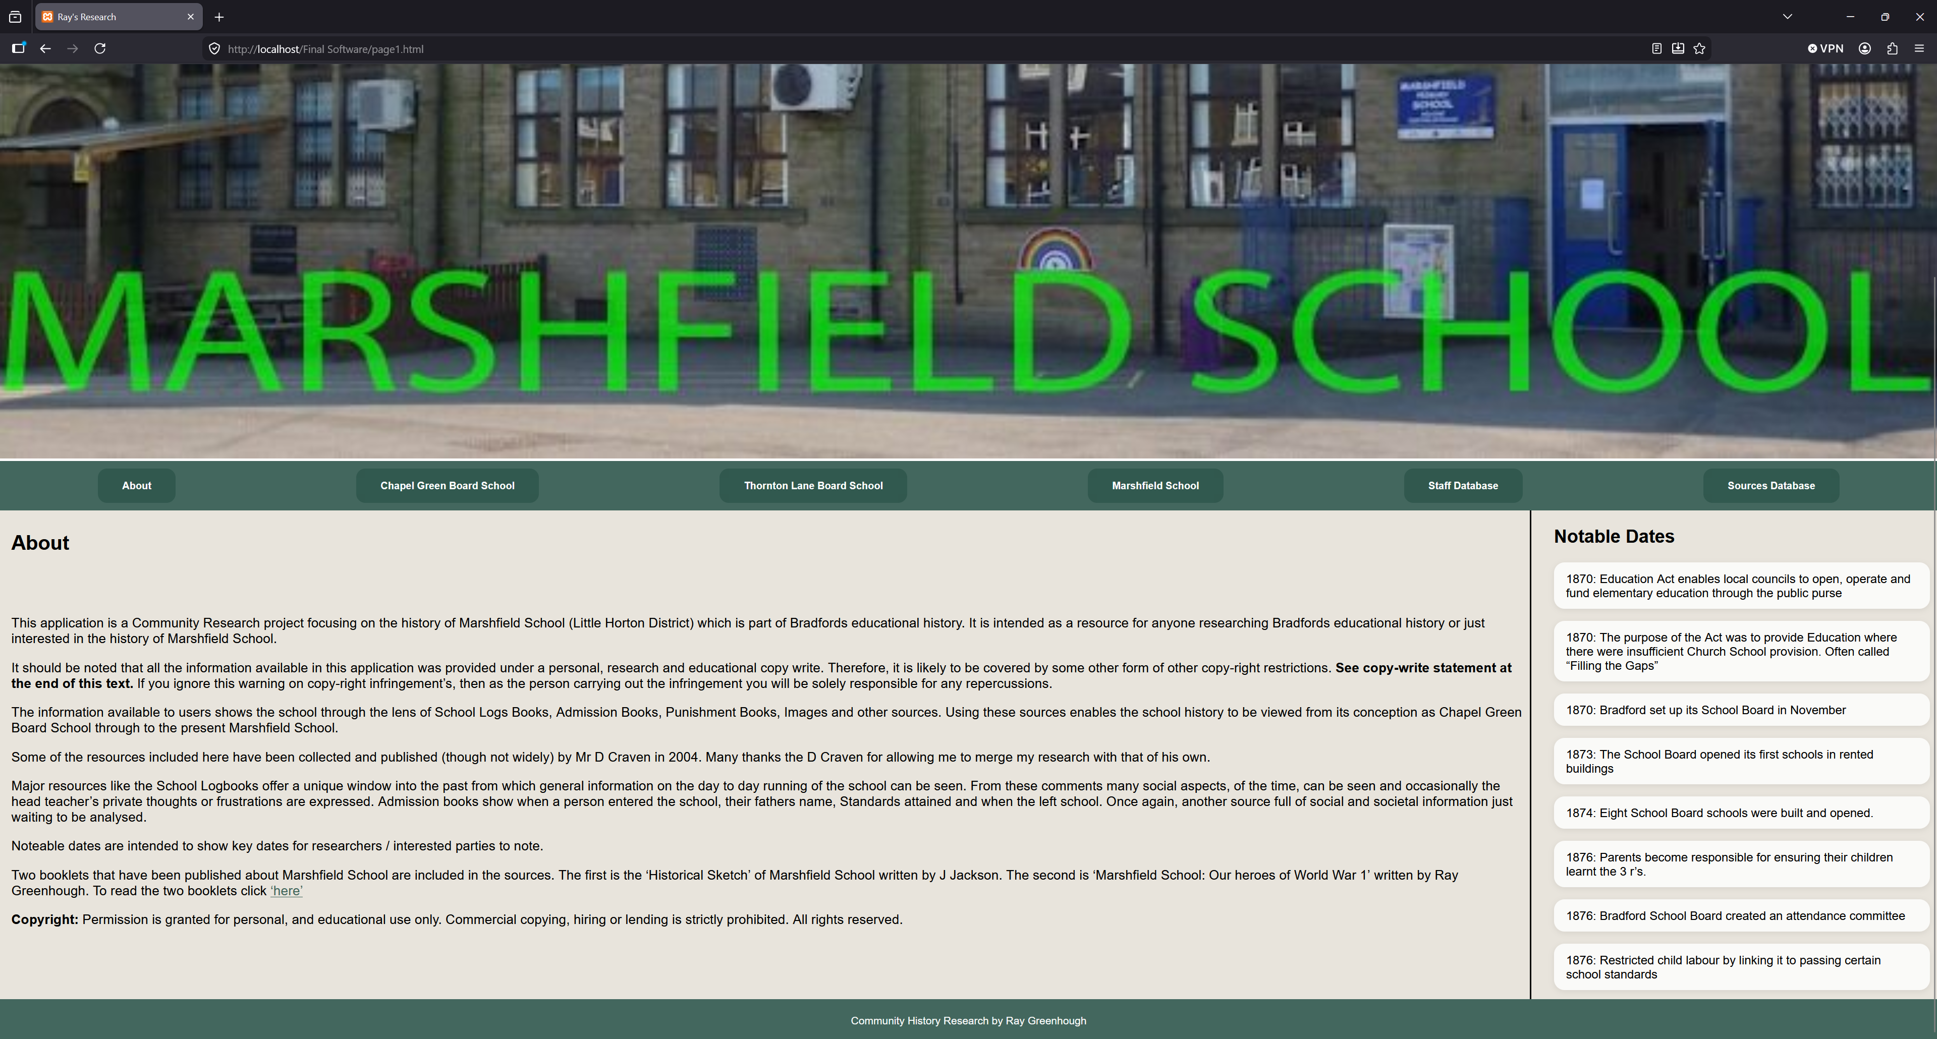
(Mozilla Firefox)

2.6 Page by Page Testing

Admission_Registers.html – Page loads, CSS loads, all hover effects work, all navigation bar buttons work, scroll bar works, all images load.
Maps_and_Plans.html - Page loads, CSS loads, all hover effects work, all navigation bar buttons work, scroll bar works, all images load.
infant_1877-1910.html - Page loads, CSS loads, all hover effects work, all navigation bar buttons work, scroll bar works, all images load.
Bradford_School_Board.html – Page loads, CSS loads, all hover effects work, all navigation bar buttons work, scroll bar works, all images load.
junior_1877-1910.html – Page loads, CSS loads, all hover effects work, all navigation bar buttons work, scroll bar works, all images load.
Punishment_Books.html – Page loads, CSS loads, all hover effects work, all navigation bar buttons work, scroll bar works, all images load.

page1.html – Page loads, CSS loads, all hover effects work, all navigation bar buttons work, hyperlink works as expected and image loads.
page1a.html – Page loads, CSS loads, all hover effects work, all navigation bar buttons work, all hyperlinks work correctly and load up the correct images.

page2.html – Page loads, CSS loads, all hover effects work, all navigation bar buttons work, all hyperlinks work as expected and image loads.

page3.html – Page loads, CSS loads, all hover effects work, all navigation bar buttons work, all hyperlinks work as expected image loads.
page3a.html – Page loads, CSS loads, all hover effects work, all navigation bar buttons work, all hyperlinks work correctly and load up the correct images.

page4.html – Page loads, CSS loads, all hover effects work, all navigation bar buttons work, all hyperlinks work as expected and image loads.
page4a.html to page4s.html – Page loads, CSS loads, all hover effects work, all navigation bar buttons work, tables formatted as per requirements.

page5.php – Page loads, CSS loads, Database connects successfully, all hover effects work, all navigation bar buttons work, all database search functionality works as expected (buttons all work, filters work as expected).

page6.php – Page loads, CSS loads, Database connects successfully, all hover effects work, all navigation bar buttons work and image loads.
page6search.php - Page loads, CSS loads, Database connects successfully, all hover effects work, all navigation bar buttons work, all database search functionality works as expected and image loads.
page6results.php - Page loads, CSS loads, Database connects successfully, all hover effects work, all navigation bar buttons work, correct results are displayed from database, and image loads.

4. Peer-review

Name | Tasks Assigned | Achieved | Contribution Score
Ibraheim  Hussain | - Contributed to the specification document.  - Documented meeting minutes.  - Assisted in developing the index HTML/CSS page.  - Created reusable HTML/CSS templates for child pages.  - Implemented the HTML/CSS for page 3, including embedding hyperlinks.  - Implemented the HTML/CSS code for page 4 child pages a-s, featuring tables.  - Created PDF files for the images folder, for image navigation.  - Produced two optimised software versions for university and client submissions.  - Integrated all member’s HTML/PHP/CSS pages into the final completed software. | - Helped define project requirements.  - Improved team communication via meeting notes.  - Contributed to a consistent website structure.  - Increased efficiency with reusable page templates.  - Delivered functional pages with working navigation.  - Improved accessibility with PDF resources.  - Resolved submission issues by creating optimized software versions.  - Integrated all components into a final working system. | 10
Tawfeeq  Hussain | - Contributed to the specification document.  - Assisted in the creation of the index HTML/CSS page.  - Coordinated tasks across team members to maintain workflow efficiency.  - Implemented the HTML/CSS code for page 2, including embedding hyperlinks.  - Collated and improved CW1 documentation. | - Contributed to requirements structured system specification design  - Developed a functional webpage.  - Coordinated team progress and task tracking to maintain an efficient development workflow.  - Refined technical documentation to improve clarity, consistency, and maintainability. | 8
Elysia  Horder | - Contributed to the specification document.  - Team speaker, spoke with the client for his requirements.  - Created the SQL database for the sources records, which included hyperlinks.  - Assisted in the creation of the HTML/CSS index page.  - Implemented PHP functionality to dynamically retrieve sources data from the database for Page 6 upon completion.  - Created an alternate page 6 version for the client. | - Defined structured project requirements.  - Led client requirement gathering and clarifying system requirements.  - Designed SQL database to manage source records with hyperlinks.  - Supported index page development, for a consistent UI.  - Developed dynamic PHP functionality to retrieve and display data for Page 6, demonstrating backend integration skills.  - Delivered an alternative locally run version of Page 6 for the client. | 10
Fayzaan  Khan | - Prepared the interview questions for the client.  - Contributed to the specification document.  - Created the PHP connection code.  - Implemented the HTML/CSS code for page 1a, including embedding hyperlinks.  - Assisted Siraaj in the debugging of page 5.  - Carried out Acceptance testing and Code inspection and formally wrote up a report to detail the findings. | - Contributed to defining project specifications  - Implemented PHP-SQL database connection, demonstrating PHP & SQL development skills.  - Developed a functional webpage  - Supported debugging for dynamic pages, improving system reliability.  - Conducted acceptance testing and code inspection, producing a report to evaluate the system performance and quality. | 10
Siraaj  Ali | - Contributed to the specification document.  - Created the SQL database for the staff records.  - Implemented PHP functionality to dynamically retrieve staff data from the database for Page 5 upon completion. | - Contributed to defining clear and structured project requirements.  - Designed and implemented a SQL database to efficiently store and manage staff records, demonstrating strong database development skills.  - Developed dynamic PHP functionality to retrieve and display staff data on Page 5, showcasing integration of backend logic with database systems. | 9
Victor  Nwagu | - Contributed to the specification document.  - Created the Instruction Manual Guide.  - Implemented the HTML/CSS code for page 4, including embedding hyperlinks. | - Contributed to defining clear and well-structured project requirements.  - Produced a comprehensive and user-friendly instruction manual, improving usability and user understanding.  - Developed a fully functional webpage with embedded hyperlinks, enhancing navigation and overall user experience. | 8

GitHub Links

Code:
https://github.com/thussain727/enterprisepro/tree/main/Final%20Software
- The code for the final prototype is accessible via the GitHub repository link provided above. To access and run the software, please refer to the readme.txt and Instruction Manual Guide.docx, both located within the repository folder, which provides full setup and usage instructions.

Minutes:
https://github.com/thussain727/enterprisepro/tree/main/Minutes
- The weekly meeting minutes are available via the GitHub repository link provided above, located within the Minutes folder.

