Table of Contents

1.Introduction 1

Problem Statement 2

Literature Review 2

Objective 3

Scope 3

work breakdown structure 4

Resource Allocation 5

Milestone Plan 5

Cost Plan 5

2.What is the System 6

Why is it important 6

User requirements 7

Based on the user level functional requirements 7

Non-Functional Requirement 10

An Overview of Existing Leave Policy Leave types 11

Leave counts 11

Possible use case 12

Current system explanation 12

Drawbacks of the current system 12

Explanation of the proposed system 13

3.Feasibility study and Requirement gathering 14

Feasibility study 14

Requirements gathering 15

Apply Leave 15

Approve Leave 15

Add Company Leave & Update Company Leave 15

Allocate Leave 15

View Leave Balance 17

Add Users to User Group 17

View Number of Persons On Leave In A Calendar View 18

View Leave Request 18

Leave History 19

Add New Leave Type 19

Calendar View with Holidays 19

Hardware 20

Software 20

Process model 21

Agile model 21

4.System architecture 23

5.Design 26

Sample work flow 26

High Level diagram 27

Use case diagram 28

Class diagram 29

Database Design 30

Tables 30

6.User Interfaces 37

7.Testing 40

Testing Life Cycle 41

Testing Type 41

Unit Test 41

Integration tests 42

Acceptance testing 42

Performance testing 42

Smoke testing 42

Regression testing 43

Manual Test Vs Automation Test 43

Why Automation Test? 44

Test plan and Testcase 45

Implementation 66

Data base Implement Part 66

API design and explanation 67

Deployment instructions 68

Future enhancements 69

Conclusion 69

# 1.Introduction

The “Leave management system” software is user-friendly software. The main objective of the system is which shows and helps you to collect most of the information about Leave details of employees.

Leave management is keeping all the records of leave taken by an employee according to the company leave policy. Using an efficient leave management system is important in a big organization. Leave management system is an automated online stage that circles all sort of leave applications and leave regard, and the system to record various types of leaves. This system can be applied to automate the work process of leave applications and their acceptance. It is straightforward and simple to use a system that dispenses with paper work, spares time and cash.

It is a major part of HR department to keep all the records of personal information and managing leave data of all the employees, most importantly paid leaves taken by employees, up to date and readily available in times of need. Maintenance of these records becomes very difficult for the HR department when all the work is manual. This requires a lot of paperwork. It faces a lot of hurdle while maintaining tons of information manually and keeping track of employee performance, their personal data, especially information of number of leave taken by an employee according to the company policy. It consumes a lot of time and creates a barrier to work efficiency.

Thus, in this fast-moving technological era, it is very crucial for a large organization to automate their employee record keeping system to make HR department more efficient and allow them to focus on most important functions like employee engagement, safety, employee benefits, etc.

The project Leave Management System includes employee login, Admin, HR login and Director login. Employee login enables employees to view their leave status. They can also apply for the leave. Admin add more users to a specific user group also should be able to create a new user group on request. admin can also generate various reports on the leave details. Director view the number of employees who are on leave while selecting a specific date on the calendar. Director should be able to search for a specific employee with the employee id and view below information. Leave status changes and leave balances should be updated there itself. HR viewing the leave request and accept or reject the leave request**.**

## Problem Statement

Employee leave management is simple HR activity and one that impacts all employees. Most organizations have clear leave policies that are properly conveyed to employees and managers through employee handbooks or HR policy manuals. However, HR is loaded with managerial administration of leave, updating of leave balances and responding to inquiries on leave statuses and entitlements from employees and their managers. Employees also finds it difficult to fill paper forms and run after the approvers to approve their leave. A substantial amount of expensive time of employee, manager and HR is wasted in a very basic HR process.

Organization is also facing similar problems even though they have a proper leave policy but not a proper HR system where leave management process can be

integrated. Organization have many employees. It has been found that 100 leave applications are received by the HR department in each month. These huge number of leave applications are recorded and signed for approvals manually using Leave Register books. Sometimes the leave forms received in previous months pile up in current month with pending approval. This manual process of leave management creates a lot of problems in day to day activities.

## Literature Review

## Objective

The objective of this document is to explain the implementation and organization rules of the proposed “Employee leave Management System” for Tec IT Center. The document addresses the functional requirements, nonfunctional requirements, constraints, possible use cases of the system. This document is proposed as an input and reference for the architectural designing process of the system. The document can be referred by the involved users.

## Scope

The advancement in technology in the last few decades has improved our lives in every aspect. Manually driven systems are being substituted by the computerized systems. The existing Leave Management System totally manual to keep track of all the leave associated records. uses a very lengthy process to grant or refuse leave including finding out the eligibility of the employees for the type of leave applied for. Moreover, the information can be distorted as it has to go through a long chain of officials. The objective of this project is to formulate a sensible analysis of the current system to find out its problems and thus design a new web based system which will be more optimized and synchronized. The management will be availed with such a system which may make their task simpler incase of leave related activities and the employees will not need to wait for a long time to know the decision of the management.

## work breakdown structure

Entity, Data Transfer Object [DTO],DTO mapping create, Entity mapping

Repository

Service, Service implement

Controller

Leave Management System

Integration

Testing

Frontend Design

Backend Design

Manual Testing

Automation

Testcase writing

Testing

Script writing

Design UI

Routing

Model

Service

## Resource Allocation

## Milestone Plan

## Cost Plan

# 2.What is the System

Leave management system is very simple to understand, easy to use and more convenient for implementation. The major use of designing such an application is to provide a staff or an employee a better way for scheduling and calculating their leave details. As the existing system increases the paper work and record maintenance which is a tedious work, so there is a need of new system which makes the record maintenance easy that is the common requirement for the management or an organization.

Application development can be generally being thought of having two major components: analysis and design. In Analysis more emphasis is given to understanding the details of an existing system or a proposed one and then deciding whether the proposed system is desirable or not and whether the existing system needs improvement. Thus, analysis is the process of investigating a system, identifying problems, and using the information to recommended improvements to the system.

## Why is it important

For any organization, especially startups and small businesses, employee vacation management is a critical aspect. These employee records can help you track their hard work. It also shows your employees' interest in his/her work. The more leaves, the less interest there is. Vacation management software helps you get the most accurate tracking of paid vacations, sick leave and holidays that employees are entitled to.

You will be able to track how many holidays your employees have used and how many holidays they have left. Vacation management is critical in any company because it shows the opinions of employees. Excessive vacation can and will greatly reduce this investment. These factors are very simple and crucial.

## User requirements

Primary users of the Leave management module will be the employees. There will be four user levels.

1. Admin
2. Director
3. HR Manager
4. Accounts Manager
5. Employees

### Based on the user level functional requirements

#### Admin

Admin should have the functionality to add more users to a specific user group also should be able to create a new user group on request. Should have the access to the archived data.

#### Director

There should be a functionality to view the number of employees who are on leave while selecting a specific date on the calendar. Director should be able to search for a specific employee with the employee id and view below information

1. Total number of leaves
2. Utilized number of leaves
3. Number of leaves in balance

Leave requests from the managerial employees should be routed to director, and the approval should be sent to both HR Manager and employees. Leave status changes and leave balances should be updated there itself.

#### HR Manager

While navigating to the Leave management dashboard, there should be a notification bar to show all the leave requests. While viewing the leave request below information need to be displayed from the relevant leave request

* Dates on which the leaves are requested
* Number of days requested for leave
* Leave reason
* Available leaves in balance
* History of leaves taken till date
* History of leaves rejected

There should be options to accept or reject the leave request. Also, there should be a place where the HR Manager could enter the rejection reason while rejecting the leave request. A notification should be sent to the employee and the department lead while accepting or rejecting the request.

There should be a calendar view where the HR Manager can see the details of the employees who are on leave while selecting the specific day. This view will help the HR Manager in measuring the hindrance while providing leaves for employees specially in same department.

A different notification is required to see the lieu leave recommendation from the respective leads of employees. Lieu leave request should have the recommendation of the lead, employee detail from whom the lieu leave request came, number of days to be added as lieu leave, leave history of the specific employee.

Lieu leave request should be routed via the respective department manager. Lieu leave request requires options to either accept or reject. While rejecting the request a notification needs to send to the respective lead and employee with the rejection reason. While accepting the request lieu leave count should be added to the respective employee and an acceptance notification needs to be sent to the relevant department manager and employee.

There should be a notification to view the ‘Leave carry forward request’, where the HR Manager could see the leave carry forward request from the employee. This request should have the relevant employee details including the number of leaves requested to carry forward.

The request should have the option to view the employee’s leave history and total available balance leaves. Also, it should have the option to either accept or reject the request. While accepting the request number of leaves requested to carry forward should be added to the respective employee. A notification should also be sent to the employee. While rejecting the request a rejection reason should be sent as a notification to the employee.

#### Employee

Employee should have the option to view the leave details in the dashboard

* Total number of leaves
* Number of medical leaves
* Number lieu leaves
* Number of Annual leaves
* Number of casual leaves
* Number of duty leaves
* Number of utilized leaves
* Number of leaves in balance
* Statuses of each leave

Employee should have the option to view the leave history details with the leave status, leave type, date and number of days of a leave. Employee should be able to send a leave request. Leave request form should include the below details

* From to Date
* Based on from and to date, number of days should be calculated automatically
* Should show the number of available leaves in balance
* Leave request reason
* An attachment field where any documents could be attached if necessary (Medical reports)

lieu leave request and leave carry forward request should be available. Both requests should be routed to the HR Manager via the respective department manager. There should be a calendar view where the employees can see the holidays and company leaves

### Non-Functional Requirement

#### Security requirement

The software should not allow unauthorized access to any module of the system. Besides, it should maintain the privileges granted to users at various user levels. User levels should be specified accurately so that the accesses to the relevant sensitive information could be secured.

#### Performance requirement

Performance is a quality attribute that describes the responsiveness of the system to various user interactions with it. The load time for user interface screens shall take no longer than two seconds. The login information shall be verified within five seconds. The queries shall return result within five seconds.

#### Usability

**Efficiency of use and easy** to understand the interface, buttons, headings etc.

### An Overview of Existing Leave Policy Leave types

1. Annual leave
2. Casual leave
3. Special leave
4. Medical leave
5. Short leave
6. Half day leave
7. Lieu leave

### Leave counts

* + Casual leave: 7 days per year
  + Annual leave: 14 days per year
  + Medical leave: 14 days per year
  + Half day: 2 per month
  + Short leave: 2 per month [8 days per year]

If an employee requests annual leave more than the number of leaves he is eligible of should request the rest number of leaves as special leave. Medical report should be attached for the medical leave requests which are more than 3 days . Annual leaves are not applied for the first year of the employment period to an employee.

On the first year of employment period an employee will gain ½ day casual leave on the completion of each month. At the end of the year the employee will earn 6 days of casual leave.

All the leave requests from the managerial employees should be routed to the director & HR manager should be notified on the request approval. Other employees leave request should be routed to the HR manger via the relevant department manager. Both the employee and respective department manager should be informed on either request approval or rejection.

### Possible use case

Employee requests medical leave more than 3 days

Employee requests annual leave more than 7 days

Employee requests half day

Employee requests lieu leave

Employee requests short leave

## Current system explanation

Employee Leave Information Management System is operated manually and it has some limitations. The major tasks that are being handled

individual to apply leave. It increases the paper work and record maintenance which is a tedious work.

### Drawbacks of the current system

1. Involves a lot of steps to get final approval

2. Too much paper works

3. High chances of data loss and data discrepancy

4. Time and energy consuming

5. Difficult to create monthly and annual leave report .

6. Leave balance is not readily available to the employee

7. Lack of report analysis opportunity

8. Lack of monitoring and controlling facilities in existing leave system.

9. Difficult for employees to apply for leave working outside head office

10. Lack of satisfaction among employees

## Explanation of the proposed system

The main objective of the proposed system is to automate the existing system. It decreases the paper work and easier record maintenance by having a database for leaves. It reduces the time and manual paper work for applying a leave. The leave management system reduces the work and risk of the Human Resource Manager

**Advantages of Proposed System are,**

* It is very faster.
* Provide user friendly.
* To have a system confronting with latest technologies and web enabled.
* To have an RDBMS as a back end for the processing of the system.
* To maintain a Centralized database management system catering the needs of all users this is fully controlled and organized by an Administrator.
* To provide a communication tool for better information exchange and organization of the system.
* Time and money can be saved.
* Employees can update their information.
* Good communication is provided with administrator.
* To have facility for online leaves application and other information processing.
* Online verification of leaves by providing the necessary information.
* Online Sanctioning of leaves along with detailed description of leaves applied in each month.
* To provide tools for generating data analysis, status report and statistical data maintenance information for better decision making and management information system.

# 3.Feasibility study and Requirement gathering

## Feasibility study

Feasibility studies aim to objectively and rationally uncover the strengths and weakness of the existing system or proposed venture. In its simplest term, the two criteria to judge feasibility are cost required and value to be attained. As such, a well-designed feasibility study should provide historical background of the project. Generally, feasibility studies precede technical development and project implementation. The assessment of feasibility study is based on the following factors:

* Economic feasibility - economic analysis the most of the frequently used method for evaluating the effectiveness of a new system .more commonly known as cost/benefit analysis, the procedure is to determine the benefits and savings that are expected from a candidate system and compare them with costs. the system can be implementation is economical if implemented for large/medial organization which can the cost of maintaining computer and sever cost.
* Technical feasibility - the system can be implemented using computer software and hardware
* Operational feasibility - it is the measure of how well a proposed system solves the problems and takes advantages of the opportunities identified during the scope definition and problem analysis phases. And how well it satisfies the system requirements identified in the requirement analysis phase.
  + Website navigation and handling
  + Security issues
  + Existing internal network

## Requirements gathering

Requirement gathering is the one of the best part. I haven’t proper requirement before start the project so i unable to start my project. I am getting the proper requirement easily find out the client requirement then design my system. Iam gathering additional requirement. These are given bellow,

### Apply Leave

* From
* To
* Number of days
* Type of leave
* Reason
* Send copy to
* Attachments

### Approve Leave

Should be able to view leave request. There should be buttons to accept/reject request. There should be a field to provide the leave rejection reason

### Add Company Leave & Update Company Leave

Calendar view should be available

Select date

Provide reason

Type of leave: company holiday

**NOTE:** Added company holidays should able to be edited.

### Allocate Leave

Employee Name :

Employee Id :

Position :

Appointment Type :

|  |  |  |  |  |
| --- | --- | --- | --- | --- |
|  | Probation 6 M | Probation 9 M | 1 Yr Contract | Permanent |
| Annual Leave | 0 | 0 | 0 |  |
| Medical Leave |  |  |  |  |
| Casual Leave | 0 |  |  | 7 |
| Maternity Leave |  |  |  |  |
| Company Leave |  |  |  |  |
| Lieu Leave |  |  |  |  |

***NOTE:***

After year completed the leaves should automatically get allocated based on the annual leave note given bellow the chart. Maximum lieu leave number should be configured and that should not allow to exceed when the employees apply above that.

#### Annual leave

The employee is permitted to 14 days of annual leave complete with the full salary for each concluded year of service. Hence, employees are not entitled to annual leave on the first year of employment. Annual leave for the second year of employment is accrued based on the date the employee joined service. The annual leave accrual is set out below.

• Between January 1 and March 31 of the previous year – 14 days

• Between April 1 and June 30 of the previous year – 10 days

• Between July 1 and September 30 of the previous year – 7 days

• Between October 1 and December 31 of the previous year – 4 days

#### Casual leave/ sick leave

The second year onwards the employee will be eligible for 7 days of casual leave. On the first year of employment, the employee is entitled to one casual leave for every two complete months of service.

#### Maternity leave

For the birth of the first and second child, a female employee is entitled to 84 days of paid leave, which includes 14 days of pre-confinement leave and 70 days after confinement. For the birth of the third child and any subsequent child, the leave entitlement is 42 days (including 14 days of pre-confinement leave and 28 days after confinement). Maternity leave is considered without considering the weekly holidays, public holidays and full moon poya holidays.

### View Leave Balance

Should able to view the leave balances separately with the leave type

#### Carry Forward Leave Request

* Number of balance annual leave
* Number of leaves to be carry forwarded (Maximum number can be 8 – this should be configured)

#### Carry Forward Leave

* Number of leaves to be carry forwarded
* Employee Name
* Employee ID
* Department

Carry forward button

### Add Users to User Group

* User group
* Employee id
* Employee Name

Update/Save Button

#### Add New User Group

* User group
* User group description

Update/Save Button

#### Remove User Group

User groups should able to be removed

#### Update User Group of Users

Assigned user group of an employee should be update in case of job role change

### View Number of Persons On Leave In A Calendar View

Should able to view the number of employees who are on leave by selecting the specific day from the calendar

The details should include the below details as the table view

* Total number of employees on leave
* Name of employee
* Department
* Type of leave

### View Leave Request

* Employee ID
* Employee Name
* Department
* Number of days
* Type of leave
* Reason

Should have the option to accept or reject the request. There should be field to enter rejection reason

#### View Specific Employee’s Leave Details

|  |  |  |  |  |  |  |  |
| --- | --- | --- | --- | --- | --- | --- | --- |
| EMPLOYEE NAME: <<Filterable>> EMPLOYEE ID: <<Filterable>> | | | | | | | |
| **Type of Leave** | **Applied on** | **Accepted or Rejected** | **Taken on** | **Reason** | **No of days** | **Allocated** | **Balance** |
| Annual leave |  |  |  |  |  |  |  |
| Medical |  |  |  |  |  |  |  |
| Casual |  |  |  |  |  |  |  |
| Maternity |  |  |  |  |  |  |  |
| Company leave |  |  |  |  |  |  |  |
| Lieu leave |  |  |  |  |  |  |  |

### Leave History

Below details should be a table view for an employee

* From date
* To date
* Number of days
* Type of leave
* Leave status

### Add New Leave Type

New leave type should able to be added

### Calendar View with Holidays

There should be a calendar view with the company holiday & other applicable holiday details

## Hardware

**Operating System:**

* Windows 7, Windows 8 or Windows 10

**Hardware:**

* Processor (CPU) with 2 gigahertz (GHz) frequency or above
* A minimum of 2 GB of RAM

[Hardware Requirements for Team Deployments](https://docs.mattermost.com/install/requirements.html#contents)

Most small to medium Matter most team deployments can be supported on a single server with the following specifications based on registered users:

1 - 1,000 users - 1 vCPU/cores, 2 GB RAM

1,000 - 2,000 users - 2 vCPUs/cores, 4 GB RAM

## Software

Web server [preferable apache ]

Java 1.8

Spring boot

Valentine studio

Visual code

PostgreSQL

Postman

Angular6 [frontend development]

Intellij IDE [for Automation Test]

Selenium web drive [Automation testing tool]

Chrome Browser

## Process model

### Agile model

The word "agile" is equivalent to "lean" operations, processes and new software for startups. Agile development is a new approach to software development that relies on layered development and iteration rather than bringing a "complete" product to market. Developers will give feedback to the market and users on how to optimize the software, remove or add new features.

Agile software development brings flexibility and convenience. Agile development includes iteration. This means that the software owner receives a viable piece of software at the end of each iteration. The first is the design of the future product; then the development is started, the product receives new features and tests, iterative iteration. In addition, software owners can track development progress by receiving reports in a timely manner. In addition, this allows the owner to shape the image of the app by providing feedback and changing the requirements..

The requirements for developing software often change. Vision and strategic change. Users may need new features or pay less attention to other "useless" features. These unexpected changes may cause some delays and excessive payments to become practical. Experience has shown that initial requirements do change. These requirements can range from insignificant requirements to the need to rewrite a significant amount of code. Agile methods add more space for changes/improvements. As an agile developer, you can track the process of changing/improving software.

Another feature of agile development is the communication between the development contractor and the software owner. Communication plays an important role in making the owner-developer very simple to move. The time required to complete the project is shorter. The software owner accurately receives what he/she wants.

Agile provides friendly, engaging atmosphere, necessary conditions, and motivation. Flexibility for employees instead of strictness – this will boost creativity. Agile simply

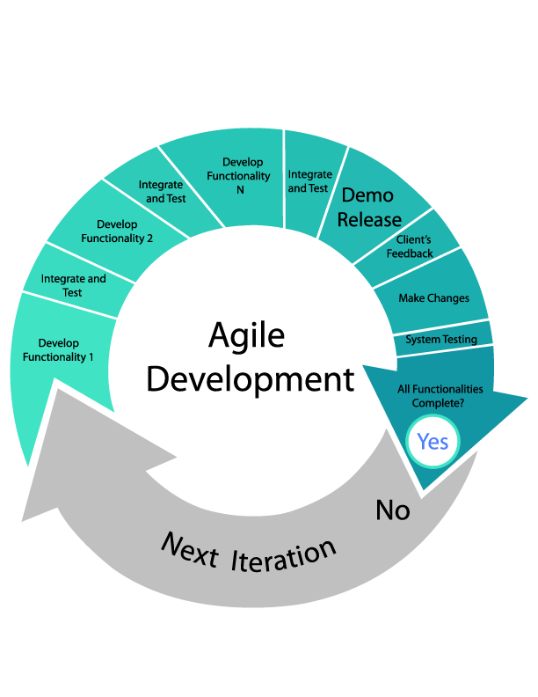works. Planning is highly important. Agile makes your software better if you choose the company that truly gets into the simple philosophy of agile development – providing the software owner and end users with a working result, and maintaining support thereafter.

# 4.System architecture

architecture diagram represents mainly flow of requests from users to database through servers. In this scenario overall system is designed in three tires separately using three layers called presentation layer, business logic layer and data link layer. This project was developed using 3-tire architecture.

The three-tier architecture offers many benefits. It allows developers to scale, modularize and be able to configure their applications. The architecture reduces time-to-market and reduces the cost of integrating new features into software-as-a-service (SaaS), cloud and on-premise applications. It also maximizes user flexibility by integrating analytics into existing infrastructure and application workflows.

Why is this is important?

First, we need to define 3-tier architecture.

3-tier architecture is a client-server architecture in which the functional process logic, data access, computer data storage and user interface are developed and maintained as independent modules on separate platforms.”

A “tier” in this case can also be referred to as a “layer”. The three tiers, or layers, involved include:

1. A **Presentation Layer** that sends content to browsers in the form of HTML/JS/CSS. This might leverage frameworks like Angular.
2. An **Application Layer** that uses an application server and processes the business logic for the application. This might be written in Java.
3. A **Data Layer** which is a database management system that provides access to application data. This could be PostgreSQL.

First, the presentation layer displays a web page with some fields for you to enter. This information is then passed to the application layer, which formats a query and passes it to the database layer. The database system runs the query and returns the results to the application layer, which formats it into a web page. The page is then sent back to the browser, where the presentation layer displays it on a laptop or other device.

Here’s a look at our platform’s 3-tier architecture.

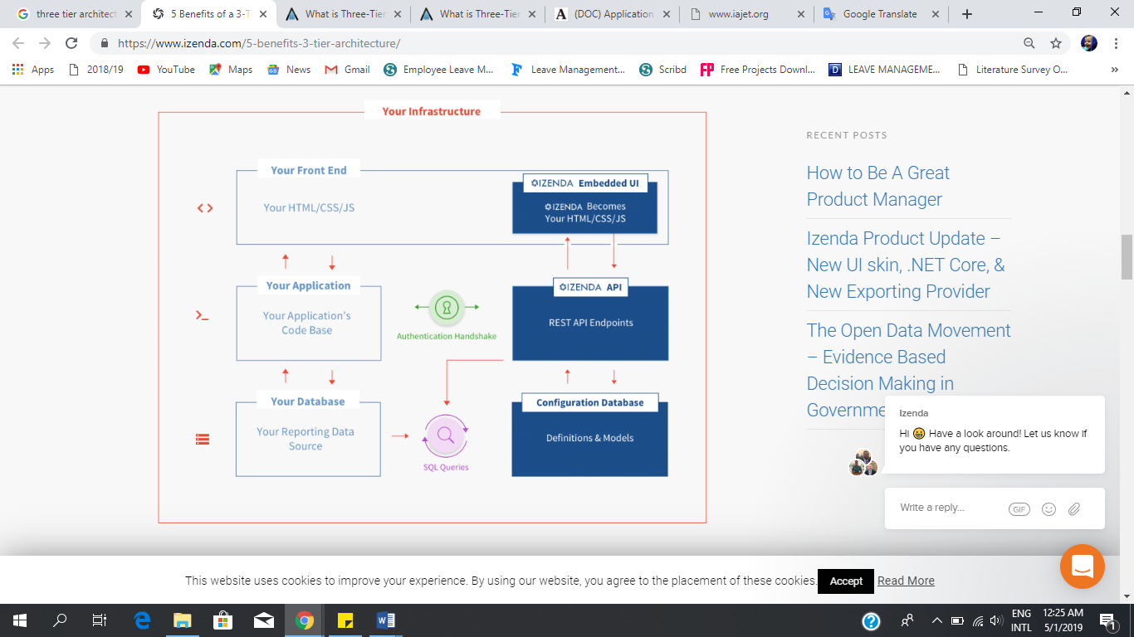

UI

API

*Here are 5 benefits of separating an application into tiers:*

1. It gives you the ability to update the technology stack of one tier, without impacting other areas of the application.
2. It allows for different development teams to each work on their own areas of expertise. Today’s developers are more likely to have deep competency in one area, like coding the front end of an application, instead of working on the full stack.
3. You are able to scale the application up and out. A separate back-end tier, for example, allows you to deploy to a variety of databases instead of being locked into one particular technology. It also allows you to scale up by adding multiple web servers.
4. It adds reliability and more independence of the underlying servers or services.
5. It provides an ease of maintenance of the code base, managing presentation code and business logic separately, so that a change to business logic, for example, does not impact the presentation layer.

With 3-tier architecture, you have the ability to utilize new technologies as they become available. This ensures your product is ready to adapt; ready for the future. You have the opportunity to redesign your product or application and actually look not only to today’s needs but into the future. Stay ahead of the game and maintain a competitive advantage.

We designed our platform around a 3-tier architecture with the future in mind.

# 5.Design

## Sample work flow

Use case: An employee request casual leave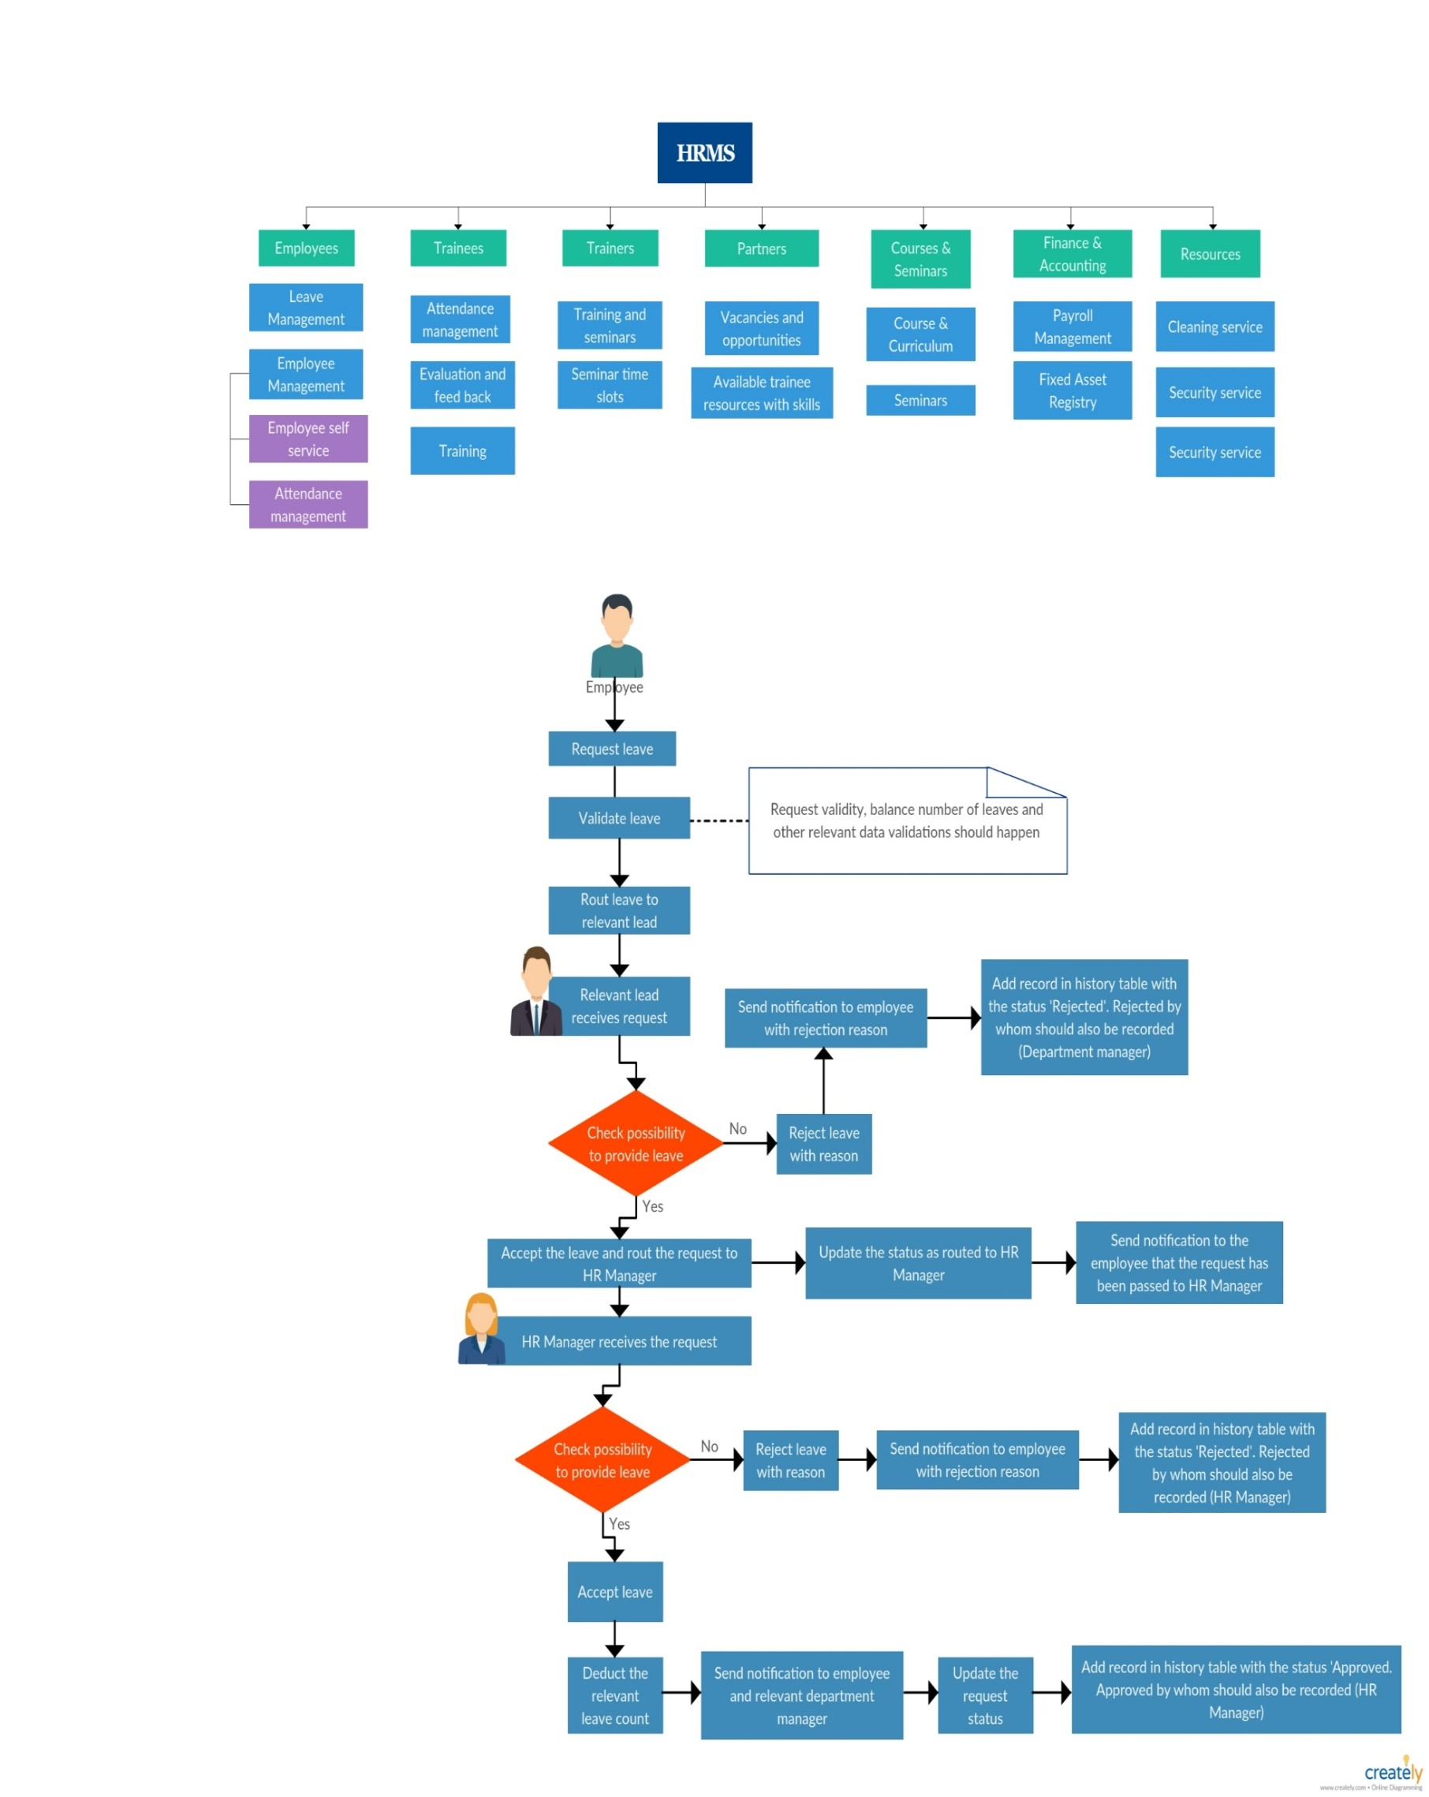

## High Level diagram

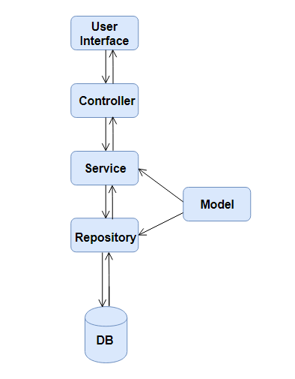

## Use case diagram

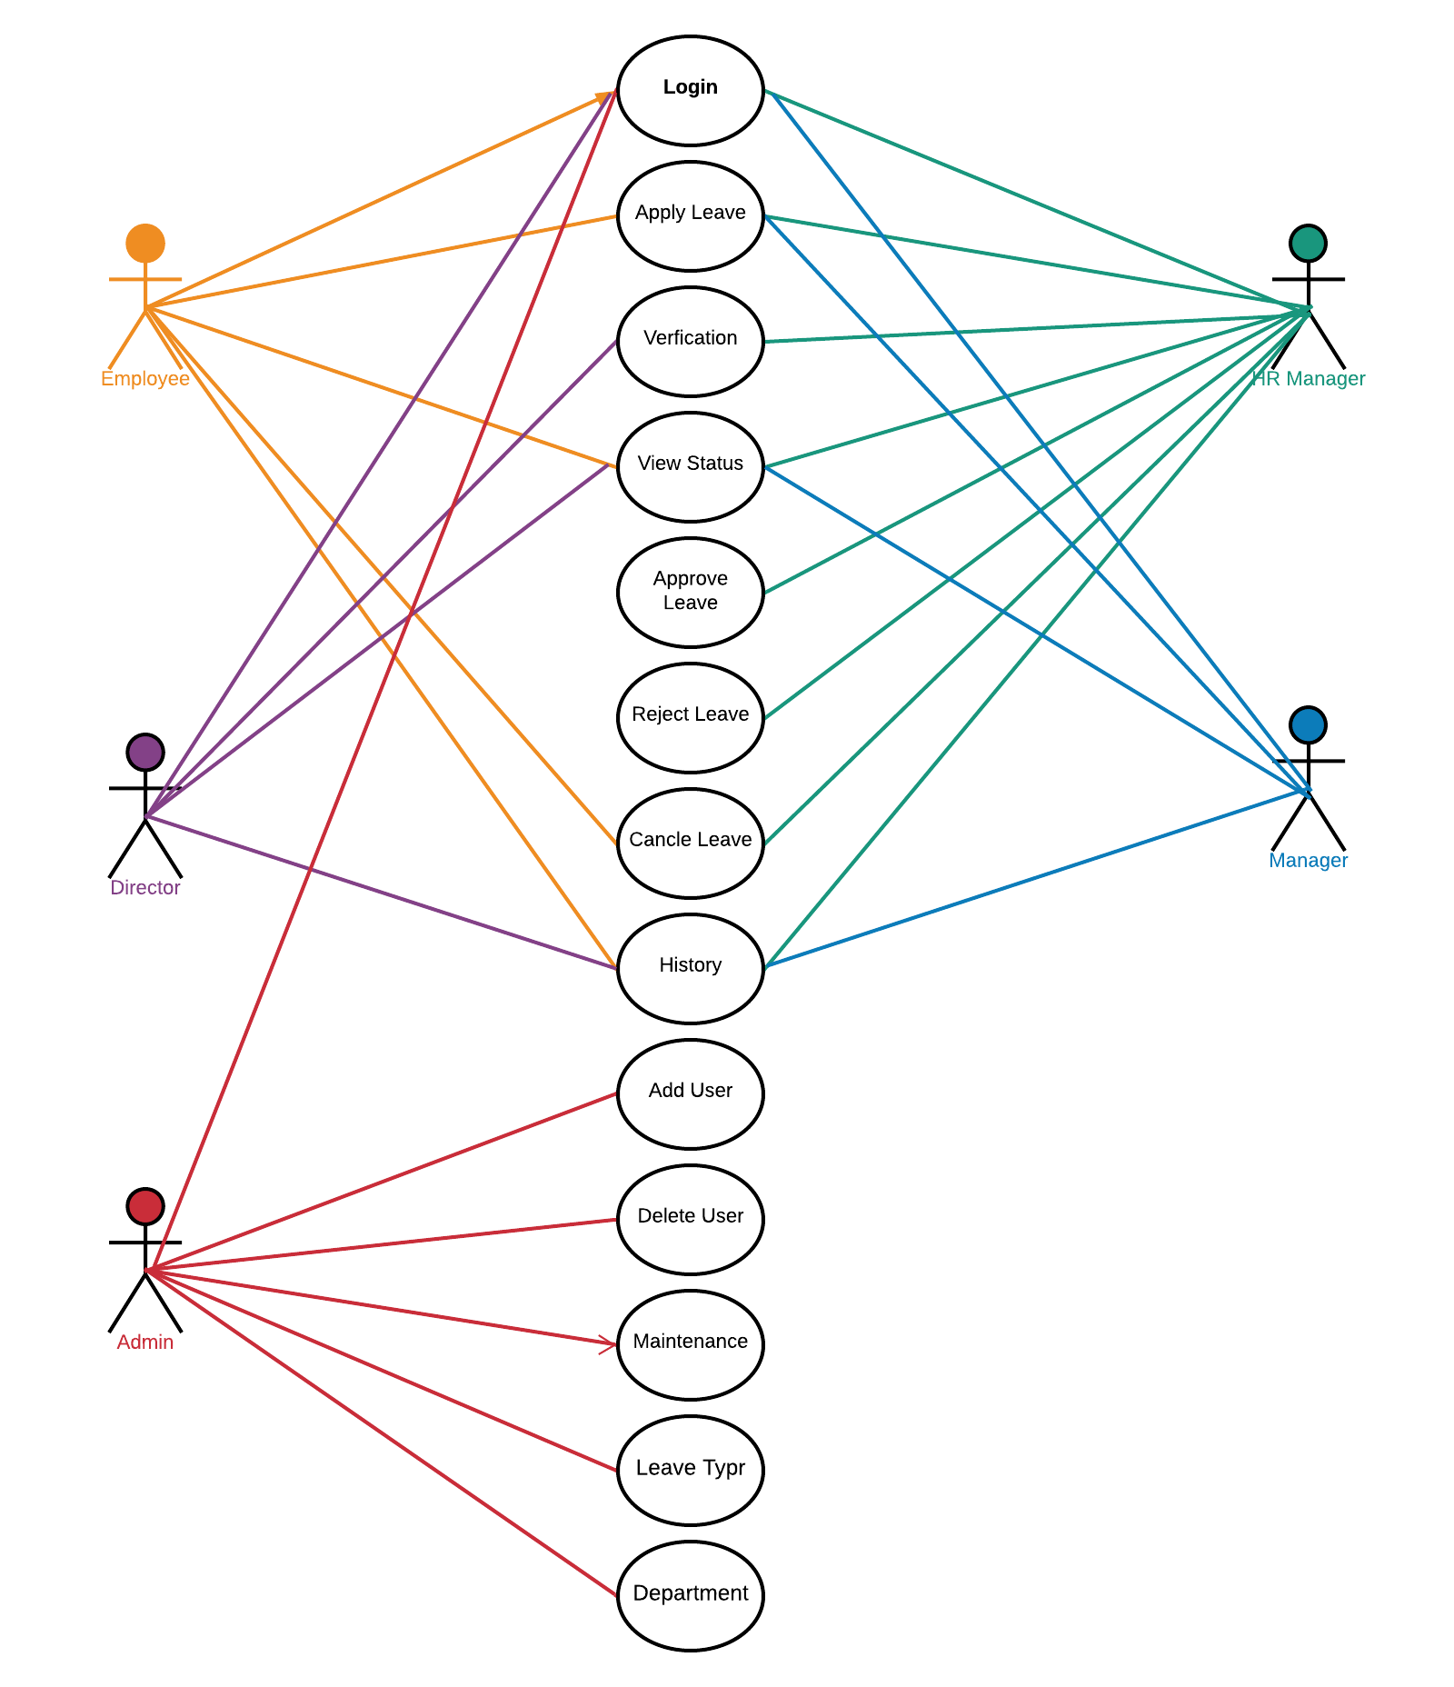

## Class diagram

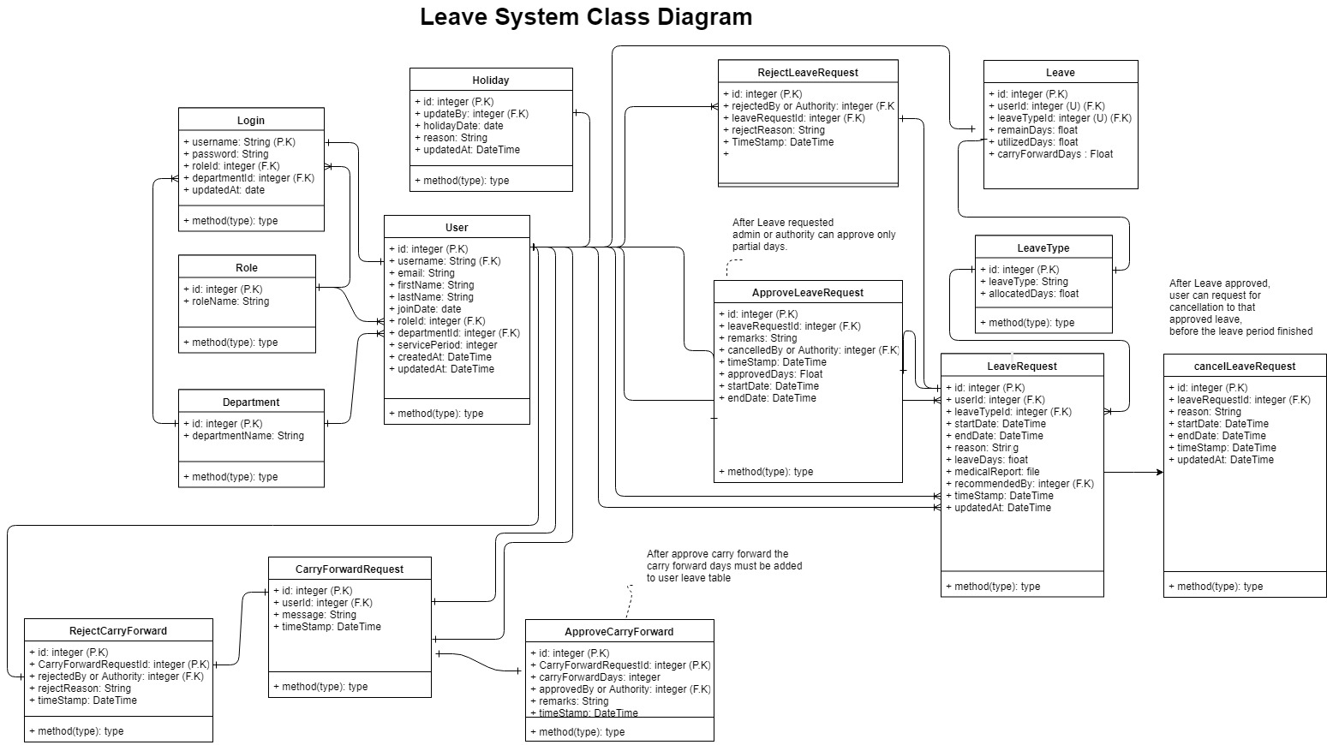

## Database Design

### Tables

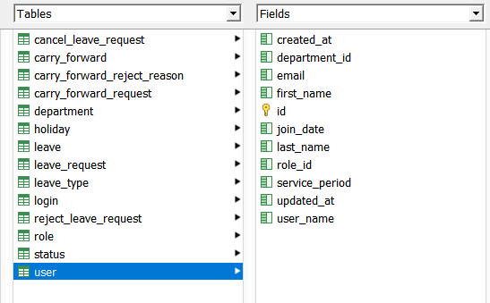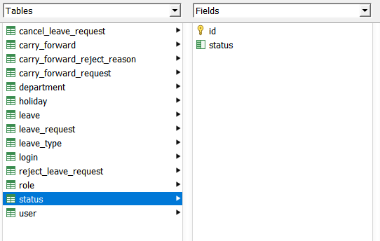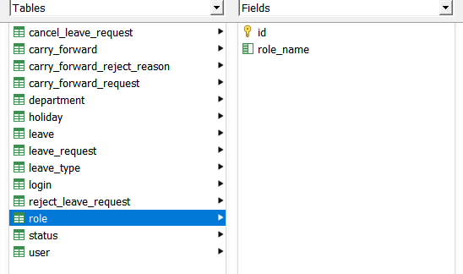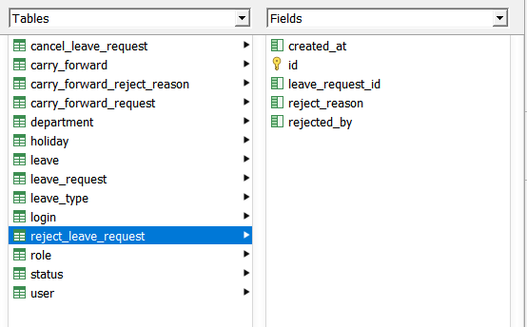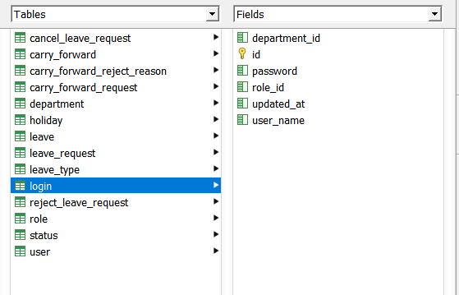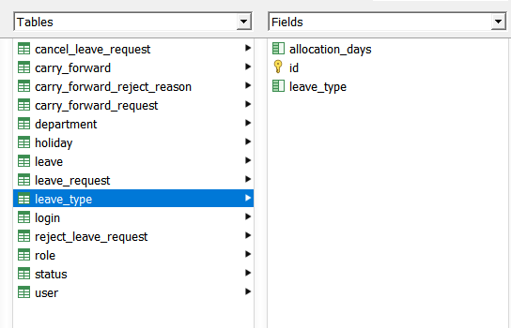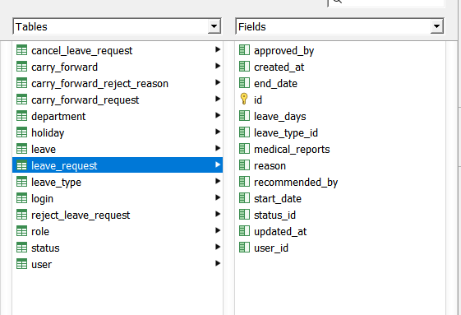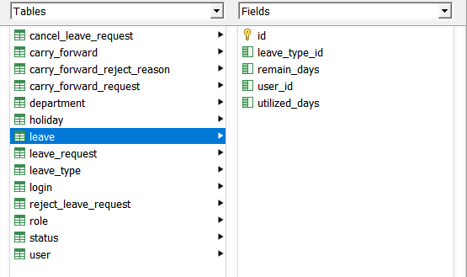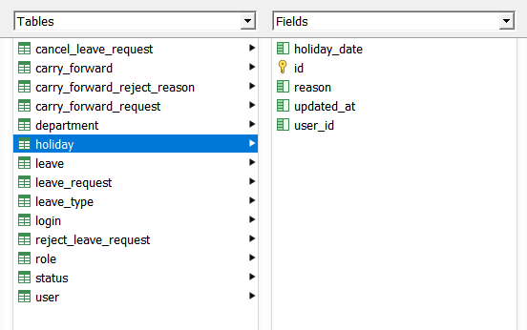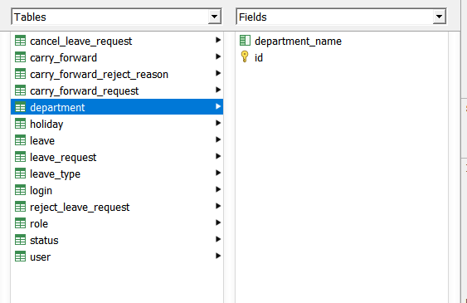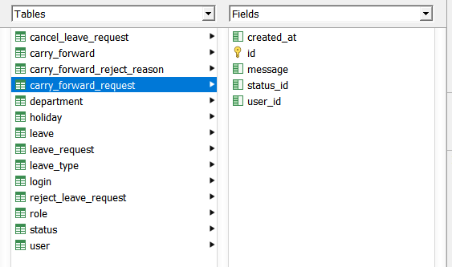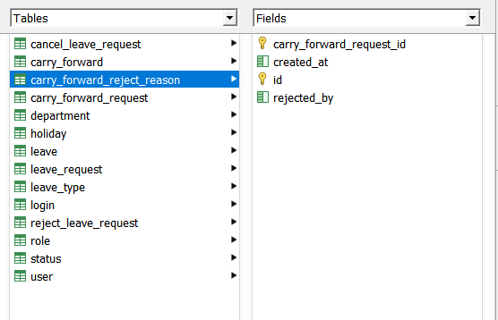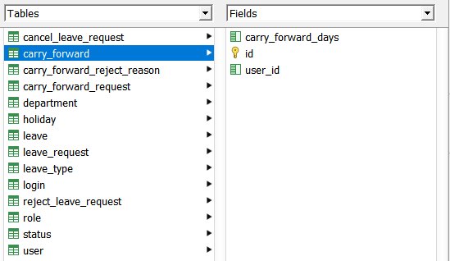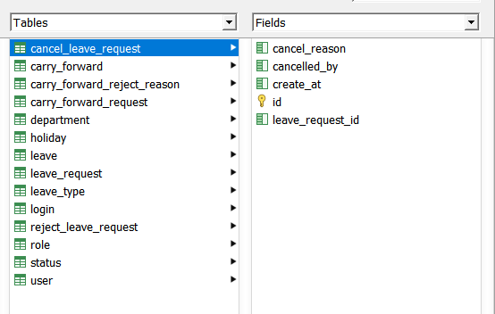

# 6.User Interfaces

Login

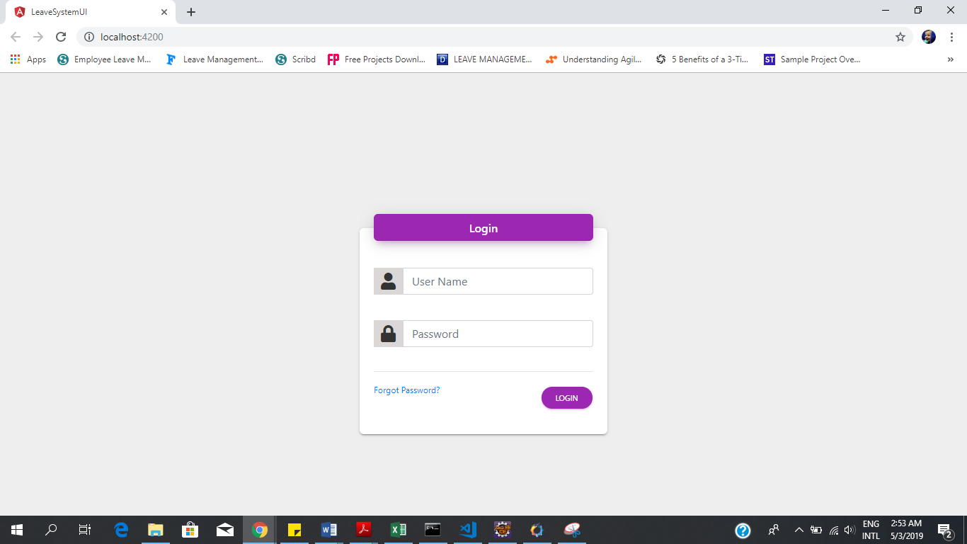

**Admin/ HR Dashboard**

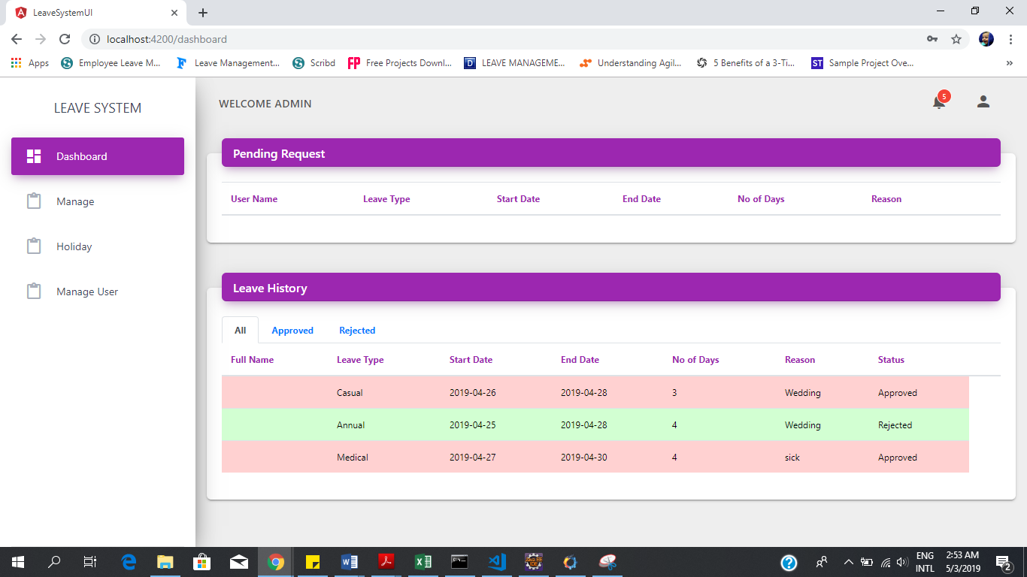

**Admin /HR Manage**

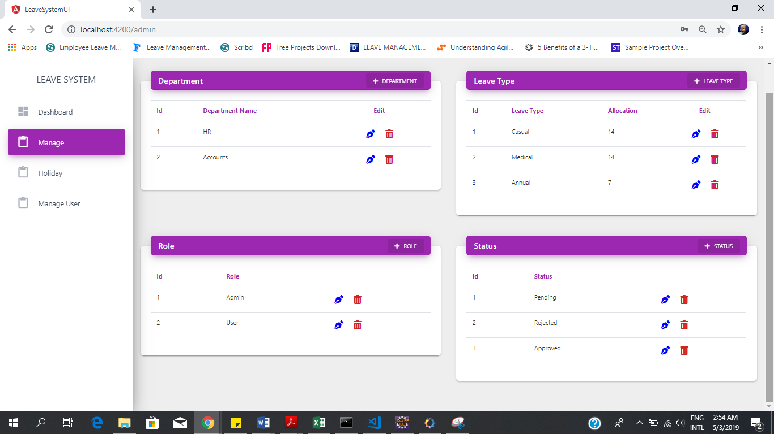

**Admin/HR Manage User**

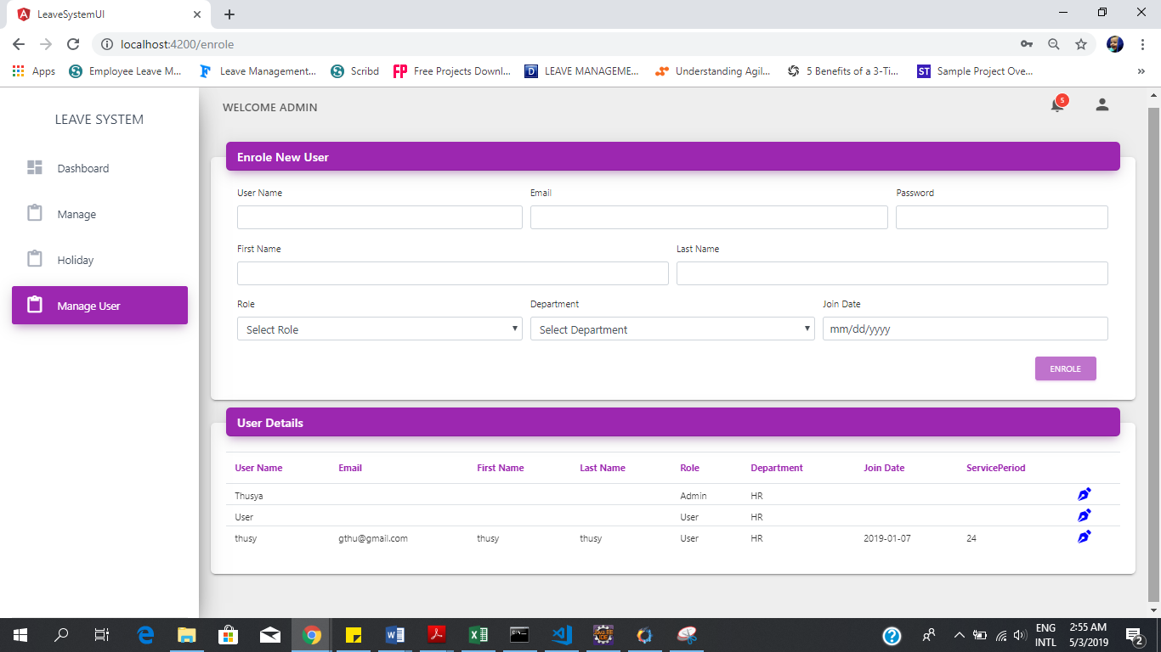

Logout

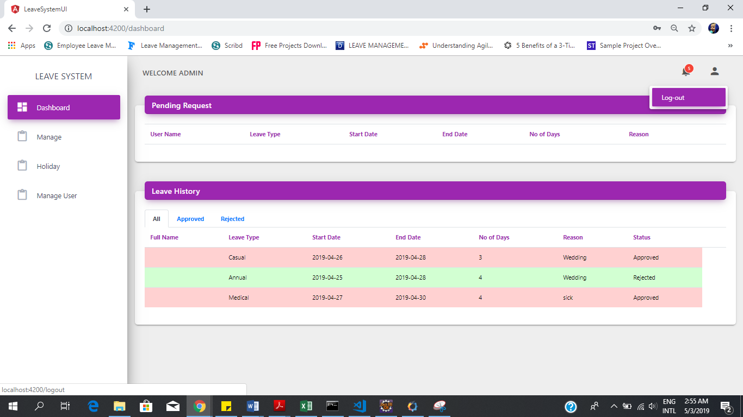

Employee Dashboard

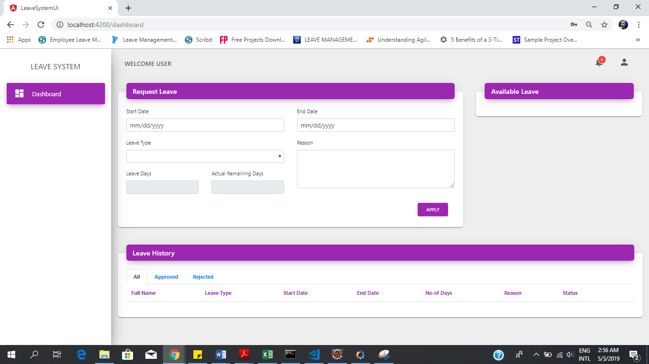

# 7.Testing

Software testing is defined as an activity that checks whether the actual results match the expected results and ensures that the software system is flawless. It involves executing software components or system components to evaluate one or more attributes of interest.

Software testing also helps identify errors, gaps, or lack of requirements that are contrary to actual requirements. It can be done manually or with automated tools. Some people prefer to call software testing white and black box testing. Black box testing is the [Software testing method](https://www.softwaretestingclass.com/what-is-software-testing/) which is used to test the software without knowing the internal structure of code or program. White box testing is the software testing method in which internal structure is being known to tester who is going to test the software.

Manual testing is done by clicking on the application or interacting with the software and API using the appropriate tools. This is very expensive because it requires someone to set up the environment and perform the tests themselves, and it can be prone to human error.

Automated testing, on the other hand, is performed by a machine that executes pre-written test scripts. The complexity of these tests can vary widely, from examining a single method in a class to ensuring that performing a complex set of operations in the UI results in the same result. It's more powerful and reliable than automated testing - but the quality of automated testing depends on how well your test scripts are written.

## Testing Life Cycle

## Testing Type

### Unit Test

Unit tests are very low level, close to the source of your application. They consist in testing individual methods and functions of the classes, components or modules used by your software. Unit tests are in general quite cheap to automate and can be run very quickly by a continuous integration server.

### Integration tests

Integration tests verify that different modules or services used by your application work well together. For example, it can be testing the interaction with the database or making sure that microservices work together as expected. These types of tests are more expensive to run as they require multiple parts of the application to be up and running.

### Acceptance testing

Acceptance tests are formal tests executed to verify if a system satisfies its business requirements. They require the entire application to be up and running and focus on replicating user behaviors. But they can also go further and measure the performance of the system and reject changes if certain goals are not met.

### Performance testing

Performance tests check the behaviors of the system when it is under significant load. These tests are non-functional and can have the various form to understand the reliability, stability, and availability of the platform. For instance, it can be observing response times when executing a high number of requests, or seeing how the system behaves with a significant of data. Performance tests are by their nature quite costly to implement and run, but they can help you understand if new changes are going to degrade your system.

### Smoke testing

Smoke tests are basic tests that check basic or main functionality of the application. They are meant to be quick to execute, and their goal is to give you the assurance that the major features of your system are working as expected. Smoke tests can be useful right after a new build is made to decide whether or not you can run more expensive tests, or right after a deployment to make sure that they application is running properly in the newly deployed environment.

### Regression testing

Regression Testing is defined as a type of software testing to confirm that a recent program or code change has not adversely affected existing features. Here we are use Automation testing.

## Manual Test Vs Automation Test

|  |  |  |
| --- | --- | --- |
|  | Manual Testing | Automation Testing |
| Pros | * Any one can test * Easiest way to improve quality * Great for people who may not have formal testing experience * Focused on the customer’s work flow primarily | * Faster test cycle * Able to identify more defects in shorter time frame * Saves companies money after the third time the test cases are run * Is an excellent way to meet the testing needs of agile development * Easy to focus on all possible work flows * Higher product quality over manually testing |
| Cons | * May not identify all test cases * May not identify all defects * Lower of higher defect count | * Test script typically written by automation testing scripter * Requires manual test cases to be written first that are then automated * Requires automation testing platform * Not cost effective for less than 3 test cycles |

## Why Automation Test?

Test Automation increases the overall software efficiency and ensures robust software quality. There are specific tools that can effectively execute Automated Test Cases, and help in comparing actual and expected results. In this manner, Automated Testing can guarantee software proficiency without involving repeated and Manual intervention.

One of the biggest business perks of [Automated Testing](https://www.youtube.com/playlist?list=PLyGqUe6Oa_5GYxp4FExLCH0y67x0ogpBC) is that it can be implemented time and again, with minimal effort and maximum accuracy.

## Test plan and Testcase

|  |  |  |  |  |  |
| --- | --- | --- | --- | --- | --- |
| Sub Module | Discription | Steps of Recreate | Expect output | Actual output | Pass/Fail |
| User login | 1.Enter The varified Username &password | 1.enter correct user name  2.enter correct password 3.click enter | redirect to the perticular page |  | Pass |
|  | 2.Enter The Wrong Username And Correct Password | 1.enter wrong username 2.enter correct password 3.click enter | show wrong user name or password error message |  | Pass |
|  | 3.Enter Correct Username And wrong Password | 1.enter correct username 2.enter wrong password 3.click enter | show wrong user name or password error message |  | Pass |
|  | 4.Double click on login button | 1.enter correct username and password 2.double click on login button | should be loged in |  | Pass |
|  | 5.Redirect to Specified page after login | 1.enter correct user credential  2.click login button/enter | redirect to the correct page |  | Pass |
|  | 6.Verify that the timeout of the login session | login with correct user credential | session work correctly |  | Pass |
|  | 7.Verify that the logout link is redirected to login/home page | 1.login with correct credentiial 2.click logut | should be direct to the login page |  | Pass |
|  | 8.verify that remember me and Forget password are there | 1.enter correct credential to login 2.click remember me 3.click login | should be remember password |  | Pass |
|  | 9.Verify that Enter/Tab key works as a substitute for the Sign in button | 1.enter correct user credential to login 2.click enter instead of click login button | should be loged in and redirect to the specified page |  | Pass |
|  | 10.Verify that all the fields such as Username, Password  has a valid placeholder | see the user name password fields in  registration forms | show suitable placeholders |  | Pass |
|  | 11.Click login button with blank space in username and  password | click login button without type anything | should not login |  | Pass |
|  | 12.limits of unsuccessfull login attempts | 1.enter wrong login credential 2.click login button 3.do it again and again | the should be given a worning to try login  afte few minutes |  | Pass |
|  | 13.Verify that User should be able to login with the new  password after changing the password | 1.click forget password 2.reset the password 3.try to login with new password | should be able to login with the new password |  | Pass |
|  | 14.Verify that User should not be able to login with the old password  after changing the password | 1.click forget password 2.reset the password 3.try to login with old password | should not login with old password |  | Pass |
|  | 15. Check with special charcter input | 1.use special charector when register  2.try to login with that special charector | should be able to login |  | Pass |

|  |  |  |  |  |  |  |  |  |
| --- | --- | --- | --- | --- | --- | --- | --- | --- |
| Sub Module | | | | Discription | Steps | Expect out put | Actual out put | Pass/Fail |
| Leave Management | Apply Leave | send leave request | As employee | select start date use drop button | 01.log in the employee dashboard 02.go to leave management  03.go to request leave 04.select start date 05.select the drop button | appear the calendar | appear the calendar | Pass |
| Leave Management | Apply Leave | send leave request | As employee | pass days in available to select drop button | 01.log in the employee dashboard 02.go to leave management  03.go to request leave 04.select start date 05.select drop button | pass days in available | pass days inavailable | Pass |
| Leave Management | Apply Leave | send leave request | As employee | select start date use dropdown button for date | 01.log in the employee dashboard 02.go to leave management  03.go to request leave 04.select start date 05.select the dropdown button 06.click the date | increase the date | show the wanted date | Pass |
| Leave Management | Apply Leave | send leave request | As employee | select start date in month use dropdown button | 01.log in the employee dashboard 02.go to leave management  03.go to request leave 04.select start date 05.select the dropdown button 06.select the month | increase the month | show the wanted month | Pass |
| Leave Management | Apply Leave | send leave request | As employee | pass month inavailableto select use the dropdown button | 01.log in the employee dashboard 02.go to leave management  03.go to request leave 04.select start date 05.select the dropdown button 06.select the month | pass month inavailable | pass month avalible | Pass |
| Leave Management | Apply Leave | send leave request | As employee | select start date use year dropdown button | 01.log in the employee dashboard 02.go to leave management  03.go to request leave 04.select start date 05.select the dropdown button | increase the month | show the wanted month | Pass |
| Leave Management | Apply Leave | send leave request | As employee | select start date use dropdown button not increase Example:in february should not increase 30 | 01.log in the employee dashboard 02.go to leave management  03.go to request leave 04.select start date 05.select the dropdown button 06.select the date | not increase the date | show the wanted date | Pass |
| Leave Management | Apply Leave | send leave request | As employee | select start date use dropdown button inavailableto select passing date | 01.log in the employee dashboard 02.go to leave management  03.go to request leave 04.select start date 05.select the dropdown button 06.select the date | only available day | show the wanted date | Pass |
| Leave Management | Apply Leave | send leave request | As employee | select start date inyear use dropdown button inavailablefor passing year | 01.log in the employee dashboard 02.go to leave management  03.go to request leave 04.select start date 05.select the dropdown button 06.select the year | pass year in available | pass days available | Pass |
| Leave Management | Apply Leave | send leave request | As employee | select start date use dropdown button | 01.log in the employee dashboard 02.go to leave management  03.go to request leave 04.select start date 05.select dropdown button | decrease the date | show the wanted date | Pass |
| Leave Management | Apply Leave | send leave request | As employee | select start date use close button | 01.log in the employee dashboard 02.go to leave management  03.go to request leave 04.select start date 05.click the close button | cancel the date | cancel the date | Pass |
| Leave Management | Apply Leave | send leave request | As employee | select end date use drop button | 01.log in the employee dashboard 02.go to leave management  03.go to request leave 04.select end date 05.select the drop button | appear the calendar | appear the calendar | Pass |
| Leave Management | Apply Leave | send leave request | As employee | pass days inavailableto select drop button | 01.log in the employee dashboard 02.go to leave management  03.go to request leave 04.select end date 05.select the drop button | pass days inavailable | pass days inavailable | Pass |
| Leave Management | Apply Leave | send leave request | As employee | select end date use dropdown button for date | 01.log in the employee dashboard 02.go to leave management  03.go to request leave 04.select end date 05.select the dropdown button 06.click the date | increase the date | show the wanted date | Pass |
| Leave Management | Apply Leave | send leave request | As employee | select end date in month use dropdown button | 01.log in the employee dashboard 02.go to leave management  03.go to request leave 04.select enddate 05.select the dropdown button 06.click the month | increase the month | show the wanted month | Pass |
| Leave Management | Apply Leave | send leave request | As employee | pass month inavailableto select use the dropdown button | 01.log in the employee dashboard 02.go to leave management  03.go to request leave 04.select start date 05.select the dropdown button 06.select the month | pass month inavailable | pass month avalible | Pass |
| Leave Management | Apply Leave | send leave request | As employee | select end date use year dropdown button | 01.log in the employee dashboard 02.go to leave management  03.go to request leave 04.select end date 05.select the dropdown button 06.click the year | increase the year | show the wanted year | Pass |
| Leave Management | Apply Leave | send leave request | As employee | select end date use dropdown button not increase Example:in february should not increase 30 | 01.log in the employee dashboard 02.go to leave management  03.go to request leave 04.select end date 05.select the dropdown button 06.click the date | not increase the date | show the wanted date | Fail |
| Leave Management | Apply Leave | send leave request | As employee | select end date use dropdown button inavailableto select passing date | 01.log in the employee dashboard 02.go to leave management  03.go to request leave 04.select end date 05.select the dropdown button 06.click the date | only availableday | show the wanted date | Pass |
| Leave Management | Apply Leave | send leave request | As employee | select end date inyear use dropdown button inavailablefor passing year | 01.log in the employee dashboard 02.go to leave management  03.go to request leave 04.select end date 05.select the dropdown button 06.select the year | pass year inavailable | pass days avalible | Pass |
| Leave Management | Apply Leave | send leave request | As employee | select end date use dropdown button | 01.log in the employee dashboard 02.go to leave management  03.go to request leave 04.select end date 05.select dropdown button 06.click the date | decrease the date | show the wanted date | Pass |
| Leave Management | Apply Leave | send leave request | As employee | select end date use close button | 01.log in the employee dashboard 02.go to leave management  03.go to request leave 04.select end date 05.click the close button | cancel the date | cancel the date | Pass |
| Leave Management | Apply Leave | send leave request | As employee | Select leave type | 01.log in the employee dashboard 02.go to leave management  03.go to request leave 04.select the type of leave | all leave type should be appear | all leave type shouldnot be appear | Pass |
| Leave Management | Apply Leave | send leave request | As employee | Calculate leave days auto | 01.log in the employee dashboard 02.go to leave management  03.go to request leave 04.select start date 05.select end date | actual days appear | actual days appear | Pass |
| Leave Management | Apply Leave | send leave request | As employee | Calculate leave days auto with out holiday | 01.log in the employee dashboard 02.go to leave management  03.go to request leave 04.select start date 05.select end date | calculate the leave day with out holiday | calculate the leave day with holiday | Fail |
| Leave Management | Apply Leave | send leave request | As employee | calculate leave days should be same date is calculate in one day | 01.log in the employee dashboard 02.go to leave management  03.go to request leave 04.select start date 05.select end date | actual days appear | actual days appear | Pass |
| Leave Management | Apply Leave | send leave request | As employee | Write leave reason | 01.login the employees  02.go to the leave management  03.go to request leave 04.enter the reason | limited text avaliable | not avaliable | Pass |
| Leave Management | Apply Leave | send leave request | As employee | reason should be in correct reason | 01.login the employees  02.go to the leave management  03.go to request leave 04.enter the reason | correct reason | not avaliable | Pass |
| Leave Management | Apply Leave | send leave request | As employee | browse the attachment | 01.login the employees 02. go to the leave management  03.go to request leave 04. click the attachment | it will show current location for the attachment letter | it will show current location for the attachment letter | Pass |
| Leave Management | Apply Leave | send leave request | As employee | click the request button | 01.login the employees 02. go to the leave management  03.go to request leave 04. click request button | sent the request leave for hr | not available | Pass |
| Leave Management | Apply Leave | send leave request | As employee | click the minmize button | 01.login the employees  02.go to the leave management  03.go to request leave 04.click the minimize button | minimize the request leave form | minimize the request leave form | Pass |
| Leave Management | Apply Leave | send leave request | As employee | click the minmize button again click the minimize button | 01.login the employees  02.go to the leave management  03.go to request leave 04.click the minimize button 05.click the minimize button | availablethe request leave form | available the request leave form | Pass |
| Leave Management | Apply Leave | send leave request | As employee | click the close button | 01.login the employees  02.go to the leave management  03.go to request leave 04.click the close button | close the request the leave form | close the request the leave form | Pass |
| Leave Management | Apply Leave | send leave request | As employee | click the close button again open the form | 01.login the employees  02.go to the leave management  03.go to request leave 04.click the close button 05.click the reuest leave | appear the request form | not appear | Pass |
| Leave Management | Apply Leave | send leave request | As employee | browse the attachment file name is appear | 01.login the employees 02. go to the leave management  03.go to request leave 04. click the attachment | appear the attachment file name | appear the attachment file name | Pass |
| Leave Management | Apply Leave | send leave request | As employee | cilck the clear button |  |  |  |  |
| Leave Management | Apply Leave | send leave request | As employee | current location only appear | 01.login the employees 02. go to the leave management  03.go to request leave | appear the request leave | appear the request leave and leave histroy | Pass |
| Leave Management | Apply Leave | send leave request | As employee | click the list button | 01.login the employees 02. go to the leave management  03.go to request leave 04.cilck the list button | reduce the side bar size | reduce the side bar size | Pass |
| Leave Management | Apply Leave | send leave request | As employee | doubleclick the list button | 01.login the employees 02. go to the leave management  03.go to request leave 04.doubleclick the list button | normal size appear | normal size appear | Pass |
| Leave Management | Apply Leave | send leave request | As employee | select start date enter the date | 01.log in the employee dashboard 02.go to leave management  03.go to request leave 04.select start date 05.select the dropdown button 06.click the date | not allow to enter the date | not allow to enter the date | Pass |
| Leave Management | Apply Leave | send leave request | As employee | select start date enter the month | 01.log in the employee dashboard 02.go to leave management  03.go to request leave 04.select start date 05.select the dropdown button 06.click the month | not allow to enter the month | not allow to enter the month | Pass |
| Leave Management | Apply Leave | send leave request | As employee | select start date enter the year | 01.log in the employee dashboard 02.go to leave management  03.go to request leave 04.select start date 05.select the dropdown button 06.click the year | not allow to enter the year | not allow to enter the year | Pass |
| Leave Management | Apply Leave | send leave request | As employee | select end date enter the date | 01.log in the employee dashboard 02.go to leave management  03.go to request leave 04.select end date 05.select the dropdown button 06.click the date | not allow to enter the date | not allow to enter the date | Pass |
| Leave Management | Apply Leave | send leave request | As employee | select end date enter the month | 01.log in the employee dashboard 02.go to leave management  03.go to request leave 04.select end date 05.select the dropdown button 06.click the month | not allow to enter the month | not allow to enter the month | Pass |
| Leave Management | Apply Leave | send leave request | As employee | select end date enter the year | 01.log in the employee dashboard 02.go to leave management  03.go to request leave 04.select end date 05.select the dropdown button 06.click the year | not allow to enter the year | not allow to enter the year | Pass |
| Leave Management | Apply Leave | send leave request | As HR | select start date use drop button | 01.log in the hr dashboard 02.go to leave management  03.go to request leave 04.select start date 05.select the drop button | appear the calendar | appear the calendar | Pass |
| Leave Management | Apply Leave | send leave request | As HR | pass days inavailableto select drop button | 01.log in the hr dashboard 02.go to leave management  03.go to request leave 04.select start date 05.select drop button | pass days inavailable | pass days inavailable | Pass |
| Leave Management | Apply Leave | send leave request | As HR | select start date use dropdown button for date | 01.log in the hr dashboard 02.go to leave management  03.go to request leave 04.select start date 05.select the dropdown button 06.click the date | increase the date | show the wanted date | Pass |
| Leave Management | Apply Leave | send leave request | As HR | select start date in month use dropdown button | 01.log in the hr dashboard 02.go to leave management  03.go to request leave 04.select start date 05.select the dropdown button 06.select the month | increase the month | show the wanted month | Pass |
| Leave Management | Apply Leave | send leave request | As HR | pass month inavailableto select use the dropdown button | 01.log in the hr dashboard 02.go to leave management  03.go to request leave 04.select start date 05.select the dropdown button 06.select the month | pass month inavailable | pass month avalible | Fail |
| Leave Management | Apply Leave | send leave request | As HR | select start date use year dropdown button | 01.log in the employee dashboard 02.go to leave management  03.go to request leave 04.select start date 05.select the dropdown button | increase the month | show the wanted month | Pass |
| Leave Management | Apply Leave | send leave request | As HR | select start date use dropdown button not increase Example:in february should not increase 30 | 01.log in the hr dashboard 02.go to leave management  03.go to request leave 04.select start date 05.select the dropdown button 06.select the date | not increase the date | show the wanted date | Fail |
| Leave Management | Apply Leave | send leave request | As HR | select start date use dropdown button inavailableto select passing date | 01.log in the hr dashboard 02.go to leave management  03.go to request leave 04.select start date 05.select the dropdown button 06.select the date | only availableday | show the wanted date | Fail |
| Leave Management | Apply Leave | send leave request | As HR | select start date inyear use dropdown button inavailablefor passing year | 01.log in the hr dashboard 02.go to leave management  03.go to request leave 04.select start date 05.select the dropdown button 06.select the year | pass year inavailable | pass days avalible | Fail |
| Leave Management | Apply Leave | send leave request | As HR | select start date use dropdown button | 01.log in the hr dashboard 02.go to leave management  03.go to request leave 04.select start date 05.select dropdown button | decrease the date | show the wanted date | Pass |
| Leave Management | Apply Leave | send leave request | As HR | select start date use close button | 01.log in the hr dashboard 02.go to leave management  03.go to request leave 04.select start date 05.click the close button | cancel the date | cancel the date | Pass |
| Leave Management | Apply Leave | send leave request | As HR | select end date use drop button | 01.log in the hr dashboard 02.go to leave management  03.go to request leave 04.select end date 05.select the drop button | appear the calendar | appear the calendar | Pass |
| Leave Management | Apply Leave | send leave request | As HR | pass days inavailableto select drop button | 01.log in the hr dashboard 02.go to leave management  03.go to request leave 04.select end date 05.select the drop button | pass days inavailable | pass days inavailable | Pass |
| Leave Management | Apply Leave | send leave request | As HR | select end date use dropdown button for date | 01.log in the hr dashboard 02.go to leave management  03.go to request leave 04.select end date 05.select the dropdown button 06.click the date | increase the date | show the wanted date | Pass |
| Leave Management | Apply Leave | send leave request | As HR | select end date in month use dropdown button | 01.log in the hr dashboard 02.go to leave management  03.go to request leave 04.select enddate 05.select the dropdown button 06.click the month | increase the month | show the wanted month | Pass |
| Leave Management | Apply Leave | send leave request | As HR | pass month inavailableto select use the dropdown button | 01.log in the hr dashboard 02.go to leave management  03.go to request leave 04.select start date 05.select the dropdown button 06.select the month | pass month inavailable | pass month avalible | Fail |
| Leave Management | Apply Leave | send leave request | As HR | select end date use year dropdown button | 01.log in the hr dashboard 02.go to leave management  03.go to request leave 04.select end date 05.select the dropdown button 06.click the year | increase the year | show the wanted year | Pass |
| Leave Management | Apply Leave | send leave request | As HR | select end date use dropdown button not increase Example:in february should not increase 30 | 01.log in the hr dashboard 02.go to leave management  03.go to request leave 04.select end date 05.select the dropdown button 06.click the date | not increase the date | show the wanted date | Fail |
| Leave Management | Apply Leave | send leave request | As HR | select end date use dropdown button inavailableto select passing date | 01.log in the hr dashboard 02.go to leave management  03.go to request leave 04.select end date 05.select the dropdown button 06.click the date | only availableday | show the wanted date | Fail |
| Leave Management | Apply Leave | send leave request | As HR | select end date year use dropdown button inavailablefor passing year | 01.log in the hr dashboard 02.go to leave management  03.go to request leave 04.select end date 05.select the dropdown button 06.select the year | pass year inavailable | pass days avalible | Fail |
| Leave Management | Apply Leave | send leave request | As HR | select end date use dropdown button | 01.log in the hr dashboard 02.go to leave management  03.go to request leave 04.select end date 05.select dropdown button 06.click the date | decrease the date | show the wanted date | Pass |
| Leave Management | Apply Leave | send leave request | As HR | select end date use close button | 01.log in the hr dashboard 02.go to leave management  03.go to request leave 04.select end date 05.click the close button | cancel the date | cancel the date | Pass |
| Leave Management | Apply Leave | send leave request | As HR | Select leave type | 01.log in the hr dashboard 02.go to leave management  03.go to request leave 04.select the type of leave | all leave type should be appear | all leave type shouldnot be appear | Pass |
| Leave Management | Apply Leave | send leave request | As HR | Calculate leave days auto | 01.log in the hr dashboard 02.go to leave management  03.go to request leave 04.select start date 05.select end date | actual days appear | actual days appear | Pass |
| Leave Management | Apply Leave | send leave request | As HR | Calculate leave days auto with out holiday | 01.log in the hr dashboard 02.go to leave management  03.go to request leave 04.select start date 05.select end date | calculate the leave day with out holiday | calculate the leave day with holiday | Fail |
| Leave Management | Apply Leave | send leave request | As HR | calculate leave days should be same date is calculate in one day | 01.log in the hr dashboard 02.go to leave management  03.go to request leave 04.select start date 05.select end date | actual days appear | actual days appear | Pass |
| Leave Management | Apply Leave | send leave request | As HR | Write leave reason | 01.log in the hr dashboard 02.go to the leave management  03.go to request leave 04.enter the reason | limited text avaliable | not avaliable | Fail |
| Leave Management | Apply Leave | send leave request | As HR | reason should be in correct reason | 01.log in the hr dashboard 02.go to the leave management  03.go to request leave 04.enter the reason | correct reason | not avaliable | Fail |
| Leave Management | Apply Leave | send leave request | As HR | browse the attachment | 01.log in the hr dashboard 02. go to the leave management  03.go to request leave 04. click the attachment | it will show current location for the attachment letter | it will show current location for the attachment letter | Pass |
| Leave Management | Apply Leave | send leave request | As HR | click the request button | 01.log in the hr dashboard 02. go to the leave management  03.go to request leave 04. click request button | sent the request leave for hr | sent the request leave for hr | Pass |
| Leave Management | Apply Leave | send leave request | As HR | click the minmize button | 01.log in the hr dashboard 02.go to the leave management  03.go to request leave 04.click the minimize button | minimize the request leave form | minimize the request leave form | Pass |
| Leave Management | Apply Leave | send leave request | As HR | click the minmize button again click the minimize button | 01.log in the hr dashboard 02.go to the leave management  03.go to request leave 04.click the minimize button 05.click the minimize button | availablethe request leave form | availablethe request leave form | Pass |
| Leave Management | Apply Leave | send leave request | As HR | click the close button | 01.log in the hr dashboard 02.go to the leave management  03.go to request leave 04.click the close button | close the request the leave form | close the request the leave form | Pass |
| Leave Management | Apply Leave | send leave request | As HR | click the close button again open the form | 01.log in the hr dashboard 02.go to the leave management  03.go to request leave 04.click the close button 05.click the reuest leave | appear the request form | not appear | Fail |
| Leave Management | Apply Leave | send leave request | As HR | browse the attachment file name is appear | 01.log in the hr dashboard 02. go to the leave management  03.go to request leave 04. click the attachment | appear the attachment file name | appear the attachment file name | Pass |
| Leave Management | Apply Leave | send leave request | As HR | click the clear button | 01.log in the hr dashboard 02. go to the leave management  03.go to request leave 04.click the clear button | clear the all data in request leave form | clear the all data in request leave form | Pass |
| Leave Management | Apply Leave | send leave request | As HR | current location only appear | 01.log in the hr dashboard 02. go to the leave management  03.go to request leave | appear the request leave | appear the request leave | Pass |
| Leave Management | Apply Leave | send leave request | As HR | click the list button | 01.log in the hr dashboard 02. go to the leave management  03.go to request leave 04.cilck the list button | reduce the side bar size | reduce the side bar size | Pass |
| Leave Management | Apply Leave | send leave request | As HR | doubleclick the list button | 01.log in the hr dashboard 02. go to the leave management  03.go to request leave 04.doubleclick the list button | normal size appear | normal size appear | Pass |
| Leave Management | Apply Leave | send leave request | As HR | select start date enter the date | 01.log in the hr dashboard 02.go to leave management  03.go to request leave 04.select start date 05.select the dropdown button 06.click the date | not allow to enter the date | not allow to enter the date | Pass |
| Leave Management | Apply Leave | send leave request | As HR | select start date enter the month | 01.log in the hr dashboard 02.go to leave management  03.go to request leave 04.select start date 05.select the dropdown button 06.click the month | not allow to enter the month | not allow to enter the month | Pass |
| Leave Management | Apply Leave | send leave request | As HR | select start date enter the year | 01.log in the hr dashboard 02.go to leave management  03.go to request leave 04.select start date 05.select the dropdown button 06.click the year | not allow to enter the year | not allow to enter the year | Pass |
| Leave Management | Apply Leave | send leave request | As HR | select end date enter the date | 01.log in the hr dashboard 02.go to leave management  03.go to request leave 04.select end date 05.select the dropdown button 06.click the date | not allow to enter the date | not allow to enter the date | Pass |
| Leave Management | Apply Leave | send leave request | As HR | select end date enter the month | 01.log in the hr dashboard 02.go to leave management  03.go to request leave 04.select end date 05.select the dropdown button 06.click the month | not allow to enter the month | not allow to enter the month | Pass |
| Leave Management | Apply Leave | send leave request | As HR | select end date enter the year | 01.log in the hr dashboard 02.go to leave management  03.go to request leave 04.select end date 05.select the dropdown button 06.click the year | not allow to enter the year | not allow to enter the year | Pass |
|  |  |  |  |  |  |  |  |  |
| Leave Management | Approve Leave | leave history | As hr | view employee name | 01.login the HR  02.go to the leave management 03. go to leave history 04.click the accpted | all name are appear | all name are appear | Pass |
|  |  |  |  | view leave type | 01.login the HR  02.go to the leave management 03. go to leave history 04.click the accpted |  |  | Pass |
|  |  |  |  | view start date | 01.login the HR  02.go to the leave management 03. go to leave history 04.click the accpted |  |  | Pass |
|  |  |  |  | view end date | 01.login the HR  02.go to the leave management 03. go to leave history 04.click the accpted |  |  | Pass |
|  |  |  |  | view number of days | 01.login the HR  02.go to the leave management 03. go to leave history 04.click the accpted |  |  | Pass |
|  |  |  |  | view reason | 01.login the HR  02.go to the leave management 03. go to leave history 04.click the accpted |  |  | Pass |
|  |  |  |  | view accepted by | 01.login the HR  02.go to the leave management 03. go to leave history 04.click the accpted |  |  | Pass |
|  |  |  |  | view Items per page | 01.login the HR  02.go to the leave management 03. go to leave history 04.click the accpted 05.click the dropdown button |  |  | Pass |
| Leave Management | Approve Leave |  |  | accept the request | 01.login the HR go to the leave management then go to leave request click accept button | conformation accept request |  | Pass |
| Leave Management | Approve Leave |  |  | Get Notification accept | 01.login the employees go to the leave management then go to the leave request | conformation accept request |  | Pass |
| Leave Management | Approve Leave | reject the leave request |  | reject the request | 01.login the HR go to the leave managemnt then go to then go to leave request click reject button | ask the reject reson |  | Pass |
| Leave Management | Approve Leave |  | Get Notification reject reson | 01.login the employees go to the leave management then go to the leave request | appear in reject reson |  | Pass |
| Leave Management | Approve Leave | remaing days |  | change the remaing days in leaves | 01.login the HR go to the leave management then go to leave request click accept button | decrease remaing days |  | Pass |
| Leave Management | Approve Leave |  |  | 02.login the HR go to the leave management then go to then go to leave request click reject button | no change in remaing days |  | Pass |
| Leave Management | Manage Company Leave | add company leave |  | view calendar | 01.login the admin got to the leave management then go to calendar | appear calendar |  | Pass |
| Leave Management |  | select date | 01.login the admin got to the leave management then go to calendarselect date | event action occurred |  | Pass |
| Leave Management |  | add leave title | 01.login the admin go to the leave management then go to calendarclick the date event action occure add event title | limited text avaliable |  | Pass |
| Leave Management |  | add leave start date | 01.1.login the admin go to the leave management then go to calendarclick the start date and time | calendarappear |  | Pass |
| Leave Management |  | add leave end date | 01.login gthe admin go to the leave management then go to calendarclick the date event action occure add end date and time | calendarappear |  | Pass |
| Leave Management |  | add primary color | 01.set the primary color | appear color |  | Pass |
| Leave Management |  | add secondary color | 01.set the secondary color | appear color |  | Pass |
| Leave Management |  | add leave | 01.login the admin got to the leave management then go to calendarclick date then click the ok | appear the leave date in calendar |  | Pass |
| Leave Management | edit company leave |  | view calendar | 01.login the admin got to the leave management then go to calendar | appear calendar |  | Pass |
| Leave Management |  | select date | 01.login the admin got to the leave management then go to calendarselect date | event action occurred |  | fail |
| Leave Management |  | edit leave title | 01.login the admin go to the leave management then go to calendarclick the date event action occure add event title | limited text avaliable |  | fail |
| Leave Management |  | edit leave start date | 01.1.login the admin go to the leave management then go to calendarclick the start date and time | calendarappear |  | fail |
| Leave Management |  | edit leave end date | 01.login gthe admin go to the leave management then go to calendarclick the date event action occure add end date and time | calendarappear |  | Fail |
| Leave Management |  | edit primary color | 01.set the primary color | appear color |  | Fail |
| Leave Management |  | edit secondary color | 01.set the secondary color | appear color |  | Fail |
| Leave Management |  | edit leave | 01.login the admin got to the leave management then go to calendarclick date then click the ok | appear the leave date in calendar |  | Fail |
| Leave Management | delete company leave |  | view calendar | 01.login the admin got to the leave management then go to calendar | appear calendar |  | Fail |
| Leave Management |  | select date | 01.login the admin got to the leave management then go to calendarselect date | event action occurred |  | Fail |
| Leave Management |  | delete leave title | 01.login the admin go to the leave management then go to calendarclick the date event action occure add event title | empty title appear |  | pass |
| Leave Management |  | delete leave start date | 01.1.login the admin go to the leave management then go to calendarclick the start date and time | calendarappear |  | pass |
| Leave Management |  | delete leave end date | 01.login gthe admin go to the leave management then go to calendarclick the date event action occure add end date and time | calendarappear |  | pass |
| Leave Management |  | delete primary color | 01.set the primary color | not appear color |  | Fail |
| Leave Management |  | delete secondary color | 01.set the secondary color | not appear color |  | Fail |
| Leave Management |  | delete leave | 01.login the admin go to the leave management then go to calendarclick date then click the ok | not appear the leave date in calendar |  | Fail |
| Leave Management | Allocate Leave | allocation for annuval leave |  | annuval leave for permanent empolyees | 01.login the hrm go to the leave manegement then go to the allocation leave | should be limited days |  | pass |
| Leave Management |  |  | annuval leave for 6 month probation empolyees | 01.login the hrm go to the leave manegement then go to the allocation leave | no days appear |  | Fail |
| Leave Management |  |  | annuval leave for 9 month probation empolyees | 01.login the hrm go to the leave manegement then go to the allocation leave | no days appear |  | pass |
| Leave Management |  |  | annuval leave for 1 year probation empolyees | 01.login the hrm go to the leave manegement then go to the allocation leave | no days appear |  | pass |
| Leave Management |  | allocation for medical leave |  | all employee should have | 01.login the hrm go to the leave manegement then go to the allocation leave | any days can available |  | fail |
| Leave Management |  | allocation for casual leave |  | casual leave for 6 month probation empolyees | 01.login the hrm go to the leave manegement then go to the allocation leave | no days appear |  | pass |
| Leave Management |  |  |  | casual leave for 9 month probation empolyees | 01.login the hrm go to the leave manegement then go to the allocation leave |  |  | pass |
| Leave Management |  | allocation for company leave |  | all employee should have | 01.login the hrm go to the leave manegement then go to the allocation leave | any days can available |  | pass |
| Leave Management | View Leave Balance |  |  | should able to view the leave balances separately with the leave type | 01.login employees go to leave management click the leave type | appear balance days |  | fail |
| Leave Management | Apply Carry Forward Leave Request |  |  | Number of balance annual leave | 01. login the employees go to the leave management then go to carry forward leave request go to number of balance annual leave | appear number of balance annual leave |  | fail |
| Leave Management |  |  |  | Number of leaves to be carry forwarded | 01. login the employees go to the leave management then go to carry forward leave request go to number of leave to be carry forwarded | should be less than 8 days |  | fail |
| Leave Management | View and Manage Carry Forward Leave Request | view carry forward leave request |  | Number of leaves to be carry forwarded | 01. login the Hrm go to the leave management then go to carry forward leave request go to number of leave to be carry forwarded | should be less than 8 days |  | fail |
| Leave Management |  | manage carry forward leave request |  | Get the carry forward | 01.login the hrm go to the leave management then go to carry forward leave | should be in employees name ,id ,department and number of days |  |  |
| Leave Management |  |  |  | get the employee holiday details | 01.login the hrm go to the leave management then go to view balance | should be in employees name ,id ,department and number of days |  |  |
| Leave Management |  |  |  | Accept the carry forward | 01.login the hrm go to the leave management then go to carry forward leave click the accept | employees get notification |  |  |
| Leave Management |  |  |  | Cancel the carry forward | 01.login the hrm go to the leave management then go to carry forward leave click the reject | employees get notification with reson |  |  |
| Leave Management |  |  |  |  |  |  |  |  |
| Leave Management | Holiday Calendar |  |  | There should be a calendar view with the company holiday & other applicable holiday details | 01.login the employees go to the leave management then go to calendar | holiday are appear in calander |  |  |
| Leave Management |  |  |  |  |  |  |  |  |
| Leave Management | View Leave Request |  |  | Select leave type | 01.login the hrm go to the leave management then go to leave request click the leave type | all leave type should be appear |  |  |
| Leave Management |  |  |  | selete start date | 01. login the hrm go to the leave management then go to leave request click the start date | past day not visible in the calendar |  |  |
| Leave Management |  |  |  | selete start end date | 01.login the hrm go to the leave management then go to leave request click the end date | only availableday are appear in the calander |  |  |
| Leave Management |  |  |  | Calculate leave days auto | 01.login the hrm go to the leave management then go to leave request click the start date | actual days appear |  |  |
| Leave Management |  |  |  | Calculate leave days auto with out holiday | 02.login the hrm go to the leave management then go to leave request click the end date | calculate the leave day with out holiday |  |  |
| Leave Management |  |  |  | Write laeve reason | 01.login the employees go to the leave management then go to leave request click the reason | limited text avaliable |  |  |
| Leave Management |  |  |  | browse the attachment | 01.login the employees go to the leave management then go to leave request click the attachment | attachment can any formet |  |  |
| Leave Management | Leave History |  |  | filter employees name | 01.login the hrm go to the leave management then go to leave history | appear the paricular empolyees histroy |  |  |
| Leave Management |  |  |  | filter in start date | 01.login the hrm go to the leave management then go to leave history | appear the paricular start datehistroy |  |  |
| Leave Management |  |  |  | filter in end date | 01.login the hrm go to the leave management then go to leave history | appear the paricular end date histroy |  |  |
| Leave Management |  |  |  | filter leave type | 01.login the hrm go to the leave management then go to leave history | appear the paricular leave type |  |  |
| Leave Management |  |  |  | filter by leave status | 01.login the hrm go to the leave management then go to leave history | appear the paricular leave status |  |  |
| Leave Management |  |  |  | filter by number of days | 01.login the hrm go to the leave management then go to leave history | appear the paricular number of days |  |  |
| Leave Management | Big calendar to view number of persons on leave (Same as scheduler calendar) |  |  | There should be a calendar view with the company holiday & other applicable holiday details | 01.login the employees go to the leave management then go to calendar | holiday are appear in calander |  |  |

# 8.Implementation

After the requirement gathering. Next very important part is implementation stage. Here iam using standard coding style .here iam using Postgres SQL for leve management system.

## Data base Implement Part

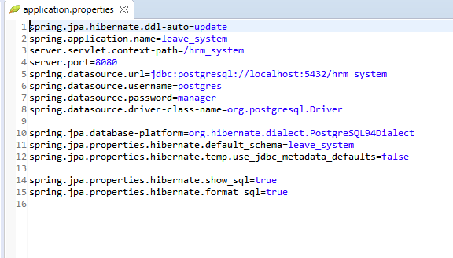

According to this Leave system database design connect to the Valentina Studio PostgreSQL then we are just create Database name and schema name after that automatically generate the database table. database design connection through the data access function is enabling database connection local host for data manipulation, data insert, data delete, data update and data view.

## API design and explanation

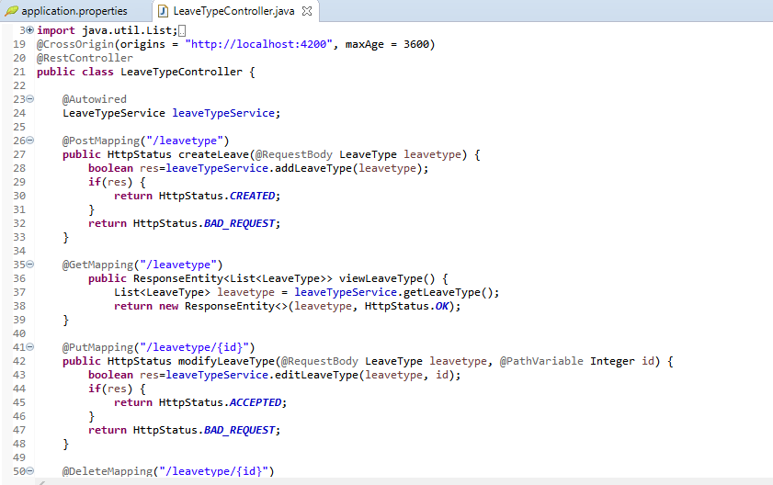

The well-designed RESTful Web API defines the resources, relationships, and navigation schemes that client applications can access. When implementing and deploying Web APIs, you should consider the physical requirements of the environment hosting the Web API and the way you build the Web API, not the logical structure of the data. This guide focuses on best practices for implementing Web APIs and publishes them for use by client applications.

|  |  |  |
| --- | --- | --- |
| Method | Scope | Semantics |
| GET | collection | Retrieve all resources in a collection |
| GET | resource | Retrieve a single resource |
| HEAD | collection | Retrieve all resources in a collection (header only) |
| HEAD | resource | Retrieve a single resource (header only) |
| POST | collection | Create a new resource in a collection |
| PUT | resource | Update a resource |
| PATCH | resource | Update a resource |
| DELETE | resource | Delete a resource |
| OPTIONS | any | Return available HTTP methods and other options |

We are using postman to Test the API Method for example,

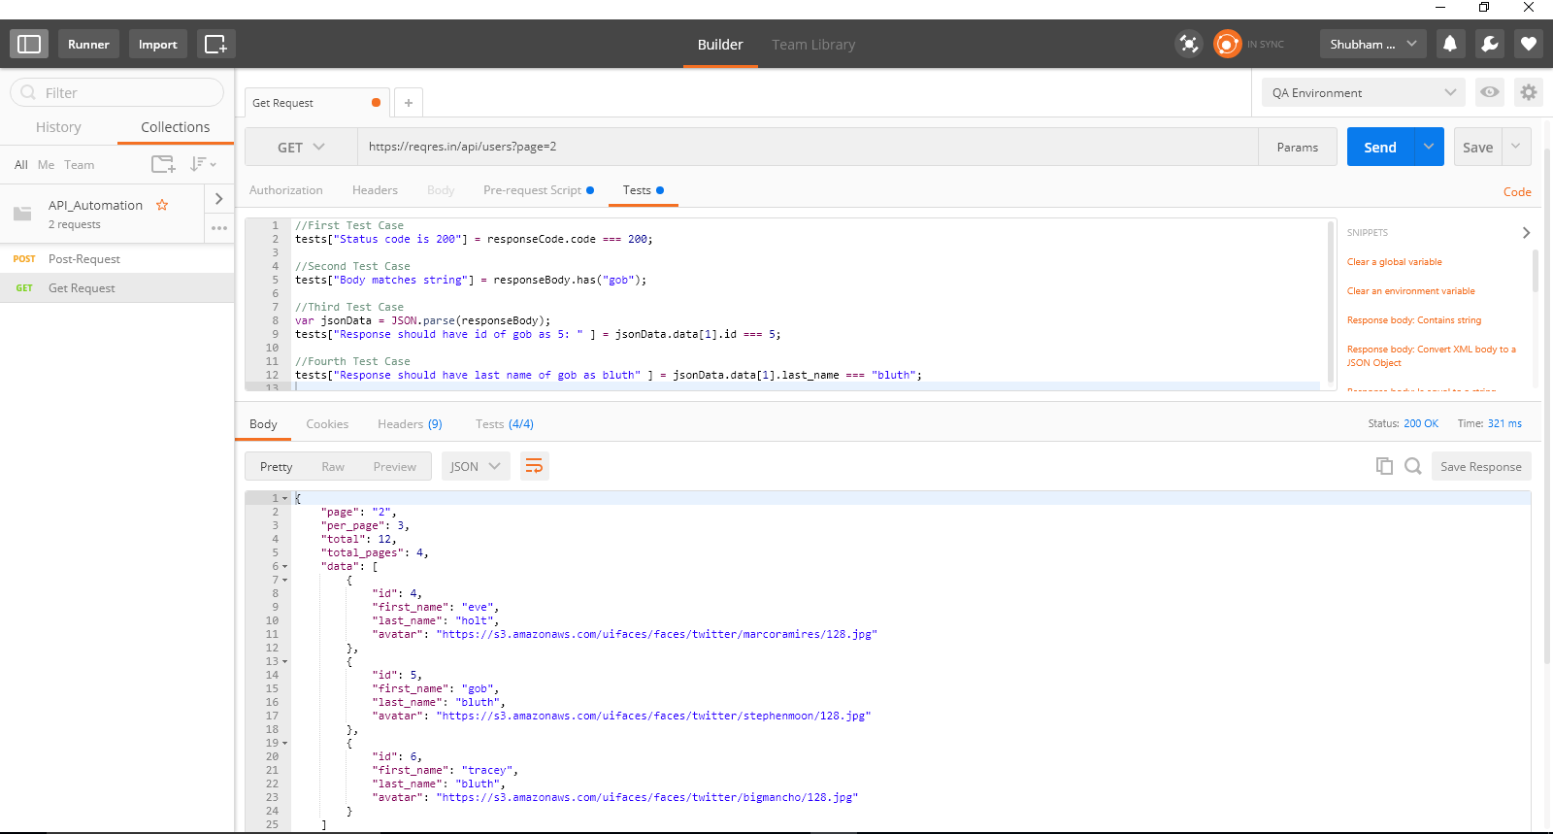

## Deployment instructions

AWS CodeDeploy is a fully managed deployment service that automatically deploys software to a variety of computing services such as Amazon EC2, AWS Fargate, AWS Lambda, and local servers. AWS CodeDeploy makes it easier for you to quickly release new features, help you avoid downtime during application deployment, and handle the complexity of updating your application. You can use AWS CodeDeploy to automate software deployments, eliminating the need for error-prone manual operations. The service scales to your deployment needs.

I will deployed the application in this sever.

# 9.Future enhancements

In future work, some additional features could be implemented in to the application code making its flexible .I will implement some privileges, notification facilities, report generation. Today, the market place is flooded with several leave management options for shoppers to choose from. A variety of innovative products and services are being

offered spoiling customers for choice. Online Leave Management System is no more

a privilege enjoyed by your company.

# 10.Conclusion

The proposed leave management system will be fully vacationed The management process is efficient. Users will be able to access the software from Anywhere. Employees can also apply for vacation at home. This support software will help management make decisions Leave the relevant transaction. In addition, it will ensure less paper work, so The whole process will be fast and reliable.