1. Led Port

My last two digits of your student's ID card to the 7-segment LEDs : 50

5: ON: a,f,g,c,d

* 0x0110 1101 = 0x6D

0 : ON : a,b,c,d,e,f

* 0x0011 1111 = 0x3F

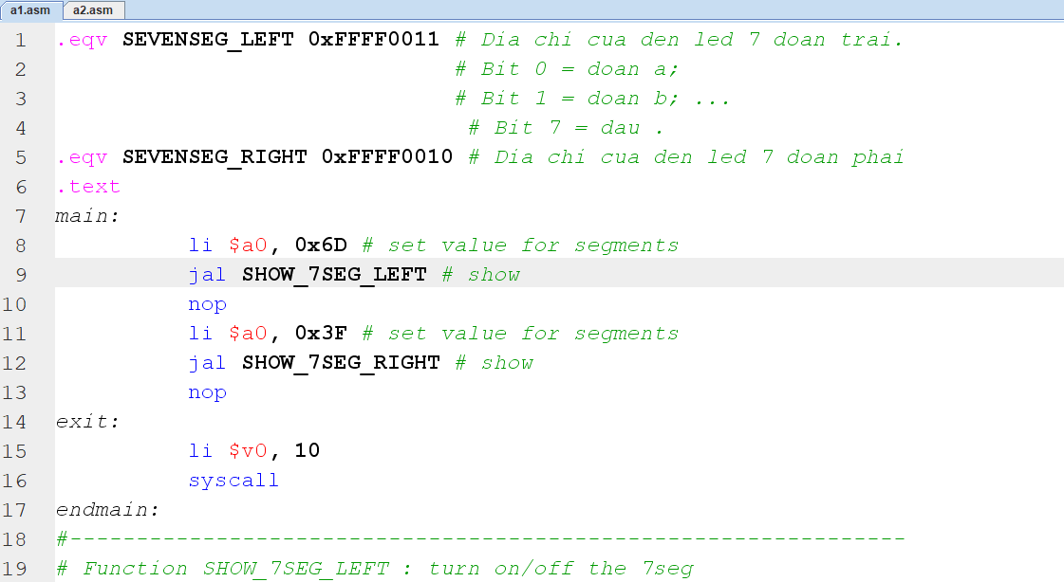

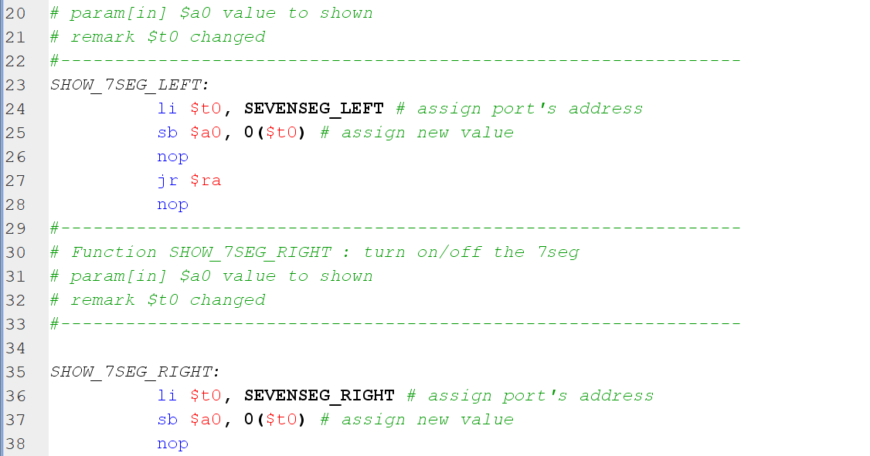



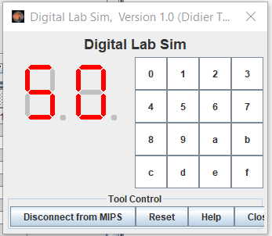

2. Bitmap display

Letter : T

|  |  |  |  |  |  |  |  |
| --- | --- | --- | --- | --- | --- | --- | --- |
| 0 | 4 | 8 | 12 | 16 |  |  |  |
| 32 |  | 40 |  |  |  |  |  |
| 64 |  | 72 |  |  |  |  |  |
| 96 |  | 104 |  |  |  |  |  |
| 128 |  | 136 |  |  |  |  |  |
| 160 |  |  |  |  |  |  |  |
| 192 |  |  |  |  |  |  |  |
| 224 |  |  |  |  |  |  |  |

